UNIT 6
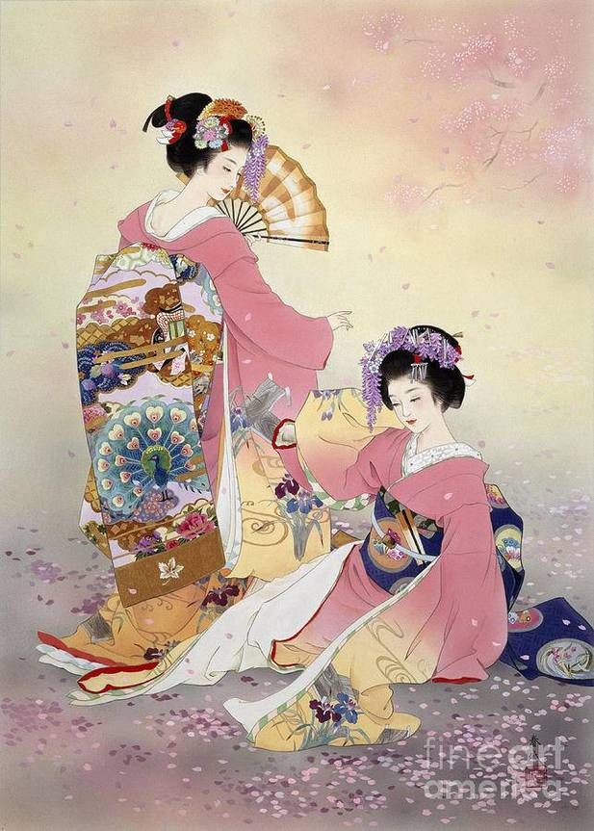
THE SECRET WORLD OF GEISHA

 Pre viewing
1. Do you know who geishas are? Where (in what country) can you meet them? Is it a common profession? What do they have to do?
2. Give Russian equivalents of the following words and phrases: iconic symbol, cultural phenomenon, pleasure districts, training, master traditional skills, calligraphy, flower arranging, conversation, practice, paint black, for life, leave the profession, public event, high privilege, high status individuals, per person, tea-house, intrigued, rampant, recognizable, apprentice geisha
 While viewing
1. Watch the video again. Read the statements and put letter T if the statement is right and W if the statement is wrong.
1. Geisha translates to “art person”
2. Geishas provide entertainment for people in the theatre.
3. If the girl wants to become a geisha she has to train some
months.
4. Geishas have to practice all life.
5. Some geishas may paint their teeth red at the ceremony
when maiko becomes geisha.
6. Geisha can work into her sixty or seventy.
7. People have to pay up to 200 dollars if they want
to attend a tea-house of geisha.

2. Watch the video again. Number the missing words in the order they appear in the film and fill in the gaps.
Geisha is an iconic symbol of Japanese culture (1) around the world. Stereotypes about Geisha are rampant but you might not know a real story (2) the cultural phenomenon. The (3) geisha were men. They provided entertainment for people in (4) districts of Japan around the 600. An (5) geisha known as maiko are trained from 3 to 5 years and have to master traditional (6) like calligraphy, playing musical instruments, flower arranging and (7) of conversation. Geisha sometimes (8) their teeth black as they used to do hundreds of years ago, as it was considered beautiful. Geishas normally (9) working as long as they can. Generally a geisha cannot (10) unless she chooses to leave the profession. But a geisha may have lovers and even their (11). Geisha is a dying way of life in Japan. There are far (12) geisha now than before. While you can be lucky to see geisha walking in the street or performing at the public (13) it is a high (14) to be entertained by geisha. Perhaps that is why the world of geisha is such (15).

pleasure ( )
recognizable ( )
marry ( )
privilege ( )
children ( )
an intrigue ( )
apprentice ( )
fewer ( )
paint ( )
art ( )
skills ( )
event ( )
continue ( )
first ( )
behind ( )

 After viewing
Discussion
1. Answer the following questions:
- How old is the profession of geisha? What is the history of this cultural phenomenon?
- What traditional skills does maiko have to learn and why?
- Why is geisha a dying profession?
2. Why are people ready to pay $ 2000 to attend geisha’s teahouse? Give reasons.

 Follow up
Develop the statement: “The career of a geisha is bitter sweet.”

Script
The Secret World of Geishas
Geisha is an iconic symbol of Japanese culture instantly recognizable around the world. Assumptions and stereotypes about Geisha are rampant but you might not know a real story behind the cultural phenomenon. The first geisha were men. Geisha translates to “art person”. These person provided entertainment for people in a pleasure districts of Japan around the 600. The first woman geisha were documented in 1751. Becoming a geisha takes years of training. An apprentice geisha known as maiko are trained from 3 to 5 years mastering traditional skills like calligraphy, playing musical instruments, flower arranging and art of conversation. They continue to practice these arts every day for the rest of their career. Geisha sometimes paint their teeth black as they used to do hundreds of years ago, as it was considered beautiful. The practice was banned in 1870 as a part of government’s effort to modernize the country. But some geisha still practice teeth blackening at the ceremony when maiko become geisha.
Geisha is for life. Geisha normally continue working as long as they can into their eighty or ninety. Generally a geisha cannot marry unless she chooses to leave the profession as the role of geisha and wife are seen as competitive. But a geisha may have lovers and even their children. Geisha is a dying way of life in Japan. There are far fewer geisha now than before. In the 1920 there were only 80 thousand geisha in the country. But now the figure is estimated between, 1 and 5 thousand. So while you seem to be to be lucky enough to spot geisha walking in the street or performing at the public event being entertained by geisha is a high privilege of a high status individuals. In fact people pay up to 2000 US dollar per person to attend exclusive tea-houses of geisha. Perhaps that is why the world of geisha is one of the such intrigued to be outside.

