This is a translation of [BOINC](https://boinc.berkeley.edu/) into [toki pona](https://en.wikipedia.org/wiki/Toki_Pona).

.po files can be edited with [Poedit](https://poedit.net/) and compiled into .mo.

To install toki pona follow these steps:

1. Copy everything from the “tok” folder.

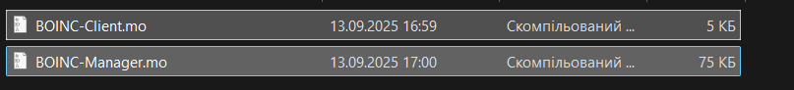

2.Go to the directory where BOINC is installed. It may be C:\Program Files\BOINC

3. Go to locale.

4. Select the language you don’t use.

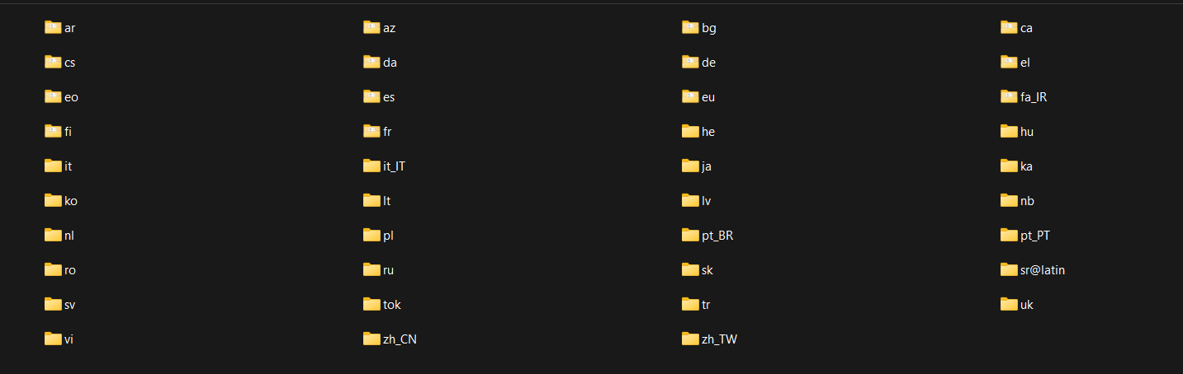

5. For example, it’s de (German). Replace everything with toki pona .mo files.

6. Start BOINC manager. Open Options > Other options. Select the language you replaced. 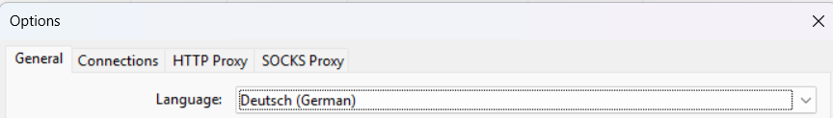

7. Restart your PC.

