Project Summary

JaniTrack - AI-Powered Workforce Monitoring for Corporate Cleaning Services
Team Members:
- Shumail Abdulrehman — SAP: 47891
- Ali Raza — SAP: 55592
- Umer Khalid — SAP: 39987

Problem Statement
The corporate cleaning and facility management industry, particularly in developing countries like Pakistan, relies heavily on manual processes for workforce management. Attendance is typically recorded through paper registers, which enables practices such as buddy punching and time fraud. Task completion is verified through infrequent physical inspections, while communication often occurs through informal channels like WhatsApp.
These outdated practices lead to several operational problems, including:
- Payroll leakage of approximately 10–15%
- Lack of real-time visibility for managers
- Frequent disputes with corporate clients due to the absence of verifiable proof of work
Currently, there is no dedicated technology solution in the Pakistani market specifically designed for cleaning workforce management.

Proposed Solution
JaniTrack is a mobile-first, AI-powered workforce monitoring platform specifically designed for corporate cleaning service providers. The system consists of four core components:
- Staff Mobile Application (React Native)
  - GPS-based attendance with geo-fencing
  - Workers can only check in when physically present at the assigned site
  - Digital task lists for assigned duties
  - Photo-based task completion with timestamped and geo-tagged evidence
- Manager Web Dashboard (React.js)
  - Real-time monitoring of staff attendance
  - Task completion tracking
  - Performance analytics with KPI dashboards
  - Direct task assignment
  - Automated alerts for missed tasks or late arrivals
- AI Cleaning Verification Module (Python / TensorFlow)
An image classification model trained on before-and-after cleaning images that:
  - Automatically evaluates uploaded task photos
  - Determines whether cleaning has been performed to an acceptable standard
  - Eliminates subjective human judgment
  - Creates an objective and scalable quality assurance system
- Backend API (Node.js / Express / PostgreSQL)
A secure and scalable backend system responsible for:
  - Authentication and role-based access control
  - Recurring task generation
  - Real-time staff tracking
  - Data processing and analytics

AI Innovation
The core innovation of JaniTrack is its AI-based cleaning verification engine. Unlike traditional systems that rely solely on photo uploads, which can be manipulated, JaniTrack combines:
- AI image classification
- GPS verification
- Timestamp validation
- Upload integrity checks
This creates a tamper-resistant proof-of-work system for cleaning services. The AI model improves continuously as more task images are collected, creating a data-driven feedback loop that enhances accuracy over time.

Market Potential
The global janitorial services market exceeds USD 300 billion. In Pakistan alone:
- 5,000+ cleaning companies
- 500,000+ workers employed in the sector
JaniTrack follows a per-worker SaaS pricing model, allowing scalable revenue growth. The platform also has expansion potential into the UAE and Gulf markets, where many Pakistani cleaning companies operate. Additionally, the system can be adapted for other blue-collar workforce sectors, including security services, delivery workforce, and construction labor management.

Team Profiles

Shumail Abdulrehman
I am a Computer Science graduate with strong interests in full-stack software development, artificial intelligence, and scalable web systems. I have experience building modern web applications using Node.js, PostgreSQL, React.js, and REST APIs.
Currently, I am working on innovative software solutions that address real-world operational problems using mobile applications, cloud infrastructure, and AI-based automation. During my academic and internship experience as a Full-Stack Engineer, I have developed systems such as HR Management Systems and Inventory Management Systems.
My technical focus includes backend architecture design, database systems, and AI-based image verification models. I am currently leading the development of JaniTrack, an AI-enabled workforce management platform designed for janitorial and facility management companies.
Email: 47891@students.riphah.edu.pk
Email: contactshumail@gmail.com
contact: 03079284502


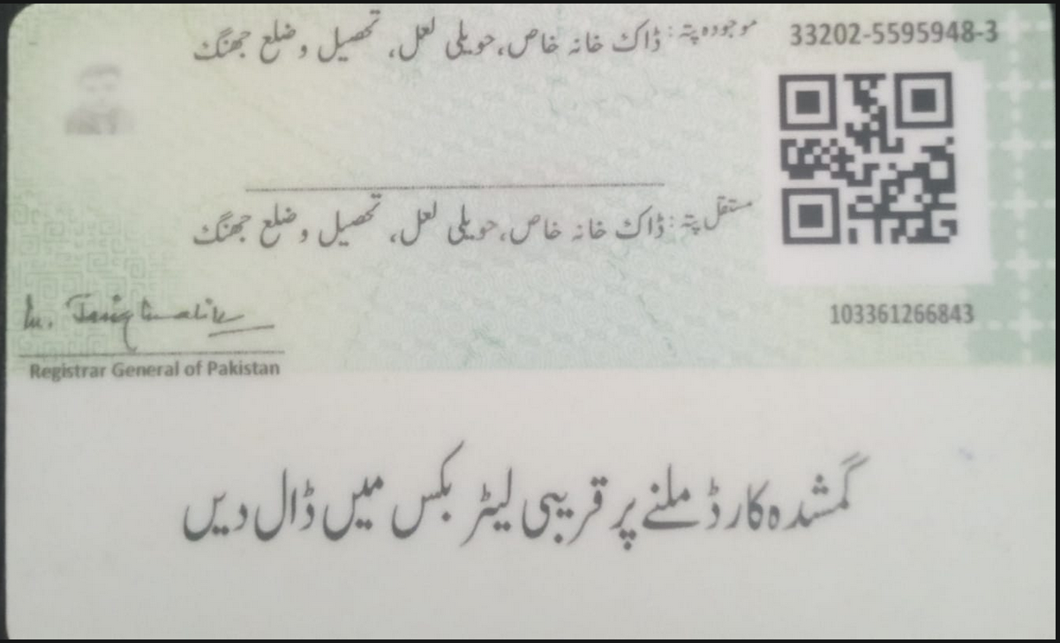

Umer Khalid
I am a Computer Science student with a strong interest in Artificial Intelligence, innovative digital solutions, and emerging technologies. I have worked on academic and practical projects including AI algorithms, mobile application development using Flutter, and blockchain-based decentralized applications.
Currently, I am working on technology solutions as part of my Final Year Project, focusing on smart service systems designed to improve efficiency and digital accessibility. My goal is to apply modern technologies to solve real-world problems and create impactful digital solutions. I am motivated to collaborate with international innovators and contribute to projects in AI, robotics, and sustainable technology development.
Contact: 0304-1659109
Email: 39987@students.riphah.edu.pk


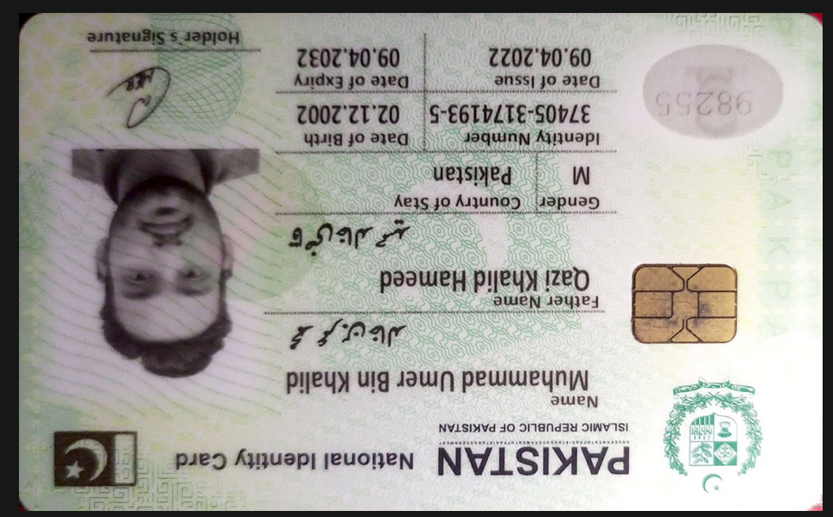

Ali Raza
I am a Computer Science graduate with a strong focus on full-stack engineering and algorithmic problem-solving. I am proficient in bridging intuitive front-end user experiences with robust back-end architectures, enabling the development of scalable and efficient software systems.
My experience includes developing applications using the MERN stack, integrating generative AI models into production environments, and implementing Dockerized CI/CD pipelines. I am passionate about solving complex software challenges and committed to delivering secure, high-quality, maintainable, and scalable software solutions. I am capable of performing effectively even in high-pressure development environments.
Email: 55592@students.riphah.edu.pk
Email: malirazakhan55777@gmail.com
contact: +92 304 1659109
