# Lab 13

# INTRODUCTION TO CSS I

**Objective**

* To acquaint the students with basic knowledge of styling web pages.

**Time Required** : 3 hrs

**Programming Language** : NIL

**Software Required** : Web Browser, Notepad++

**Hardware Required** : Computer System

**CSS:**

CSS stands for Cascading Style Sheets. It is used to style and lay out web pages — for example, to alter the font, color, size, and spacing of your content, split it into multiple columns, or add animations and other decorative features.

**CSS Syntax:**

Selector {

Property 1 : value;

Property 2 : value;

Property 3 : value;

}

**For example:**

h1 /* target an element */

{

Color: red;

Text-align: center;

}

#unique /* target an element with a unique id */

{

color: green;

}

.some

{ /* target some elements with class */

color: red;

}

**How to include CSS in HTML files:**

There are 3 ways to write CSS in HTML file.

1. Inline CSS
2. Internal CSS
3. External CSS

* Priority order
  1. Inline
  2. Internal
  3. External

**Inline CSS:**

<h3 style=”color: red;”> Have a great day </h3>

<p style=”color: green;”> I did this , I did that </p>

**Internal CSS:**

<style>

h1{

color: red;

}

</style>

<h3> Have a great day </h3>

**External CSS:**

<head>

<link rel="stylesheet" type="text/css" href="name_of_CSS_file.css">

</head>

**CSS Colors:**

Three widely used colouring schemes in CSS are the following:

1. **RGB**

**RGB color values are supported in all browsers. An RGB color value is specified with: rgb(red, green, blue)**

color: rgb(255,0,0);

1. **RGBA**

**RGBA color values are an extension of RGB color values with an alpha channel - which specifies the opacity for a color. An RGBA color value is specified with:**

**rgba(red, green, blue, alpha)**

color: rgba(255,0,0,0.5);

1. **HEX**

**This color scheme represents each color using 6 hexadecimal digits starting with # e.g.**

**color: #ff0000;**

**Let us explore some CSS properties:**

**font-size**: medium|xx-small|x-small|small|large|x-large|xx-large|smaller |larger|*length*|initial|inherit;

**font-family**: *family-name*|generic-family|initial|inherit;

**font-style**: normal|italic|oblique|initial|inherit;

**font-weight**: normal|bold|bolder|lighter|*number*|initial|inherit;

**color**: *color*|initial|inherit;

**line-height**: normal|*number*|*length*|initial|inherit;

**text-decoration**: text-decoration-line text-decoration-color

text-decoration-style|initial|inherit;

**text-align**: left|right|center|justify|initial|inherit;

**text-shadow**: *h-shadow v-shadow blur-radius color*|none|initial|inherit;

**text-transform**: none|capitalize|uppercase|lowercase|initial|inherit;

**text-indent**: *length*|initial|inherit;

**letter-spacing**: normal|*length*|initial|inherit;

**word-spacing**: normal|*length*|initial|inherit;

**transform**: none|*transform-functions*|initial|inherit;

**border**: *border-width* *border-style* *border-color*|initial|inherit;

**border-radius**: *1-4 length*|*%* / *1-4 length*|*%*|initial|inherit;

**background-color**: *color*|transparent|initial|inherit;

**background-image**: *url*|none|initial|inherit;

**background-repeat**: repeat|repeat-x|repeat-y|no-repeat|initial|inherit;

**background-size**: auto|*length*|cover|contain|initial|inherit;

**margin**: *length*|auto|initial|inherit;

**padding**: *length*|initial|inherit;

**height**: auto|*length*|initial|inherit;

**width**: auto|*value*|initial|inherit;

**float**: none|left|right|initial|inherit;

**EXERCISE**

**Exercise 13.1 [5]**

Design the following HTML page.

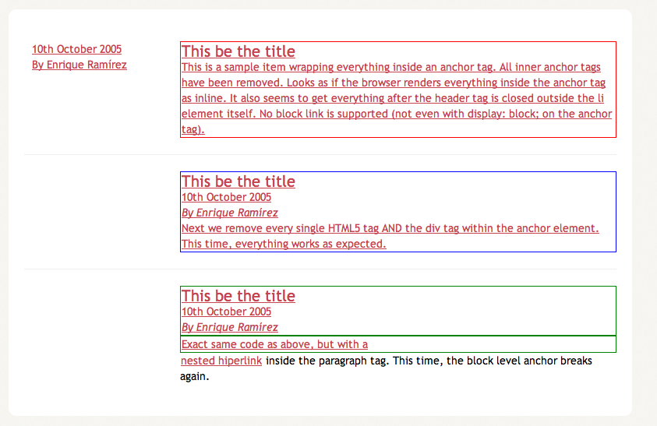

**Exercise 13.2 [5]**

Design the following HTML page.



**Exercise 13.3 [5]**

Design the following HTML page.

