**Let us explore some other CSS properties:**

**list-style**: *list-style-type* *list-style-position* *list-style-image* |initial |inherit;

**list-style-image**: none|*url*|initial|inherit;

**list-style-position**: inside|outside|initial|inherit;

**display**: *inline|block|flex|inline-block|none*;

**min-height**: *length*|initial|inherit;

**min-width**: *length*|initial|inherit;

**overflow**: visible|hidden|scroll|auto|initial|inherit;

**:hover** {  
  css declarations;  
}

**word-wrap**: normal|break-word|initial|inherit;

**z-index**: auto|*number*|initial|inherit;

**position**: static|absolute|fixed|relative|sticky|initial|inherit;

**direction**: ltr|rtl|initial|inherit;

**overflow**: visible|hidden|scroll|auto|initial|inherit;

**EXERCISE**

**Exercise 14.1 [5]**

Design the following HTML page.

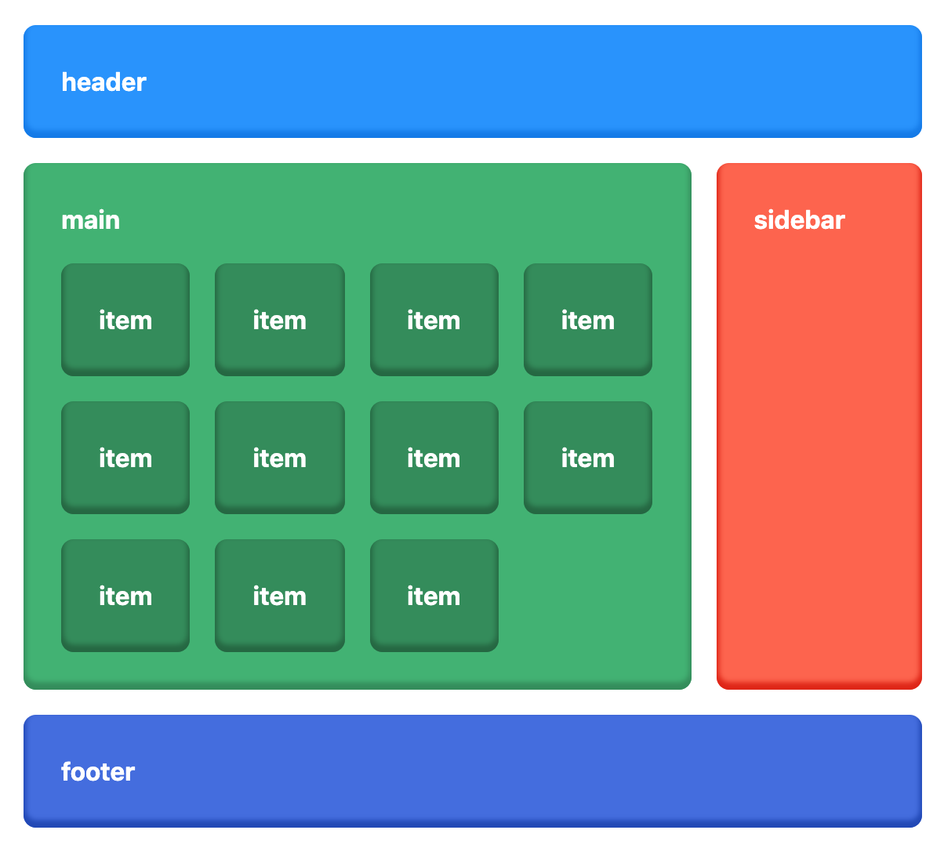

**Exercise 14.2 [5]**

Design the following HTML page.

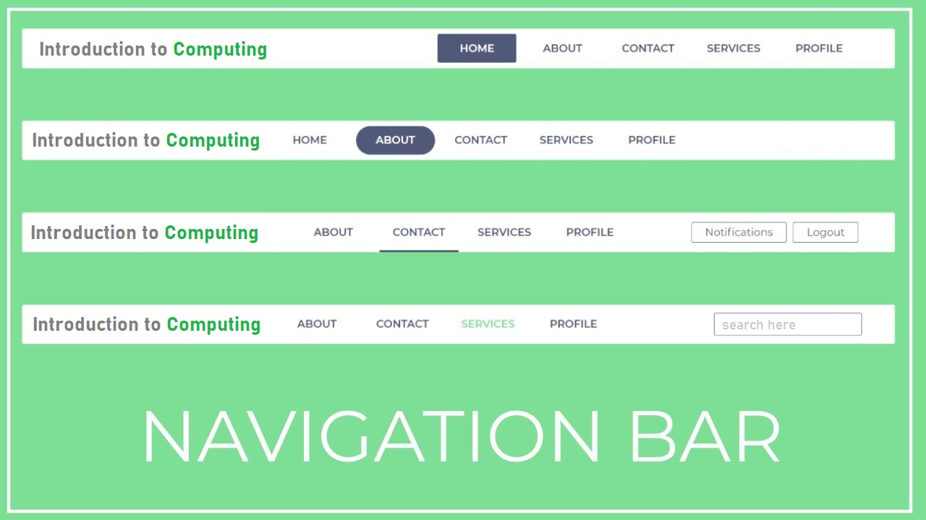

**Exercise 14.3 [5]**

Design the following HTML page.

