ETL and Data Cleaning Process
Overview
Before creating SQL queries, Python visualisations, and the Power BI dashboard, the raw datasets were cleaned and prepared using the ETL (Extract, Transform, Load) process. This ensured the data was accurate, consistent, and ready for analysis.

ETL Workflow
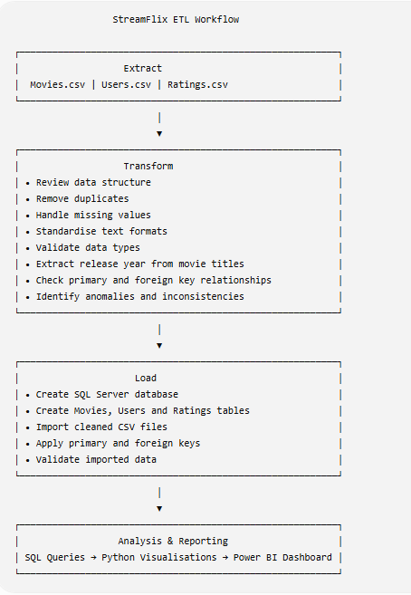

Data Cleaning Activities
Movies Dataset
- Checked for missing values.
- Removed duplicate records.
- Standardised text formatting.
- Extracted the release year from the movie title.
- Verified genres, language, and country values.
- Validated total views.

Users Dataset
- Checked age values.
- Reviewed gender information.
- Validated country names.
- Standardised subscription status.
- Reviewed device categories.
- Validated total watch time.

Ratings Dataset
- Verified rating values.
- Checked timestamp format.
- Confirmed Movie ID and User ID relationships.
- Ensured referential integrity with SQL foreign keys.

Technologies Used
Phase | Tool
Data Review | Microsoft Excel
Data Cleaning | Excel / Power Query
Database | SQL Server Management Studio
Data Import | SQL Server Import Wizard
Data Analysis | SQL
Data Visualisation | Python (Pandas & Matplotlib)
Dashboard | Microsoft Power BI

Outcome
The cleaned datasets were successfully loaded into SQL Server, analysed using SQL and Python, and visualised through an interactive Power BI dashboard. The ETL process ensured that all reporting and business insights were based on accurate and consistent data.

