Shumokh Alhattami

**Task1 part a: Write an algorithm to operate servo motors to simulate the walking movement of a robot.**

1-Initialization: Begin by setting up the servo motors for the hip and knee joints of the robot leg.

2-Attach Servos: Connect the hip servo and knee servo to the appropriate pins on the microcontroller. Set Initial Positions: Start both servos at a neutral position, typically around 90 degrees, to prepare for leg movement and making the robot stand still.

3-Leg Movement Loop: Enter a continuous loop to simulate the leg movement. Move Leg Forward: Incrementally increase the hip servo angle from its initial position towards a forward position, e.g. 120 degrees.

Adjust the knee servo angle as well to maintain a coordinated leg movement pattern. (180-hip degree) to maintain a neutral state.

Introduce a delay between angle adjustments to ensure smooth motion.

4-Move Leg Backward: Once the leg reaches the forward position (120 degrees): Gradually decrease the hip servo angle back to its starting position (90 degrees).

Correspondingly adjust the knee servo angle to mirror the hip movement. Maintain consistent timing delays between servo adjustments for fluid motion.

5-Repeat: Continuously cycle through the forward and backward leg movement within the loop, creating a repetitive walking motion.

**Task1 part b: Connect and program an electronic circuit containing 6 servo motors using the simulation software.**

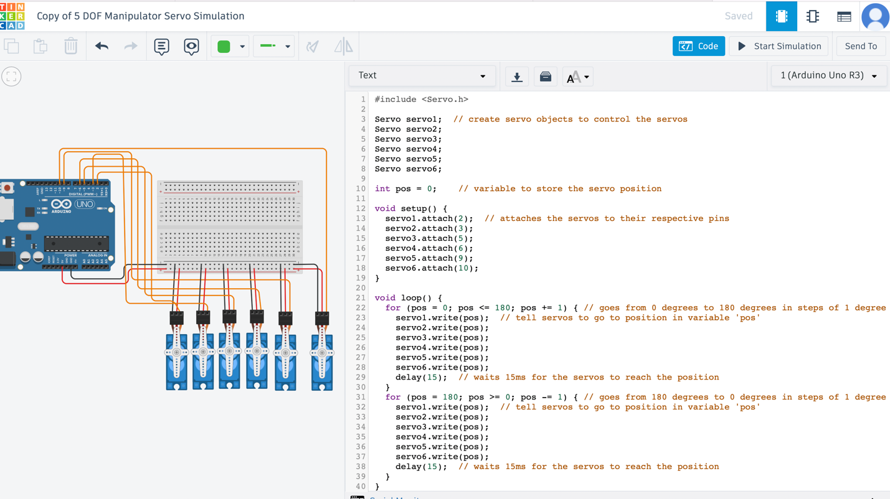

<https://www.tinkercad.com/things/6AMVncpI3rR-6-servomotor-simulation?sharecode=_ttexi6nGOnO3piKFPMvXSiBwzZUOxMnj4WMQLXnqjo>