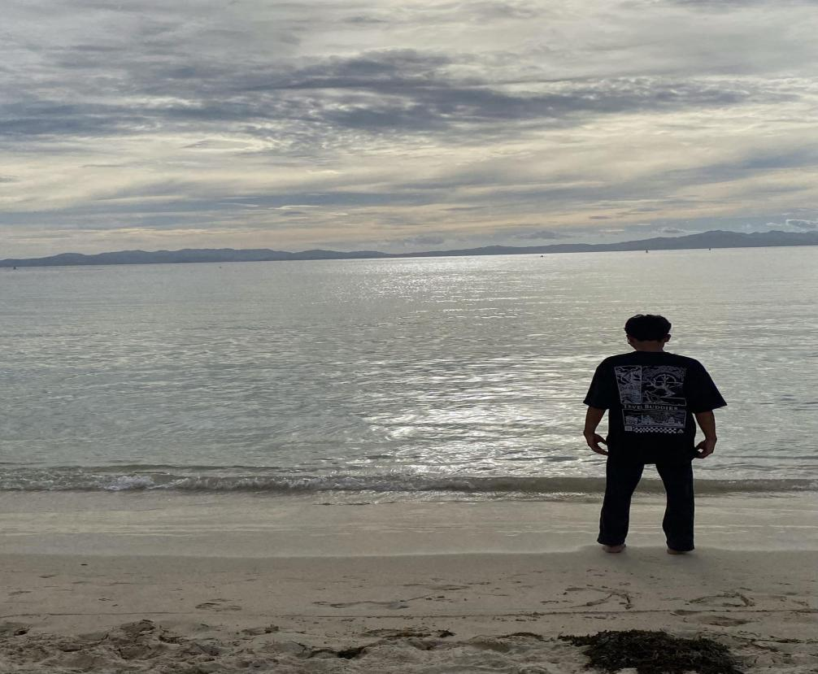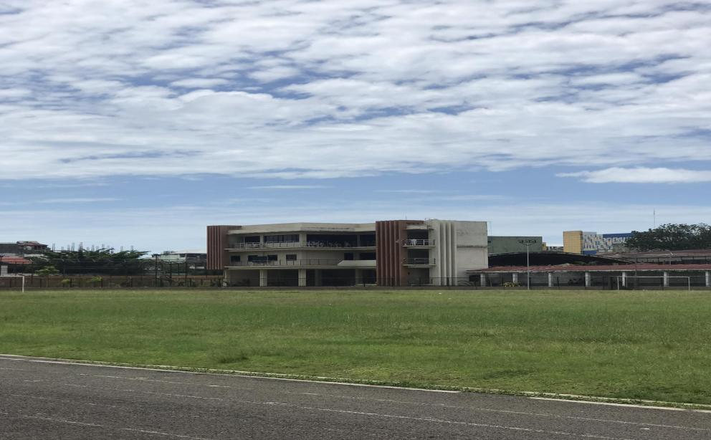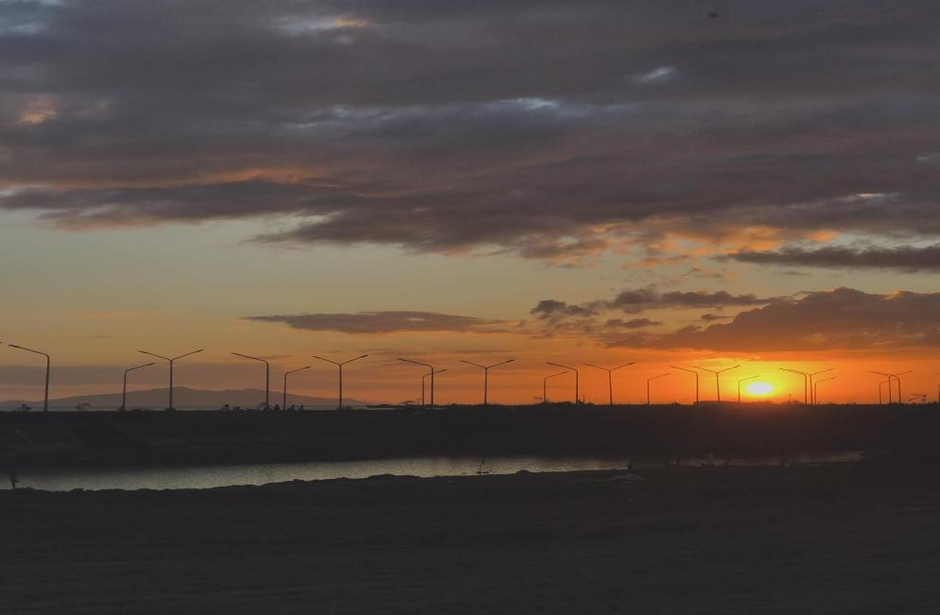**NAME:** Jayson F. Mancol  **Program/Section:** BSIT 2A

"Lost in the horizon, finding peace in the waves."

4o

"Peaceful day at NwSSU, where learning meets open skies."

“Golden sunset perfectly framed by nature and streetlights.”