Reanalysis on diversity indices

Shun Hasegawa

13 August 2016

## Issues in Year0

As we discussed in the last meeting, we have some issues with the vegetation survey conducted in Year0. Briefly, the survey was carried out twice in 2012: September and December. In September, grass species were not identified. In December, whilst grasses were identified, forb species were not accurately recorded. In the last meeting, it was suggested that we use those species only observed in the subsequent year; in other words remove those only observed in Year0

Herein, I compared three different solutions as below, analysing diversity indices (diversity, evenness and species richness).

1. S1. Combine September and December (the was we have analysed so far)
2. S2. Following S1, remove non-grass species only observed in Year0
3. S3. Following S2, also remove non-grass species that were observed in the subsequent years but not in the same plots

Number of species in Year0 for each solution

|  |  |  |  |
| --- | --- | --- | --- |
| form | s1 | s2 | s3 |
| Fern | 1 | 1 | 1 |
| Forb | 42 | 30 | 26 |
| Grass | 23 | 23 | 23 |
| Moss | 1 | 1 | 1 |
| Wood | 11 | 7 | 7 |

Thus, 12-16 non-grass species were removed in S2 and S3.

## Diversity indices

Using data sets generated based on the above three solutions I have analysed diversity indices. In addition, I have also analysed Grass and Forb, separately, as Paul suggested. Here, I show the results of 54 analyses as below.

* 3 solutions (S1, S2, S3)
* 3 data sets (all species, grass species, forb species)
* 3 diversity indices (diversity, evenness, richness)
* 2 statistics
  + Two-way anova (CO2, Year, CO2xYear)
  + ANCOVA with Year0 (BL) as a covariate (CO2, Year, CO2xYear, BL)

## Figures

### S1

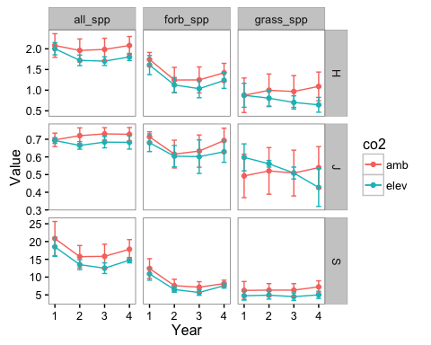

Fig.1 Diversity indices for S1

### S2

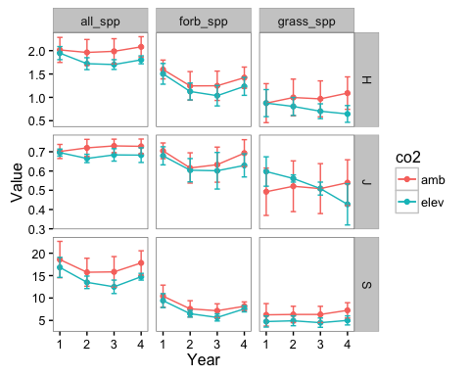

Fig.2 Diversity indices for S2

### S3

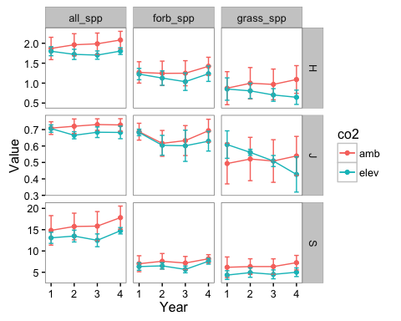

Fig.3 Diversity indices for S3

## Stats

Results of two-way anova and ancova

|  |  |  |  |  |  |  |  |  |  |  |  |
| --- | --- | --- | --- | --- | --- | --- | --- | --- | --- | --- | --- |
| S | Form | Ind | term | DFden | DFnum | F | P | DFden | DFnum | F | P |
| s1 | all_spp | H | CO2 | 2 | 1 | 7.16 | *0.126* | 2 | 1 | 1.19 | *0.389* |
| s1 | all_spp | H | Year | 44 | 2 | 3.69 | ***0.033*** | 66 | 3 | 8.88 | ***0*** |
| s1 | all_spp | H | CO2xYear | 44 | 2 | 0.15 | *0.859* | 66 | 3 | 2.28 | ***0.088*** |
| s1 | all_spp | H | BL | 5 | 1 | 31.56 | ***0.002*** | - | - | - | ***-*** |
| s1 | all_spp | J | CO2 | 2 | 1 | 1.72 | *0.323* | 2 | 1 | 0.74 | *0.481* |
| s1 | all_spp | J | Year | 44 | 2 | 0.63 | *0.537* | 66 | 3 | 0.5 | *0.686* |
| s1 | all_spp | J | CO2xYear | 44 | 2 | 0.07 | *0.935* | 66 | 3 | 1.24 | *0.302* |
| s1 | all_spp | J | BL | 20 | 1 | 8.35 | ***0.009*** | - | - | - | ***-*** |
| s1 | all_spp | S | CO2 | 2 | 1 | 1.87 | *0.311* | 2 | 1 | 1.72 | *0.32* |
| s1 | all_spp | S | Year | 44 | 2 | 6.41 | ***0.004*** | 66 | 3 | 22.08 | ***0*** |
| s1 | all_spp | S | CO2xYear | 44 | 2 | 0.41 | *0.665* | 66 | 3 | 0.84 | *0.477* |
| s1 | all_spp | S | BL | 11 | 1 | 35.48 | ***0*** | - | - | - | ***-*** |
| s1 | forb_spp | H | CO2 | 2 | 1 | 0.31 | *0.633* | 2 | 1 | 0.52 | *0.545* |
| s1 | forb_spp | H | Year | 44 | 2 | 6.39 | ***0.004*** | 66 | 3 | 20.99 | ***0*** |
| s1 | forb_spp | H | CO2xYear | 44 | 2 | 0.39 | *0.68* | 66 | 3 | 0.17 | *0.916* |
| s1 | forb_spp | H | BL | 19 | 1 | 1.68 | *0.21* | - | - | - | ***-*** |
| s1 | forb_spp | J | CO2 | 2 | 1 | 0.29 | *0.646* | 2 | 1 | 0.3 | *0.64* |
| s1 | forb_spp | J | Year | 44 | 2 | 1.88 | *0.165* | 66 | 3 | 2.57 | ***0.062*** |
| s1 | forb_spp | J | CO2xYear | 44 | 2 | 0.43 | *0.656* | 66 | 3 | 0.18 | *0.91* |
| s1 | forb_spp | J | BL | 18 | 1 | 2.21 | *0.154* | - | - | - | ***-*** |
| s1 | forb_spp | S | CO2 | 2 | 1 | 0.75 | *0.483* | 2 | 1 | 0.32 | *0.629* |
| s1 | forb_spp | S | Year | 44 | 2 | 5.45 | ***0.008*** | 66 | 3 | 30.17 | ***0*** |
| s1 | forb_spp | S | CO2xYear | 44 | 2 | 0.54 | *0.589* | 66 | 3 | 0.41 | *0.746* |
| s1 | forb_spp | S | BL | 6 | 1 | 24.96 | ***0.003*** | - | - | - | ***-*** |
| s1 | grass_spp | H | CO2 | 2 | 1 | 10.99 | ***0.085*** | 2 | 1 | 1.13 | *0.399* |
| s1 | grass_spp | H | Year | 44 | 2 | 1.29 | *0.284* | 66 | 3 | 0.77 | *0.516* |
| s1 | grass_spp | H | CO2xYear | 44 | 2 | 5.14 | ***0.01*** | 66 | 3 | 8.87 | ***0*** |
| s1 | grass_spp | H | BL | 3 | 1 | 69.2 | ***0.003*** | - | - | - | ***-*** |
| s1 | grass_spp | J | CO2 | 2 | 1 | 1.84 | *0.307* | 2 | 1 | 0 | *0.986* |
| s1 | grass_spp | J | Year | 43 | 2 | 1.14 | *0.331* | 65 | 3 | 1.36 | *0.263* |
| s1 | grass_spp | J | CO2xYear | 43 | 2 | 2.81 | ***0.071*** | 65 | 3 | 3.83 | ***0.014*** |
| s1 | grass_spp | J | BL | 18 | 1 | 14.93 | ***0.001*** | - | - | - | ***-*** |
| s1 | grass_spp | S | CO2 | 2 | 1 | 3.71 | *0.192* | 2 | 1 | 0 | *1* |
| s1 | grass_spp | S | Year | 44 | 2 | 2.55 | ***0.09*** | 66 | 3 | 2.86 | ***0.044*** |
| s1 | grass_spp | S | CO2xYear | 44 | 2 | 0.84 | *0.441* | 66 | 3 | 0.81 | *0.493* |
| s1 | grass_spp | S | BL | 5 | 1 | 69.37 | ***0*** | - | - | - | ***-*** |
| s2 | all_spp | H | CO2 | 2 | 1 | 6.66 | *0.13* | 2 | 1 | 1.25 | *0.379* |
| s2 | all_spp | H | Year | 44 | 2 | 3.69 | ***0.033*** | 66 | 3 | 5.03 | ***0.003*** |
| s2 | all_spp | H | CO2xYear | 44 | 2 | 0.15 | *0.859* | 66 | 3 | 2.6 | ***0.06*** |
| s2 | all_spp | H | BL | 6 | 1 | 29.78 | ***0.002*** | - | - | - | ***-*** |
| s2 | all_spp | J | CO2 | 2 | 1 | 1.45 | *0.353* | 2 | 1 | 0.78 | *0.469* |
| s2 | all_spp | J | Year | 44 | 2 | 0.63 | *0.537* | 66 | 3 | 0.39 | *0.76* |
| s2 | all_spp | J | CO2xYear | 44 | 2 | 0.07 | *0.935* | 66 | 3 | 1.1 | *0.356* |
| s2 | all_spp | J | BL | 19 | 1 | 7.76 | ***0.012*** | - | - | - | ***-*** |
| s2 | all_spp | S | CO2 | 2 | 1 | 3.11 | *0.225* | 2 | 1 | 1.68 | *0.324* |
| s2 | all_spp | S | Year | 44 | 2 | 6.41 | ***0.004*** | 66 | 3 | 12.17 | ***0*** |
| s2 | all_spp | S | CO2xYear | 44 | 2 | 0.41 | *0.665* | 66 | 3 | 1.22 | *0.309* |
| s2 | all_spp | S | BL | 13 | 1 | 46.6 | ***0*** | - | - | - | ***-*** |
| s2 | forb_spp | H | CO2 | 2 | 1 | 0.34 | *0.621* | 2 | 1 | 0.48 | *0.559* |
| s2 | forb_spp | H | Year | 44 | 2 | 6.39 | ***0.004*** | 66 | 3 | 12.83 | ***0*** |
| s2 | forb_spp | H | CO2xYear | 44 | 2 | 0.39 | *0.68* | 66 | 3 | 0.3 | *0.827* |
| s2 | forb_spp | H | BL | 19 | 1 | 2.35 | *0.141* | - | - | - | ***-*** |
| s2 | forb_spp | J | CO2 | 2 | 1 | 0.28 | *0.65* | 2 | 1 | 0.3 | *0.641* |
| s2 | forb_spp | J | Year | 44 | 2 | 1.88 | *0.165* | 66 | 3 | 2.26 | ***0.09*** |
| s2 | forb_spp | J | CO2xYear | 44 | 2 | 0.43 | *0.656* | 66 | 3 | 0.18 | *0.906* |
| s2 | forb_spp | J | BL | 18 | 1 | 2.09 | *0.165* | - | - | - | ***-*** |
| s2 | forb_spp | S | CO2 | 2 | 1 | 1.37 | *0.369* | 2 | 1 | 0.27 | *0.655* |
| s2 | forb_spp | S | Year | 44 | 2 | 5.45 | ***0.008*** | 66 | 3 | 15.65 | ***0*** |
| s2 | forb_spp | S | CO2xYear | 44 | 2 | 0.54 | *0.589* | 66 | 3 | 0.44 | *0.722* |
| s2 | forb_spp | S | BL | 5 | 1 | 26.02 | ***0.004*** | - | - | - | ***-*** |
| s3 | all_spp | H | CO2 | 2 | 1 | 4.95 | *0.163* | 2 | 1 | 1.22 | *0.384* |
| s3 | all_spp | H | Year | 44 | 2 | 3.69 | ***0.033*** | 66 | 3 | 2.76 | ***0.049*** |
| s3 | all_spp | H | CO2xYear | 44 | 2 | 0.15 | *0.859* | 66 | 3 | 2.63 | ***0.058*** |
| s3 | all_spp | H | BL | 12 | 1 | 30.8 | ***0*** | - | - | - | ***-*** |
| s3 | all_spp | J | CO2 | 2 | 1 | 1.24 | *0.382* | 2 | 1 | 0.8 | *0.466* |
| s3 | all_spp | J | Year | 44 | 2 | 0.63 | *0.537* | 66 | 3 | 0.4 | *0.755* |
| s3 | all_spp | J | CO2xYear | 44 | 2 | 0.07 | *0.935* | 66 | 3 | 1.12 | *0.346* |
| s3 | all_spp | J | BL | 19 | 1 | 8.53 | ***0.009*** | - | - | - | ***-*** |
| s3 | all_spp | S | CO2 | 2 | 1 | 3.89 | *0.194* | 2 | 1 | 1.45 | *0.352* |
| s3 | all_spp | S | Year | 44 | 2 | 6.83 | ***0.003*** | 66 | 3 | 7.53 | ***0*** |
| s3 | all_spp | S | CO2xYear | 44 | 2 | 0.44 | *0.647* | 66 | 3 | 1.2 | *0.316* |
| s3 | all_spp | S | BL | 11 | 1 | 86.76 | ***0*** | - | - | - | ***-*** |
| s3 | forb_spp | H | CO2 | 2 | 1 | 0.55 | *0.537* | 2 | 1 | 0.33 | *0.625* |
| s3 | forb_spp | H | Year | 44 | 2 | 6.39 | ***0.004*** | 66 | 3 | 2.99 | ***0.037*** |
| s3 | forb_spp | H | CO2xYear | 44 | 2 | 0.39 | *0.68* | 66 | 3 | 0.66 | *0.579* |
| s3 | forb_spp | H | BL | 20 | 1 | 6.69 | ***0.018*** | - | - | - | ***-*** |
| s3 | forb_spp | J | CO2 | 2 | 1 | 0.17 | *0.72* | 2 | 1 | 0.21 | *0.692* |
| s3 | forb_spp | J | Year | 44 | 2 | 1.88 | *0.165* | 66 | 3 | 1.77 | *0.161* |
| s3 | forb_spp | J | CO2xYear | 44 | 2 | 0.43 | *0.656* | 66 | 3 | 0.24 | *0.865* |
| s3 | forb_spp | J | BL | 18 | 1 | 0.31 | *0.584* | - | - | - | ***-*** |
| s3 | forb_spp | S | CO2 | 2 | 1 | 2.19 | *0.301* | 2 | 1 | 0.17 | *0.723* |
| s3 | forb_spp | S | Year | 44 | 2 | 5.45 | ***0.008*** | 66 | 3 | 4.62 | ***0.005*** |
| s3 | forb_spp | S | CO2xYear | 44 | 2 | 0.54 | *0.589* | 66 | 3 | 0.56 | *0.645* |
| s3 | forb_spp | S | BL | 10 | 1 | 39.01 | ***0*** | - | - | - | ***-*** |

## Conclusion

In general there is only little difference in the final outcomes between tree solutions. A small hint of CO2 effects on diversity index (H') seems to be driven by changes in grass species composition, as such when it's analysed only for grass species, CO2 effec was significant (CO2 x Time; *P < 0.01*).

My suggestions are: 1. Using the full data set withought removing any species (i.e. S1) and anlyse 1) all species, 2) forb species and 3) grass species, separately, not only for diversity indices but also othere analyses (i.e. RDA, C3 vs C4 for grass, legume vs. non-legume). 2. Whilst adding more analyses as above, reomve RDA analysis with PFG composition and magnitude of annual composition change as messages from these aren't very strong. 3. Using ancova with Year0 as covariate in stead of two-way ANOVA, as such we can justify that we take the initial differences into account. Where the covariate is not significant in models (e.g. forb species), it may imply that the initial difference is not effectively taken into account due to Year0 suvery method. However, there's no CO2 effect either way.