Reanalysis on diversity indices

Shun Hasegawa

13 August 2016

## Issues in Year0

As we discussed in the last meeting, we have some issues with the vegetation survey conducted in Year0. Briefly, the survey was carried out twice in 2012: September and December. In September, grass species were not identified. In December, whilst grasses were identified, forb species were not accurately recorded. In the last meeting, it was suggested that we use those species only observed in the subsequent year; in other words remove those only observed in Year0

Herein, I compared three different solutions as below, analysing diversity indices (diversity, evenness and species richness).

1. S1. Combine September and December (the was we have analysed so far)
2. S2. Following S1, remove non-grass species only observed in Year0
3. S3. Following S2, also remove non-grass species that were observed in the subsequent years but not in the same plots

Number of species in Year0 for each solution

|  |  |  |  |
| --- | --- | --- | --- |
| form | s1 | s2 | s3 |
| Fern | 1 | 1 | 1 |
| Forb | 42 | 30 | 26 |
| Grass | 23 | 23 | 23 |
| Moss | 1 | 1 | 1 |
| Wood | 11 | 7 | 7 |

Thus, 12-16 non-grass species were removed in S2 and S3.

## Diversity indices

Using data sets generated based on the above three solutions I have analysed diversity indices. In addition, I have also analysed Grass and Forb, separately, as Paul suggested. Here, I show the results of analyses as below.

* 3 solutions (S1, S2, S3)
* 3 data sets (all species, grass species, forb species). Note that grass species are not altered between solutions.
* 3 diversity indices (diversity, evenness, richness)
* 2 statistics
  + Two-way anova (CO2, Year, CO2xYear)
  + ANCOVA with Year0 (BL) as a covariate (CO2, Year, CO2xYear, BL)

### Figures

#### S1

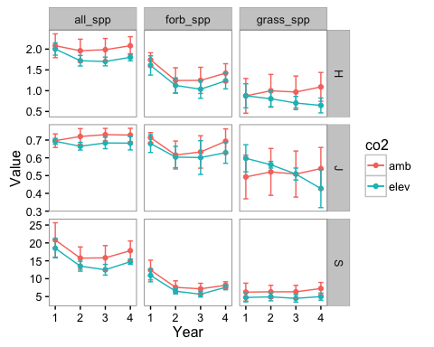

Fig.1 Diversity indices for S1

#### S2

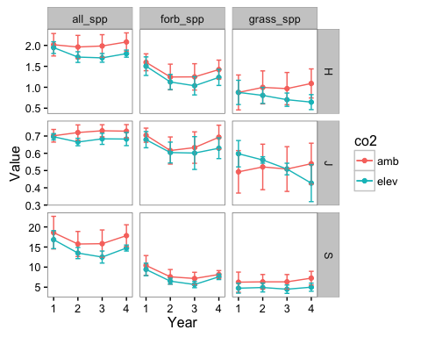

Fig.2 Diversity indices for S2

#### S3

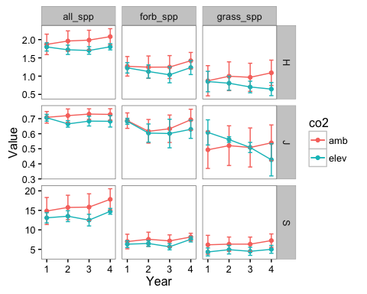

Fig.3 Diversity indices for S3

### Stats

Results of two-way anova and ancova (continued below)

|  |  |  |  | ***ANCOVA*** | | | |  | ***Two-way ANOVA*** | | | |
| --- | --- | --- | --- | --- | --- | --- | --- | --- | --- | --- | --- | --- |
|  |  |  | ***term*** | ***DFden*** | ***DFnum*** | ***F*** | ***P*** |  | ***DFden*** | ***DFnum*** | ***F*** | ***P*** |
| S1 | all | H | CO2 | 2 | 1 | 7.16 | *0.126* |  | 2 | 1 | 1.19 | *0.389* |
| Year | 44 | 2 | 3.69 | ***0.033*** |  | 66 | 3 | 8.88 | ***0*** |
| CO2xYear | 44 | 2 | 0.15 | *0.859* |  | 66 | 3 | 2.28 | ***0.088*** |
| BL | 5 | 1 | 31.56 | ***0.002*** |  | - | - | - | ***-*** |
| J | CO2 | 2 | 1 | 1.72 | *0.323* |  | 2 | 1 | 0.74 | *0.481* |
| Year | 44 | 2 | 0.63 | *0.537* |  | 66 | 3 | 0.5 | *0.686* |
| CO2xYear | 44 | 2 | 0.07 | *0.935* |  | 66 | 3 | 1.24 | *0.302* |
| BL | 20 | 1 | 8.35 | ***0.009*** |  | - | - | - | ***-*** |
| S | CO2 | 2 | 1 | 1.87 | *0.311* |  | 2 | 1 | 1.72 | *0.32* |
| Year | 44 | 2 | 6.41 | ***0.004*** |  | 66 | 3 | 22.08 | ***0*** |
| CO2xYear | 44 | 2 | 0.41 | *0.665* |  | 66 | 3 | 0.84 | *0.477* |
| BL | 11 | 1 | 35.48 | ***0*** |  | - | - | - | ***-*** |
| forb | H | CO2 | 2 | 1 | 0.31 | *0.633* |  | 2 | 1 | 0.52 | *0.545* |
| Year | 44 | 2 | 6.39 | ***0.004*** |  | 66 | 3 | 20.99 | ***0*** |
| CO2xYear | 44 | 2 | 0.39 | *0.68* |  | 66 | 3 | 0.17 | *0.916* |
| BL | 19 | 1 | 1.68 | *0.21* |  | - | - | - | ***-*** |
| J | CO2 | 2 | 1 | 0.29 | *0.646* |  | 2 | 1 | 0.3 | *0.64* |
| Year | 44 | 2 | 1.88 | *0.165* |  | 66 | 3 | 2.57 | ***0.062*** |
| CO2xYear | 44 | 2 | 0.43 | *0.656* |  | 66 | 3 | 0.18 | *0.91* |
| BL | 18 | 1 | 2.21 | *0.154* |  | - | - | - | ***-*** |
| S | CO2 | 2 | 1 | 0.75 | *0.483* |  | 2 | 1 | 0.32 | *0.629* |
| Year | 44 | 2 | 5.45 | ***0.008*** |  | 66 | 3 | 30.17 | ***0*** |
| CO2xYear | 44 | 2 | 0.54 | *0.589* |  | 66 | 3 | 0.41 | *0.746* |
| BL | 6 | 1 | 24.96 | ***0.003*** |  | - | - | - | ***-*** |
| grass | H | CO2 | 2 | 1 | 10.99 | ***0.085*** |  | 2 | 1 | 1.13 | *0.399* |
| Year | 44 | 2 | 1.29 | *0.284* |  | 66 | 3 | 0.77 | *0.516* |
| CO2xYear | 44 | 2 | 5.14 | ***0.01*** |  | 66 | 3 | 8.87 | ***0*** |
| BL | 3 | 1 | 69.2 | ***0.003*** |  | - | - | - | ***-*** |
| J | CO2 | 2 | 1 | 1.84 | *0.307* |  | 2 | 1 | 0 | *0.986* |
| Year | 43 | 2 | 1.14 | *0.331* |  | 65 | 3 | 1.36 | *0.263* |
| CO2xYear | 43 | 2 | 2.81 | ***0.071*** |  | 65 | 3 | 3.83 | ***0.014*** |
| BL | 18 | 1 | 14.93 | ***0.001*** |  | - | - | - | ***-*** |
| S | CO2 | 2 | 1 | 3.71 | *0.192* |  | 2 | 1 | 0 | *1* |
| Year | 44 | 2 | 2.55 | ***0.09*** |  | 66 | 3 | 2.86 | ***0.044*** |
| CO2xYear | 44 | 2 | 0.84 | *0.441* |  | 66 | 3 | 0.81 | *0.493* |
| BL | 5 | 1 | 69.37 | ***0*** |  | - | - | - | ***-*** |
| S2 | all | H | CO2 | 2 | 1 | 6.66 | *0.13* |  | 2 | 1 | 1.25 | *0.379* |
| Year | 44 | 2 | 3.69 | ***0.033*** |  | 66 | 3 | 5.03 | ***0.003*** |
| CO2xYear | 44 | 2 | 0.15 | *0.859* |  | 66 | 3 | 2.6 | ***0.06*** |
| BL | 6 | 1 | 29.78 | ***0.002*** |  | - | - | - | ***-*** |
| J | CO2 | 2 | 1 | 1.45 | *0.353* |  | 2 | 1 | 0.78 | *0.469* |
| Year | 44 | 2 | 0.63 | *0.537* |  | 66 | 3 | 0.39 | *0.76* |
| CO2xYear | 44 | 2 | 0.07 | *0.935* |  | 66 | 3 | 1.1 | *0.356* |
| BL | 19 | 1 | 7.76 | ***0.012*** |  | - | - | - | ***-*** |
| S | CO2 | 2 | 1 | 3.11 | *0.225* |  | 2 | 1 | 1.68 | *0.324* |
| Year | 44 | 2 | 6.41 | ***0.004*** |  | 66 | 3 | 12.17 | ***0*** |
| CO2xYear | 44 | 2 | 0.41 | *0.665* |  | 66 | 3 | 1.22 | *0.309* |
| BL | 13 | 1 | 46.6 | ***0*** |  | - | - | - | ***-*** |
| forb | H | CO2 | 2 | 1 | 0.34 | *0.621* |  | 2 | 1 | 0.48 | *0.559* |
| Year | 44 | 2 | 6.39 | ***0.004*** |  | 66 | 3 | 12.83 | ***0*** |
| CO2xYear | 44 | 2 | 0.39 | *0.68* |  | 66 | 3 | 0.3 | *0.827* |
| BL | 19 | 1 | 2.35 | *0.141* |  | - | - | - | ***-*** |
| J | CO2 | 2 | 1 | 0.28 | *0.65* |  | 2 | 1 | 0.3 | *0.641* |
| Year | 44 | 2 | 1.88 | *0.165* |  | 66 | 3 | 2.26 | ***0.09*** |
| CO2xYear | 44 | 2 | 0.43 | *0.656* |  | 66 | 3 | 0.18 | *0.906* |
| BL | 18 | 1 | 2.09 | *0.165* |  | - | - | - | ***-*** |
| S | CO2 | 2 | 1 | 1.37 | *0.369* |  | 2 | 1 | 0.27 | *0.655* |
| Year | 44 | 2 | 5.45 | ***0.008*** |  | 66 | 3 | 15.65 | ***0*** |
| CO2xYear | 44 | 2 | 0.54 | *0.589* |  | 66 | 3 | 0.44 | *0.722* |
| BL | 5 | 1 | 26.02 | ***0.004*** |  | - | - | - | ***-*** |
| S3 | all | H | CO2 | 2 | 1 | 4.95 | *0.163* |  | 2 | 1 | 1.22 | *0.384* |
| Year | 44 | 2 | 3.69 | ***0.033*** |  | 66 | 3 | 2.76 | ***0.049*** |
| CO2xYear | 44 | 2 | 0.15 | *0.859* |  | 66 | 3 | 2.63 | ***0.058*** |
| BL | 12 | 1 | 30.8 | ***0*** |  | - | - | - | ***-*** |
| J | CO2 | 2 | 1 | 1.24 | *0.382* |  | 2 | 1 | 0.8 | *0.466* |
| Year | 44 | 2 | 0.63 | *0.537* |  | 66 | 3 | 0.4 | *0.755* |
| CO2xYear | 44 | 2 | 0.07 | *0.935* |  | 66 | 3 | 1.12 | *0.346* |
| BL | 19 | 1 | 8.53 | ***0.009*** |  | - | - | - | ***-*** |
| S | CO2 | 2 | 1 | 3.89 | *0.194* |  | 2 | 1 | 1.45 | *0.352* |
| Year | 44 | 2 | 6.83 | ***0.003*** |  | 66 | 3 | 7.53 | ***0*** |
| CO2xYear | 44 | 2 | 0.44 | *0.647* |  | 66 | 3 | 1.2 | *0.316* |
| BL | 11 | 1 | 86.76 | ***0*** |  | - | - | - | ***-*** |
| forb | H | CO2 | 2 | 1 | 0.55 | *0.537* |  | 2 | 1 | 0.33 | *0.625* |
| Year | 44 | 2 | 6.39 | ***0.004*** |  | 66 | 3 | 2.99 | ***0.037*** |
| CO2xYear | 44 | 2 | 0.39 | *0.68* |  | 66 | 3 | 0.66 | *0.579* |
| BL | 20 | 1 | 6.69 | ***0.018*** |  | - | - | - | ***-*** |
| J | CO2 | 2 | 1 | 0.17 | *0.72* |  | 2 | 1 | 0.21 | *0.692* |
| Year | 44 | 2 | 1.88 | *0.165* |  | 66 | 3 | 1.77 | *0.161* |
| CO2xYear | 44 | 2 | 0.43 | *0.656* |  | 66 | 3 | 0.24 | *0.865* |
| BL | 18 | 1 | 0.31 | *0.584* |  | - | - | - | ***-*** |
| S | CO2 | 2 | 1 | 2.19 | *0.301* |  | 2 | 1 | 0.17 | *0.723* |
| Year | 44 | 2 | 5.45 | ***0.008*** |  | 66 | 3 | 4.62 | ***0.005*** |
| CO2xYear | 44 | 2 | 0.54 | *0.589* |  | 66 | 3 | 0.56 | *0.645* |
| BL | 10 | 1 | 39.01 | ***0*** |  | - | - | - | ***-*** |