The Impact of Weather on Flight Delay
Author 1’s name
Author 2’s name
Abstract
This is a sample article for illustrating how to write a reproducible research article using R and Quarto. “custom-reference-doc.docx” is used as the template for Word output. “american-journal-of-agricultural-economics.csl” is the citation style for AJAE. It can be downloaded from https://github.com/citation-style-language/styles. The template folder contains these two files. “bibliography.bib” is the bibliography file.

1. Introduction
Nothing is more frustrating than flight delays. The goal of this article is to understand what weather variables affect flights delays so that we can control weather when such time comes in the future.

2. Method
Regression analysis was used in this article. The econometric model writes as follows ( Equation 1):
$$y_{i,t}=β_{0}+β_{1}temp_{i,t}+β_{2}precip_{i,t}+β_{3}wind_{s}peed_{i,t}+v_{i,t} (1)$$

2.1 Code availability
All computations (including creating tables and plots) were conducted using R software (R Core Team 2022), The Bergé (2018) package was used to run regressions.

3. Data
We use publicly available datasets from the R nycflights13 package (Wickham 2021). Table 1 presents the summary statistics.

Table 1: Summary Statistics
 | Mean | SD | Max
dep_delay | 12.64 | 40.21 | 1301.00
temp | 55.57 | 17.10 | 92.14
precip | 0.00 | 0.01 | 0.15
wind_speed | 10.45 | 4.19 | 56.39

Figure 1 shows the histogram of departure delay by carrier for each of the airports.

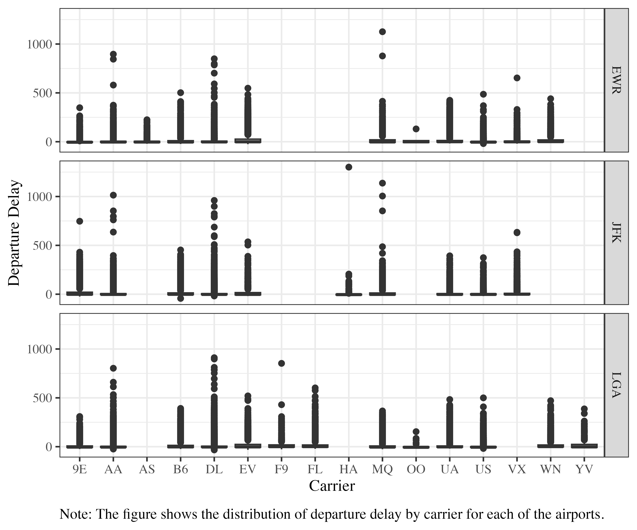
Figure 1: Distribution of delay by carrier

4. Results and Discussions
Table 2 presents the regression results.
Table 2: Regression Results
 | (1) | (2) | (3)
Temperature | 0.145*** | 0.251*** | 0.251**
 | (0.004) | (0.010) | (0.023)
Precipitation | 379.641*** | 348.979*** | 348.979**
 | (5.363) | (5.437) | (28.751)
Wind Speed | 0.274*** | 0.326*** | 0.326*
 | (0.018) | (0.018) | (0.059)
Num.Obs. | 326164 | 326164 | 326164
R2 | 0.020 | 0.034 | 0.034
Std.Errors | IID | IID | by: origin
+ p < 0.1, * p < 0.05, ** p < 0.01, *** p < 0.001

5. Conclusion
Weather matters.

References
Bergé, L. 2018. “Efficient estimation of maximum likelihood models with multiple fixed-effects: The R package FENmlm.” CREA Discussion Papers (13).
R Core Team. 2022. R: A language and environment for statistical computing. Vienna, Austria: R Foundation for Statistical Computing. Available at: https://www.R-project.org/.
Wickham, H. 2021. nycflights13: Flights that departed NYC in 2013. Available at: https://CRAN.R-project.org/package=nycflights13.

This is just for illustrating how to create a footnote

