1. Solution

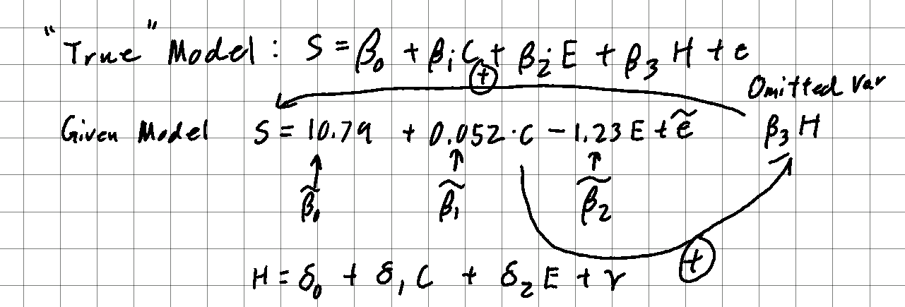

Variable shortcuts:

S – Security Breaches

C – Cybersecurity Training Hours

E – Emails Encrypted

H – High-Value Asset

The omitted variable “High-Value Assets” has a positive effect on Security Breaches since the more high-value assets a company has, the more attractive it is to hackers, who will try to breach the company’s security, therefore, β3 > 0 (positive).

The variable “Cybersecurity Training Hours” has a positive effect on the omitted variable “High-Value Assets” since the more cybersecurity training a company has, the more apparent high-value assets it has as well. If a company does not have high-value assets, it most likely will not invest a lot in cybersecurity training, therefore, δ1 > 0 (positive).

Omitted Variable Bias = 1 – β1  = β3 δ1 = (positive) (positive) > 0 (positive)

Therefore, the omitted variable bias is away from zero.

1. Solution

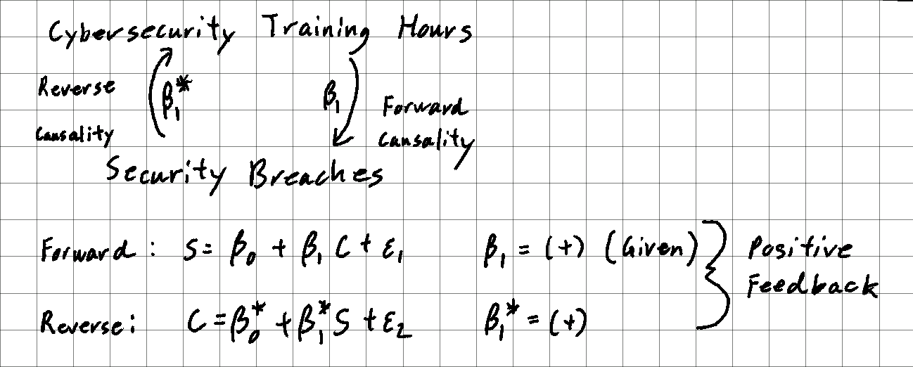

There is a possibility of reverse causality where an increase in security breaches leads to an increase in cybersecurity training hours to counter those breaches.

Therefore, β\*1 > 0 (positive feedback), meaning the measured β1 would be greater than the actual β1.

Given β1 = 0.052(positive), the positive feedback would result in the direction of bias being away from zero.

1. Solution

The variable “Cybersecurity Training Hours” has an effect on the variable “Emails Encrypted” since after employees get training, they will more likely use email encryption. Therefore, there is an outcome variable on the right-hand side.

If we remove the outcome variable “Emails Encrypted” and treat it as an omitted variable, we can determine its effect on Cybersecurity Training Hours.

Given “Emails Encrypted” has a negative effect on Security Breaches in the model (β2 < 0), and “Cybersecurity Training Hours” has a positive effect on the omitted variable “Emails Encrypted,” (δ1 > 0), the omitted variable bias = 1 – β1  = β2 δ1 = (negative) (positive) < 0 (negative).

Therefore, removing “Emails Encrypted” would make the coefficient on “Cybersecurity Training Hours” move down, towards zero or potentially negative.

1. Solution

We conclude that the company should continue investing in cybersecurity training because of the largely negative causal relationship Emails Encrypted has significantly mitigates the small, positive relationship of Cybersecurity Training Hours respective to Security Breaches.