实验编号：实验004
实验题目：新的迭代面向对象设计
实验日期：2026-05-06
实验内容：
https://github.com/Shuo-tong/work2.git
用户需求：
小强要离校外出实习，找了好友小雨帮忙，并告诉了华经理。小强简单介绍了背景、进展，把程序都教给了小雨。特别告诉小雨，华经理对程序没有清晰、完整的想象，经常增加新的功能，有时候会改变一些需求。小雨正刚刚学完面向对象技术，正想练习一下，就参考小强的描述和程序，重新编写程序。

分析：
- “把程序都教给了小雨……”：其实是第2章的程序示例。Public class Exercise ……
- “华经理对程序没有清晰、完整的想象，经常增加新的功能”：需求经常在改变，更应该注意“高内聚、低耦合”的设计原则，抽象出对象，减少类、对象的改变对整体程序的冲击；
- “学完面向对象技术，正想练习一下”：应该使用Java程序，加入类的设计。

实验报告：
- 构建并运行P69案例设计一，要求：（a）包含BinaryOperation类（b）包含Exercise3_1类（c）补全缺失代码
- 画出UML类关系图（可以拍照、vscode、visio等作图）

案例设计一的完整代码：
import java.util.Random;
public class Binaryoperation {
static final int UPPER = 100;
static final int LOWER = 0;
protected int left_operand=0, right_operand=0;
protected char operator='+';
protected int value=0;
//不是构造器
protected void construct (int left, int right, char op) {
left_operand = left;
right_operand = right;
operator = op;
switch (op) {
case '+': value = left + right; break;
case '-': value = left - right; break;
case '*': value = left * right; break;
case '/': value = left / right; break;
}
}
//实际产生对象的三个方法，（这里已经放到子类里面了）
// public Binaryoperation generateAdditionOperation() {
// Random random = new Random();
// int left, right, result;
// left = random.nextInt(UPPER+1);
// do {
// right = random.nextInt(UPPER+1);
// result = left + right;
// } while (result > UPPER);
// Binaryoperation bop = new Binaryoperation();
// bop.construct(left, right, '+');
// return bop;
// }
// public Binaryoperation generateSubstractOperation() {
// Random random = new Random();
// int left, right;
// left = random.nextInt(UPPER + 1);
// do {
// right = random.nextInt(UPPER + 1);
// } while (right > left); // 确保结果不小于 LOWER(0)
// Binaryoperation bop = new Binaryoperation();
// bop.construct(left, right, '-');
// return bop;
// }
public Binaryoperation generateBinaryoperation() {
// Random random = new Random();
// if (random.nextBoolean()) {
// return generateAdditionOperation();
// } else {
// return generateSubstractOperation();
// }
return null;
}
//实例变量访问器
public int getLeftOperand() { return left_operand; }
public int getRightOperand() { return right_operand; }
public char getOperator() { return operator; }
public int getResult() { return value; }
public boolean equals (Binaryoperation anOperation) {
//要使用 getOperator()
return left_operand == anOperation.getLeftOperand() & right_operand == anOperation.getRightOperand() & operator == anOperation.getOperator();
}
public String toString() { return left_operand + "" + operator + right_operand; } //示例：对运算32+5返回字符串"32+5"
public String asString() { return toString() + "="; } //示例：对运算32+5返回字符串"32+5="
public String fullString() { return asString() + value; } //示例：对运算32+5返回字符串"32+5=37"
}

子类示例（Addition）：

import java.util.Random;
public class Addition extends Binaryoperation {
public Addition generate() {
Random random = new Random();
int left, right, result;
left = random.nextInt(UPPER + 1);
do {
right = random.nextInt(UPPER + 1);
result = left + right;
} while (result > UPPER);
Addition op = new Addition();
op.construct(left, right, '+');
return op;
}
}

下面是习题类：
import java.util.ArrayList;
public abstract class Exercise {
protected static final short OPERATION_NUMBER = 50;
protected static final short COLUMN_NUMBER = 5;
protected ArrayList<Binaryoperation> operationList = new ArrayList<Binaryoperation>();
// 模板方法：通用生成循环，子类只需实现 generateOperation()
public void generate() {
operationList.clear();
for (int i = 0; i < OPERATION_NUMBER; i++) {
Binaryoperation anOperation;
do {
anOperation = generateOperation();
} while (contains(anOperation, i - 1));
operationList.add(anOperation);
}
}
// 抽象方法：由子类决定生成哪种运算题
protected abstract Binaryoperation generateOperation();
// 只要产生的算式没在当前练习题中，就加入尾部
private boolean contains(Binaryoperation anOperation, int length) {
boolean found = false;
for (int i = 0; i <= length; i++) {
if (anOperation.equals(operationList.get(i))) {
found = true;
break;
}
}
return found;
}
void formateAndDisplay() {
for (int i = 0; i < operationList.size(); i++) {
// 每道题固定宽度为12，左对齐
System.out.printf("%-12s", operationList.get(i).asString());
// 每 COLUMN_NUMBER 道题换行
if ((i + 1) % COLUMN_NUMBER == 0) {
System.out.println();
}
}
System.out.println();
}
}

子类示例（MixedExercise混合运算）：
import java.util.Random;
public class MixedExercise extends Exercise {
private Addition addCreator = new Addition();
private Substraction subCreator = new Substraction();
private Multiplication mulCreator = new Multiplication();
private Division divCreator = new Division();
private Random random = new Random();
@Override
protected Binaryoperation generateOperation() {
switch (random.nextInt(4)) {
case 0: return addCreator.generate();
case 1: return subCreator.generate();
case 2: return mulCreator.generate();
default: return divCreator.generate();
}
}
}

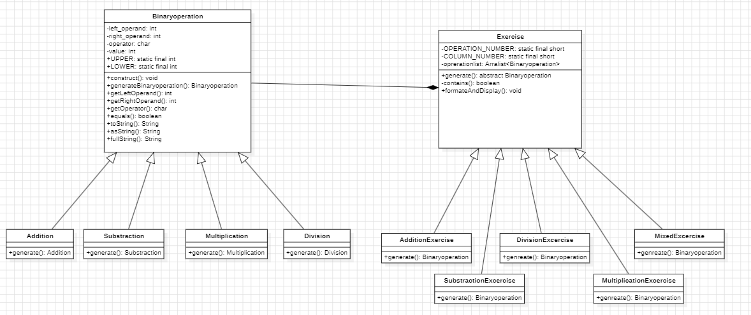

参考文献：
1.
2.

