Fabric Control Plane — Working Guide
Metadata-driven, config-first lakehouse platform for Microsoft Fabric

1. Architecture at a glance
You describe WHAT to load and build in config tables; the framework does the HOW — extract to bronze, curate to silver (with data quality), build a gold star schema — orchestrated by Fabric Data Pipelines and promotable across environments from git.
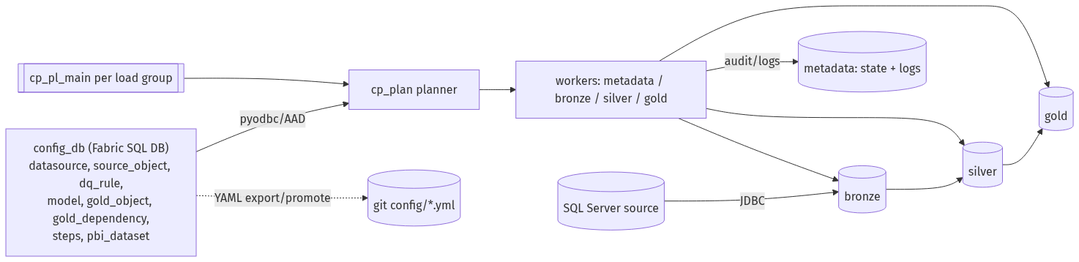
Figure 1. End-to-end architecture
Figure 2. Medallion data flow (bronze → silver → gold)

Key principles
- Config is data, not code: authored config lives in config_db (T-SQL editable); runtime state/logs live in the metadata lakehouse. Only authored config is promoted.
- Items vs data promotion: Fabric items promote together via deployment; config data promotes as YAML (cp_export_config → git → cp_config). Runtime state never promotes.
- Notebooks are param-driven workers: they never read config; a planner (cp_plan) reads config and the pipeline fans work out to the workers.
- Zero hardcoding: workspace + lakehouse IDs resolve at runtime; environment values come from the cp_vars Variable Library.

2. Resources and what they do

2.1 Lakehouses
Lakehouse | Purpose | Contents
bronze | Raw landing (as-extracted) | <source>_<schema>_<table> Delta + control cols
silver | Curated, deduped, DQ-passed | same names; snake_case, _row_hash; quarantine_<target>
gold | Star schema (business) | dim_* / fact_*; plus stage_*
metadata | Runtime state + logs + config mirror | audit/state tables; error tracebacks in Files

2.2 config_db (Fabric SQL Database)
Holds the authored config tables (section 4). Edited with T-SQL. Auto-mirrors to OneLake; tooling reads/writes via pyodbc + Entra token.

2.3 Variable Library cp_vars
Per-environment values, swappable via value sets: lakehouse names, source_server, source_connection. Notebooks read it at runtime.

2.4 Notebooks
Notebook | Folder | Role | Key parameters
cp_framework | utility | Shared library (%run by all): paths, config read, JDBC, Delta helpers, gold writers, DAG sort, audit | —
cp_plan | utility | Reads config_db, returns the ForEach work-list | load_group, plan_type
cp_log_fail | utility | Writes a failure row to pipeline_run_log | pipeline_name, run_id, load_group, activity, message
metadata_worker | notebook | Start run; discover source schema; log drift | run_id, load_group, src_user, src_password
bronze_worker | notebook | Extract ONE object to bronze (full/incremental) | run_id, object_json, src_user, src_password
silver_worker | notebook | Build silver for ONE object: dedupe, DQ→quarantine | run_id, object_json
gold_runner | notebook | Build ONE model's gold objects in DAG order (runs sq_*) | run_id, model_id
sq_* | sourcequery | Source-query builder per gold object: silver→stage→gold | run_id

2.5 Pipelines (in the 'pipeline' folder)
Pipeline | Purpose | Parameters
cp_pl_main | Orchestrator per load group: read steps, run 5 steps in order, skip inactive, fail-fast | load_group, run_id, src_user, src_password
cp_pl_metadata | Runs metadata_worker | load_group, run_id, src_user, src_password
cp_pl_bronze | cp_plan(objects) → ForEach → bronze_worker | load_group, run_id, src_user, src_password
cp_pl_silver | cp_plan(objects) → ForEach → silver_worker | load_group, run_id
cp_pl_gold | cp_plan(models) → ForEach → gold_runner | load_group, run_id
cp_pl_pbi | cp_plan(datasets) → ForEach → Power BI REST refresh (scaffold) | load_group, run_id

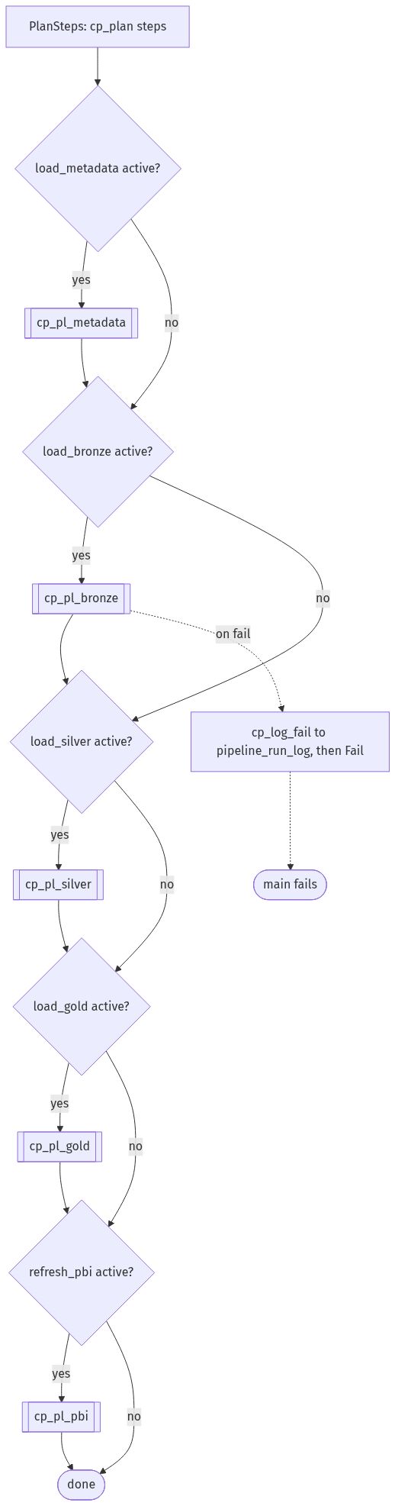
Figure 3. Main orchestrator: sequential, is_active-gated, fail-fast
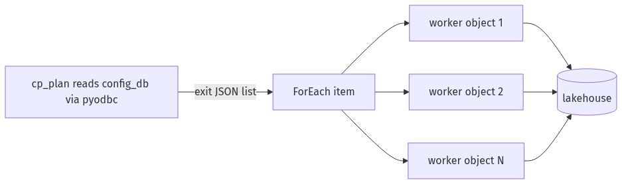
Figure 4. Planner–worker pattern inside a child pipeline
Every pipeline: on a work-activity failure → cp_log_fail writes to pipeline_run_log, then a Fail activity re-fails so cp_pl_main errors out (fail-fast).

3. How to operate
- Deploy an environment: python control_plane/deploy/cp_bootstrap.py <workspace_base> <ENV> (idempotent, deploy-only), or run the Deploy Control Plane GitHub Action.
- Run the pipeline: trigger cp_pl_main(load_group, run_id, src_user, src_password).
- Trial-capacity note: don't run two full pipelines on one capacity at once — Spark session slots are limited; run environments sequentially.
- Author/change config: edit config_db via T-SQL, then cp_export_config (SQL→YAML, commit) and cp_config (YAML→target SQL) to promote.
- Add a source object → source_object row; Add a gold table → sq_<name> + gold_object (+ gold_dependency); Add a DQ rule → dq_rule row; Toggle a step → steps.is_active.

4. config_db table reference (authored config)
is_active is a BIT on every authored table; only active rows are processed. Standard/enumerated values are noted below.
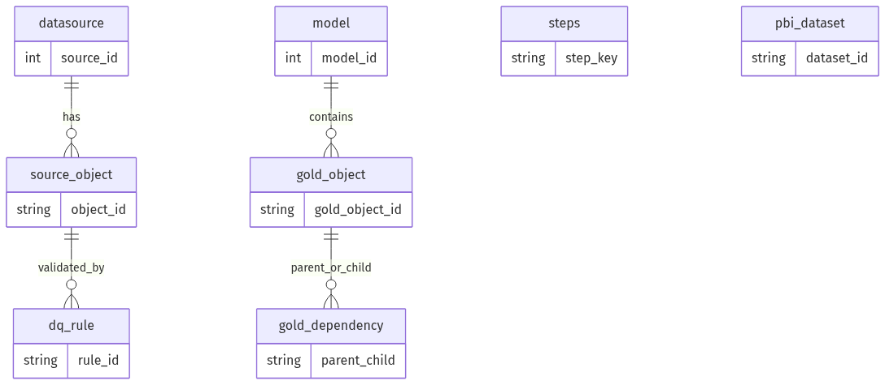
Figure 5. Config database — entity relationships

4.1 datasource — source systems
Column | Notes / allowed values
source_id (PK) | unique id
source_name | display name
source_type | SQL
database_name | source database
load_group | the run unit; cp_pl_main runs one load group
ingestion_mode | custom_jdbc
is_active | BIT

4.2 source_object — objects to ingest
Column | Notes / allowed values
object_id (PK) | stable logical id (e.g. customer)
source_id (FK) | → datasource
source_schema, source_table | source location
target_name | bronze/silver Delta table name
load_type | full = overwrite each run · incremental = append rows past the watermark
key_columns_json | business key(s), JSON array e.g. ["SalesOrderID","SalesOrderDetailID"]
watermark_column | column for incremental (e.g. ModifiedDate)
watermark_type | datetime
processing_state | ACTIVE (only ACTIVE objects run)
is_active | BIT

Incremental: first run pulls all and records max(watermark); later runs pull rows past the stored watermark and append. Full loads overwrite. Complex source types (xml/geography/geometry/hierarchyid/varbinary/image/sql_variant) are excluded automatically.

4.3 dq_rule — data-quality rules (evaluated on silver)
column_name is the SILVER column (snake_case), e.g. total_due, customer_id.
rule_type | Fill these columns | Passes when | Example
not_null | column_name | column IS NOT NULL | customer_id not null
min | column_name, min_value | column ≥ min (NULL passes) | total_due ≥ 0
max | column_name, max_value | column ≤ max (NULL passes) | discount ≤ 1
allowed_values | column_name, allowed_values_json | column ∈ list (NULL passes) | person_type ∈ ["EM","IN"]
expression | rule_expression (column_name optional) | the boolean expression is TRUE | order_qty > 0 AND unit_price >= 0

severity: error = failing rows quarantined and excluded from silver (written to quarantine_<target>); warn = counted in dq_result only. All rule counts are recorded in dq_result.
Example (T-SQL): INSERT INTO dbo.dq_rule (rule_id, object_id, column_name, rule_type, min_value, severity, is_active) VALUES ('soh_total_due_nonneg','sales_order_header','total_due','min',0,'error',1);

4.4 model — gold data models
Column | Notes
model_id (PK)
model_name | e.g. sales_star
load_group | gold-phase load group
is_active | BIT

4.5 gold_object — gold tables
Column | Notes / allowed values
gold_object_id (PK) | e.g. dim_customer
model_id (FK) | → model
gold_type | scd1 (upsert by key) · scd2 (history: _is_current, _effective_start/end_ts, _row_hash) · fact (upsert by key)
stage_table | staging table name (stage_* in gold)
gold_table | final gold table name
business_key_columns_json | key(s), snake_case, e.g. ["product_key"]
source_query_notebook | the sq_* notebook that builds this object's stage
is_active | BIT

4.6 gold_dependency — build order (DAG)
Column | Notes
parent_gold_object_id | built first
child_gold_object_id | built after parent

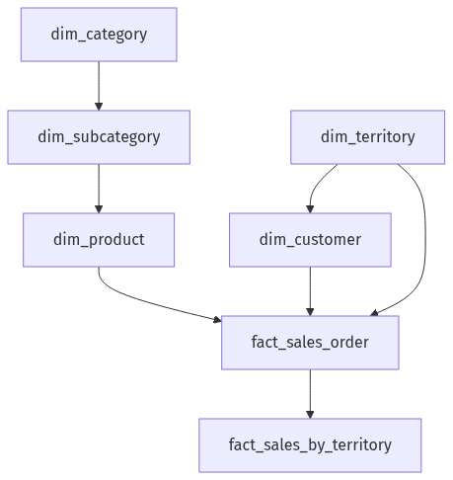
Figure 6. Example gold DAG (sales_star) — order gold_runner derives

4.7 steps — orchestration steps per load group
Column | Notes / allowed values
load_group | INT
step_order | 1..5 (execution order)
step_key | load_metadata · load_bronze · load_silver · load_gold · refresh_pbi
child_pipeline | pipeline to invoke
is_active | BIT — inactive steps are skipped

4.8 pbi_dataset — Power BI refresh targets (scaffold)
Column | Notes
dataset_id (PK), workspace_id, dataset_name, load_group, is_active | REST refresh issued per active row

5. Runtime state / log tables (generated — never authored, never promoted)
Table | What it records
ingestion_run | one row per run start/finish
object_load_run | per object × layer: status + source/target/quarantine counts
watermark_state | latest watermark per object (incremental)
source_column | discovered source schema snapshot (drift baseline)
schema_drift_event | column added/removed vs previous snapshot
dq_result | per rule: passed/failed counts, PASS/FAIL
quarantine_<target> | (silver) rows that failed an error-severity DQ rule
pipeline_run_log | pipeline failures (pipeline, activity, error message)

6. Promotion & environments
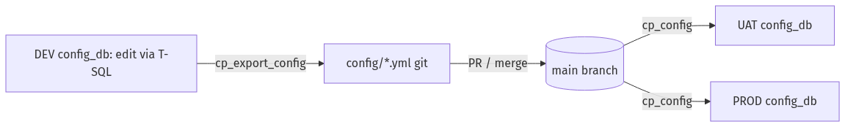
Figure 7. Config authoring & promotion loop (tables are source of truth)
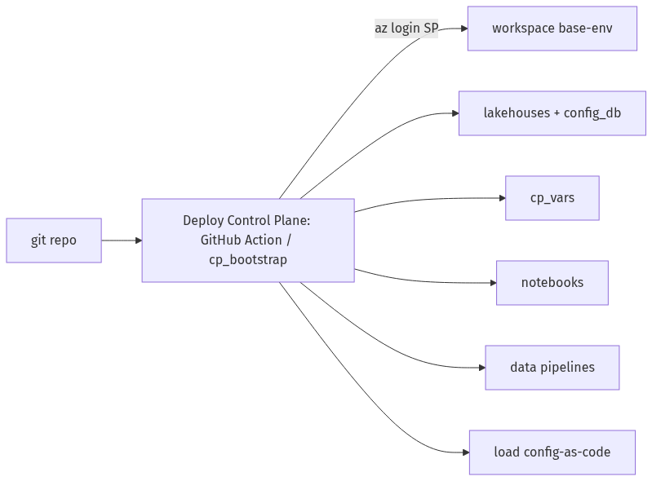
Figure 8. Item deployment per environment
- Items deploy per environment via the bootstrap or CI/CD; naming is <workspace_base>-<environment>.
- Environment values come from cp_vars value sets; deploy parameters from environments/<env>.yml.
- Config data promotes as YAML: cp_export_config (SQL→YAML) then cp_config (YAML→target SQL).
- Secrets: source password passed at run time; SP client id/secret drive CI auth. Key Vault + native pipeline SQL Lookups are planned upgrades once an SP exists.

