BC Pension Corporation — Fabric Delivery Guide
What this is. A plain-language companion to the milestone plan. For every item in the three
milestones it answers two questions: what it means in Microsoft Fabric (concept, not deep tech)
and how we control it — either because our Fabric platform already handles it, or because we
recommend a standard for BCPC to adopt.
Audience. Anyone with a working familiarity of Fabric. We stay at the "what and how we manage
it" level and avoid implementation detail.
How to read each item. Every item below carries one tag:
- Platform — already implemented in our Fabric control plane (our config-as-code framework does it).
- Standard — a governance/operating standard we recommend BCPC adopt (a policy or decision, not code).
- Both — the platform provides the mechanism; a standard sets the policy on top of it.
> Our control plane is the config-as-code framework we built on Fabric: you declare *what* to
> load and *how* to govern it as configuration, and the framework connects, ingests, cleanses,
> quality-checks, models, and secures the data across DEV / UAT / PROD. Wherever an item says
> Platform, this is what's doing the work.

The three milestones at a glance
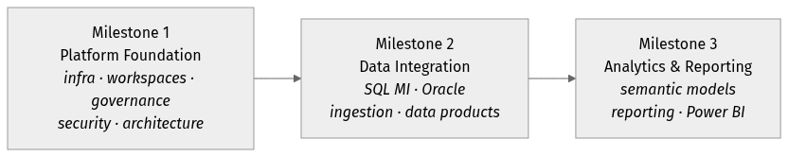
*Foundation first (the platform everything runs on), then get data in and managed, then turn it
into governed analytics.*

Milestone 1 — Fabric Platform Foundation
Goal: stand up the infrastructure, governance, security, architecture, and operating framework
that everything else runs on.

How the platform fits together
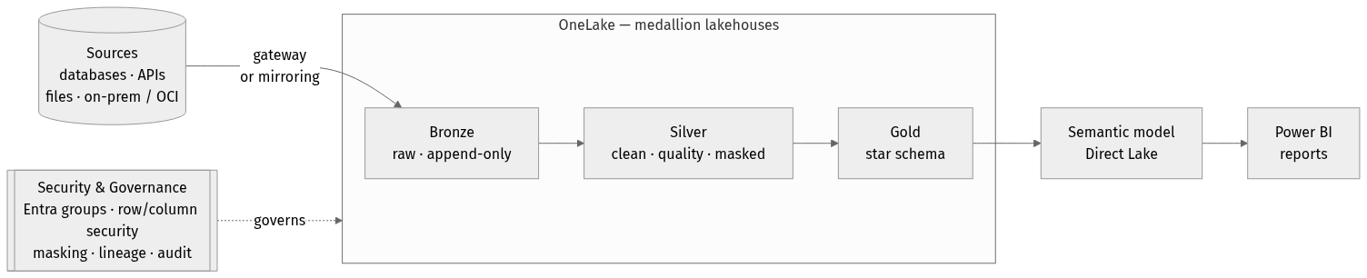
*Everything sits on a Capacity, is organized into Workspaces / Domains, and flows through
the medallion to reports — with security and governance applied across every layer. The
items below are the pieces of this picture.*

Establish Fabric Infrastructure Foundation
*The physical footing: the compute we buy, the network path to our data, and the replication options.*
Item | What it means in Fabric | How we control it
Provision Fabric Capacity | The compute + storage tier (an F-SKU) that powers every workspace, pipeline, and report in the tenant. | Standard. Size an F-SKU to the workload and assign it to the project workspaces; our provisioning script then stands up everything that runs on it, identically per environment.
Configure Capacity Administration | The admin controls for that capacity — who manages it, feature switches, workload limits, surge protection. | Standard. A named capacity-admin group manages it in the Admin portal; we recommend surge-protection and throttling guardrails so one workload can't starve others.
Deploy Fabric Data Gateway | Software that lets Fabric reach data behind a private network (on-prem or private OCI/Azure). | Both. Our ingestion routes private sources through the gateway; we've documented the gateway architecture, including reusing the existing VNet gateway vs standing up a dedicated one.
Validate Gateway Connectivity | Confirming Fabric can actually reach a source through the gateway. | Standard. A "test connection" per source before onboarding, plus a documented checklist (firewall, DNS, service account).
Review Gateway Architecture | Choosing gateway type and network path (VNet data gateway vs on-premises data gateway). | Platform. We produced the private-OCI architecture diagrams — the framework path reusing the VNet gateway, and the mirroring path requiring a dedicated on-prem gateway.
Validate SQL MI Mirroring Architecture | Confirming near-real-time mirroring works for Azure SQL Managed Instance. | Both. Mirroring is Microsoft-managed; we've mapped how a mirrored database feeds our Silver/Gold and recommend it for specific near-real-time tables.
Assess Oracle Mirroring Feasibility | Whether Oracle mirroring fits BCPC (prerequisites, limits, cost, promotion). | Platform. Delivered as our *Bronze vs Mirroring* analysis — GA status, the invasive prerequisites, coverage limits, gateway needs, and a clear recommendation.
Document Infrastructure Architecture | A written, shared picture of the platform's infrastructure. | Platform. The architecture diagrams and this guide are that documentation, kept in the repo alongside the code.

Establish Fabric Platform Foundation
*The logical structure: workspaces, domains, and the lakehouses where data lives — plus the reusable patterns that make new work fast.*
Item | What it means in Fabric | How we control it
Create Initial Fabric Workspaces | Workspaces are the containers that hold items (lakehouses, pipelines, reports) and carry access + capacity. | Platform. Our provisioning script creates the workspaces per environment; nothing is hand-clicked.
Define Workspace Structure | How you divide work into workspaces (by environment, domain, project, or product). | Standard. We recommend an environment split (DEV / UAT / PROD) with domain-aligned workspaces inside, so promotion and access stay clean.
Define Domain Alignment Strategy | Fabric domains group workspaces by business area for ownership and discovery. | Standard. Map domains to BCPC business areas (e.g. Pensions, Employer, Member) so ownership and data discovery follow the org.
Create Initial Lakehouses | Lakehouses are the storage+table layer in OneLake where data lands and is modelled. | Platform. The framework creates the schema-enabled lakehouses (metadata, bronze, silver, gold, file-drop) as declared config.
Define Lakehouse Organization Standards | Naming and layout of lakehouses, schemas, and tables. | Platform. Enforced by convention: schema-enabled lakehouses, medallion layers, and a single naming rule (schema.table), all driven from config.
Implement Public Dataset Reference Solution | A pattern for bringing external/open reference data into the platform. | Platform. Demonstrated end-to-end with a Statistics Canada open-data feed loaded through our generic HTTP connector to Silver.
Validate Auto-Ingestion Framework | Proving that data can be onboarded by configuration rather than bespoke code. | Platform. This is the core of the control plane — plus an event-driven "drop a file, it loads itself" intake — validated on real data.
Establish Reusable Platform Patterns | Turning one-off solutions into repeatable building blocks. | Platform. One registry of connectors, config-as-code onboarding, and a packaged engine mean a new source is *configuration*, not new code.

Define Fabric Platform Governance
*Who runs the platform and by what process — ownership, capacity, onboarding, and endorsement.*
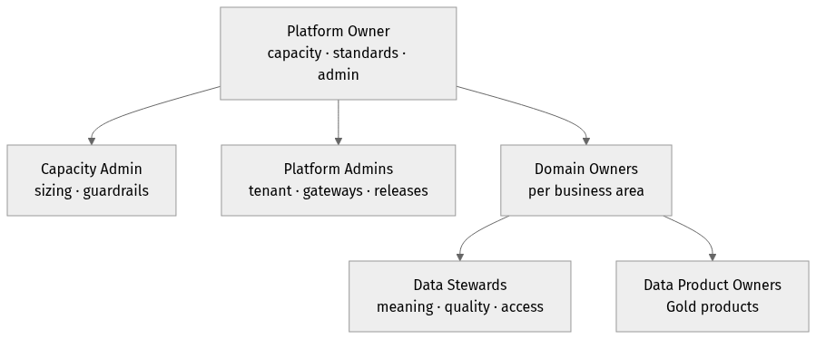
*The operating model in one picture: a central Platform Owner sets standards and runs capacity;
Domain Owners own their business area's data, supported by Stewards and **Data Product
Owners**.*
Item | What it means in Fabric | How we control it
Define Platform Ownership Model | Who owns the Fabric platform overall (the "landlord" of capacity, admin settings, standards). | Standard. A platform-owner role (small central team) accountable for capacity, tenant/admin settings, and the standards in this guide.
Define Workspace Creation Process | How new workspaces get requested, approved, and created consistently. | Both. A request→approve step feeding our provisioning script, so every workspace is created to standard (naming, access, capacity) rather than ad hoc.
Define Workspace Ownership Standards | Who owns each workspace and is accountable for its contents. | Standard. Each workspace has a named owner (domain-aligned) responsible for access reviews and its data products.
Define Capacity Governance Process | How capacity is monitored, allocated, and protected from overload. | Standard. Monitor via the Capacity Metrics app; set throttling/surge guardrails; a defined path to scale or rebalance workloads.
Define Platform Administration Responsibilities | The concrete duties of the admins (tenant settings, gateways, updates, incidents). | Standard. A responsibilities matrix (RACI) covering tenant settings, gateway upkeep, capacity, and release management.
Define Monitoring and Support Model | How platform health and issues are watched and resolved. | Both. Fabric monitoring + our run/audit logs feed a defined support model (who watches what, escalation path).
Define Onboarding Process | The repeatable path for a new team, source, or data product to join the platform. | Both. A checklist that ends in config-as-code entries + our discovery step, so onboarding a source is guided and consistent.
Define Endorsement and Certification Process | Fabric's Promoted / Certified labels that signal trustworthy, official items. | Standard. Define who can certify, the criteria (owner, quality, documentation), and reserve "Certified" for governed Gold data products.

Define Fabric Data Governance Framework
*Who owns the data and how its quality, meaning, lineage, and lifecycle are managed.*
Item | What it means in Fabric | How we control it
Define Data Domain Ownership Model | Which business area owns which data. | Standard. Data domains map to business areas with a named domain owner accountable for the data within.
Define Data Steward Responsibilities | The people who curate meaning, quality, and access for a data area. | Standard. A steward role per domain — owns definitions, quality rules, and access decisions for their data.
Define Data Product Ownership Model | Treating governed datasets as "products" with an owner and consumers. | Standard. Gold outputs are the data products; each has an owner, a documented purpose, and a consumer contract.
Define Metadata Management Approach | How we capture what data exists, its schema, and its meaning. | Both. The platform captures technical metadata (sources, schemas, drift, run history) in config + audit tables; the OneLake catalog + a business glossary standard add business meaning.
Define Data Quality Standards | The rules that decide whether data is fit to use. | Platform. Declarative quality rules (not-null, ranges, allowed values, expressions) run on the way to Silver, with failing rows quarantined off the clean layer.
Define Data Lineage Requirements | Being able to trace where data came from and what it feeds. | Both. Fabric's built-in lineage view across items, plus our audit tables that record every source→bronze→silver→gold run.
Define Data Lifecycle Standards | Retention, history, and archival of data over time. | Both. Bronze is an append-only history (audit trail); Silver/Gold hold current + modelled history (slowly-changing dimensions); a retention standard sets how long each is kept.
Define Data Sharing Standards | How data is shared across teams without copying it. | Standard. Prefer OneLake shortcuts / sharing over copies, governed by access model + certification, so there's one trusted copy.

Define Fabric Security Framework
*Who can see what — from workspace down to the row and column.*
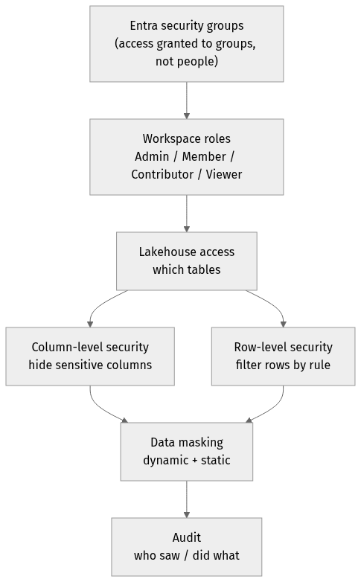
*Access narrows as you go down: from broad workspace roles to specific tables, then to individual
rows and columns, then masked values — all granted through Entra groups and recorded in
audit.*
Item | What it means in Fabric | How we control it
Define Entra Security Group Strategy | Using Microsoft Entra ID groups (not individuals) to grant access. | Both. Access is granted to Entra groups; our security config references those groups so membership — not per-person edits — drives access.
Define Workspace Access Model | The workspace roles (Admin / Member / Contributor / Viewer) that set broad access. | Standard. A least-privilege role mapping per workspace, assigned to Entra groups and reviewed on a cadence.
Define Lakehouse Access Model | Fine-grained access to tables/columns/rows within a lakehouse. | Platform. Applied from config as OneLake column-level and row-level security — sensitive columns and restricted rows are enforced consistently per environment.
Define Row-Level Security Standards | Restricting which rows a user can see (e.g. by region or plan). | Platform. Row filters declared in config and applied by the framework, so the same rule ships to every environment.
Define Data Masking Requirements | Hiding or obscuring sensitive values (e.g. SIN, salary). | Platform. Dynamic masking at the query layer plus static masking during processing — sensitive columns can be masked, or never land in raw form at all.
Define Audit Requirements | Recording who did what, and what the pipeline did. | Both. Fabric's tenant audit logs for user activity, plus our run/quality/drift audit tables for the data pipeline itself.
Define Compliance Requirements | Meeting BCPC's regulatory and privacy obligations. | Standard. Map controls (access, masking, audit, residency) to the applicable obligations; the platform's security + audit features provide the evidence.

Define Fabric Architecture Standards
*The blueprint everyone builds to — layers, storage choice, and how data is brought in and shaped.*
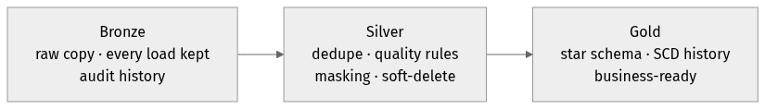
*The medallion in one line: raw in Bronze, cleaned and governed in Silver, business-ready in
Gold. Each item below is a rule for one part of this flow.*
Item | What it means in Fabric | How we control it
Define Bronze / Silver / Gold Architecture | The medallion pattern: raw → cleaned/conformed → business-ready. | Platform. This is the spine of the control plane — Bronze (raw, append-only), Silver (deduped, quality-checked, masked), Gold (modelled star schema).
Define Lakehouse vs Warehouse Guidance | When to use a Lakehouse (files+tables, Spark) vs a Warehouse (T-SQL). | Standard. Default to Lakehouse for the medallion (what we've built); reach for a Warehouse only where a pure T-SQL surface is required — with the trade-offs documented.
Define Ingestion Patterns | The approved ways data comes in (batch pull, event/file drop, mirroring, gateway). | Platform. One connector registry covers databases, APIs, files (event-driven drop), and gateway-staged on-prem; mirroring is the managed option for near-real-time.
Define Transformation Patterns | The approved ways data is cleaned and modelled. | Platform. Config-driven cleanse + quality rules into Silver, and SQL-based transforms into a Gold star schema with slowly-changing-dimension history.

Milestone 2 — Data Integration Foundation
Goal: prove BCPC can onboard, move, transform, and manage enterprise data in Fabric.

Implement SQL Managed Instance Integration
*Bring an Azure SQL Managed Instance in via mirroring and prove it stays fresh.*
Item | What it means in Fabric | How we control it
Validate Mirroring Configuration | Setting up and confirming a mirrored SQL MI database in Fabric. | Both. Mirroring is Microsoft-managed; we validate the setup and confirm the replica lands in OneLake ready for Silver/Gold.
Validate Incremental Data Synchronization | Confirming ongoing changes flow through continuously (not just the first load). | Both. Mirroring streams changes automatically; we verify inserts/updates/deletes propagate and reconcile against expectations.
Define Operational Procedures | The run-book for keeping mirroring healthy (start/stop, re-seed, monitor). | Standard. A documented procedure for monitoring replication state, handling re-seeds, and responding to pauses.
Measure Refresh Performance | How fresh the mirrored data is (latency) and its load impact. | Standard. Baseline latency and resource use, with thresholds that tell us when to tune or scale.

Implement Oracle Integration
*Determine how BCPC's Oracle data comes in — and the trade-offs.*
Item | What it means in Fabric | How we control it
Validate Connectivity | Confirming Fabric can reach the Oracle database (through the gateway). | Both. Our Oracle connector reaches the source via the gateway; a connection test confirms the path before onboarding.
Assess Supplemental Logging Requirements | Oracle change-data-capture needs supplemental logging enabled — an invasive DBA change. | Platform. Documented precisely in our analysis (database- and table-level logging), so BCPC's DBAs know exactly what mirroring would require.
Review LogMiner Requirements | Mirroring reads Oracle's redo logs via LogMiner, which has prerequisites and limits. | Platform. Captured in the analysis — LogMiner prerequisites, the broad grants required, and the read-write-source constraint.
Document Limitations and Recommendations | A clear statement of what works, what doesn't, and the recommended approach. | Platform. Delivered as the *Bronze vs Mirroring* recommendation: framework-based ingestion by default, mirroring selectively for near-real-time tables.

Establish Data Ingestion Framework
*Make ingestion standard, reusable, monitored, and resilient.*
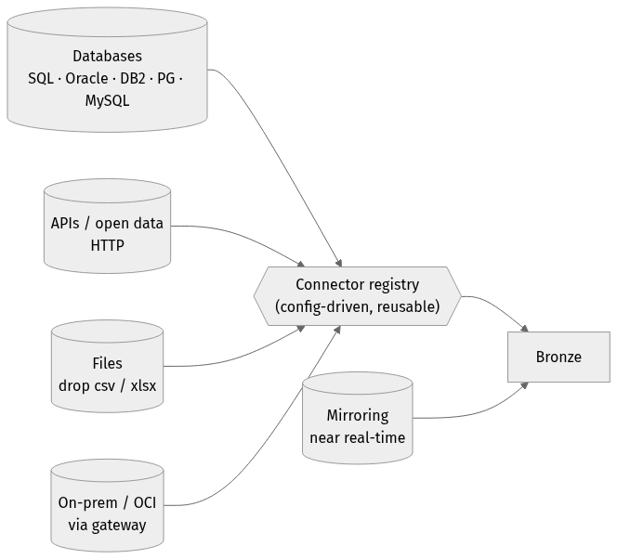
*Many source types, one config-driven connector registry, one landing pattern. Mirroring is the
managed option that lands straight in Bronze for near-real-time needs.*
Item | What it means in Fabric | How we control it
Define Ingestion Standards | The consistent way every source is onboarded and lands. | Platform. Every source is a config entry (connection, keys, load type); the framework applies the same landing, history, and naming rules to all.
Create Reusable Ingestion Templates | Templates so a new source doesn't start from scratch. | Platform. Adding a source is filling in config; adding a *new kind* of source is dropping one connector file — both are templated, not bespoke.
Implement Monitoring and Alerting | Knowing when a load runs, succeeds, or fails. | Both. Every run is logged to audit tables with status and row counts; failures are captured for alerting, wired into the support model.
Implement Error Handling Standards | Predictable behaviour when something goes wrong. | Platform. Failures are isolated per source (one bad file/source doesn't stop the rest), captured with detail, and safe to re-run (idempotent).

Establish Data Product Standards
*Turn governed datasets into managed, published, certified products.*

*A data product (a governed Gold dataset) moves through a defined lifecycle with an accountable
owner at every stage.*
Item | What it means in Fabric | How we control it
Define Data Product Lifecycle | The stages a data product moves through (draft → published → certified → retired). | Standard. A defined lifecycle with entry/exit criteria at each stage, owned by the data product owner.
Define Publication Standards | What "published and ready to consume" means. | Standard. A publication checklist — owner, documentation, quality passing, access set — before a Gold product is announced.
Define Ownership Standards | Every product has a clear, accountable owner. | Standard. Named owner per data product, recorded and visible, responsible for quality and consumer support.
Define Certification Process | Using Fabric endorsement to mark trusted, official products. | Standard. Only reviewed Gold products earn "Certified"; the process defines reviewer, criteria, and re-review cadence.

Milestone 3 — Analytics & Reporting Foundation
Goal: demonstrate end-to-end analytics on Fabric — from modelled data to governed reports.

From Gold to a governed report
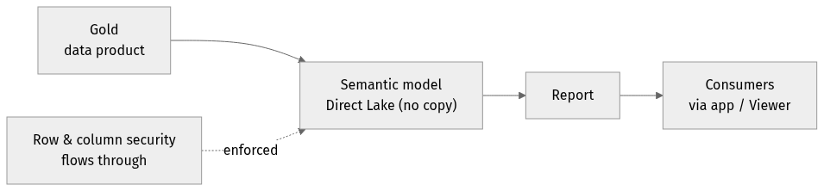
*Reports read the Gold model live (Direct Lake — no data copy), through a **shared semantic
model, with security enforced end-to-end**. The items below govern each hop.*

Establish Semantic Model Standards
*The shared business model that reports sit on.*
Item | What it means in Fabric | How we control it
Define Semantic Model Architecture | The reusable model (measures, relationships) between Gold data and reports — ideally Direct Lake. | Both. Our Gold star schema is built to be Direct-Lake-ready; the standard defines shared models over Gold rather than per-report copies.
Define Naming Standards | Consistent, business-friendly names for tables, measures, and fields. | Standard. A naming convention (business terms, consistent casing) so models read the same across teams.
Define Reuse Standards | Sharing one certified model instead of rebuilding per report. | Standard. One governed semantic model per subject area, reused by many reports; discourage private duplicates.
Define Certification Standards | Marking the trusted, official semantic models. | Standard. Certification criteria for models (owner, built on Gold, documented, quality-backed), aligned with the data-product process.

Establish Reporting Standards
*How reports are governed, published, and consumed.*
Item | What it means in Fabric | How we control it
Define Report Governance Standards | Rules for how reports are built, reviewed, and trusted. | Standard. Reports build on certified semantic models, follow design/accessibility guidelines, and are reviewed before wide release.
Define Publishing Standards | Where and how reports are released to audiences. | Standard. Publish through governed workspaces / apps with defined audiences, versioning, and a clear promotion path.
Define Workspace Consumption Standards | How consumers access reports vs where authors build them. | Standard. Separate build workspaces from consumption (apps/Viewer access), so consumers get a stable, curated experience.

Validate Power BI Integration
*Prove the end-to-end path from Gold to a governed, secure report.*
Item | What it means in Fabric | How we control it
Validate Semantic Model Integration | Confirming Power BI reads the Gold model efficiently (Direct Lake, no data copy). | Both. Gold is Direct-Lake-ready; we validate reports read it live without import refresh.
Validate Security Integration | Confirming access rules (row/column security) carry through to reports. | Platform. Row- and column-level security applied at the lakehouse flows through to the model and report — one rule, enforced end-to-end.
Validate Workspace Strategy | Confirming the workspace/app layout works for real authoring and consumption. | Standard. Validate the build-vs-consume workspace split with a real report and audience before rolling out broadly.

*Companion documents:* the Bronze vs Mirroring analysis (Oracle/SQL-MI ingestion trade-offs and
recommendation), the private-OCI architecture diagrams (framework and mirroring paths), and the
control-plane engine + working guides in the repository.

