CI/CD Guide — Deploying the Fabric Control Plane
Two streams: GitHub Actions and Azure DevOps Pipelines. Both call the same cp_bootstrap.py (idempotent, deploy-only).

Two kinds of secret
Context | What | Where it belongs
Deploy-time | Identity that provisions/deploys Fabric items | CI identity — Entra SP via OIDC / Workload Identity Federation (preferred) or client secret in CI store
Run-time | Source DB password used when cp_pl_main runs | Azure Key Vault, read by the notebook at run time — not needed for deploy

The CI/CD pipelines only DEPLOY (provision items + load config). They do not need the source password; that is a run-time secret (see Vault).

Service principal (shared prerequisite)
- Enable tenant settings: service principals can use Fabric APIs, and can create workspaces/connections/pipelines.
- Add the SP as Admin on each target workspace.
- Grant capacity assignment/contributor rights.
- Grant config_db access: CREATE USER [<sp>] FROM EXTERNAL PROVIDER; ALTER ROLE db_owner ADD MEMBER [<sp>];
- Prefer federated credentials (OIDC) over a client secret — nothing to store or rotate.

Repository layout (both platforms)
.github/workflows/deploy.yml (GitHub) · control_plane/cicd/azure-pipelines.yml (DevOps) · control_plane/environments/{dev,uat,prod}.yml · config/ variable_library/ notebooks/ deploy/ requirements.txt

Stream A — GitHub Actions
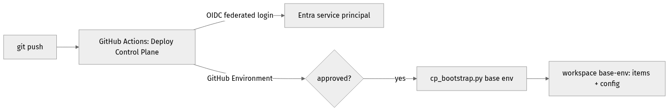
Figure 1. GitHub Actions deploy flow
- Push the repo; the workflow is .github/workflows/deploy.yml.
- Settings → Environments: create DEV/UAT/PROD; add required reviewers on UAT/PROD; scope secrets per environment.
- Secure auth (recommended): OIDC — add a federated credential on the Entra app (issuer token.actions.githubusercontent.com, subject repo:<org>/<repo>:environment:<ENV>), store only AZURE_CLIENT_ID.
- Fallback: AZURE_CLIENT_ID + AZURE_CLIENT_SECRET secrets; workflow runs az login --service-principal.
- Run: Actions → Deploy Control Plane → Run workflow → pick environment.

Stream B — Azure DevOps Pipelines
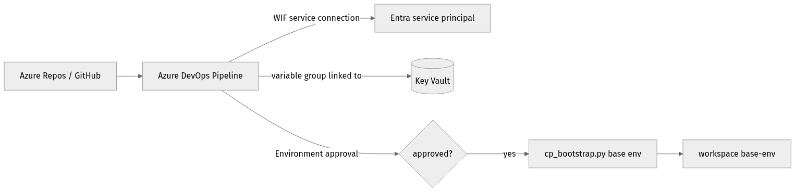
Figure 2. Azure DevOps deploy flow
- Push to Azure Repos (or connect a GitHub repo). New pipeline → Existing YAML → control_plane/cicd/azure-pipelines.yml.
- Secure auth (recommended): ARM service connection 'fabric-sp' with Workload Identity Federation — no stored secret.
- Secrets from Key Vault: Library → Variable group 'fabric-control-plane' → link secrets from Azure Key Vault; grant the service connection Get/List.
- Environments: create fabric-dev/uat/prod; add Approvals & checks on uat/prod.
- Multi-stage promotion: chain DEV → UAT → PROD deployment jobs; environment approvals are the gates.

Multi-environment model
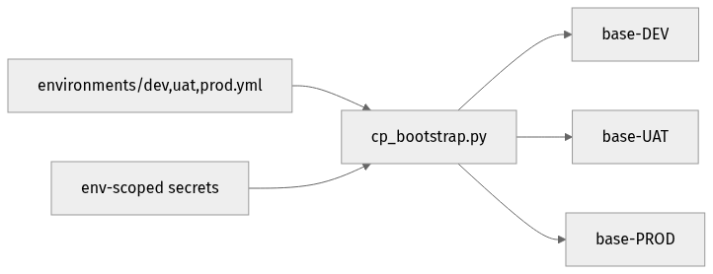
Figure 3. One codebase → per-environment workspaces
- One workspace per environment: <workspace_base>-<ENV>.
- Per-env inputs from environments/<env>.yml (non-secret, in git).
- Per-env runtime values from cp_vars value sets (lakehouse names, source_server).
- Per-env secrets scoped by the platform (GitHub Environment secrets / DevOps KV-linked variable groups).

Vault & secure storage
- Deploy-time identity: prefer OIDC / Workload Identity Federation (no stored secret); else client secret in a GitHub Environment secret or KV-linked DevOps variable group; rotate.
- Run-time source secret: store in Azure Key Vault; the worker reads it via notebookutils.credentials.getSecret('https://<vault>.vault.azure.net/','source-db-password'); grant the workspace identity Key Vault Secrets User.
- Never in git: SP secrets, DB passwords, PATs, connection strings — only non-secret params and config structure.

GitHub vs Azure DevOps — at a glance
Concern | GitHub Actions | Azure DevOps
CI file | .github/workflows/deploy.yml | control_plane/cicd/azure-pipelines.yml
Secure auth | OIDC federated credential (or SP secret) | WIF service connection (or SP secret)
Secrets store | Repo/Environment Secrets | Variable group linked to Key Vault
Approvals | Environments → required reviewers | Environments → approvals & checks
Multi-env | env input → GitHub Environment | parameter → Environment; multi-stage promotion
Vault | Key Vault via az keyvault / OIDC | Native KV-linked variable group

