Control Plane — Engine Design
How the Fabric control-plane engine is structured, why it's a modular package instead of one
big notebook, and how you extend it. For *using* the control plane (config tables, connectors,
DQ, promotion) see `WORKING_GUIDE.md`; for governance see
`GOVERNANCE_SECURITY.md`.

1. The idea in one paragraph
All runtime logic lives in a modular Python package (control_plane/src/cp/) — one concern
per module, one file per connector. The pipeline-called notebooks are dumb 3-cell shells
(parameters → import → one function call); they hold no logic, so they never change when the
engine changes. For the Fabric runtime, a bundler flattens the package into the single
cp_framework notebook that workers %run (zero session-startup cost, no Environment needed).
The *same* package also builds a wheel. Adding a source is dropping one file in
cp/connectors/ — you never open the framework.
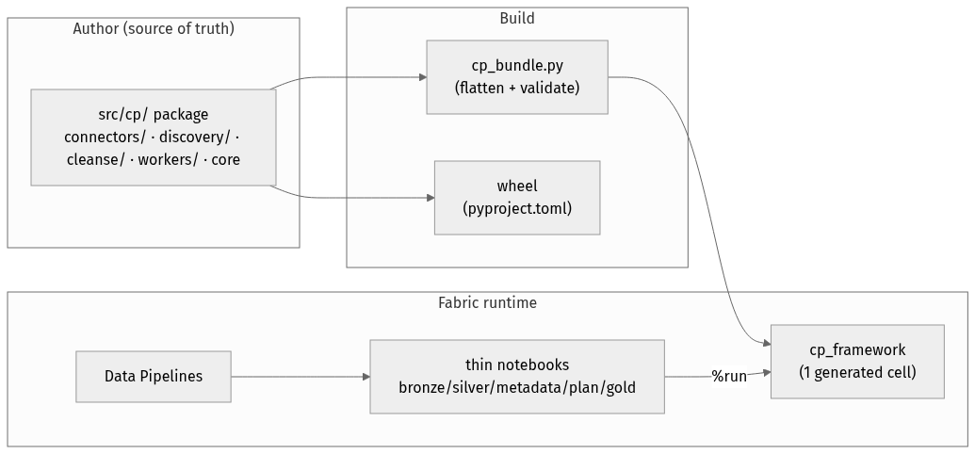

2. Repository layout
control_plane/
src/cp/ # THE ENGINE (source of truth; edit here)
__init__.py # minimal — keeps pure modules importable off-cluster
runtime.py # spark, notebookutils, cp_vars, lakehouse GUIDs, WS id, config-DB id, tpath
naming.py # snake, _norm_ident, now_ts, landed_table (pure — unit-tested)
dag.py # topo_levels (pure — unit-tested)
storage.py # delta_exists, read/write_path, read_config, files_put
secrets.py # get_secret (Key Vault)
config_db.py # config_conn/query/exec/exec_many (pyodbc + AAD)
transform.py # business_cols, row_hash, merge_upsert
audit.py # run/object logging, watermarks, seed_control_tables, SCHEMAS
gold.py # gold_write, scd2 merge, build_stage_and_gold
connectors/ # ONE FILE PER SOURCE — auto-registered
__init__.py # registry + @ingest_connector + resolve/run_connector
base.py # shared: connection resolution, jdbc dialects/loader, apply_select
jdbc.py odbc.py http.py oracle.py db2.py staged.py
discovery/ # ONE FILE PER DISCOVERER — auto-registered
__init__.py sqlserver.py statcan.py
cleanse/ # cleanse function library — auto-registered
__init__.py functions.py
workers/ # entrypoints called by the thin notebooks
__init__.py plan.py bronze.py silver.py metadata.py gold.py
notebooks/
cp_framework.py # GENERATED by cp_bundle.py — do not edit
bronze_worker.py silver_worker.py metadata_worker.py cp_plan.py gold_runner.py # 3-cell shells
sq_*.py # gold source-query notebooks (per gold object; use gold_write)
deploy/
cp_bundle.py # package -> cp_framework cell (validates public API + registries)
cp_deploy.py cp_config.py cp_sqldb.py ... # deploy tooling (already modular)
tests/ # off-cluster pytest (pure modules + bundle validity)
pyproject.toml # builds the wheel (package `cp`)
Dependency direction (no cycles): `runtime → naming/dag → storage/secrets/config_db →
transform/audit → cleanse/connectors/discovery → gold → workers`.

3. Extending the engine — the whole point

Add a source connector (zero framework edits)
Drop src/cp/connectors/<name>.py:
from . import ingest_connector
from .base import _resolve_conn, _opts
@ingest_connector("salesforce") # one or more names/aliases
def salesforce(o, user, password):
c, opts = _resolve_conn(o), _opts(o) # KV connection + per-object options
... # fetch
return spark.createDataFrame(pdf) # MUST return a Spark DataFrame
Then set datasource.connector = "salesforce". The folder auto-scan (connectors/__init__.py)
imports every module, so the decorator registers it — **you never touch a registry list or the
framework**. Rebuild the bundle (python deploy/cp_bundle.py) or just redeploy.

Add a discoverer
src/cp/discovery/<name>.py with @discoverer("connector_name") returning candidate object
dicts. Same auto-scan.

Add a cleanse function
src/cp/cleanse/<something>.py (or extend functions.py) with @cleanse_fn("name"). Reference
it from a cleanse_rule row.
Contract summary
Extension | File | Decorator | Signature
Connector | connectors/*.py | @ingest_connector("name", …) | (o, user, password) -> DataFrame
Discoverer | discovery/*.py | @discoverer("connector") | (datasource) -> [candidate dicts]
Cleanse fn | cleanse/*.py | @cleanse_fn("name") | (df, cols, params) -> df

4. Thin worker notebooks
Every pipeline-called notebook is exactly three cells and holds no logic — so it is identical
under the %run bundle today and a wheel tomorrow:
# PARAMETERS # cell 1 — pipeline injects these (tagged `parameters`)
run_id = "manual"; object_json = "{}"; src_user = ""; src_password = ""
# COMMAND ---------- # cell 2 — import the engine
%run cp_framework # (wheel era: from cp import workers)
# COMMAND ---------- # cell 3 — one flexible call does the work
workers.bronze(run_id=run_id, object_json=object_json, src_user=src_user, src_password=src_password)
The workers namespace is provided identically in both eras: the bundle binds
workers = SimpleNamespace(plan, bronze, silver, metadata, gold); the wheel exposes the same via
cp/workers/__init__.py. Entrypoints take keyword args with defaults and **kw, so the pipeline
can pass any subset (e.g. load_group as a string is coerced with int(...)).
Notebook | Entrypoint | Does
cp_plan | workers.plan(load_group, plan_type) | reads config_db, notebookutils.notebook.exit(work_list)
metadata_worker | workers.metadata(run_id, load_group, …) | discover objects (is_active=0) + column-drift snapshot
bronze_worker | workers.bronze(run_id, object_json, …) | one object: connector → select → control cols → bronze
silver_worker | workers.silver(run_id, object_json) | dedupe by key, cleanse, DQ+quarantine, upsert
gold_runner | workers.gold(run_id, model_id) | run the model's sq_* notebooks in topo order

5. The bundler (cp_bundle.py)
Fabric's %run shares a flat namespace — it is not Python package import. The bundler bridges the
clean package to that runtime:
1. Concatenates modules in dependency order (runtime first; folders globbed so new files are
auto-included).
2. Strips intra-package imports (from .x import y) — everything is one namespace in the cell
— and drops # --8<-- strip blocks (the pkgutil folder auto-scan, which only applies to the
real package).
3. Appends the workers namespace binding and print("cp_framework loaded").
4. Validates: ast.parse the result, assert every name in EXPECTED_PUBLIC is defined and
every expected connector/cleanse registry key appears — so a bundling mistake fails the build,
never the pipeline.
cp_deploy.py deploy regenerates cp_framework.py from the package first (and the tests/
assert the committed file equals a fresh bundle, so it can't drift).
Why not just use a wheel + Fabric Environment? A wheel gives real import cp, but a Fabric
Environment adds session-startup latency to every notebook and must be republished on each change.
The bundler keeps the zero-setup %run runtime while we still author a real package — and it emits
the wheel too (python -m build), so the Environment route is available later with no rework.

6. Runtime dependency model
runtime.py resolves spark via SparkSession.builder.getOrCreate() and imports
notebookutils; both come from the live Fabric session (bundle or wheel). Off-cluster these
imports fail by design — only the pure modules (naming, dag) and the bundler import
cleanly, which is exactly what the off-cluster tests exercise. No hardcoded IDs: workspace id,
lakehouse GUIDs, and the config-DB id are all resolved from the running context; environment
values come from the cp_vars Variable Library.

7. Testing
- Off-cluster (`pytest tests/`) — pure logic (snake, landed_table, topo_levels) and the
bundler (parses, exposes the full public API, all connector files bundled, committed file in
sync). Runs anywhere, no Fabric.
- On-cluster smoke — deploy, run cp_plan (proves the bundle loads, registries populate, the
workers namespace binds, config DB reads), then a wipe + reload through the pipelines
(AdventureWorks = jdbc/discovery/cleanse/DQ/gold; StatCan = http).

8. Design principles
- One concern per module; one file per source. A file you can hold in your head; changing one
connector can't break another.
- Registries over edits. Decorator + folder auto-scan means adding capability never touches
shared code — the smallest possible blast radius.
- The notebook is a shell. All logic in the package → the same notebooks work under %run
today and a wheel tomorrow.
- Generated artifacts are validated, not trusted. The bundle is checked against an explicit
public-API contract before it can deploy.

