1. Download Navicat---Free trial

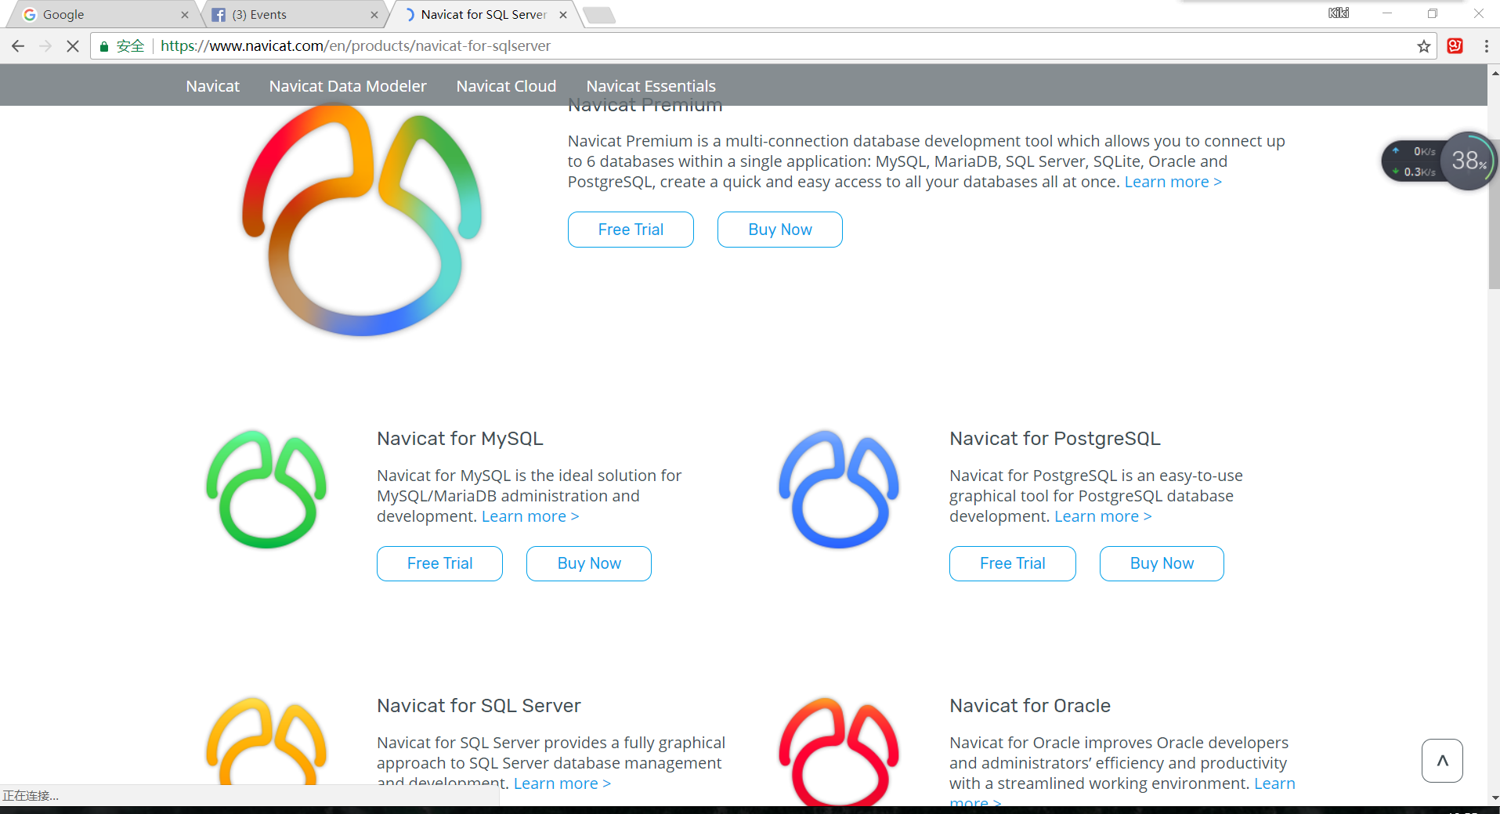

1. Create a new connection

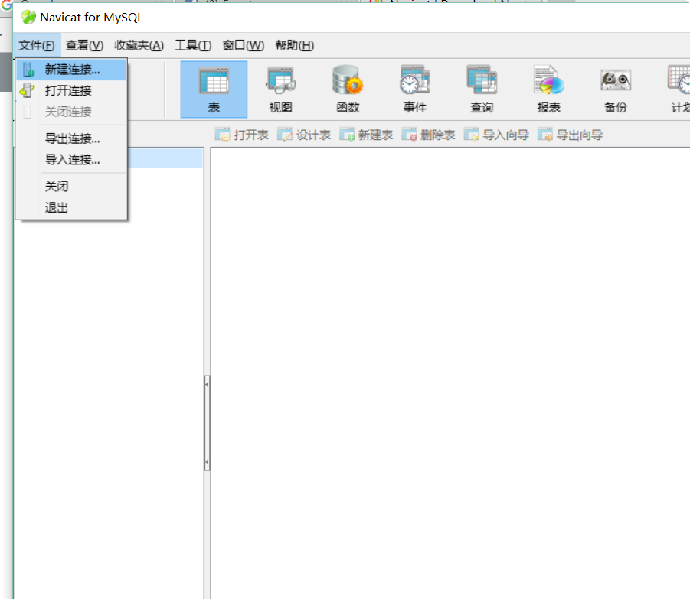

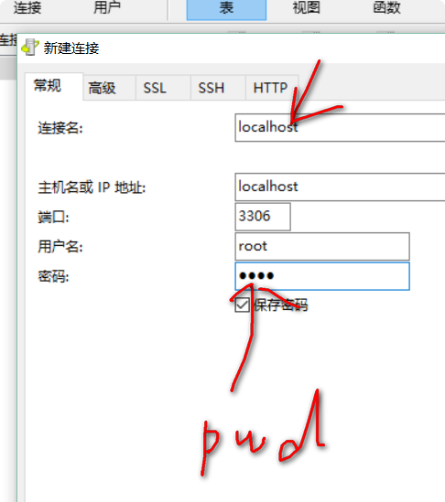

First enter whatever name you want for this connection

Enter password of your mysql. You have already created this pwd when you installed MySQL.

Mine pwd is 1234.

Keep this password in mind, we need this in our code.

1. Create a database

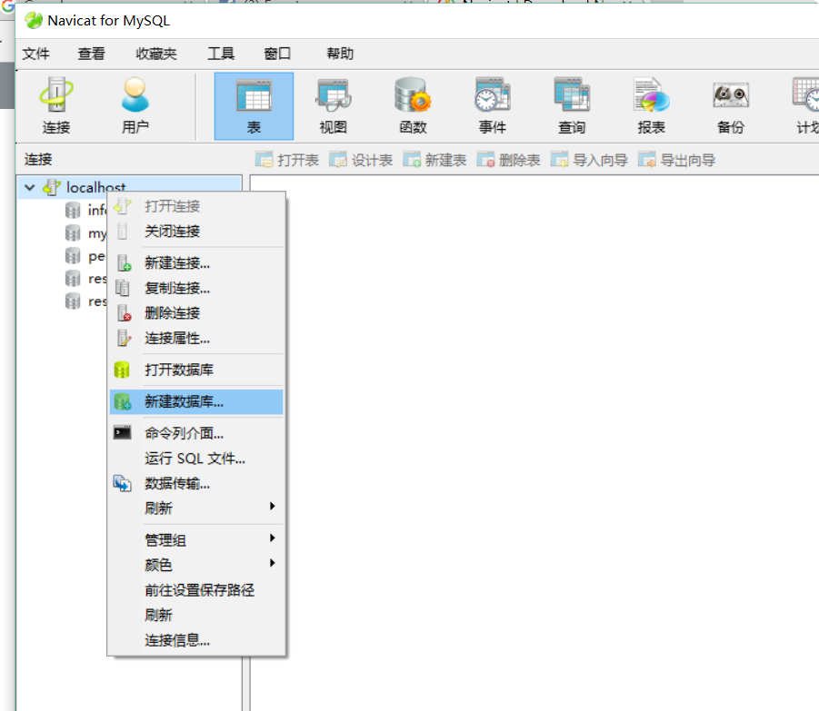

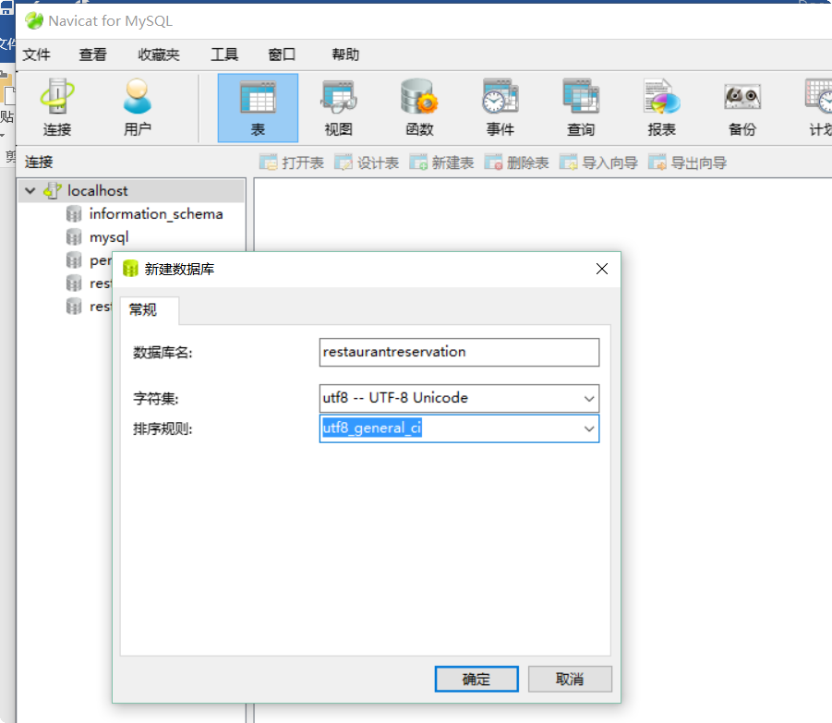

Everything should be same as this pic. The name, Unicode, etc.

1. Import sql query

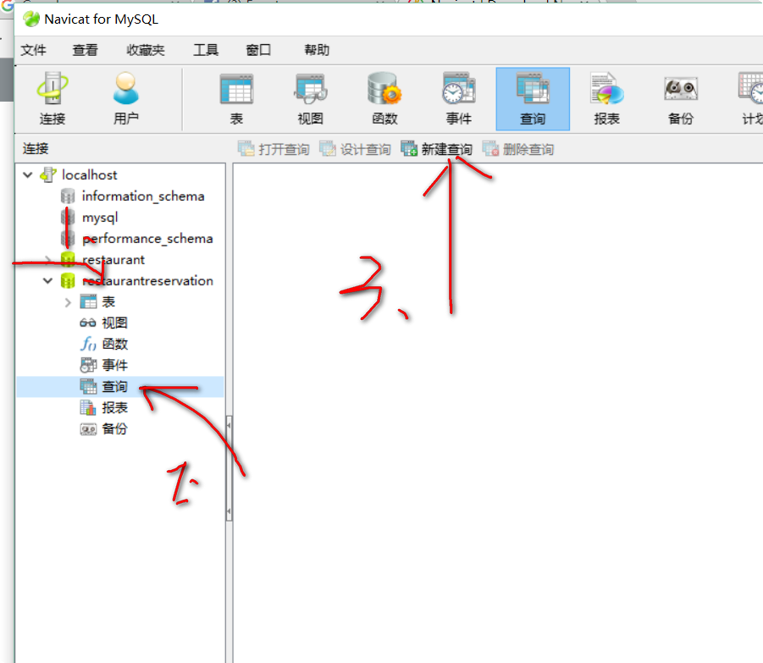

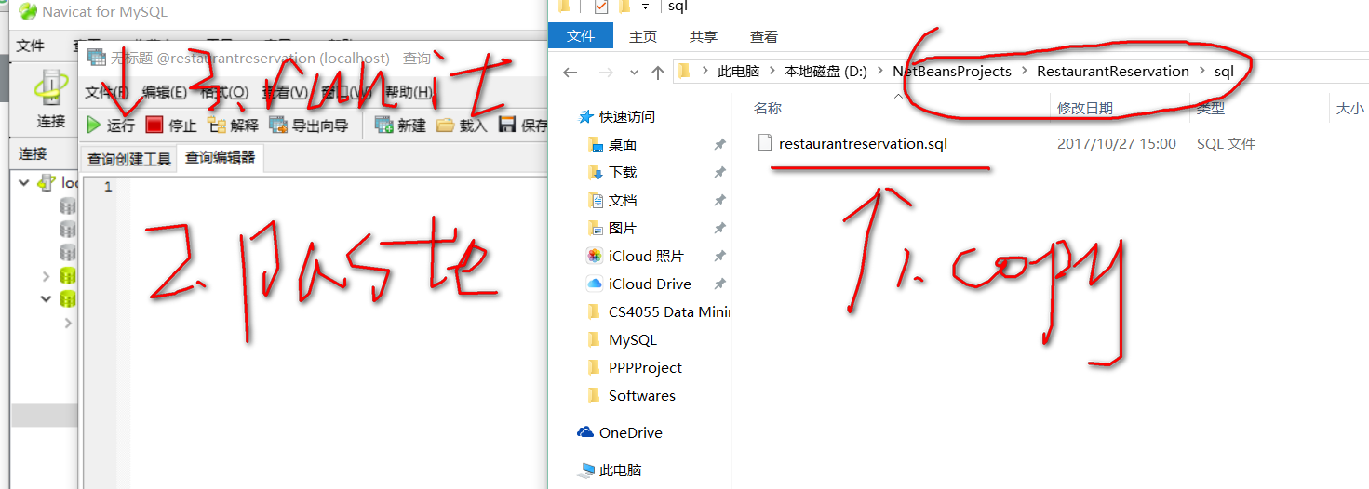

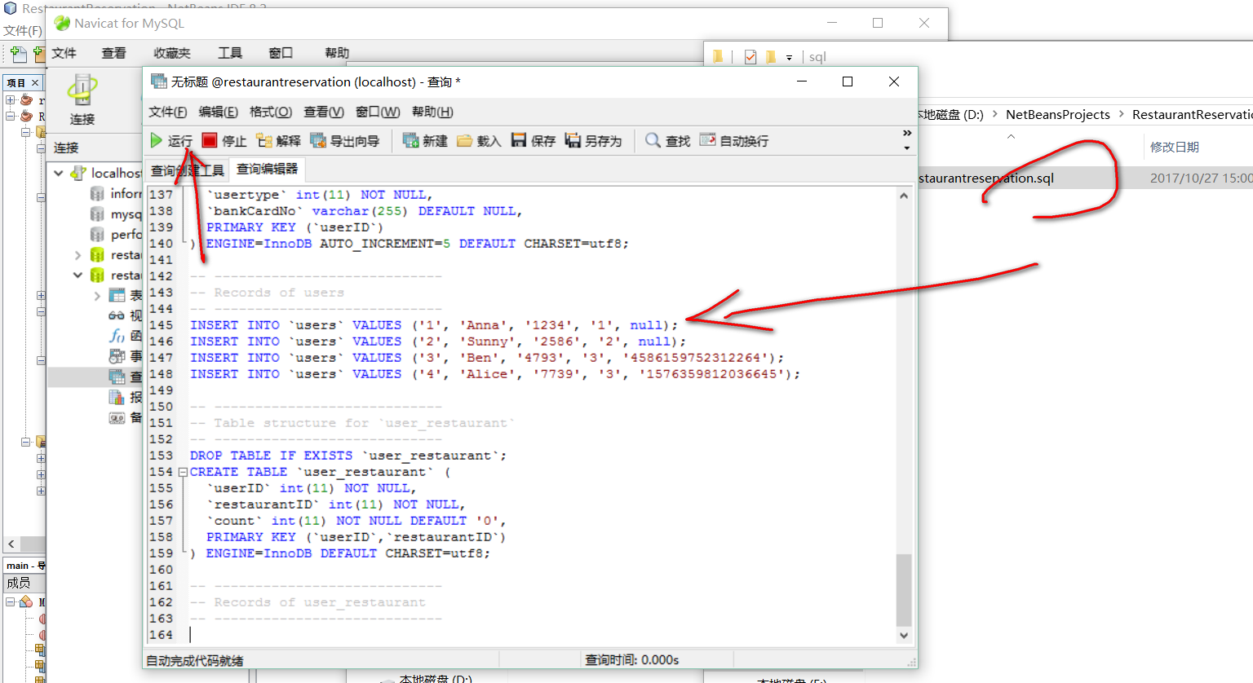

1. Refresh the database Or just close it and open it again, you can see all the tables and data

