11/23/2020 Git and GitHub learning
Shuqiang Chen @BU
Pipeline:
Create the GitHub account
Install git
Configure name and email

git remote add origin <REMOTE_URL>
# Sets the new remote
git remote -v
# Verifies the new remote URL

Change the local file such as modify/remove/add
git rm filename / git add filename / git add ./ git add *.m
git add --all . when there’s deletion in the local
git commit -m "comments about this change"
git push, git push origin master
after folk, git clone https://github.com/ShuqiangChen/BU-MA665-MA666.git

Some basic commands:
- cd (enter some file)
- cd .. ( back )
- ls ( list all the files)
- pwd (dictionary)
- git status (Get an idea of the git command to use next)

Difference between folk and clone:
Folk: you are able to have a link with the original repo, easy to track(merge/pull…) it.
Clone: No link with original repo, suitable when find some well-developed things and you want to learn and modify in your own local & remote, attached figure is the way to clone and upload to your own repo
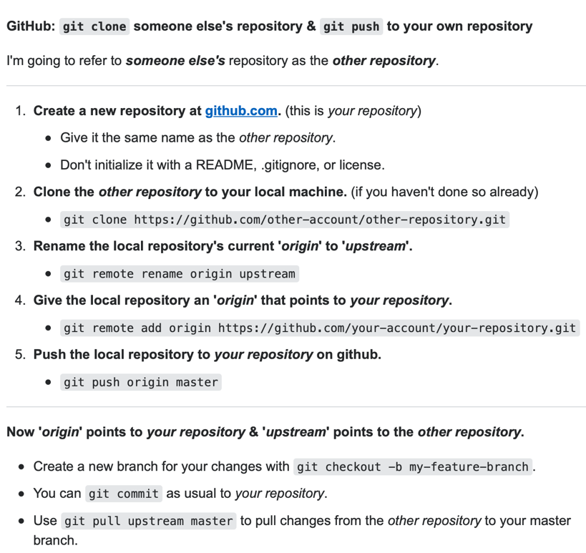

And a flowchart to illustrate their functions
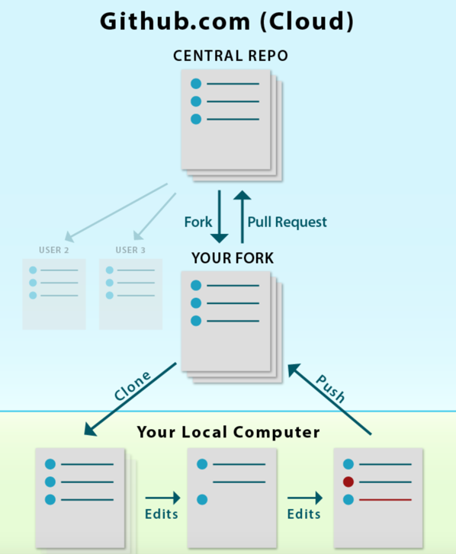

Other tricks:
- On the GitHub web, if you want to view the differences of the changings of the file, click the commit comments name, and split

