1. Login to openlab.ics.uci.edu

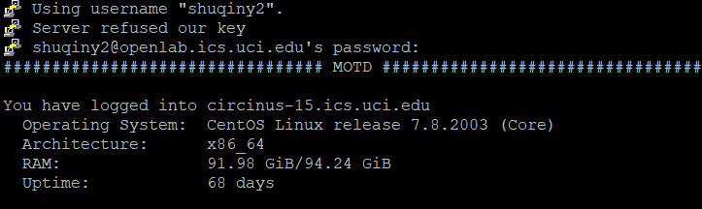

1. Add a new command to .bash_profile in login directory

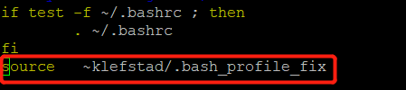

1. Create a folder for homework 0

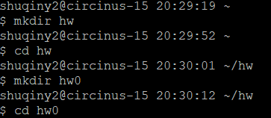

1. Create main.cpp and compile with g++

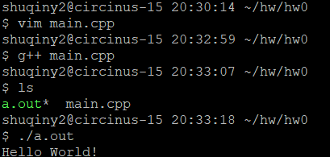

1. run gdb on the program and set breakpoints

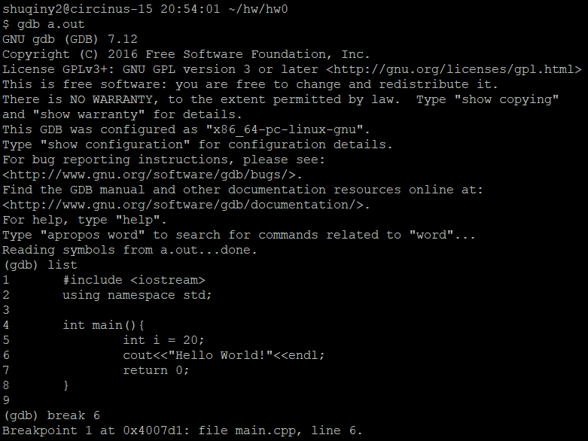

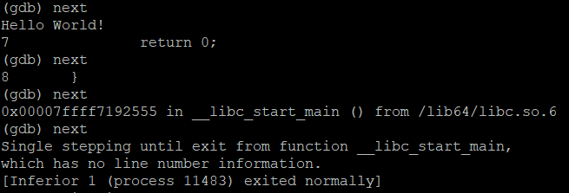

1. See breakpoint details and delete it

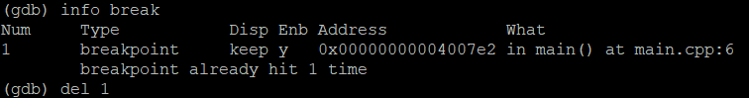

1. run valgrind to check for memory leaks

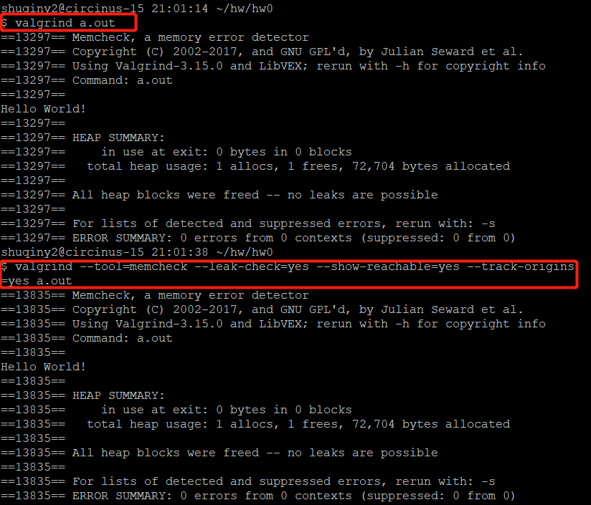

1. Create a Makefile

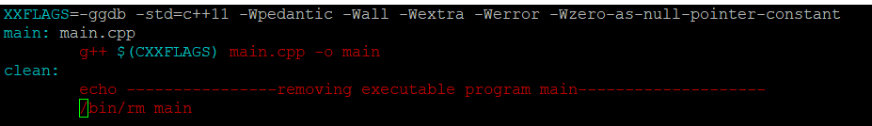

1. Use make to build program and run it by calling main

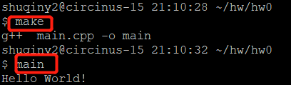

1. Make clean to remove the executable “main”

