**HW 2.1**

Compile

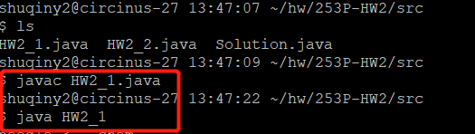

Test case 1 (the provided example from the assignment)

[input](https://drive.google.com/open?id=1haMDYvSQULgD9hTNFCJapZHN_s5sn3c0):

needle <-- chem

haystack <-- alchemy

output:

2

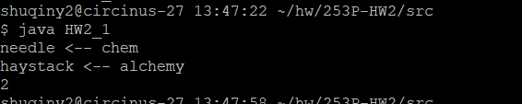

Test case 2(the provided example from the assignment)

[input](https://drive.google.com/open?id=1haMDYvSQULgD9hTNFCJapZHN_s5sn3c0):

needle <-- chem

haystack <-- heartache

output:

-1

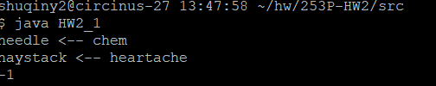

Test case 3

[input](https://drive.google.com/open?id=1haMDYvSQULgD9hTNFCJapZHN_s5sn3c0):

needle <-- “” // empty String

haystack <-- “” // empty String

output:

-1

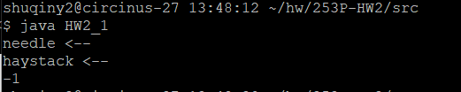

Test case 4

[input](https://drive.google.com/open?id=1haMDYvSQULgD9hTNFCJapZHN_s5sn3c0):

needle <-- abc

haystack <-- ab

output:

-1

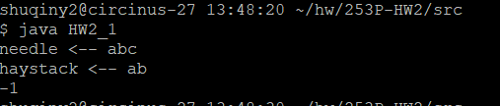

Test case 5

[input](https://drive.google.com/open?id=1haMDYvSQULgD9hTNFCJapZHN_s5sn3c0):

needle <-- ab

haystack <-- ababab

output:

0

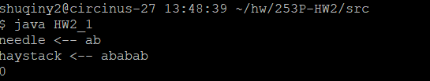

**HW 2.2**

Compile

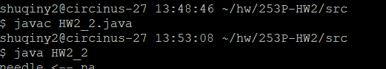

Test case 1 (the provided example from the assignment)

[input](https://drive.google.com/open?id=1haMDYvSQULgD9hTNFCJapZHN_s5sn3c0):

needle <-- na

haystack <-- bananas

output:

2

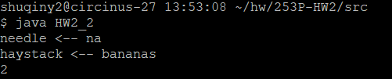

Test case 2 (the provided example from the assignment)

[input](https://drive.google.com/open?id=1haMDYvSQULgD9hTNFCJapZHN_s5sn3c0):

needle <-- na

haystack <-- potato

output:

0

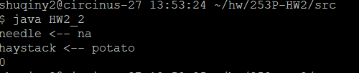

Test case 3

[input](https://drive.google.com/open?id=1haMDYvSQULgD9hTNFCJapZHN_s5sn3c0):

needle <-- “”

haystack <-- “” // Empty String

output:

-1

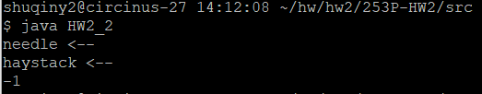

Test case 4

[input](https://drive.google.com/open?id=1haMDYvSQULgD9hTNFCJapZHN_s5sn3c0):

needle <-- aaa

haystack <-- aa

output:

-1

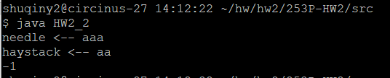

Test case 5

[input](https://drive.google.com/open?id=1haMDYvSQULgD9hTNFCJapZHN_s5sn3c0):

needle <-- bab

haystack <-- abababab

output:

3

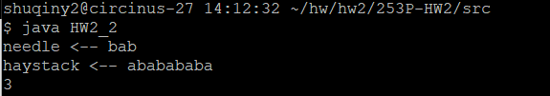

**HW 2.3**

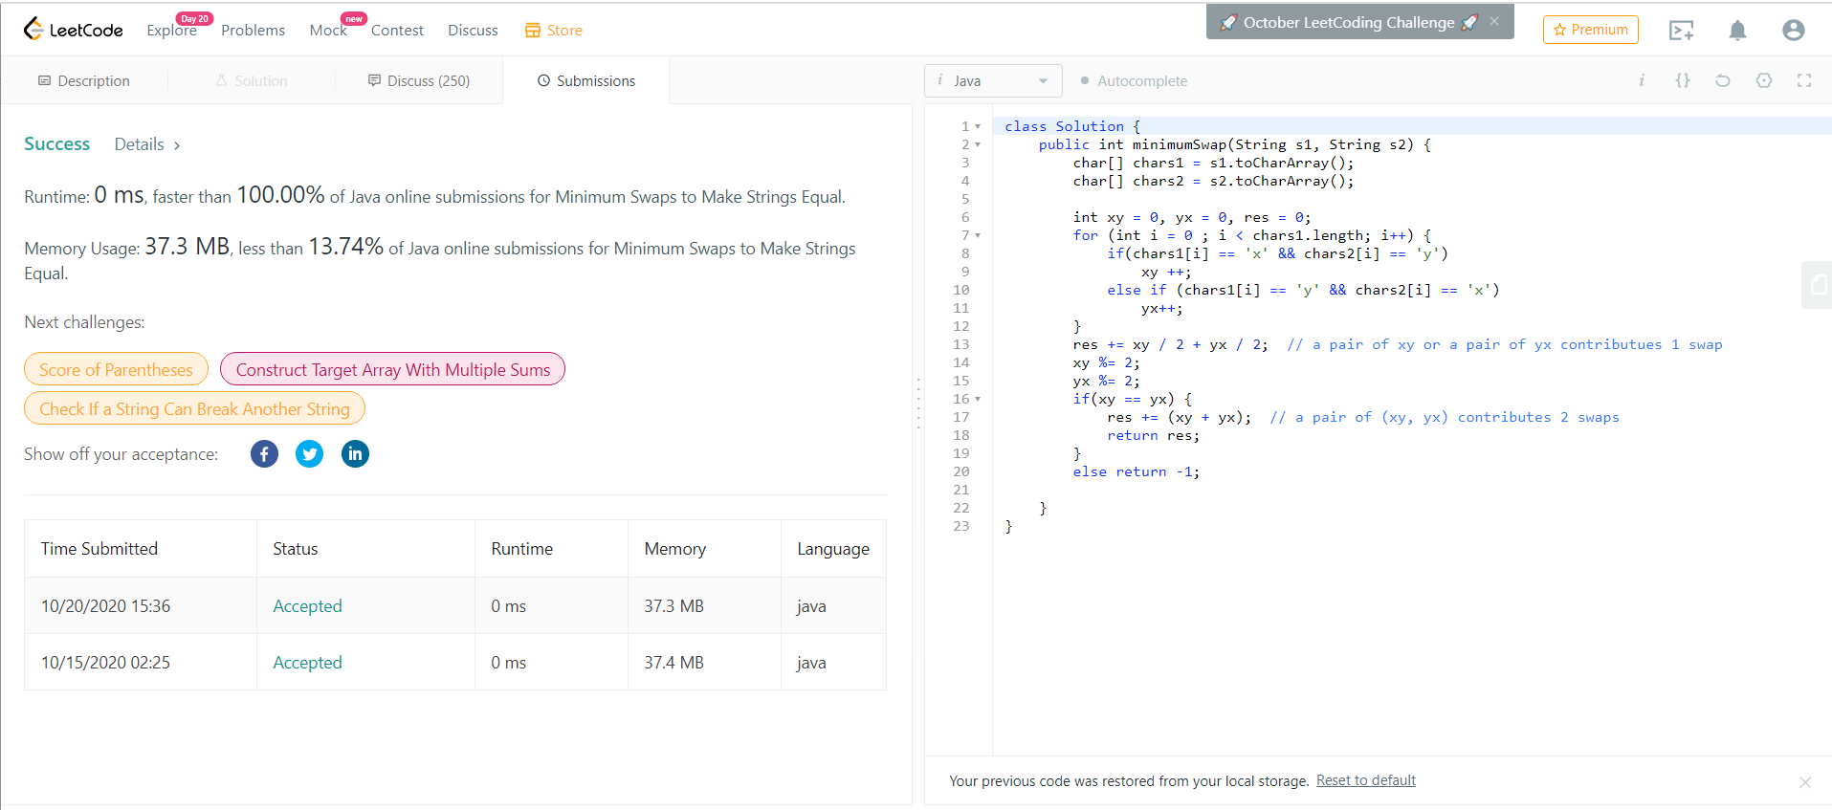Substitute by LeetCode # 1247, String related, medium

**HW 2.4**

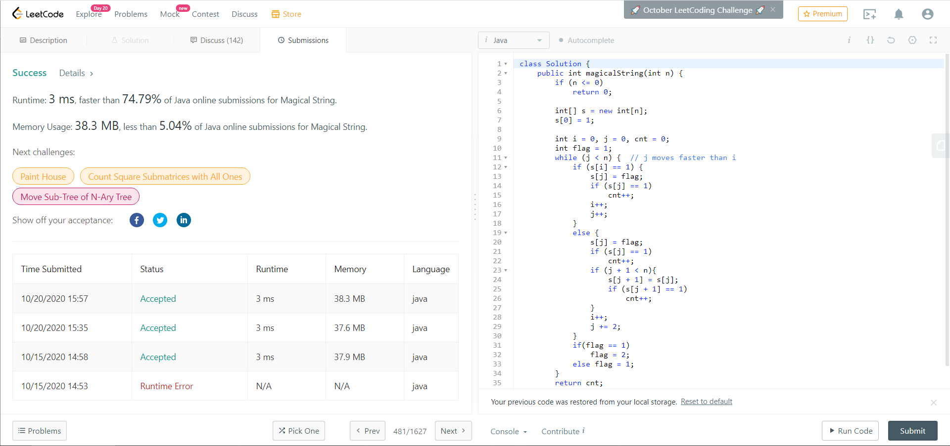Substitute by LeetCode # 481, string related, medium