**HW 3.1**

Compile

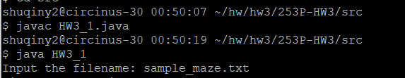

Test case 1 (the provided example from the assignment)

[input](https://drive.google.com/open?id=1haMDYvSQULgD9hTNFCJapZHN_s5sn3c0):

[sample_maze.txt](https://drive.google.com/a/uci.edu/file/d/1MnCvG_XX25XGNhtXpYr21a37XUH05ZlB/view?usp=sharing)

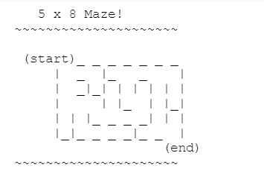

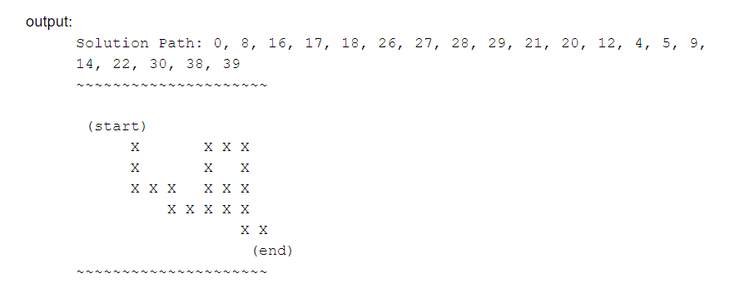

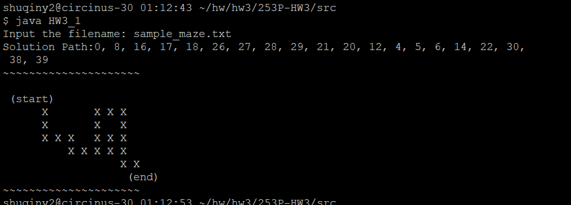

Test case 2

[input](https://drive.google.com/open?id=1haMDYvSQULgD9hTNFCJapZHN_s5sn3c0):

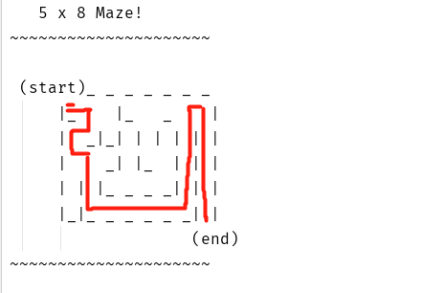

output:

Solution Path:0, 1, 9, 8, 16, 17, 25, 33, 34, 35, 36, 37, 38, 30, 22, 14, 6, 7, 15, 23, 31, 39

~~~~~~~~~~~~~~~~~~~~~

(start)

X X X X

X X X X

X X X X

X X X

X X X X X X

(end)

~~~~~~~~~~~~~~~~~~~~~

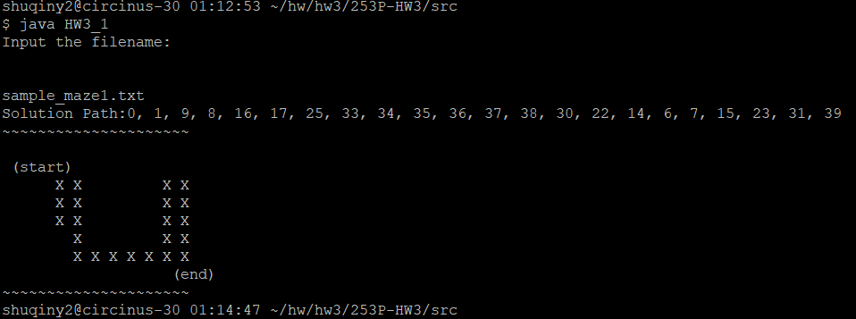

Test case 3(the provided example from the assignment)

[input](https://drive.google.com/open?id=1haMDYvSQULgD9hTNFCJapZHN_s5sn3c0):

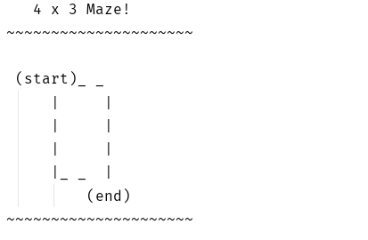

output:

// solutions can be alternative

Solution Path:0, 1, 2, 5, 4, 3, 6, 8, 7, 11

~~~~~~~~~~~

(start)

X X X

X X X

X X X

X

(end)

~~~~~~~~~~~

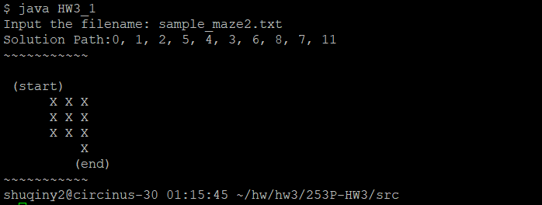

Test case 4

[input](https://drive.google.com/open?id=1haMDYvSQULgD9hTNFCJapZHN_s5sn3c0):

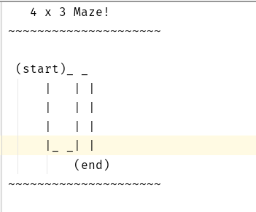

output:

Solution Path: Can't find a solution!

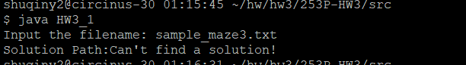

Test case 5

[input](https://drive.google.com/open?id=1haMDYvSQULgD9hTNFCJapZHN_s5sn3c0):

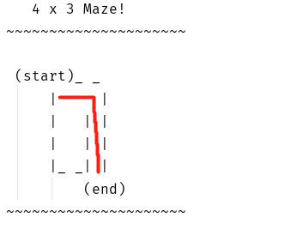

output:

Solution Path:0, 1, 2, 5, 8, 11

~~~~~~~~~~~

(start)

X X X

X

X

X

(end)

~~~~~~~~~~~

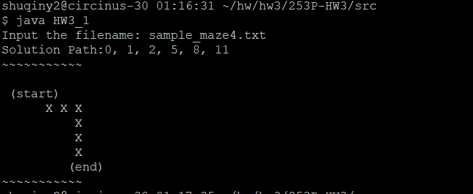

**HW 3.2 - 1**

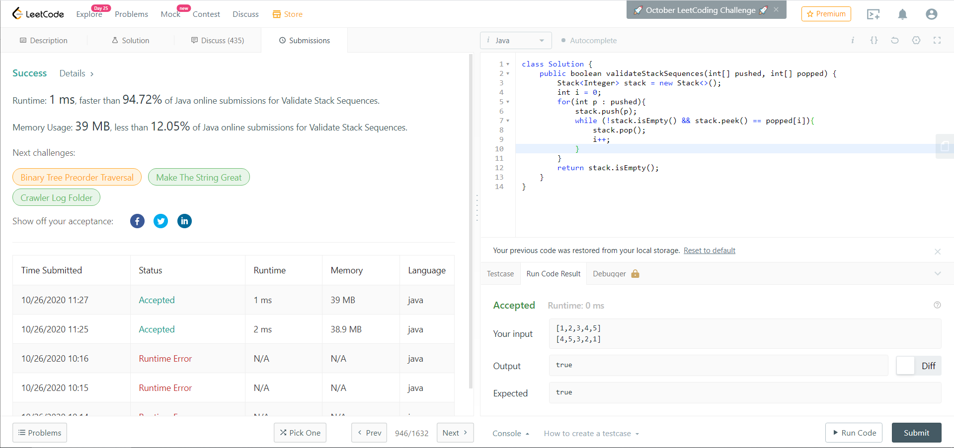Substitute by LeetCode # 946, medium

**HW 3.2 - 2**

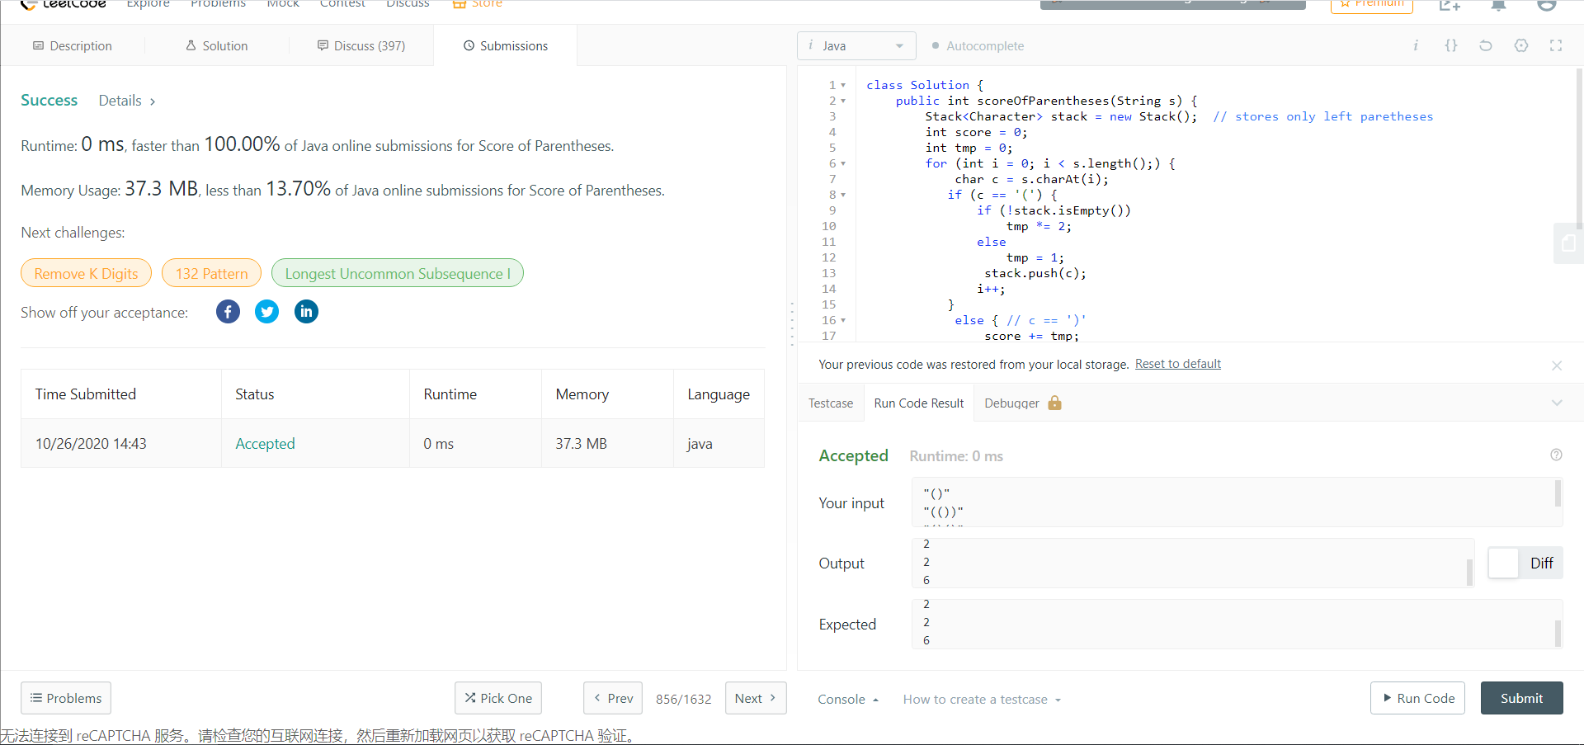Substitute by LeetCode # 856, medium