1. What data structure did you implement ***SimplePlayList*** as?

I implement SimplyPlayList as a linked list, each song can be seen as a node.

1. List all the attributes (aka fields) you needed in order to implement ***SimplePlayList*** (also include the attributes for any other auxiliary data structures it uses)?  (Do not list functions (aka methods)).

**Class** SimplePlayList {

**protected** Node **head**; *// The first song of playlist***protected** Node **cur**; *// The current song of playlist***protected int size**; *// The size of playlist*

}

**class** Node {  
 **protected** Song **song**;  
 **protected** Node **next**;

}

**class** Song {  
 **protected** String **title**;  
 **protected** String **artist**;

}

1. How does ***SimplePlayList*** retrieve a random song in *O(n)* time?  Explain in detail using a few sentences.

Get a random n ( n is between 0 and the length of playlist ), move the pointer from current position to its next n times.

1. If ***prev*** is processed in *O(n)* time, then how is ***find*** able to print the previous song of the found song in *O(1)* time?

The cur pointer can only move to the next node, so if you want to visit the previous node, you have to start from the beginning. That’s how ***prev*** works in O(n). But in ***find***, since we have to traverse the whole list***,*** we can keep the location of the previous song in an extra pointer. By using this pointer we can achieve O(1) in ***find.***

Two Leetcode problems are substitutions, but I’d like to briefly talk about some ideas about 4.2 and 4.3

1. Very briefly explain how ***GeneralPlayList*** differs from ***SimplePlayList*** as? (Just one or two short sentences that gets the main point(s) across).

***SimplePlayList*** is a linked list while ***GeneralPlayList*** is a doubleLinkedList. Also, ***GeneralPlayList*** keeps a pointer pointing to its tail.

1. List all the attributes (aka fields) you needed in order to implement ***GeneralPlayList*** (also include the attributes for any other auxiliary data structures it uses)? (Do not list functions (aka methods)).

**class** DoubleLinkedNode {  
 protected Song song;  
 protected DoubleLinkedNode next;  
 protected DoubleLinkedNode pre;

}

**class** GeneralPlayList **implements** MusicPlayerImpl {  
  
 protected DoubleLinkedNode head; // The first song of playlist  
 protected DoubleLinkedNode tail; // The first song of playlist  
 protected DoubleLinkedNode cur; // The current song of playlist  
 protected int randomPos;  
 protected int[] randomArray;

}

1. What allows queue to be able to add to the end of the playlist in O(1) time now?

We keep a tail pointer. Every time queue an element, just append to the tail and move the pointer.

1. How does ***GeneralPlayList*** retrieve a random song without iterating over a song twice? Explain in detail using a few sentences.

~~We use two params, int randomPos and int[] randomArray. randomPos is within[0, playlist.size – 1), every time function~~ ***~~random~~*** ~~is called, it increment one. When~~ ***~~GeneralPlayList~~*** ~~is initialized,~~

1. Very briefly explain how ***AdvancedPlayList*** differs from ***GeneralPlayList*** as? (Just one or two short sentences that gets the main point(s) across).

***AdvancedPlayList*** has one more HashMap<String, DoubleLinkedNode>, whose key is the title and artist of a song and value is the node of playlist.

1. What additional data structure did you use to help you achieve the desired improvements?

A hashMap.

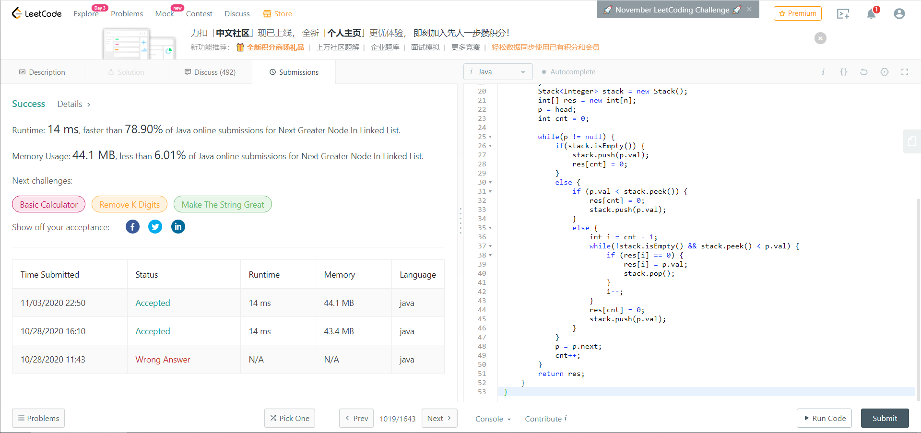Leetcode 1019

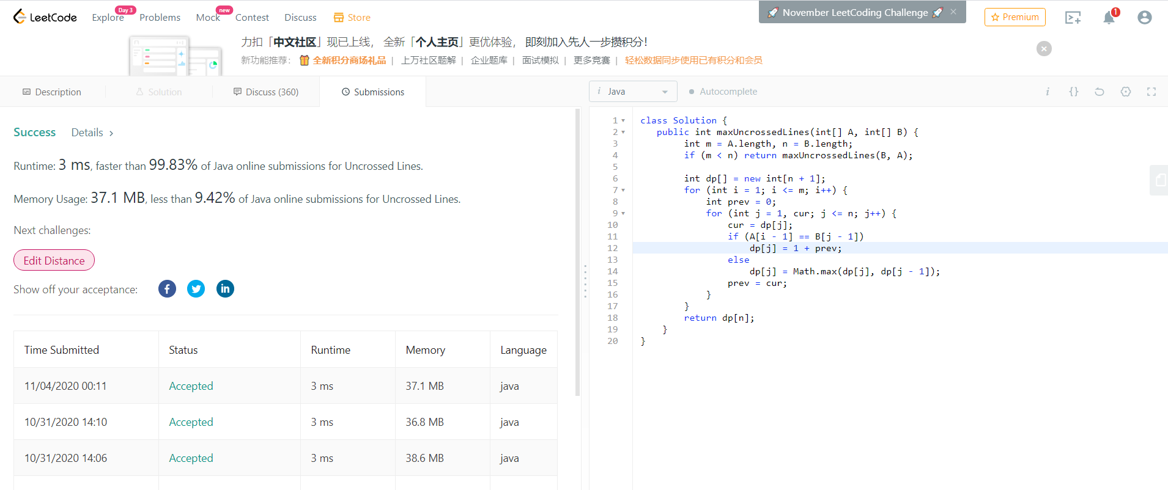Leetcode 1035