Compile

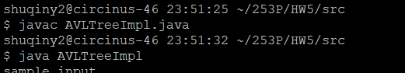

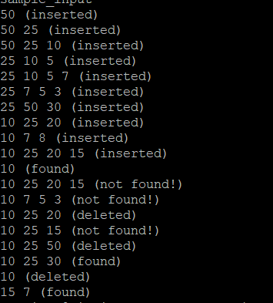

input:

insert 50

insert 25

insert 10

insert 5

insert 7

insert 3

insert 30

insert 20

insert 8

insert 15

find 10

find 12

delete 4

delete 20

find 22

delete 50

find 30

delete 10

find 7

output:

50 (inserted)

50 25 (inserted)

50 25 10 (inserted)

25 10 5 (inserted)

25 10 5 7 (inserted)

25 7 5 3 (inserted)

7 25 50 30 (inserted)

7 25 10 20 (inserted)

7 25 10 8 (inserted)

7 25 10 20 15 (inserted)

10 (found)

10 25 20 15 (not found!)

10 7 5 3 (not found!)

10 25 20 (deleted)

10 25 15 (not found!)

10 25 50 (deleted)

10 25 30 (found)

10 (deleted)

8 5 7 (found)

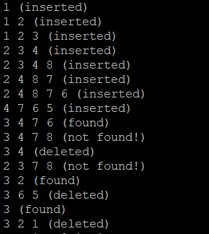

input:

insert 1

insert 2

insert 3

insert 4

insert 8

insert 7

insert 6

insert 5

find 6

find 9

delete 4

delete 20

find 2

delete 5

find 3

delete 1

output:

1 (inserted)

1 2 (inserted)

1 2 3 (inserted)

2 3 4 (inserted)

2 3 4 8 (inserted)

2 4 8 7 (inserted)

2 4 8 7 6 (inserted)

4 7 6 5 (inserted)

3 4 7 6 (found)

3 4 7 8 (not found!)

3 4 (deleted)

2 3 7 8 (not found!)

3 2 (found)

3 6 5 (deleted)

3 (found)

3 2 1 (deleted)

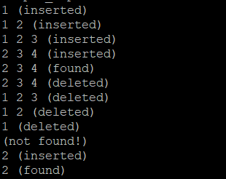

input:

insert 1

insert 2

insert 3

insert 4

find 4

delete 4

delete 3

delete 2

delete 1

find 2

insert 2

find 2

output:

1 (inserted)

1 2 (inserted)

1 2 3 (inserted)

2 3 4 (inserted)

2 3 4 (found)

2 3 4 (deleted)

1 2 3 (deleted)

1 2 (deleted)

1 (deleted)

(not found!)

2 (inserted)

2 (found)

Leetcode 814

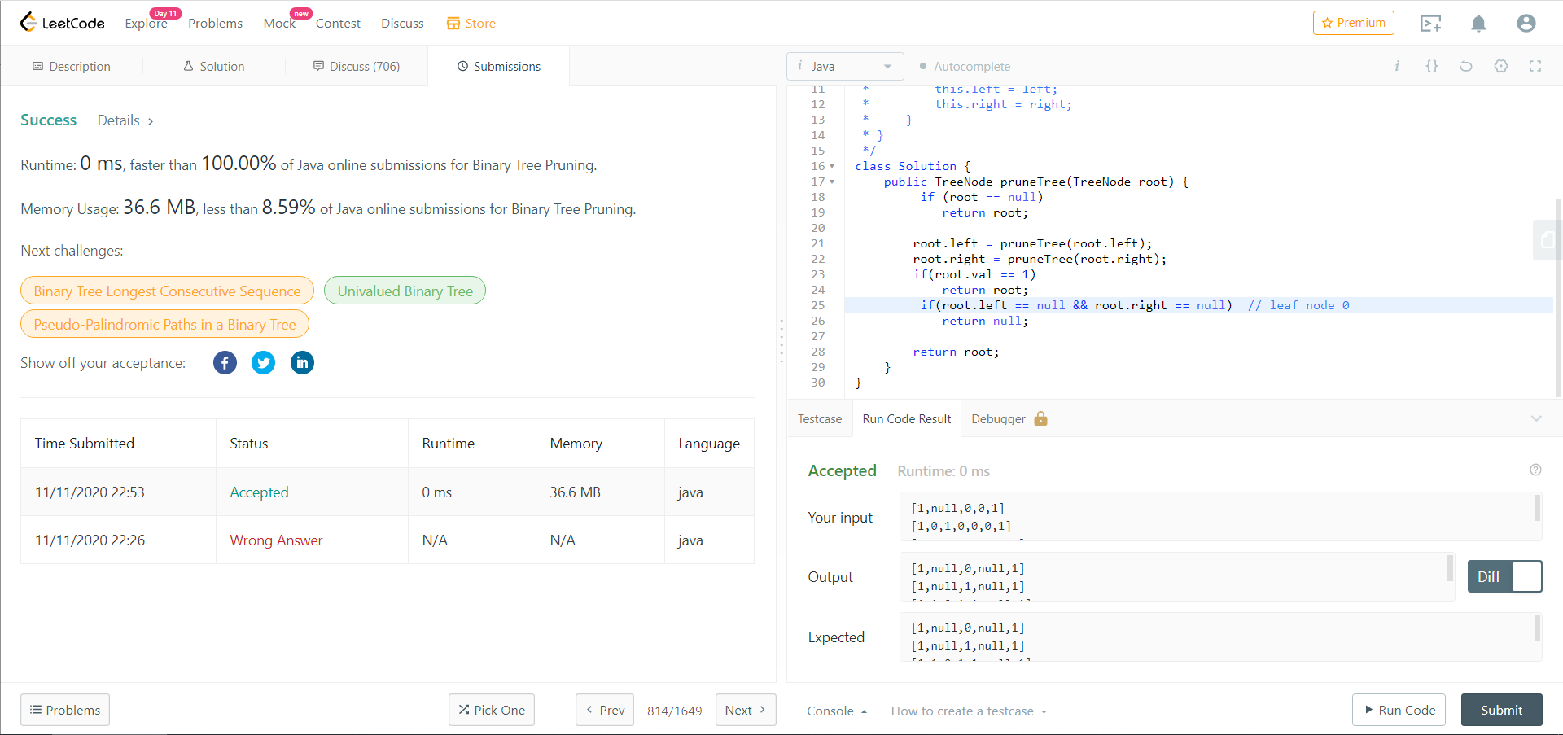

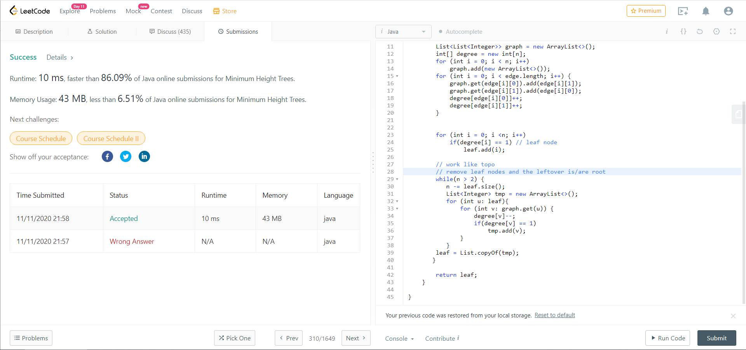Leetcode 310