Compile

Input:

Output:

Input:

Output:

Input:

Output:

Input:

Output:

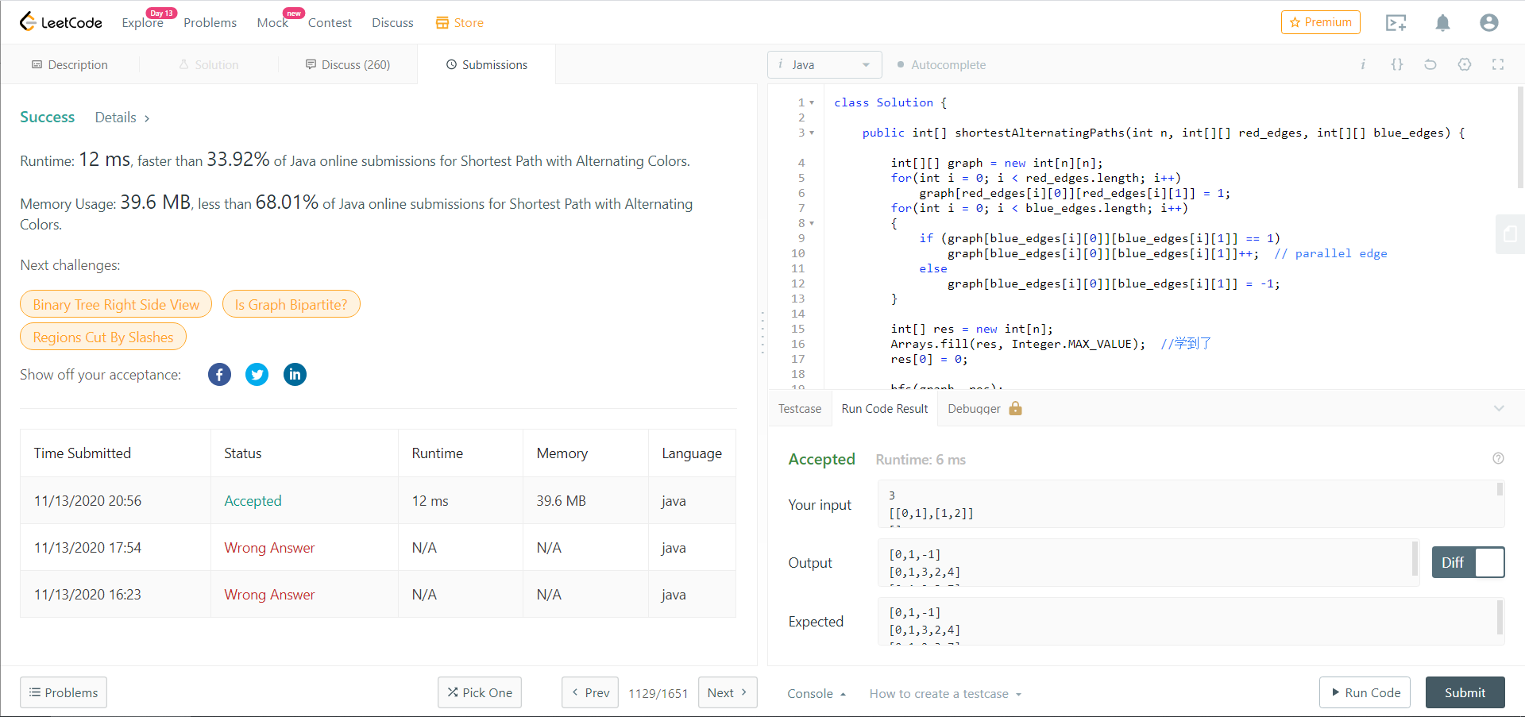Leetcode 1129

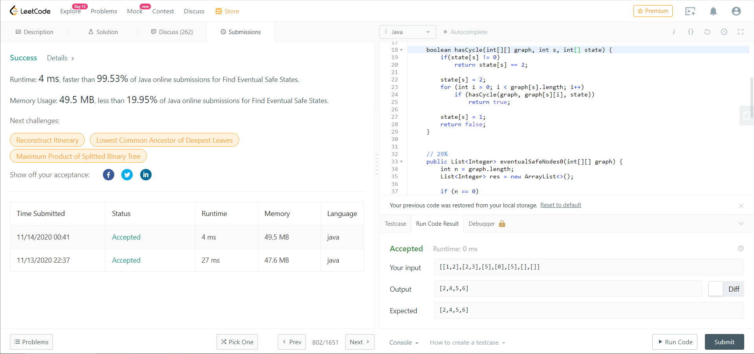LeetCode 802