Compile

Input:

9

IX

476

CDLXXVI

Output:

IX

9

CDLXXVI

476

Input:

0

-1

4000

Output:

UNDEFINED

Error

Error

Input:

ABC

X123

MMMM

Output:

Error

Error

Error

Input:

3845

1999

235

64

3

MMMDCCCXLV

MCMXCIX

CCXXXV

LXIV

III

Output:

MMMDCCCXLV

MCMXCIX

CCXXXV

LXIV

III

3845

1999

235

64

3

Leetcode 778. Swim in Rising Water

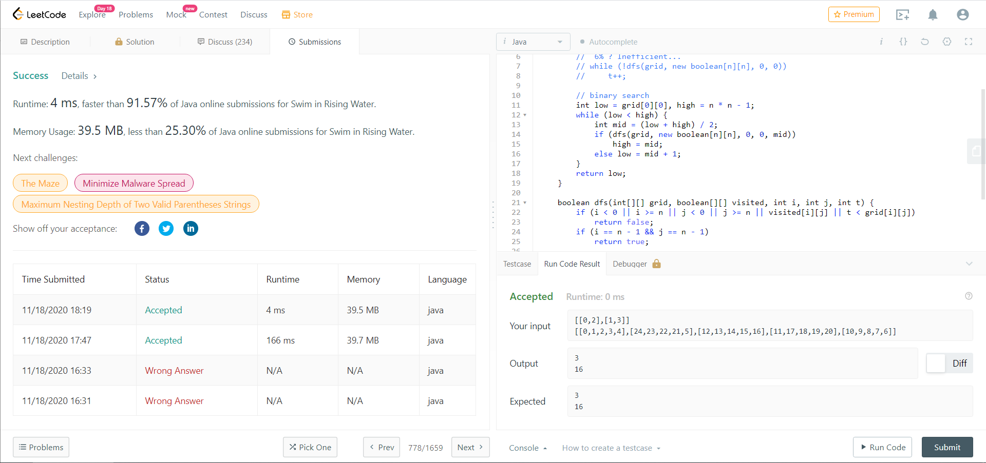

Leetcode 42. Trapping Rain Water

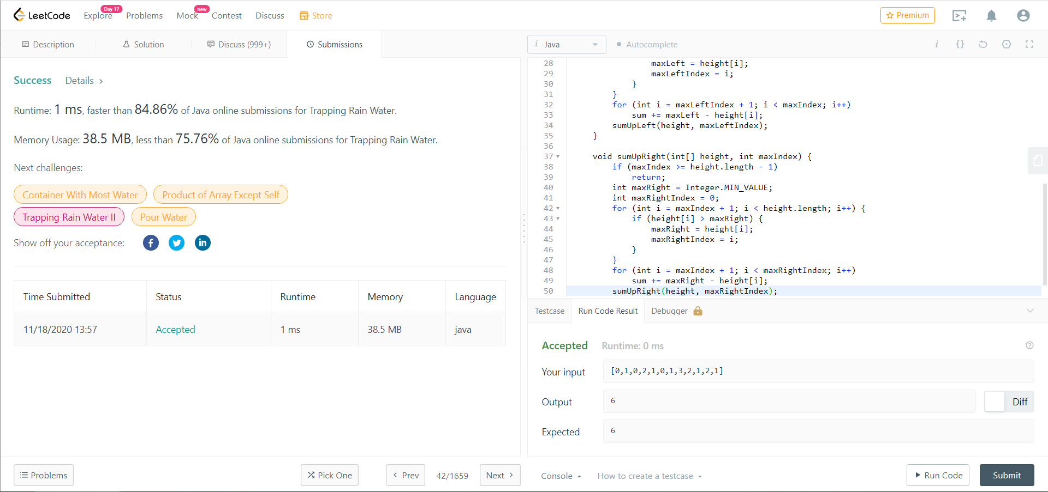

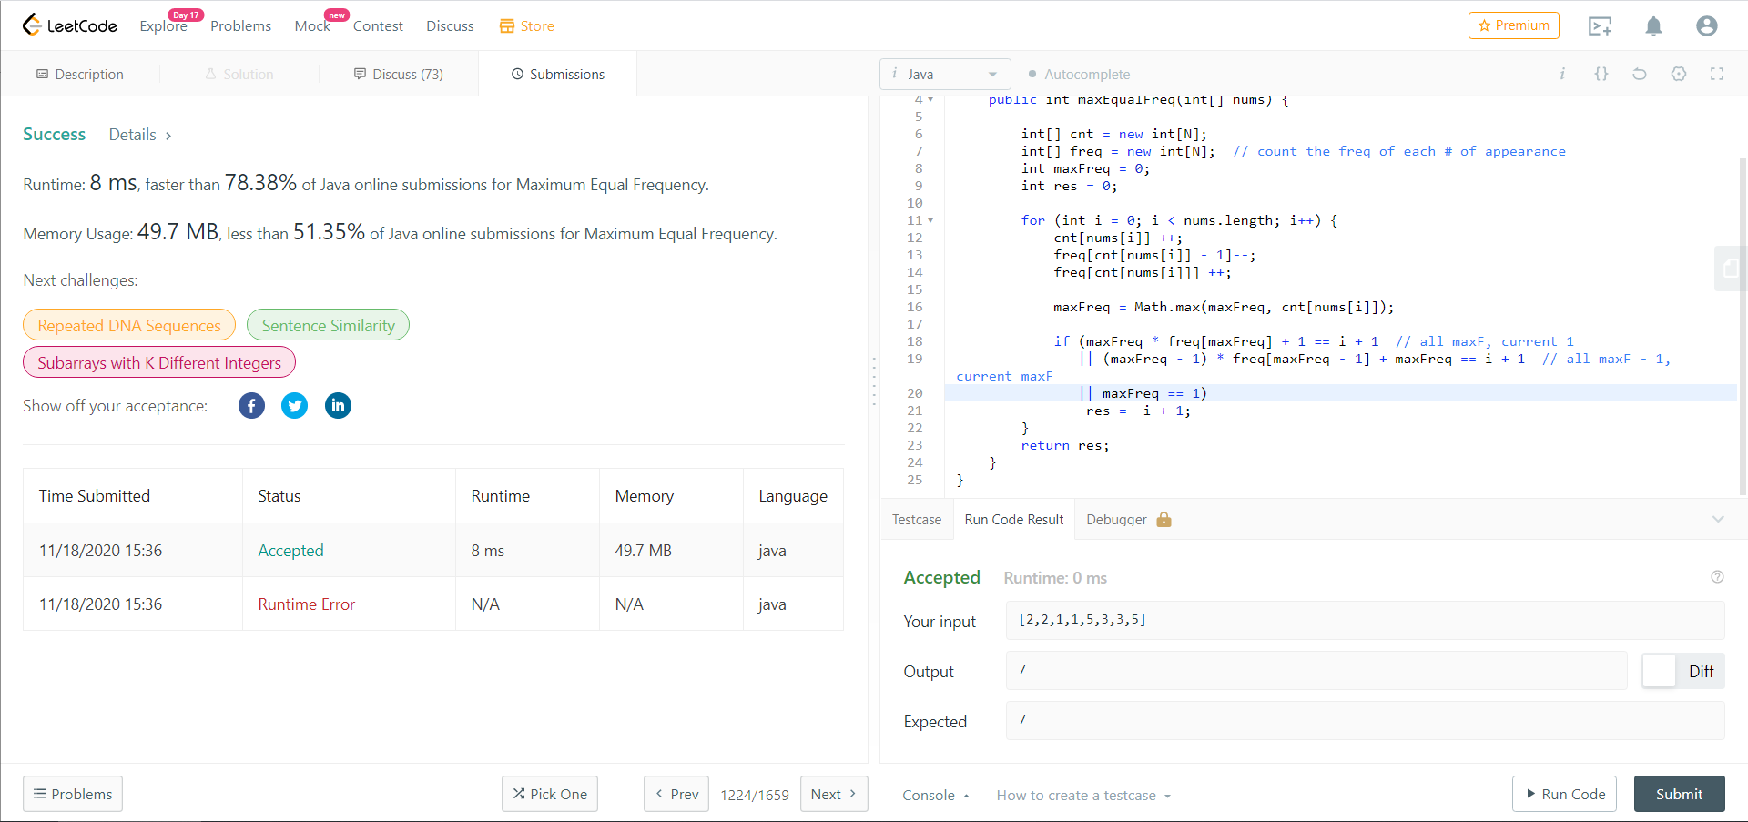LeetCode 1224. Maximum Equal Frequency