HW 8.3 - DNA Sequence Alignment Part I (25 pts)

Compile

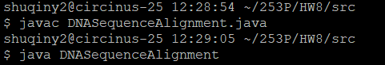

input:

A G C T T G

T G C G A A

output:

A _ G C T T G

T G C G A A _

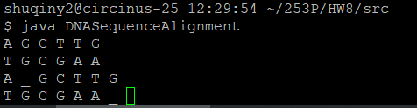

Error detection

Illegal letters or empty string

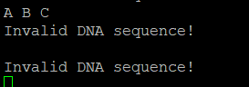

HW 8.4 - DNA Sequence Alignment Part II (25 pts)

Compile

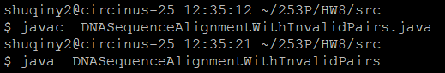

Input:

T T C G C T

A A G G C T

Output:

T T C G C _ T

A A G _ G C T *(or equivalent solution)*

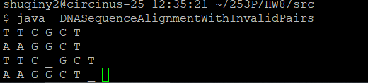

(This is an equivalent solution to sample output because T - T,  C - C, and T – C are with the same penalty)

Error detection (Same as HW8.3)

Illegal letters or empty string



Leetcode 322. Coin Change

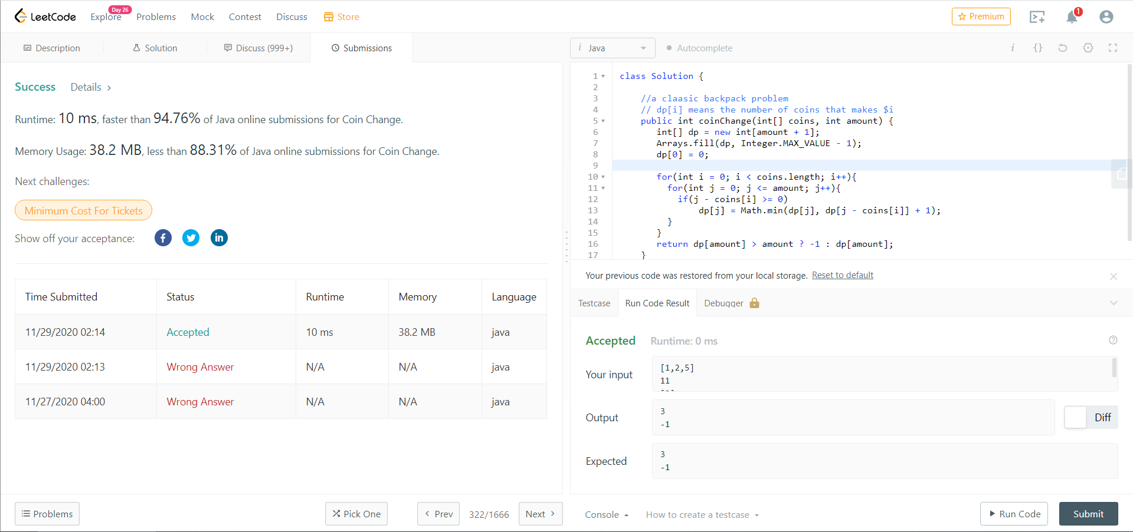

LeetCode 518. Coin Change 2

