Leetcode 881. Boats to Save People

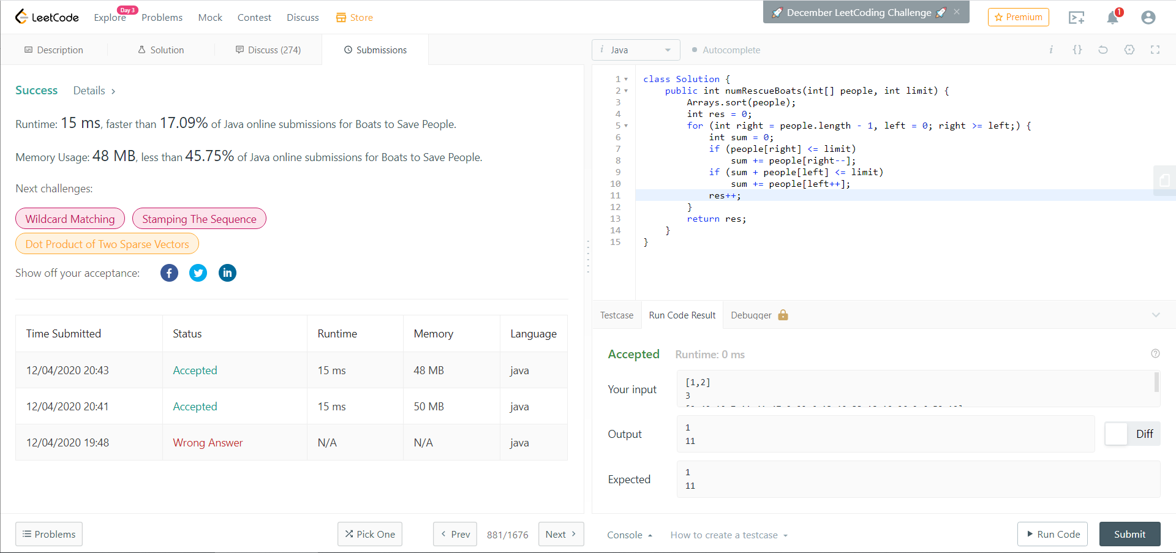

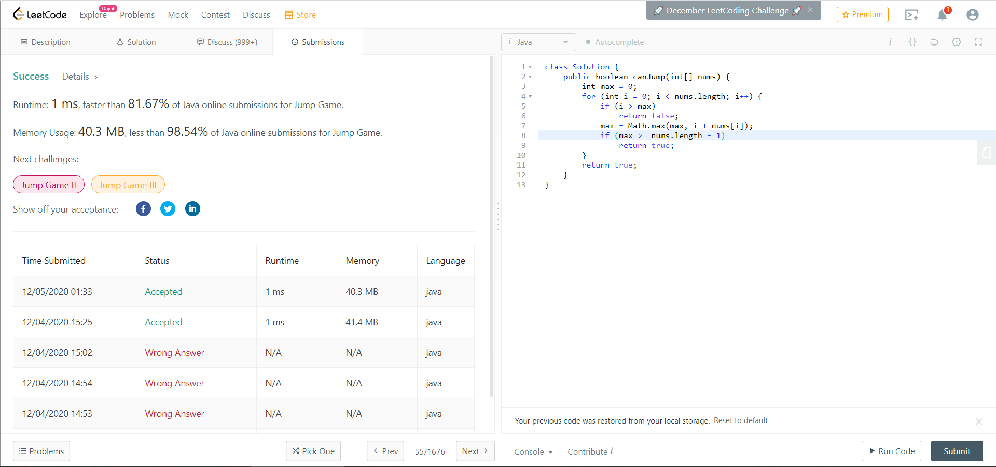 Leetcode 55. Jump Game

Leetcode 403. Frog Jump

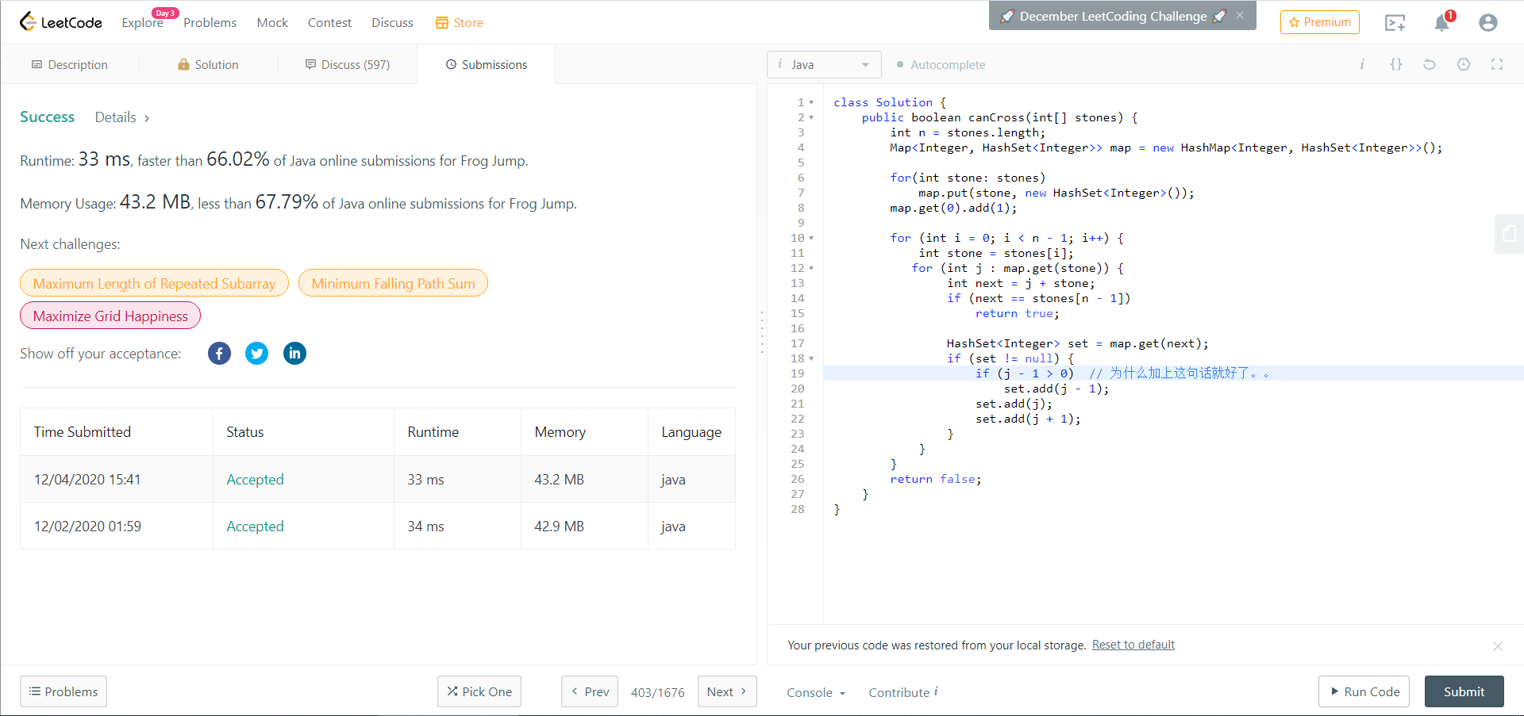

LeetCode 354. Russian Doll Envelopes

