**How to get access to the program?**

git clone https://github.com/ShuqingYe1997/253P-Lab1.git

cd 253P-Lab1

cd src

javac Roster.java

java Roster

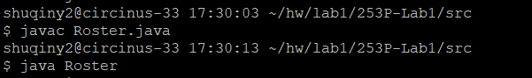

**Program started!**

Create a program that automatically takes in a class roster file called roster.txt, and creates small random groups of a dynamically specified size.

Input:

1. roster file *roster.txt*
2. an integer specifying the size of the groups (entered via stdin)
3. absent students (entered via stdin; format up to developer)

Output:

an easy to read list of numbered group assignments. If there are left-over students, each should be added to a different existing group, making those groups one larger than the specified size

Let’s start with 2 regular cases. When we input group size = 4 and absent students = [“Bobak Pezeshki”, “Ray Klefstad”], and the result is 3 groups of five, just as expected!

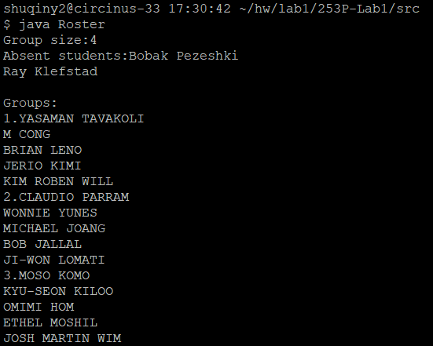

When we use group size = 3 and absent students = [ “Ray Klefstad”], we expect the result to be 1 group of 4 and 4 group of 3.

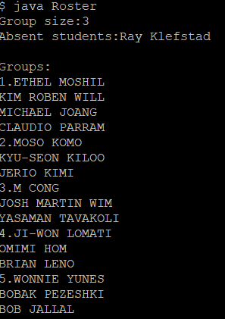

Let’s try some edge cases.

* group size = 17

absent students = []

Expected output: 1 group of 17.

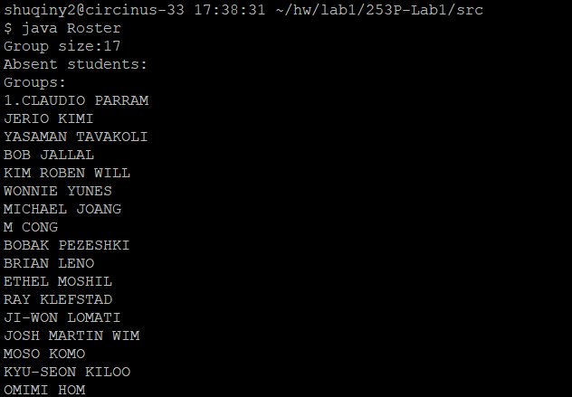

* group size = 1

absent students = []

Expected output: 17 groups of 1.

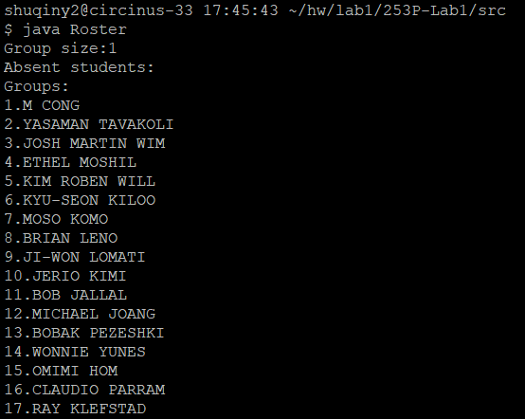

* group size = 18

absent students = []

Expected output: 1 group of 17.

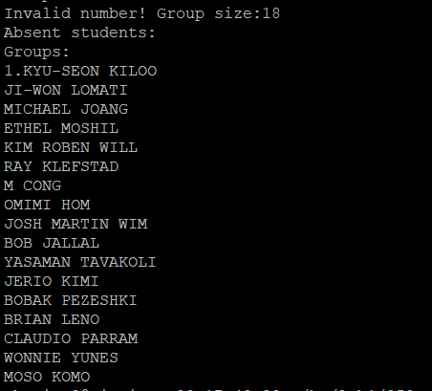

* group size = 0

absent students = []

Expected output: error and asking to re-input

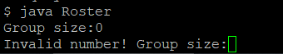

* group size = 4

absent students = [all the students enrolled]

Expected output: 0 groups

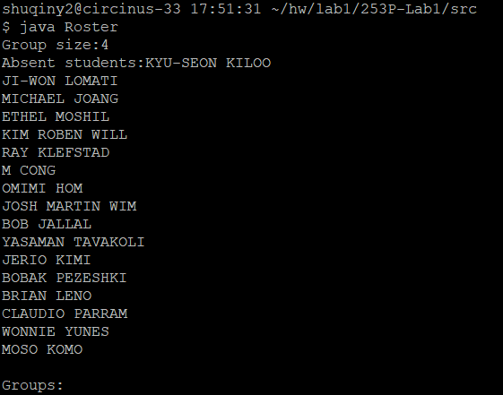

This program seems to work fine~