Compile:

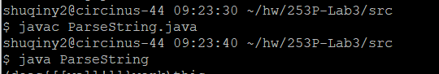

Test case1:

Input:

(does{[[well!]]}work)this

Expected output:

|this

|  does work

|        well!

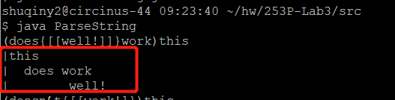

Test case2:

Input:

(doesn’t{[[work!]})this

Expected output:

|mismatched groups!

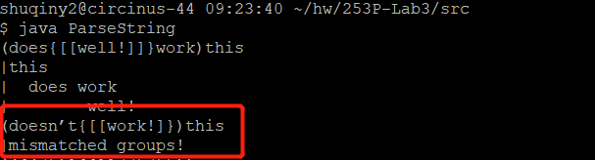

Test case3:

Input:

{{[{()}][[] (()())}} // missing one ‘]’

Expected output:

|mismatched groups!

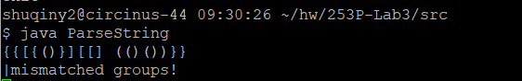

Test case4:

Input:

( level1 {([level4] []{} level3) level2 }) {( )}level0 ()[]{}

Expected output:

|level0

| level1

| level2

| level3

| level4

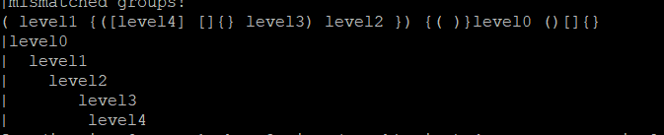

Test case5:

Input:

for (int i = 0, a = 1, b = 2; i < (a + b); i++) { System.out.println( array[i] ); }

Expected output:

|for

| int i = 0, a = 1, b = 2; i < ; i++ System.out.println ;

| a + b array

| i

