Leetcode 207. Course Schedule

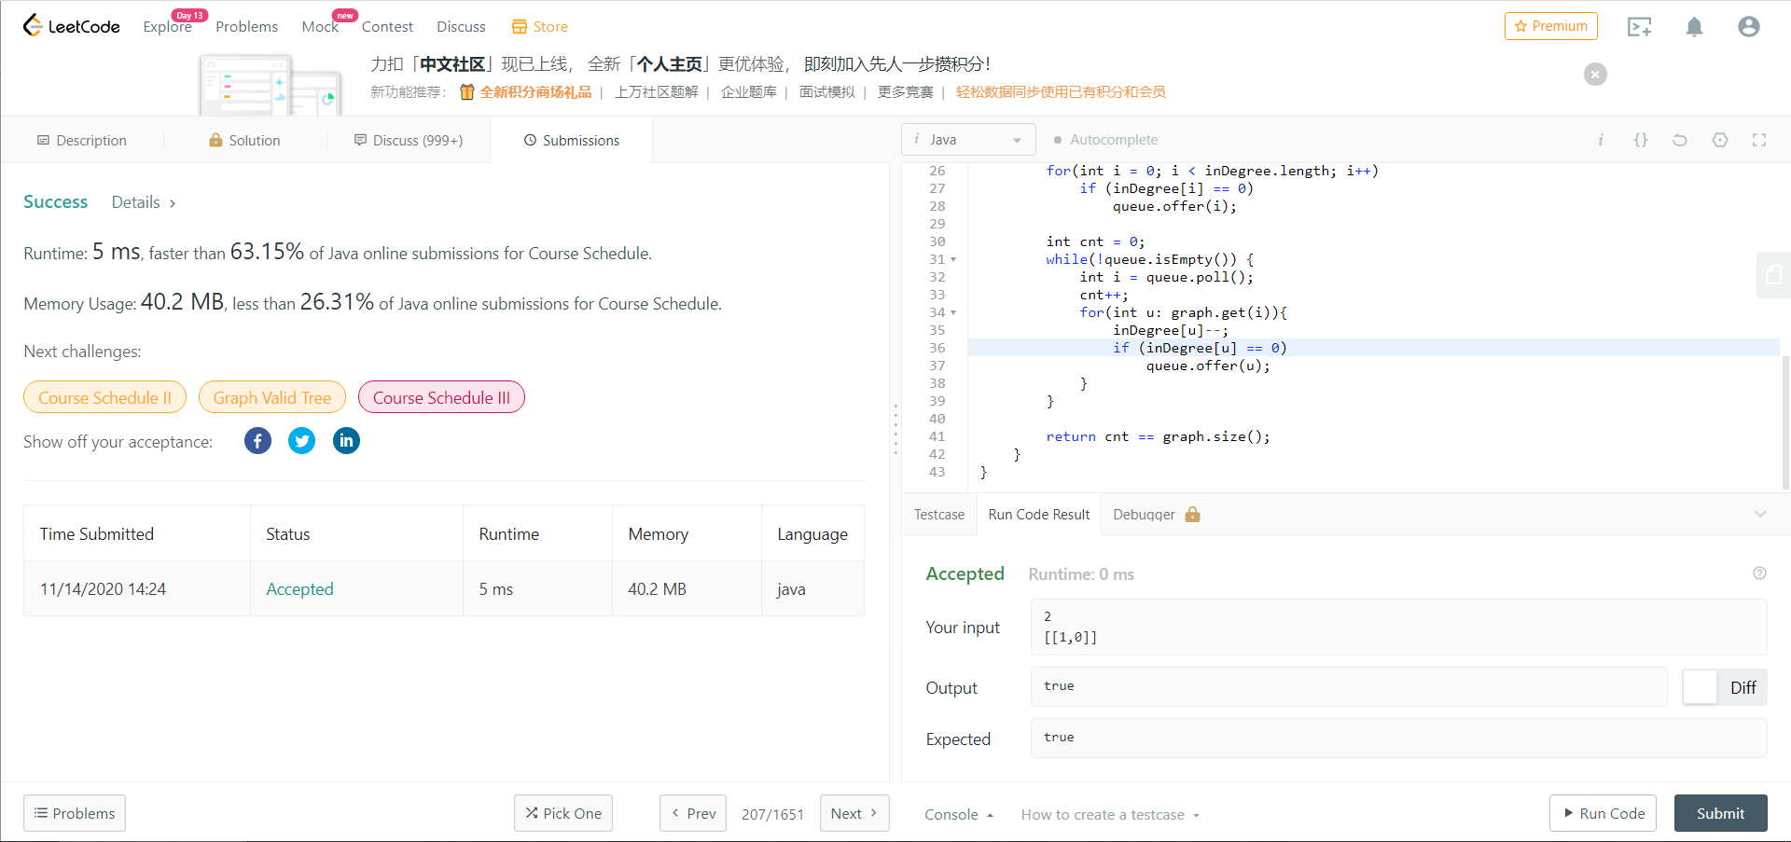// detecting cycles with topoSort

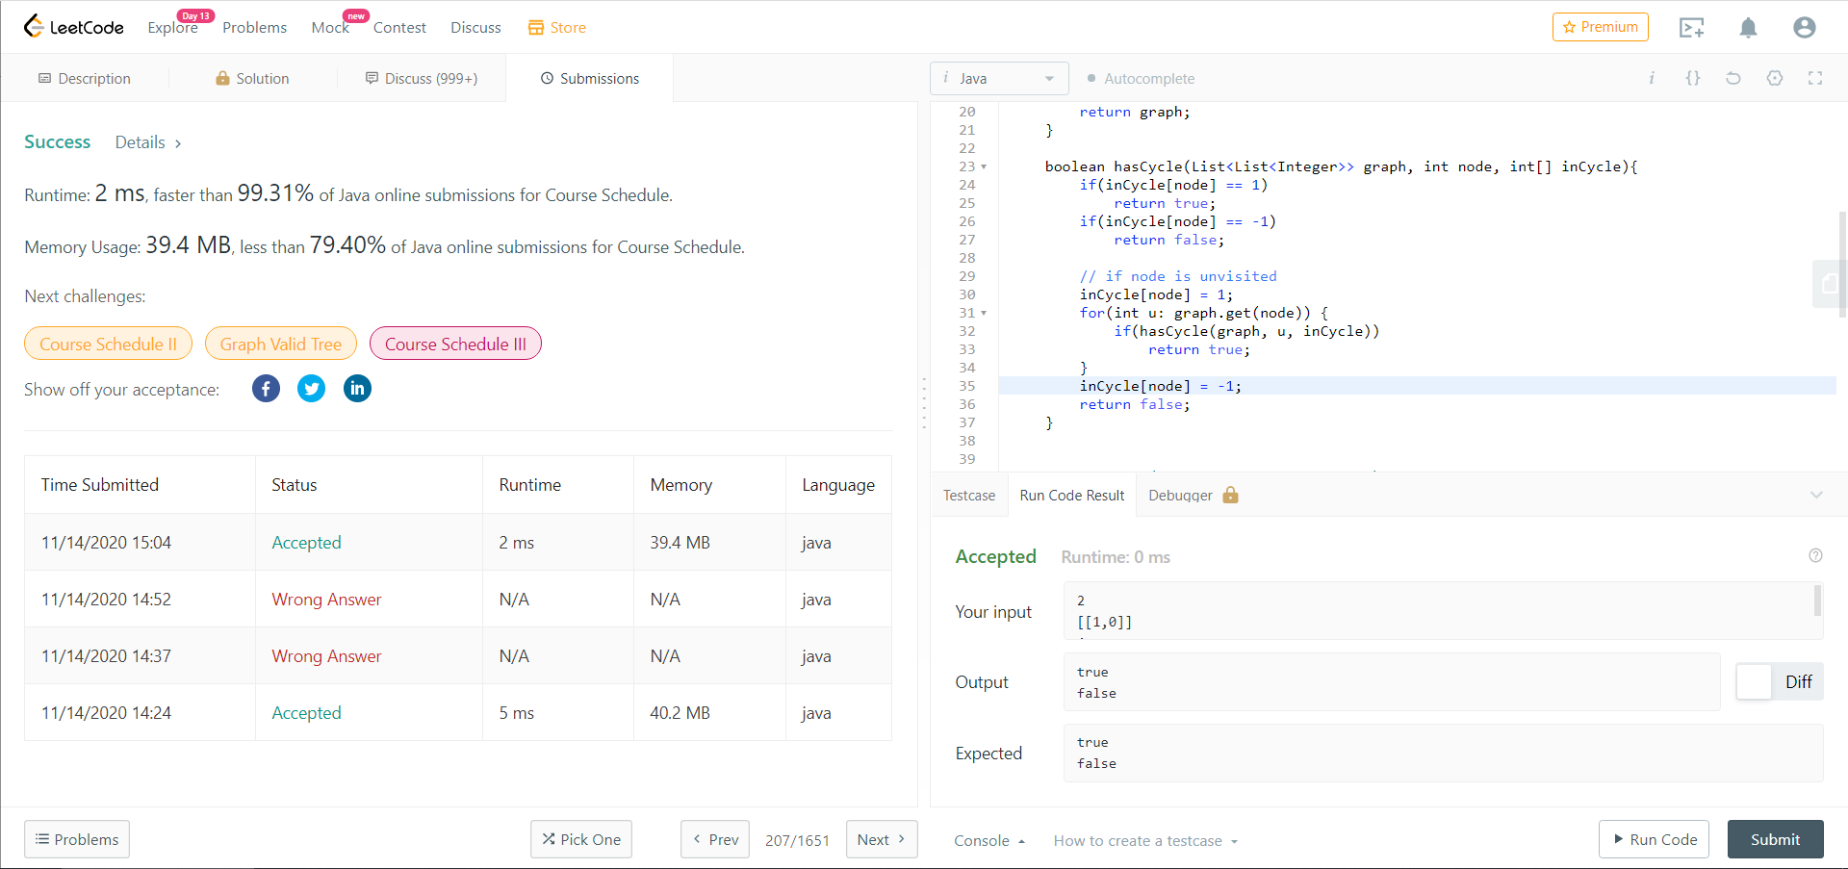// detecting cycles with dfs