Leetcode 17. Letter Combinations of a Phone Number

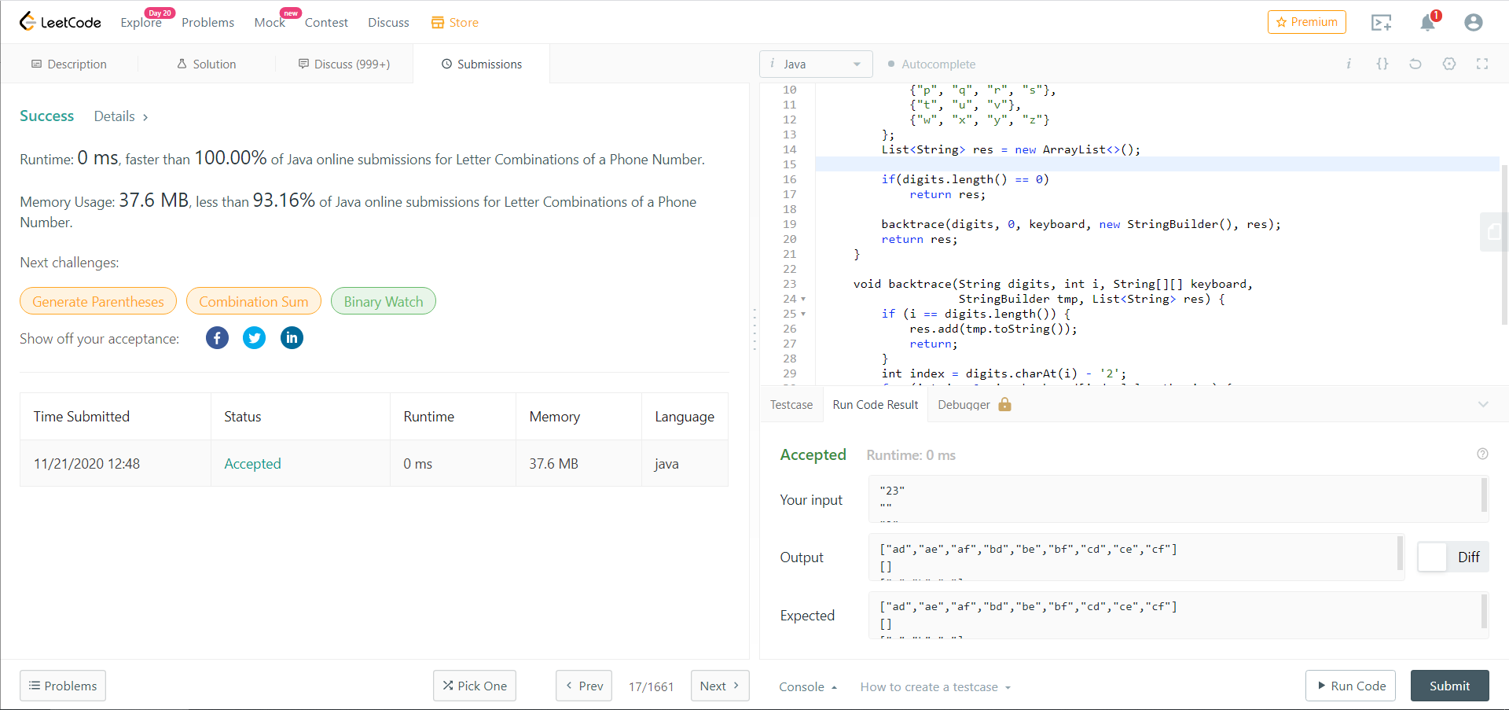

Main algorithm: backTrace

T(n) = O(kn), k is the max number of letters per button, n is the size of input string

Space complexity: O(1) + O(n) + O(kn) = O(kn)

O(1): pre-defined digit-letter mapping

O(n): temporary result during backTrace

O(kn): final result