Leetcode 1049. Last Stone Weight II

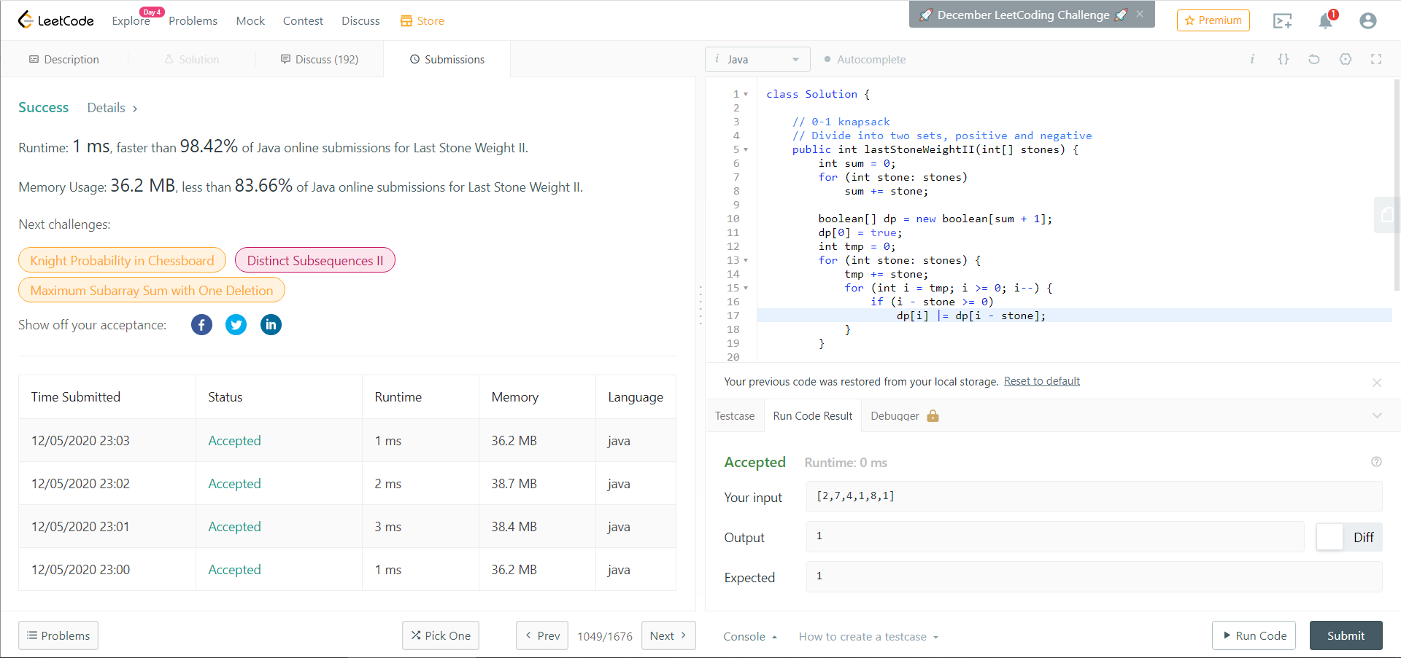

DP, 0-1 knapsack problem

Divide the numbers into two groups, positive and negative (multiple -1), and the find the **smallest possible** result of Sum(positive) + Sum(negative), call this result S.

We have:

S = Sum(positive) + Sum(negative)

Sum(num) = Sum(positive) - Sum(negative)

Then S = 2 * Sum(positive) – Sum(num)

Let dp[0…Sum(num)], dp[i] denotes whether i can be calculated

dp[i] = dp[i] || dp[i - stone] for all stones

Finally, we only need to find the largest possible i (i <= sum/2)and return sum - i * 2.