EXP 9: CREATE A VIRTUAL HARD DISK AND ALLOCATE THE STORAGEUSING VM WARE WORKSTATION.

Name:Mohammed Shuraim.M
Reg.No:192211316

AIM:

To create a virtual hard disk and allocate the storage using vm ware workstation

PROCEDURE:

STEP 1:GOTO VM WARE WORKSTATION.

STEP2: RIGHT CLICK THE VM AND GOTO THE SETTINGS.

STEP 3: ADD HARDWARE WIZARD AND SELECT SCSI AND CLICK NEXT.

STEP 4: CREATE NEW VIRTUAL DISK.

STEP 5: SELCT THE DISK SIZE AS 2.0. AND SELCT SPLIT VIRTUAL DISK INTOMULTIFILES.

STEP 6: GIVE NAME AND CLICK THE FINISH.

IMPLEMENTATION:

STEP 1:GOTO VM WARE WORKSTATION
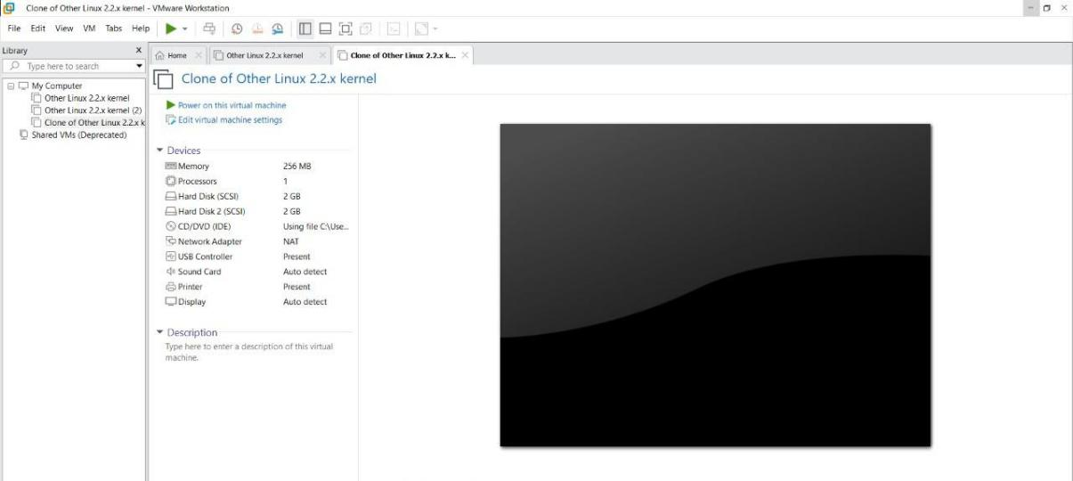
STEP2: RIGHT CLICK THE VM AND GOTO THE SETTINGS
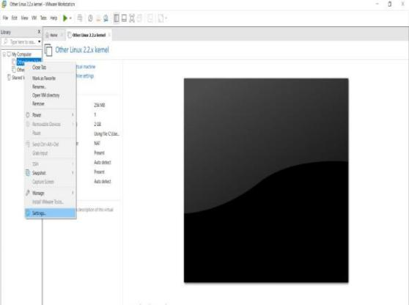

STEP 3: ADD HARDWARE WIZARD AND SELECT SCSI AND CLICK NEXT
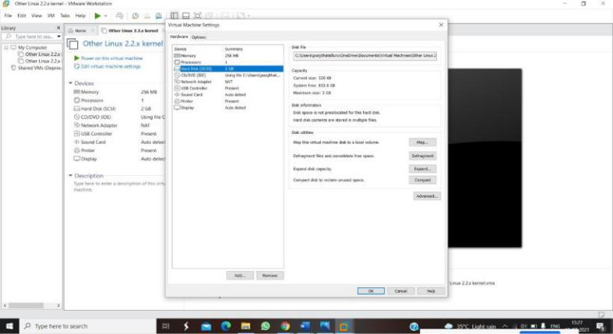

STEP 4: CREATE NEW VIRTUAL DISK
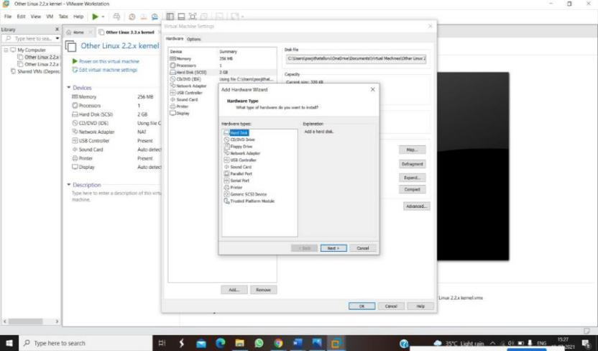


STEP 5: SELCT THE DISK SIZE AS 2.0. AND SELCT SPLIT VIRTUAL DISK INTOMULTIFILES.
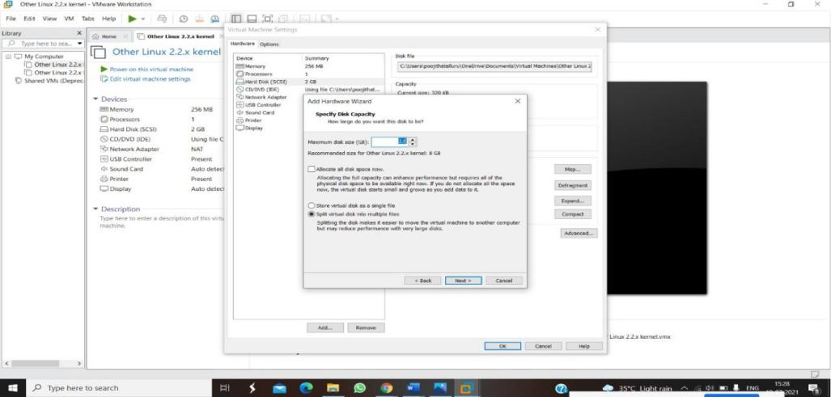

STEP 6: GIVE NAME AND CLICK THE FINISH
