EXPNO 10: CREATE A SNAPSHOT OF A VM AND TEST IT BY LOADING THE PREVIOUS VERSION/CLONED VM

Name:Mohammed Shuraim.M
Reg.No:192211316

AIM:

To create a snapshot of a vm and test it by loading the previous version/cloned vm

PROCEDURE:

STEP 1: GOTO VMWARE WORKSTATION.

STEP 2: CREATE FILES ON DESKTOP.

STEP 3: CLICK ON VM AND SELECTS SNAPSHOT-> TAKE SNAPSHOT.

STEP 4: SNAPSHOT IS BEING DONE

IMPLEMENTATION:

STEP 1: GOTO VMWARE WORKSTATION
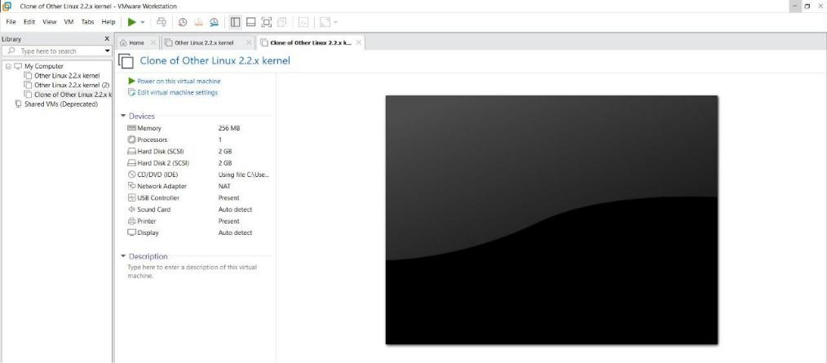

STEP 2: CREATE FILES ON DESKTOP
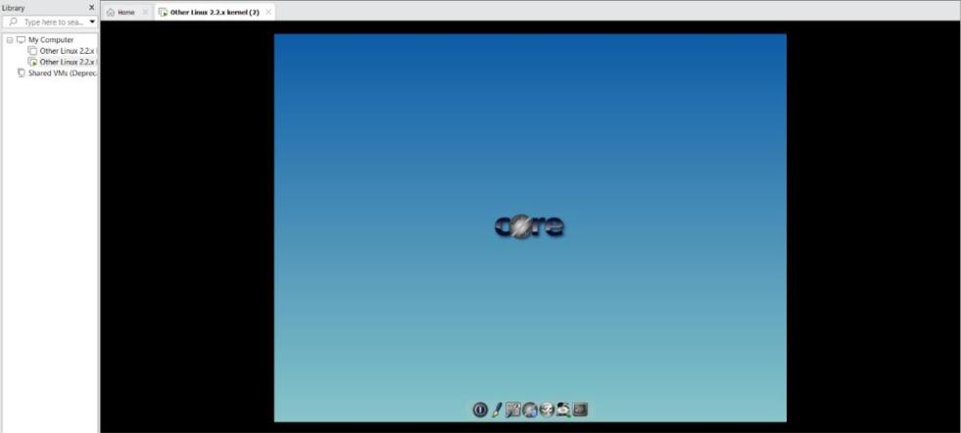
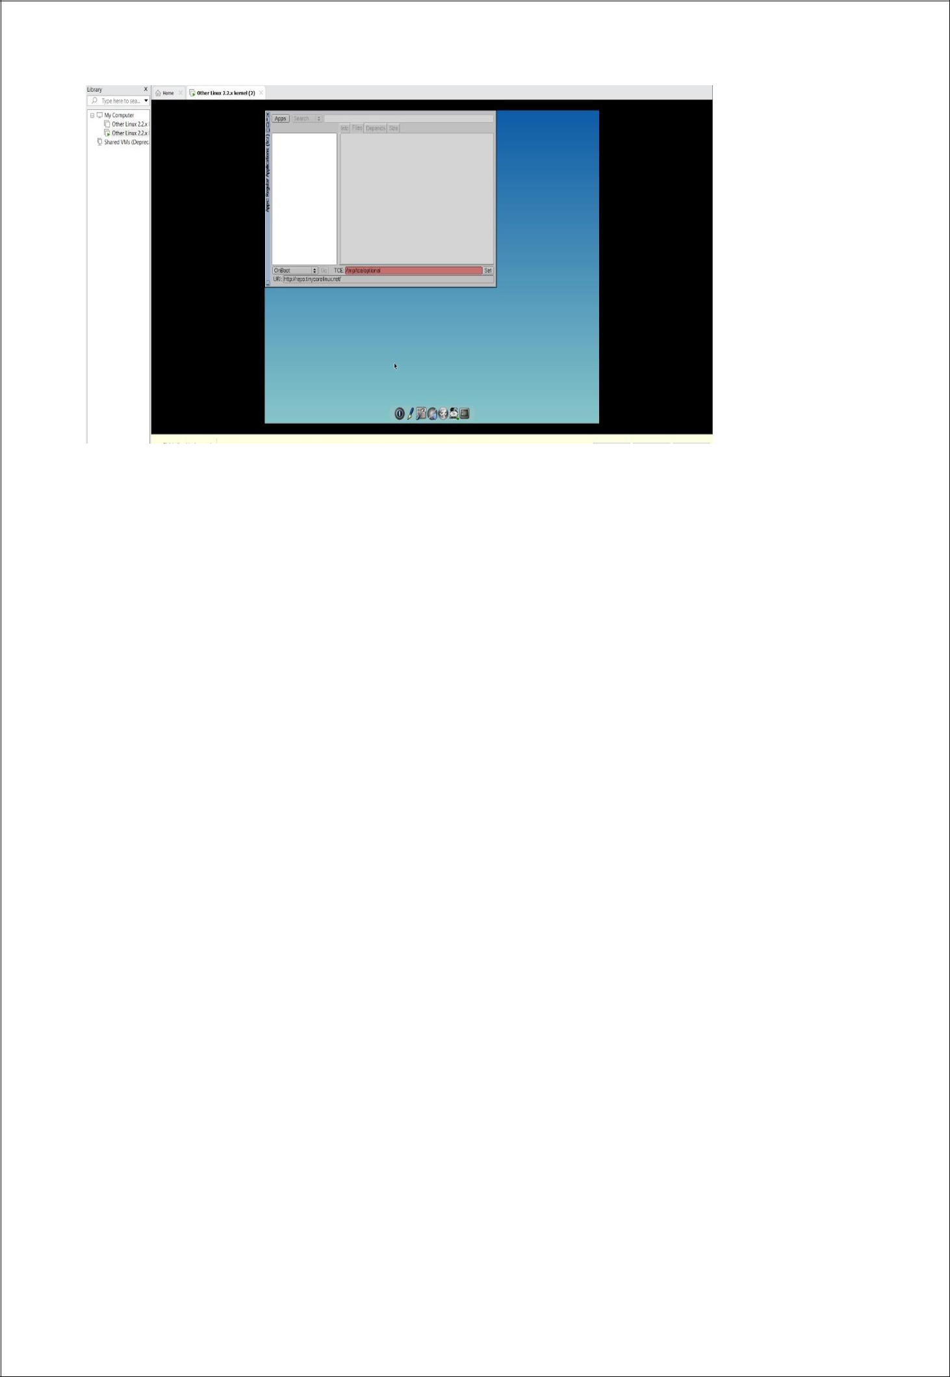

STEP 3: CLICK ON VM AND SELECTS SNAPSHOT-> TAKE SNAPSHOT.
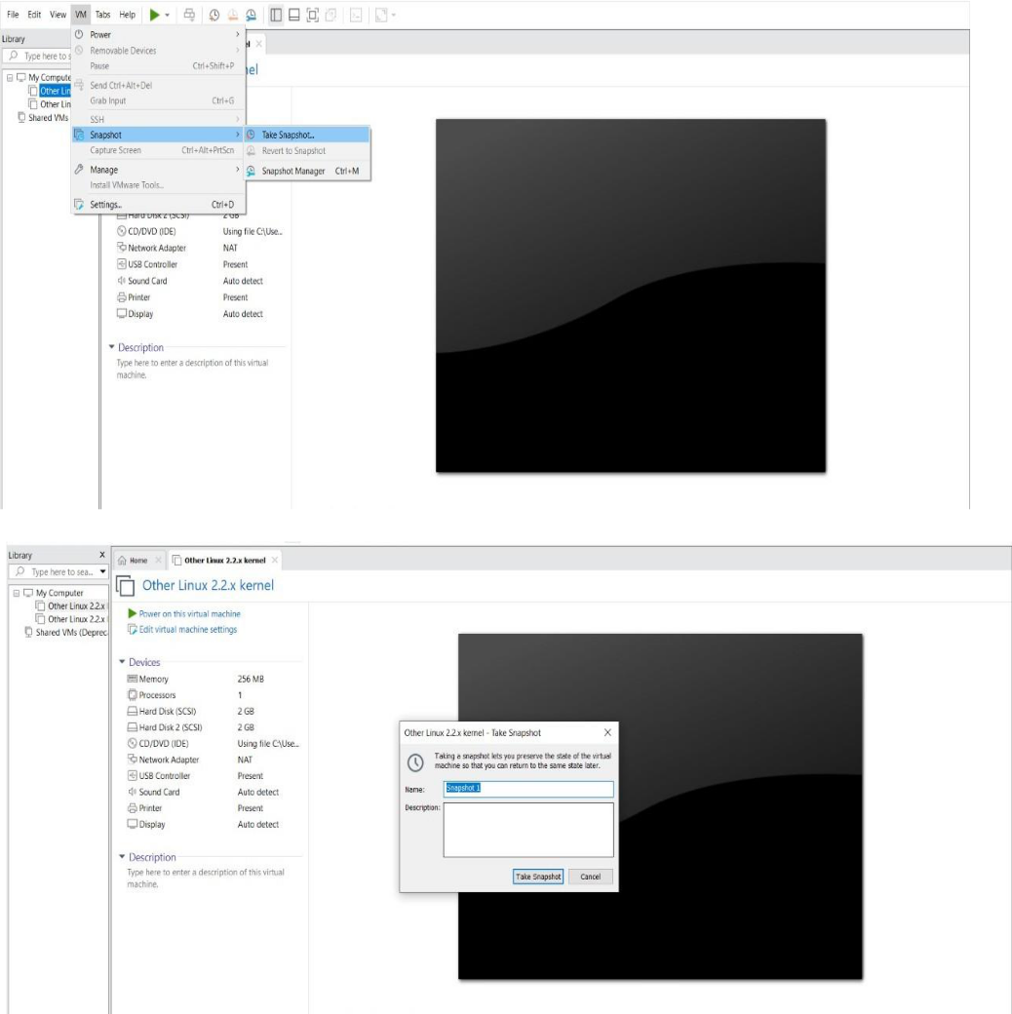

STEP 4: SNAPSHOT IS BEING DONE
