EXP. 24: LAUNCH THE HADOOP 2.X AND PERFORM MAPREDUCE PROGRAMFOR A WORD COUNT PROBLEM

Name:Mohammed Shuraim.M
Reg.No:192211316

AIM: LAUNCH THE HADOOP 2.X AND PERFORM MAPREDUCE PROGRAMFOR A WORD COUNT PROBLEM

PROCEDURE:

Step 1 - Open Terminal

$ su

hduser

Password:

Step 2 - Start dfs and mapreduce services

$ cd /usr/local/hadoop/hadoop-2.7.2/sbin

$ start-dfs.sh

$ start-yarn.sh

$ jps

Step 3 - Check Hadoop through web UI

- Go to browser type http://localhost:8088 – All Applications Hadoop Cluster

- Go to browser type http://localhost:50070 – Hadoop Namenode

Step 4 – Open New Terminal

$ cd Desktop/

$ mkdir inputdata

$ cd inputdata/

$ echo “Hai, Hello, How are you? How is your health?” >> hello.txt $ cat >> hello.txt

Step 5 – Go back to old Terminal

$ hadoop fs –copyFromLocal /home/hduser/Desktop/inputdata/hello.txt /folder/hduser // Check in hello.txt in Namenode using Web UI

Step 6 – Download and open eclipse by creating workspace

Create a new java project.

Step 7 – Add jar to the project

You need to remove dependencies by adding jar files in the hadoop source folder. Now Clickon Project tab and go to Properties.Under Libraries tab, click Add External JARs and select all thejars in the folder (click on 1st jar, and Press Shift and Click on last jat to select all jars in between and click ok)

/usr/local/hadoop/hadoop-2.7.2/share/hadoop/commonand

/usr/local/hadoop/hadoop-2.7.2/share/hadoop/mapreduce folders.

Step -8 – WordCount

Create 3 java files named

- WordCount.java

- WordCountMapper.java

- WordCountReducer.java

WordCount.java

import org.apache.hadoop.conf.Configured;

import org.apache.hadoop.fs.Path;

import org.apache.hadoop.io.IntWritable;

import org.apache.hadoop.mapred.FileInputFormat;

import

org.apache.hadoop.mapred.FileOutputFormat;import

org.apache.hadoop.mapred.JobClient;

import org.apache.hadoop.mapred.JobConf;

import org.apache.hadoop.util.Tool;

import org.apache.hadoop.util.ToolRunner;

import org.apache.hadoop.io.Text;

public class WordCount extends Configured implements Tool {@Override

public int run(String[] arg0) throws Exception {

- TODO Auto-generated method stubif(arg0.length<2)

{

System.out.println("check the command line arguments");

}

JobConf conf=new JobConf(WordCount.class); FileInputFormat.setInputPaths(conf, new Path(arg0[0]));

FileOutputFormat.setOutputPath(conf, new Path(arg0[1])); conf.setMapperClass(WordMapper.class); conf.setReducerClass(WordReducer.class); conf.setOutputKeyClass(Text.class); conf.setOutputValueClass(IntWritable.class); conf.setOutputKeyClass(Text.class);

}

}

WordCountMapper.java

import java.io.IOException;

import org.apache.hadoop.io.IntWritable;

import org.apache.hadoop.io.LongWritable;

import

org.apache.hadoop.mapred.MapReduceBase;

import

org.apache.hadoop.mapred.OutputCollector;

import org.apache.hadoop.mapred.Reporter;

import org.apache.hadoop.io.Text;

import org.apache.hadoop.mapred.Mapper;

public class WordCountMapper extends MapReduceBase implements Mapper<LongWritable,Text,Text,IntWritable>

{

@Override

public void map(LongWritable arg0, Text arg1, OutputCollector<Text, IntWritable> arg2, Reporter arg3)

WordCountReducer.java

import java.io.IOException;import

java.util.Iterator;

import org.apache.hadoop.io.IntWritable;

import org.apache.hadoop.mapred.JobConf;

import org.apache.hadoop.mapred.OutputCollector; import org.apache.hadoop.mapred.Reducer;

import org.apache.hadoop.mapred.Reporter;

import org.apache.hadoop.io.Text;

public class WordCountReducer implements Reducer<Text,IntWritable,Text,IntWritable> { @Override

public void configure(JobConf arg0) {

}

@Override

public void reduce(Text arg0, Iterator<IntWritable> arg1, OutputCollector<Text, IntWritable> arg2, Reporter arg3)

throws IOException {

- TODO Auto-generated method stubint count=0;

while(arg1.hasNext())

{

IntWritable i=arg1.next();

count+=i.get();

Step 9 - Creatr JAR file

Now Click on the Run tab and click Run-Configurations. Click on New Configuration button on the left-top side and Apply after filling the following properties.

Step 10 - Export JAR file

Now click on File tab and select Export. under Java, select Runnable Jar.

In Launch Config – select the config fie you created in Step 9 (WordCountConfig).

Select an export destination (lets say desktop.)

Under Library handling, select Extract Required Libraries into generated JAR and click Finish.

Right-Click the jar file, go to Properties and under Permissionstab, Check Allow executingfile as a program. and give Read and Write access to all the users

Step 11 – Go back to old Terminal for Execution of WordCount Program

$hadoop jar wordcount.jar/usr/local/hadoop/input/usr/local/hadoop/output

Step 12 – To view results in old Terminal

$hdfs dfs -cat /usr/local/hadoop/output/part-r-00000
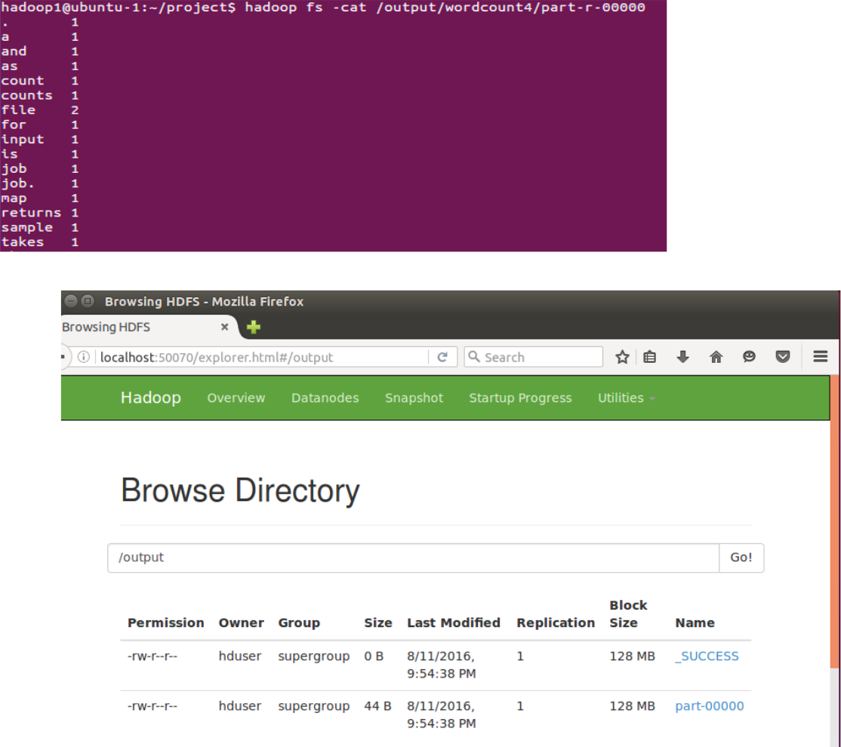

Step 13 - To Remove folders created using hdfs

$ hdfs dfs -rm -R /usr/local/hadoop/output

