EXP NO 3: CREATE A SIMPLE CLOUD SOFTWARE APPLICATION FOR PROPERTY BUYING & RENTAL PROCESS (IN CHENNAI CITY) USING ANY CLOUD SERVICE PROVIDER TO DEMONSTRATE SAAS.

Name:Mohammed Shuraim.M
Reg.No:192211316

AIM:

To Create a simple cloud software application for Property Buying & Rental process (In Chennai city) using any Cloud Service Provider to demonstrate SaaS.

PROCEDURE:

step1: Go to zoho.com.

step 2: Log into the zoho.com.

step 3: Select one application step.

step4: Enter application name as property buying & rental.

step 5: Created new application as property buying & rental.

step 6: Select one form

step 7: The software has been created.

IMPLEMENTATION:

STEP1: GOTO ZOHO.COM
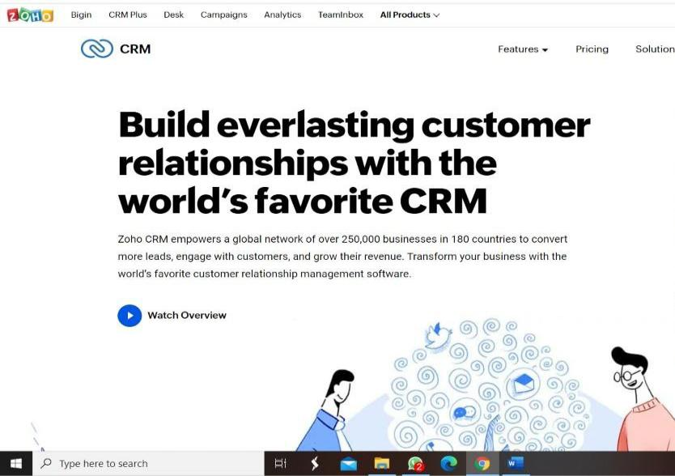
STEP 2: LOGINTOTHE ZOHO.COM
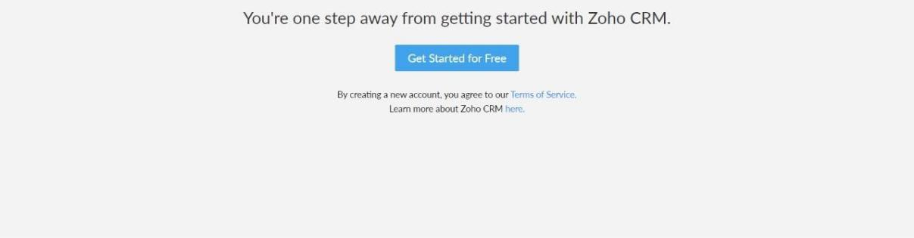

STEP 3: SELECT ONE APPLICATION
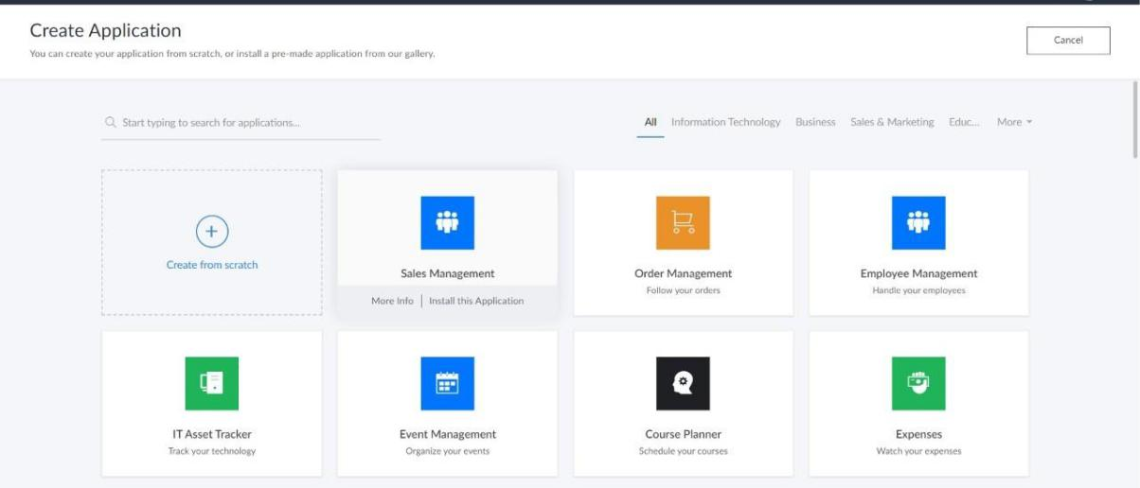

STEP 4: ENTER APPLICATION NAME
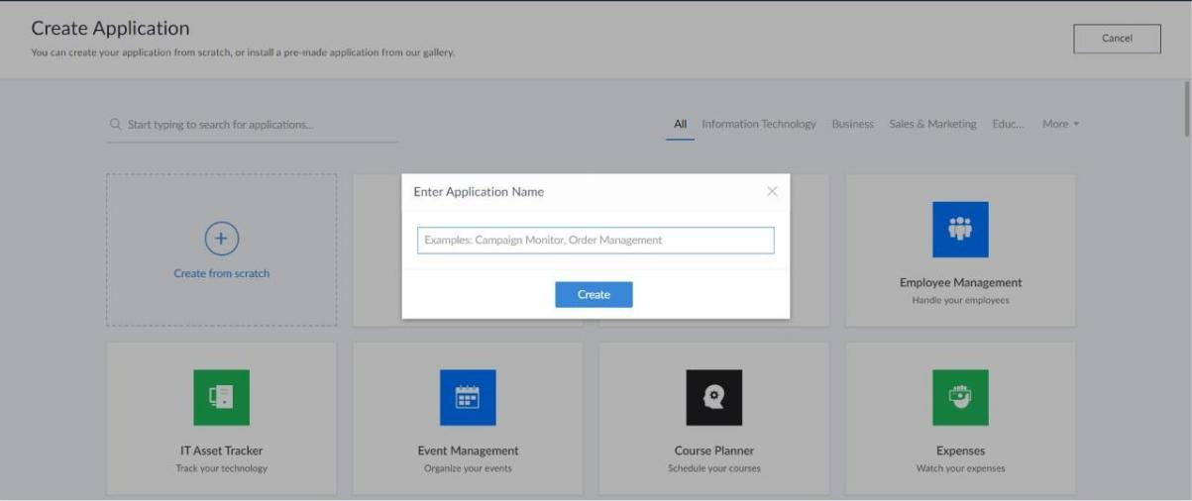
STEP 5: CREATED NEW APPLICATION
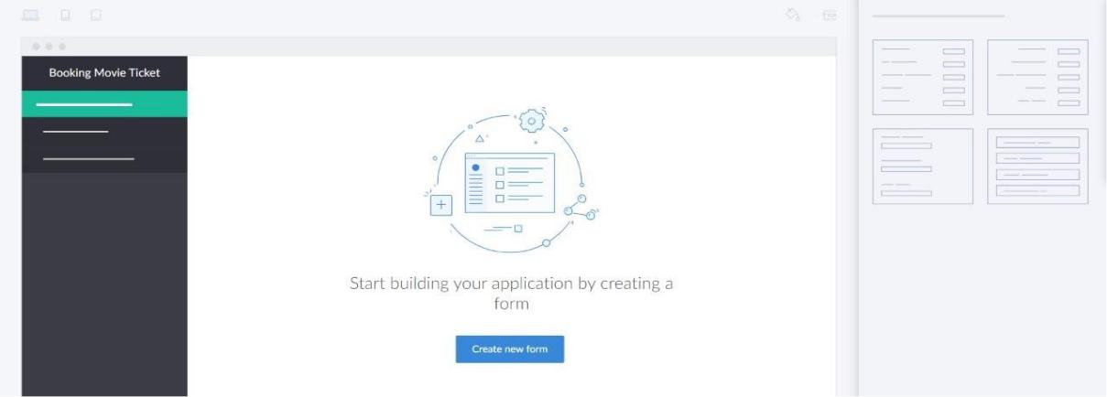

STEP 6: SELECT ONE FORM

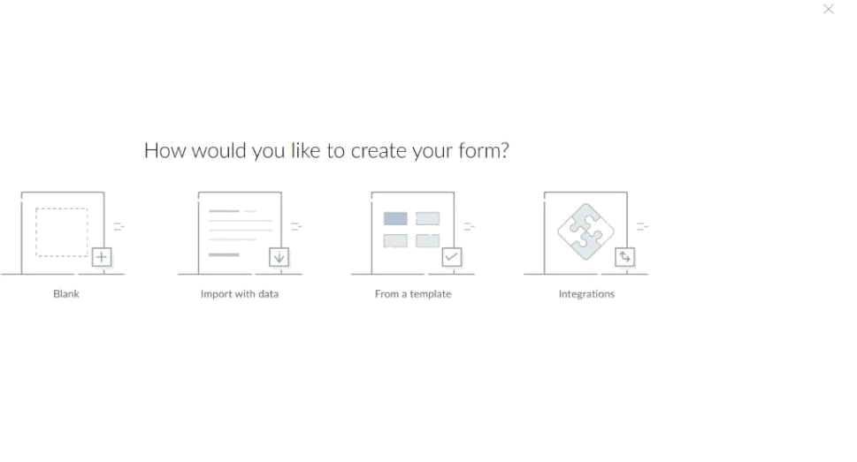

STEP 7: THE SOFTWARE HASE BEEN CREATED.
