View
ViewModel
Model

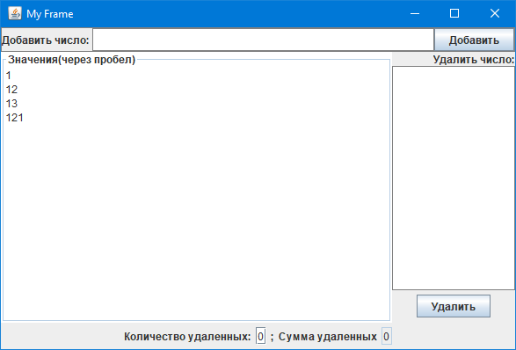
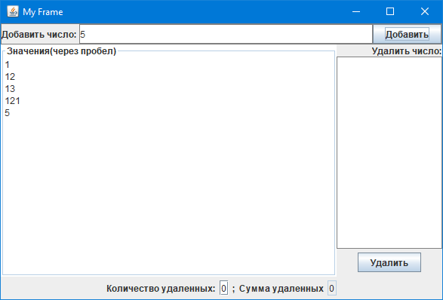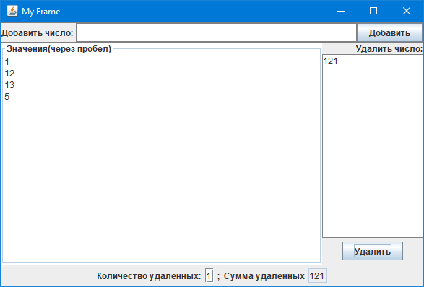
Model
public class Model {
private List<Integer> values = new ArrayList<>();
public int sum = 0;
public int count = 0;
public Model() {
this.values.add(1);
this.values.add(12);
this.values.add(13);
this.values.add(121);
}
public void addValue(int value) {
if(!values.contains(value)){
values.add(value);
}
}
public List<Integer> getValues() {
return values;
}
public void removeValue(int value){
if(values.contains(value)){
values.remove(values.indexOf(value));
}
sum+=value;
count++;
}
}
ViewModel
public class ViewModel {
private Model model = new Model();
private List<Integer> getList(){
return model.getValues();
}
public String createStringWithValues(){
List<Integer> list = model.getValues();
String str = "";
for(Integer val : list){
str+=val+"\n";
}
return str;
}
public void removeValue(String str){
model.removeValue(Integer.parseInt(str));
}
public void addValue(String str){
model.addValue(Integer.parseInt(str));
}
public String getCount(){
return String.valueOf(model.count);
}
public String getSum(){
return String.valueOf(model.sum);
}
}

View
public class View {
static ViewModel viewModel = new ViewModel();
public static void main(String[] args) {
JFrame frame = getFrame();
JPanel framePanel = getFramePanel();
frame.add(framePanel);
}
static JFrame getFrame(){
JFrame frame = new JFrame();
frame.setVisible(true);
frame.setDefaultCloseOperation(JFrame.EXIT_ON_CLOSE);
Toolkit toolkit = Toolkit.getDefaultToolkit();
Dimension dimension = toolkit.getScreenSize();
frame.setBounds(dimension.width/2-250, dimension.height/2-150, 600,400);
frame.setTitle("My Frame");
return frame;
}
static JPanel getFramePanel(){
JPanel framePanel = new JPanel();
framePanel.setLayout(new BorderLayout());
JTextArea list = new JTextArea();
list.setText(viewModel.createStringWithValues());
list.setBorder(BorderFactory.createTitledBorder("Значения(через пробел)"));
list.setEditable(false);
framePanel.add(list, BorderLayout.CENTER);
JTextField sumField = new JTextField("150");
sumField.setEditable(false);
JPanel sumLabelPanel = new JPanel();
sumLabelPanel.add(new JLabel("Количество удаленных:"));
JTextField countField = new JTextField("150");
sumField.setEditable(false);
sumLabelPanel.add(countField);
sumLabelPanel.add(new JLabel(";"));
sumLabelPanel.add(new JLabel("Сумма удаленных"));
sumLabelPanel.add(sumField);
countField.setText(viewModel.getCount());
sumField.setText(viewModel.getSum());
framePanel.add(sumLabelPanel, BorderLayout.SOUTH);
JPanel eastPanel = new JPanel();
eastPanel.setLayout(new BoxLayout(eastPanel, BoxLayout.Y_AXIS));
framePanel.add(eastPanel, BorderLayout.EAST);
eastPanel.add(new JLabel("Удалить число:"));
JTextArea toRemove = new JTextArea();
toRemove.setBorder(BorderFactory.createLineBorder(Color.gray));
eastPanel.add(toRemove);
JButton removeButton = new JButton("Удалить");
removeButton.addActionListener(new ActionListener() {
@Override
public void actionPerformed(ActionEvent e) {
viewModel.removeValue(toRemove.getText());
list.setText(viewModel.createStringWithValues());
countField.setText(viewModel.getCount());
sumField.setText(viewModel.getSum());
}
});
JPanel removeButtonPanel = new JPanel();
removeButtonPanel.add(removeButton);
eastPanel.add(removeButtonPanel);
JPanel northPanel = new JPanel();
framePanel.add(northPanel, BorderLayout.NORTH);
northPanel.setLayout(new BoxLayout(northPanel, BoxLayout.X_AXIS));
northPanel.setBorder(BorderFactory.createLineBorder(Color.gray));
northPanel.add(new JLabel("Добавить число: "));
JTextField toInsert = new JTextField();
toInsert.setBorder(BorderFactory.createLineBorder(Color.gray));
northPanel.add(toInsert);
JButton insertButton = new JButton("Добавить");
insertButton.addActionListener(new ActionListener() {
@Override
public void actionPerformed(ActionEvent e) {
viewModel.addValue(toInsert.getText());
list.setText(viewModel.createStringWithValues());
}
});
northPanel.add(insertButton);
return framePanel;
}
}

