- Code
Please refer to the GitHub repository:
- How the code works
In a leader–follower system, N is the total number of nodes, W is the number of acknowledgments required for a write, and R is the number of nodes consulted on a read. All writes go through the leader, which writes locally and waits until W nodes acknowledge before responding, with any remaining replication happening asynchronously. Reads can either return the leader’s local value (R=1) or query multiple nodes (R>1) and return the value with the highest version. Increasing W improves durability but increases write latency, while increasing R improves freshness but increases read latency; importantly, when W + R > N, the system guarantees strong consistency, otherwise stale reads are possible.

- Graphs
  - For W1R5:
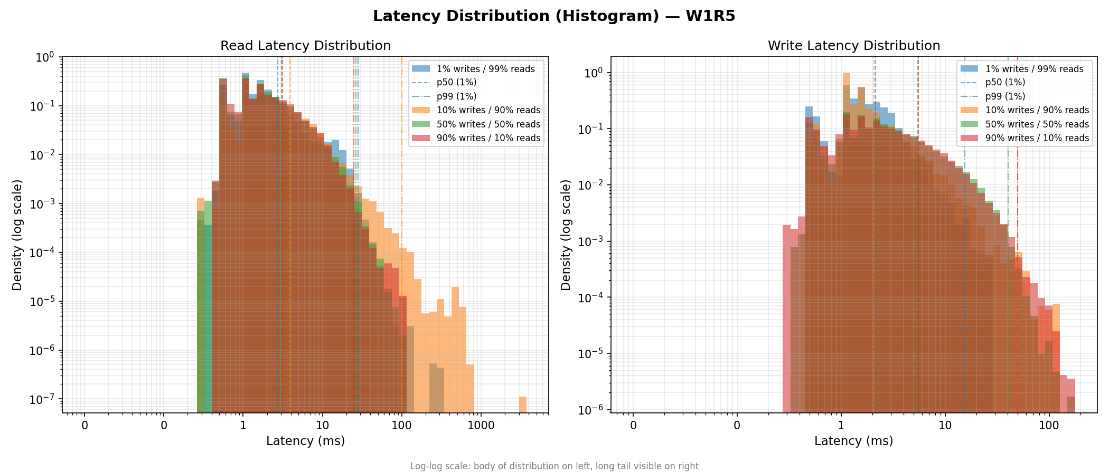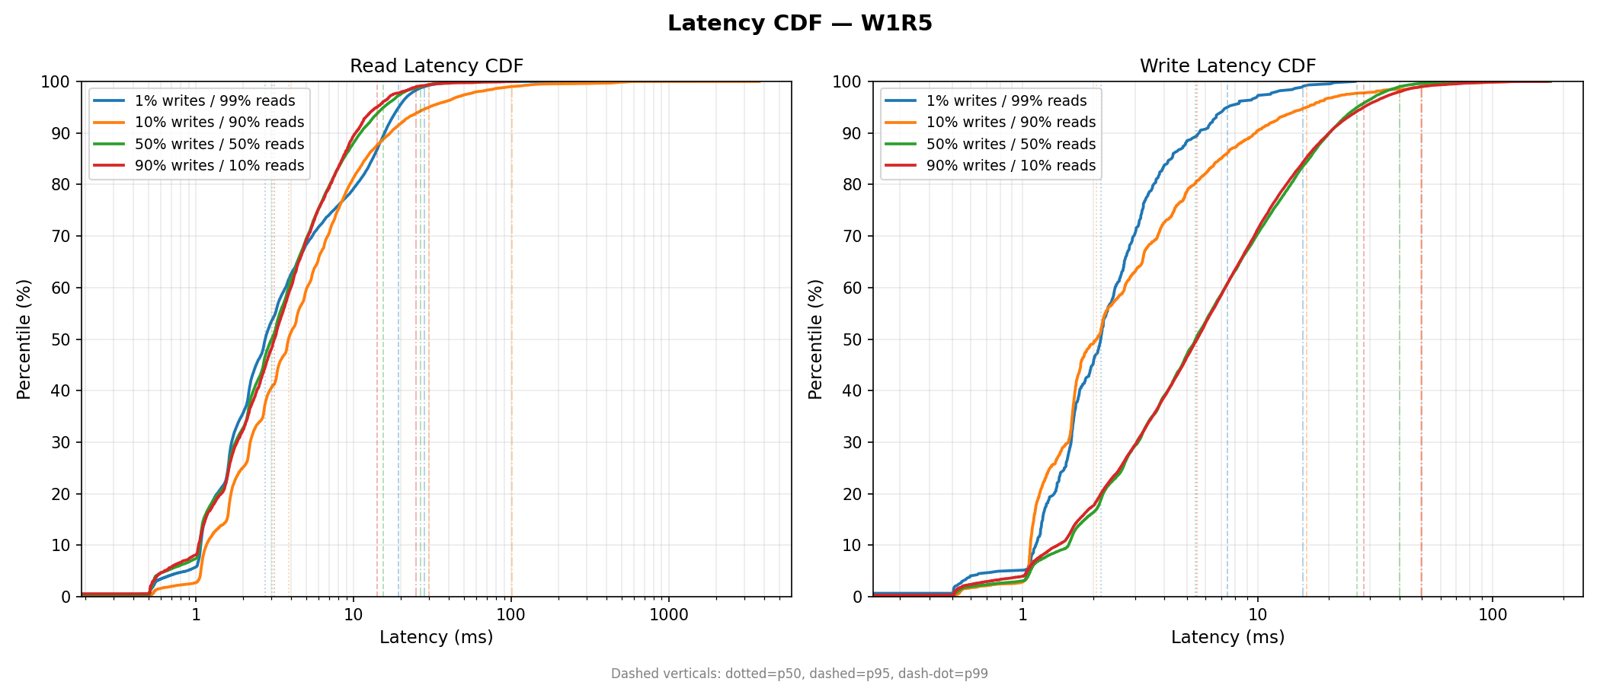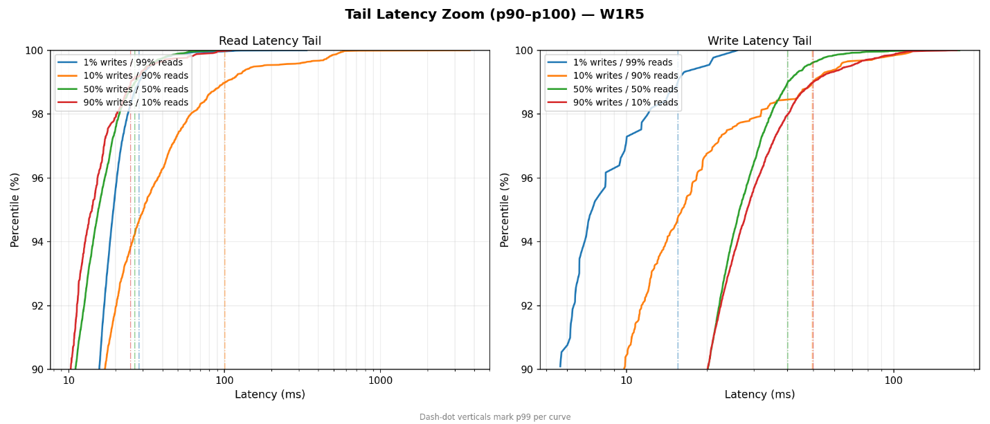
  - W3R3
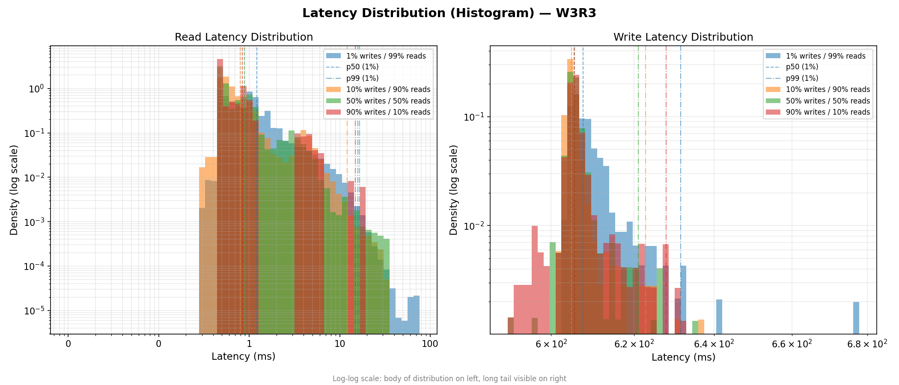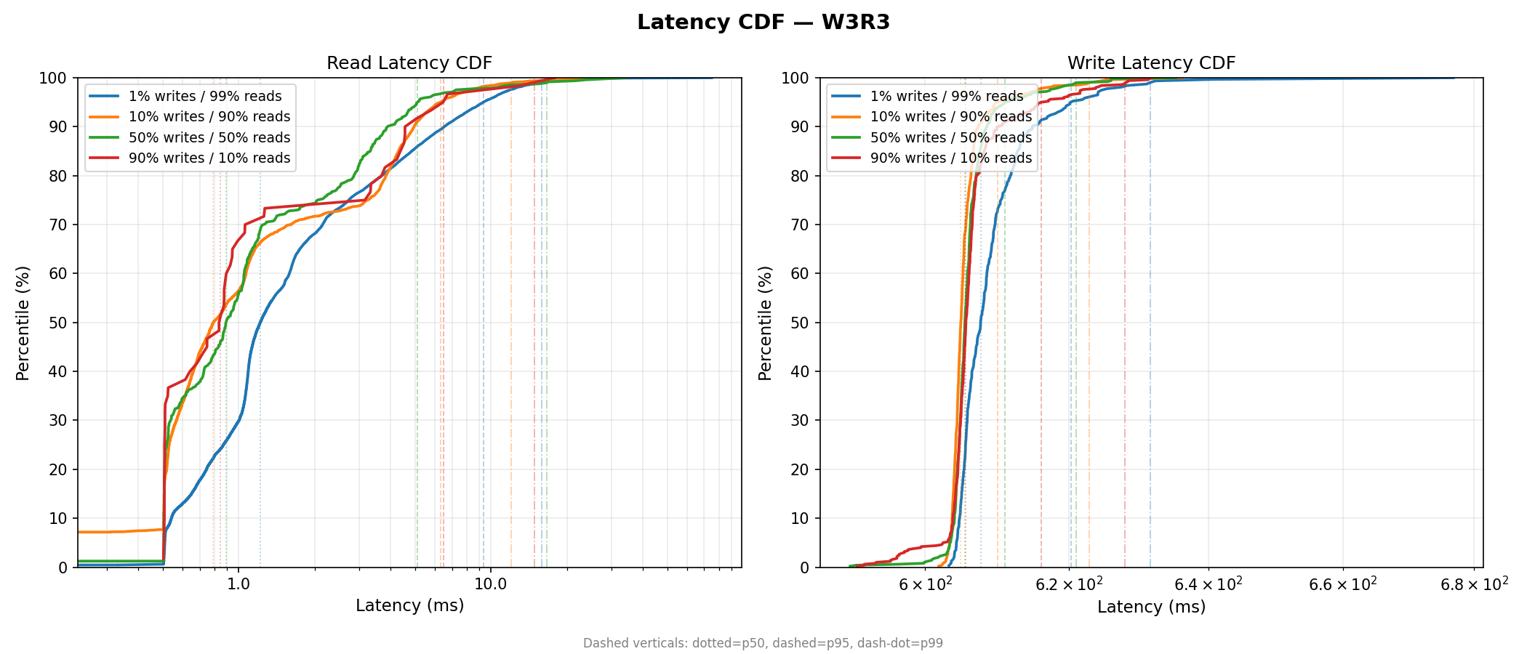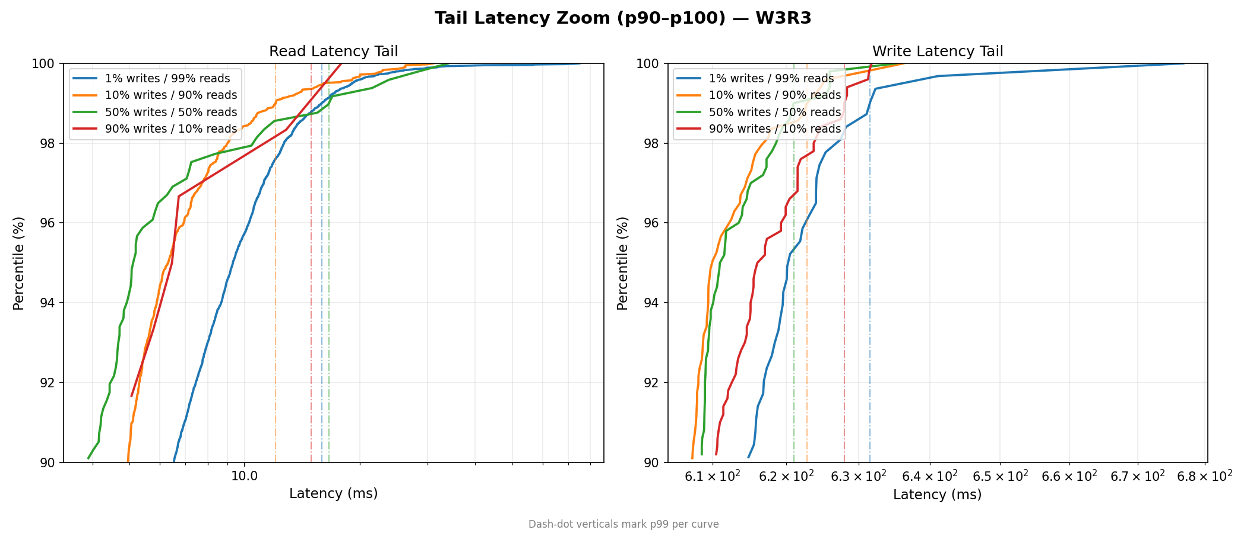
  - W5R1:
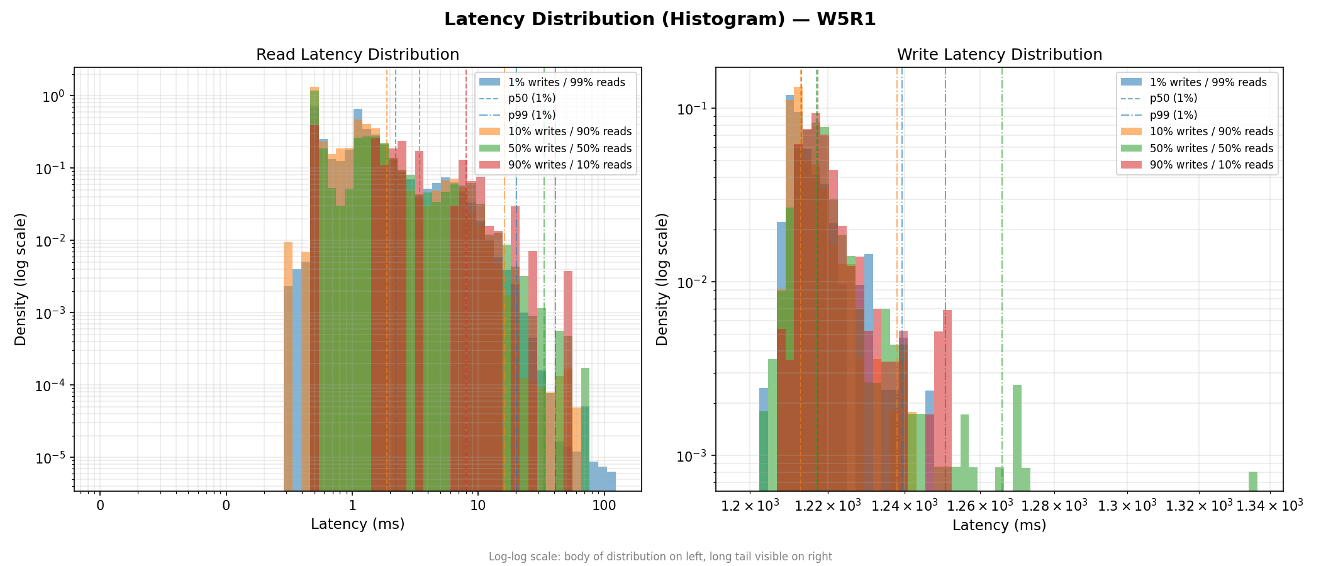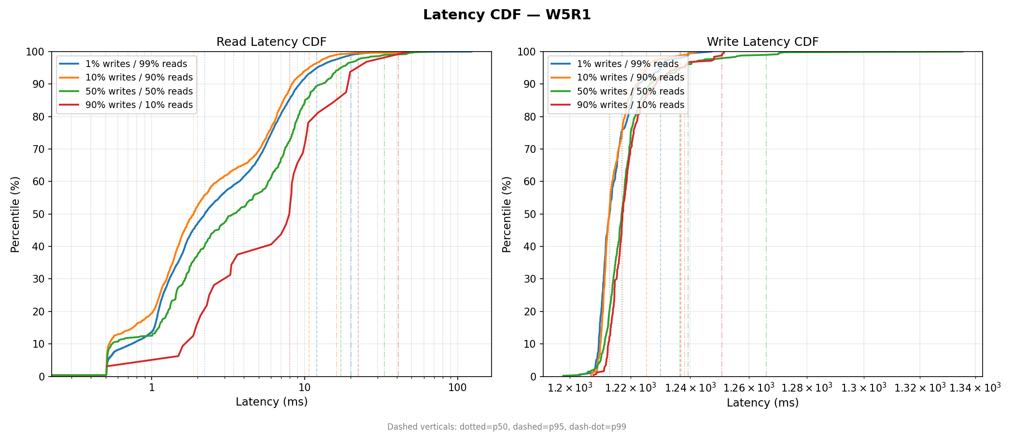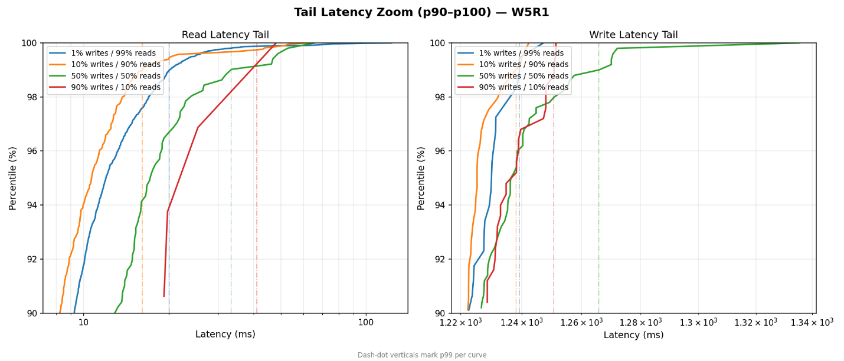
  - R-W Gap

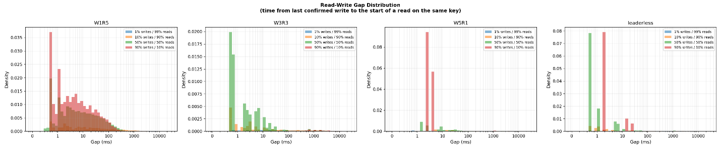

For 1% writes, W1R5 is best because the reads are the fastest and staleness is not a major issue as writes are small amount.
For 10% writes, W3R3 is best because W3R3 balances consistency and throughput.
For 50% writes W3R3 is better because it reduces the high staleness of W1R5 but also have a desirable throughput.
For 90% writes, W3R3 is still better because it ensures throughput while limiting staleness.

Database Types Choices
W1R5 — Fast writes, quorum reads
Use for: write-heavy, read-rare systems, like Logs, telemetry, IoT, metrics
- Very fast writes, but reads may be stale unless querying many nodes
Avoid: frequent read-after-write (high staleness)
W3R3 — Balanced quorum
Use for: general-purpose, consistent apps
- E-commerce, user data, inventory
- Strong consistency (W+R > N), balanced latency
Avoid: extremely write-heavy workloads (writes are slower)
W5R1 — Slow writes, fast reads
Use for: read-heavy, rarely changing data
- Config, feature flags, DNS, catalogs
- Reads are instant and always consistent
Avoid: frequent writes (very expensive)
Leaderless (Dynamo-style)
Use for: high availability, global systems
- Social feeds, carts, distributed apps
- No single point of failure, survives outages
Trade-off: eventual consistency + conflict resolution needed
Avoid: strict consistency without merge logic

