Sepehr Atyabi C3571782

A Smart property

management system to simulate the automation of estate agent property management.

**Abstract**

A smart Property management system is a form of ‘estate agency automation’ which involves a variety of information that are linked together to automate functions within an estate agent.

The system will calculate important figures and information for the landlord to assess the property in question, which can help assess rent prices, mortgage agreements, and other important figures.

As the demand for rental properties has increase 20% higher than the previous year in the UK, there is an inevitable increase in the demand for estate agents to manage those properties for the landlord.

This report will cover the conceptual design of a smart property management system that can be used in the day-to-day operation of a rental property. The concept will be supported by a logic programming-based application SWI-Prolog which will simulate the proposed concept.

Table of contents

Section 1: Introduction – **Page 3 - 4**

* 1a: Background of the system
* 1b: Aims and Objectives the system should achieve.
* 1c: Rationale
* 1d: Contribution
* 1e: Outline of the report

Section 2: Literature review of similar systems – **Page 4 - 5**

* Overview of literature
* Reviews of related products

Section 3: Methodology – **Page 5 - 12**

* 3a: Domain Analysis **(Page 5)**
* 3b: Design **(Page 6 – 7)**
* 3c: Implementation of the application **(Page 7 – 12)**

Section 4: Summary, evaluation and conclusion **(Page 12 - 13)**

Bibliography – **Page 14 - 15**

**Section 1 – introduction**

**1a. Background of the system**

The idea of “property management automation” covers a variety of areas. From creating tenancy agreements via details from tenant, landlord, property, and agreement details, or calculating the total payable VAT from a commercial property; property management automation is a powerful tool that can make a landlords or agencies life easier by automating their responsibilities such as assessing whether a tenant has paid the full amount of the agreement.

The intent of this research is to produce a system that can take on some of the responsibilities of an agency or independent landlord, to make the day to day running of a rental property automated.

**1b. Aims and Objectives the system should achieve.**

The research and development of the system has 5 goals:

1. To learn the responsibilities and requirements for a landlord to rent or lease a property.
2. To store details of a lease or tenancy agreement within the system for the user query when needed (for example deposit protection schemes ).
3. To store details of a loan and calculate the monthly and yearly payments for the loan.
4. To store details of repairs conducted on a property and calculate the total repair costs of the property in question.
5. Calculate the total profit of a property after deducting costs such as loan payments, repair costs, and VAT charges.

**1c. Rationale**

With the increase in demand for buy to let properties from landlords and demand for rental properties from tenants, various challenges come to light during the development process of the system.

As there is an increase in landlords and rental properties, for landlord with over 10 properties can find it difficult to keep track of various aspects of each property, such as rent payments, repair requests, property assessments, etc.

This would lead to a private landlord looking for an agency to manage their properties, however agencies can be expensive. Which leads to private landlords looking for alternatives, which is where a smart property management system comes to play.

As the private landlord can carry on with their day-to-day activities knowing their properties are being monitored and managed efficiently, through a smart system where the tenant can make rent payments, and repair requests; then notifying the landlord of any late payments or repairs that need to be arranged.

**1d. Contribution**

This research should contribute to smart property management by providing future systems with a base model of what property management is and the responsibilities that come with a rental property. Which can be used to produce a smart property management system.

**1e. Outline of the report**

The remainder of the report will explore systems that are like the one in development and will include a literature review of the systems in question providing an overview of the system and analyse the strengths and weaknesses of the system.

Then this report will provide an analysis of how this system has been implemented and outline the conceptual development of the smart property management system and how the systems simulate this concept.

**Section 2: literature review of similar systems**

This literature review will provide an analysis of the framework and systems that are used for property management. The literature reviews similar systems and evaluates the advantages and disadvantages of using the smart system.

**Overview of the literature.**

The literature reviews the framework of smart estate agent systems and gives an example of systems presently on the market today. This report will provide an analysis of advantages and disadvantages of the systems discussed. The systems provide a flexible system that helps manage electronic leases, accounting information regarding the tenant and properties, insightful financial reports which allow management to make the correct decisions regarding a particular property. Also allows scheduled inspections and manages maintenance requests for a particular property, with online rent collections it automatically inputs the information for accounting and allows the landlord to keep track of rent payments more efficiently.

However, a property management systems downsides may come in over complex systems with unnecessary tools which may confuse users and create problems, also maintenance of these types of systems often needs regular updates and maintenance to ensure data is secured and payments are made securely through the system.

But these systems are still a great asset for landlords and estate agents responsible for multiple properties, as these systems can provide an easy and efficient tool to managing properties day to day and keeping track of the financial side of property management.

**Reviews of related product**

The Housters system is a rental property management software, that deals with tenant rent tracking which tracks how much rent should be paid overtime by the tenant, determining the right property management fees which tracks the property management fees and allows the estate agent can assess and track the fees owed by the landlord. Also, the systems coordinate between contractors and landlords/ property managers by creating a schedule, emailing clients with online invoices and online payment system.

**Section 3: Methodology**

The methodology in this report will include the domain analysis, design of the system, and implementation includes how the system will run.

**Domain analysis**

The concept of the smart property management system involves tenants, landlords, property, lease or tenancy agreements and accounting. Ontologies for this smart system hasn’t been developed, however this report provides an ontology of the property smart system.

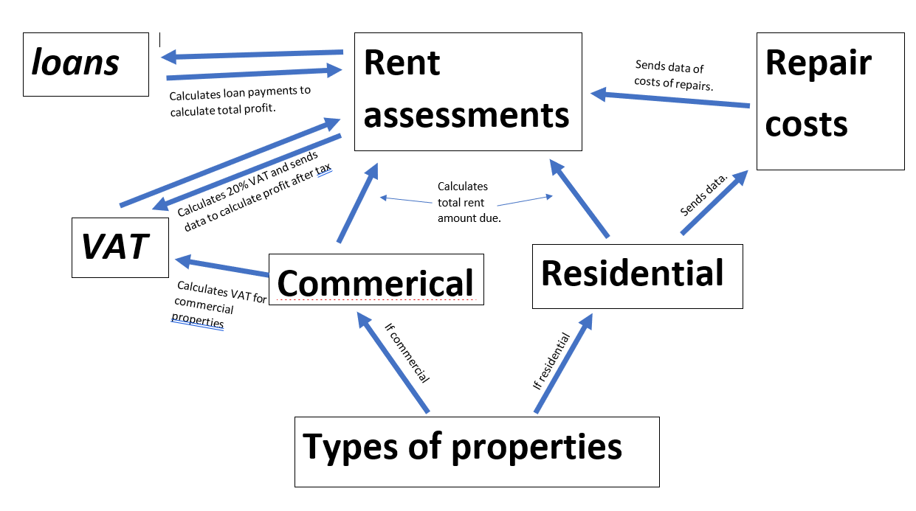The above diagram shows the relationship between rent assessments and types of property are mapped out. The rent assessment is connected via commercial or residential as they have different requirements for the different types of property; for example, commercial properties must pay 20% Vat for profit before tax whereas residential properties don’t have to pay VAT.

As a smart property management system is developed and improved there will be more relationships, such as key holdings to track who has each key in their possessions, multi room lettings where a landlord lets out each room individually from one property such as student properties, tenancy deposit schemes and much more as property management is a very large subject.

**Design**

The system produced in this report should be suitable for basic property management as it records information such as tenant details, property details, agreement details, loan details and using this information, the system can calculate the total revenue, total costs including repairs, loan repayments, and VAT, which will lead to calculating total profit excluding VAT and including VAT.

The data set for tenant includes personal details of each tenant. The information includes tenantID, name, email, and telephone number. The tenantID is unique for each tenant because if it was a larger system with a large number of tenants, it may cause confusion within the system as each tenant may share similar details such as names.

The data set for each property includes information such as PropertyID, type of property (residential or commercial) and address. The PropertyID is unique for each property because if the system held the details of a number of properties, without a unique ID it will cause confusion within the system as properties may share the same address and type.

The data set for businesses includes information of the business that is leasing a commercial properties. This information includes BusinessID, company number, Business name, business type (restaurant or storage), business email and business telephone. This information is important to store when letting commercial properties intended for businesses to ensure the landlord can contact the tenant if there was an issue with the agreement or tenancy.

The data set for lease includes information of the lease agreement which includes information of the tenant, property and business. This information includes PropertyID, TenantID, BusinessID, start date of lease, end date of lease, duration of agreement in years, rent per calendar month, and the deposit paid. This information is essential for the system as it will be used to calculate the profit made from the agreement in a year, and total profit from the full duration of the lease.

The data set for tenancy agreement includes information of the tenancy agreement which includes PropertyID, TenantID, start date of tenancy, end date of tenancy, duration of agreement in months, rent per calendar month, and deposit. This information is essential for the system as it will be used to calculate the profit made from the agreement in a year.

The data set for repair details includes information of the repair such as PropertyID, RepairNo, Date of the repair, the type of repair (plumbing, leak from roof), and the cost of the repair. For each repair, a unique RepairNo is included as a fully functioning property management system will have many repair request which can be very similar, to ensure there is no confusion within the system a RepairNo is included which represents the repair number. This information is used to calculate total costs of a property, and total profit of a property.

The data set for loan details includes information of each loan such as PropertyID, Value of the property, deposit paid for the loan, amount due to be paid, and the duration of the loan in years. This information is used to calculate monthly and yearly loan repayments of each Property which helps landlords and property managers to assess and decide a fair rent price to ensure the landlord is making a profit from each property after loan repayments and costs.

Using the data sets provided, the system allows easy management and analysis of each rental property. As all landlords must assess rent prices in correlation to the costs and profit that the property is currently providing, if the profit is too low the landlord may decide to increase the price of rent or if the profit is too high they may consider reducing the rent price to attract more tenants. Although even though the system allows financial tracking of each property, the system also allows landlords to make informed decisions with the information provided by the system such as how often a property requires repairs; if a property has many repair requests the landlord may decide to renovate the property or decide to sell the property if it has too many problems.

**Implementation**

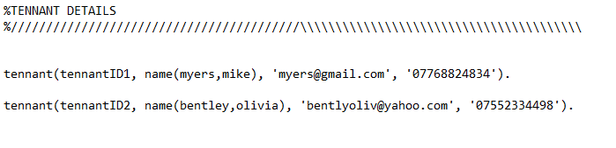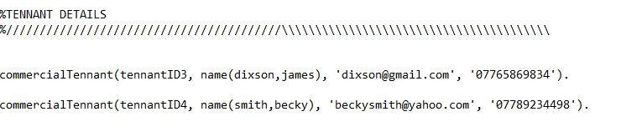Prolog and notepad was used to develop the smart property management system. Prolog is defined as a logic programming language, which includes facts and rules that will lead to an end goal. The system is implemented with data sets which must follow the same formats which will allow each data set to interact between each other.

The tenant data set is divided between residential and commercial types. Both types of tenant have the same data type: TenantID, Name(surname, firstname), email address, phone number.

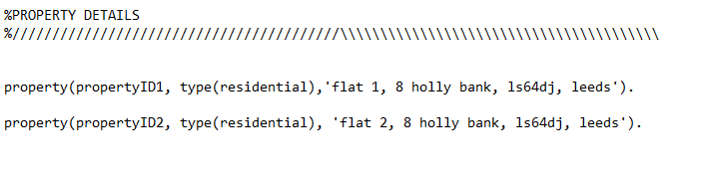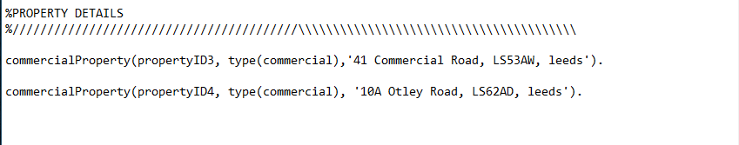

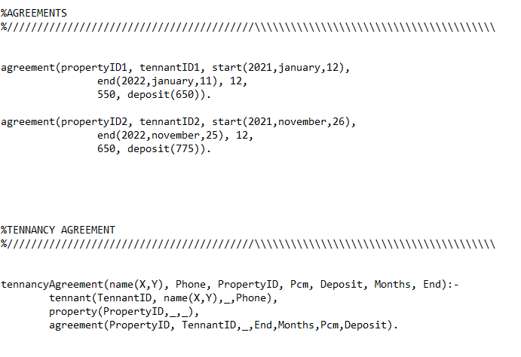The property data set was again split between residential and commercial type to avoid any confusion that could occur within the smart system. But both residential and commercial properties share the same data set: PropertyID, Type of property, address. As the system gets more developed more data sets would be added to property such as electric and gas suppliers, key holders, if the property is furnished.

Figure # above, is the residential tenancy agreement. The agreement data set includes PropertyID, TenantID, start date of tenancy, end date of tenancy, duration of tenancy in months, rent per calendar month, and the deposit paid.

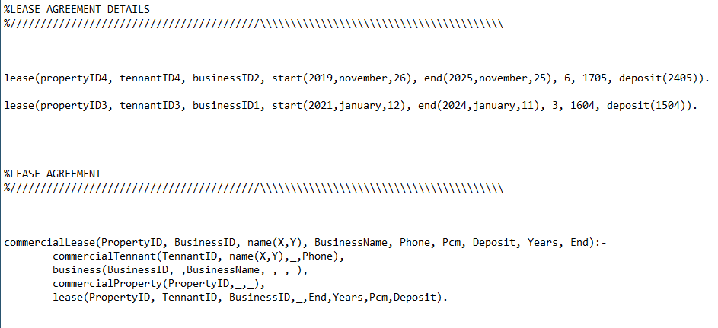This is the essential information needed to create a tenancy agreement, this data would be used within the system by the tenancyAgreement function which collects information from the data sets tenant, property, and agreement. This would allow the user to search for important information regarding the tenancy agreement such as details of the current tenant and contact details.

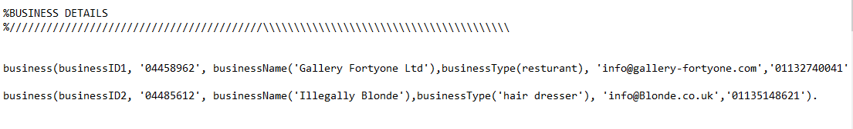For commercial lettings, the system would create a lease between the landlord and tenant, in a similar format and data set of tenancy agreement. However, the main difference of commercial Lease and Tenancy Agreement is that commercial lease stores important information about the business that will be trading within the property. This data is stored in case any issues arise between the tenant and landlord.

The data type for business is as follows BusinessID, company registration number, business name, type of business, business email, business contact number.

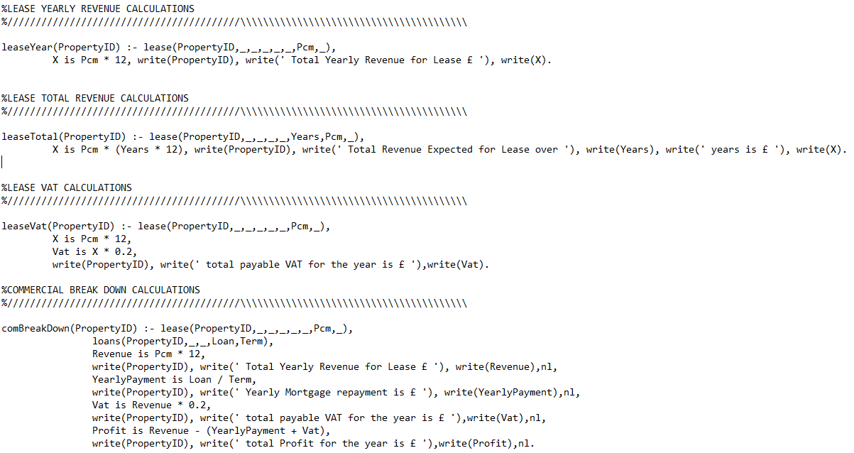The Figure above shows the calculations made for commercial properties and leases, there are 4 main calculations included with this function, yearly revenue calculations, total revenue of lease agreement duration, lease vat yearly calculations, and break down calculation, which calculates the total costs (loan repayment, repair costs, vat costs) and the total revenue, using the two figures the system calculates the total profit the property has made within a year.

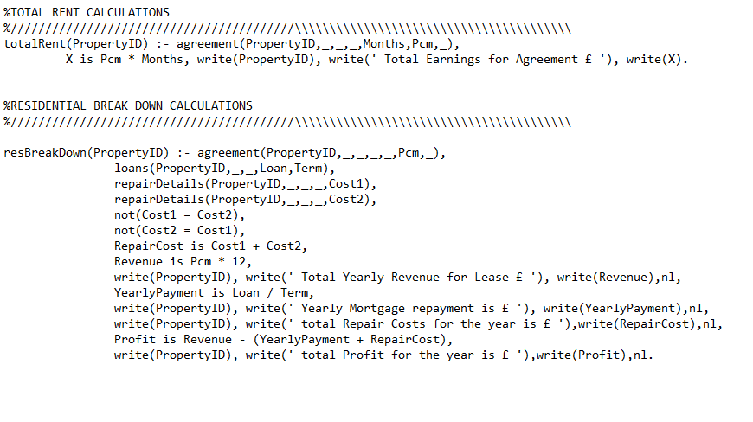

The Figure above shows the calculations made for residential properties and tenancy agreements. The calculations are similar to commercial properties, but vat calculations aren’t included. The calculations include total revenue of a property with a tenancy agreement, and the break down which included total costs of repairs, loan repayments, and total revenue generated by rent these figures are used to calculate total profit.

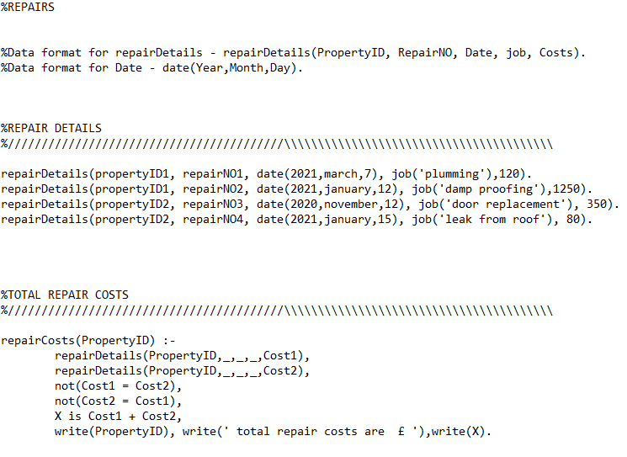

The Figure above shows the repairs function, which has repair details and repair costs. The data format for repair details is PropertyID, RepairNO, date of the repair, what type of repair was required, and costs of the repair. If the user wanted to calculate the total repair costs of a specific property the repair function will calculate the figure and display the data for the user.

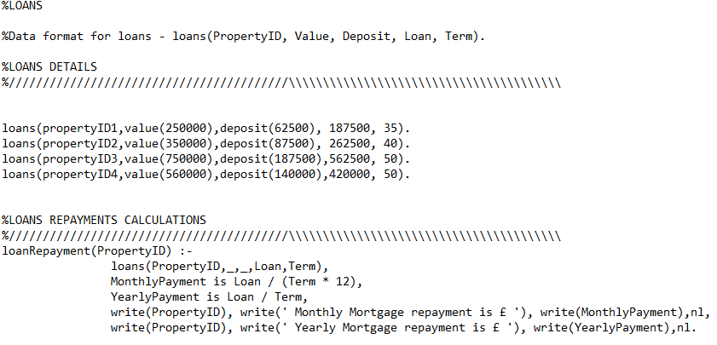

The smart system can store details regarding the loans or mortgages on each property to allow landlords to assess their properties and make the right decisions regarding the property such as increasing rent. The data format of loans is PropertyID, value of the property, deposit paid for the property, the loan figure, and the term of repayment in years.

The loanRepayment function allows the user to search the repayment amount of a loan taken out for a specific property. This function calculates the yearly loan repayment amount and the monthly loan repayment amount, which is used to calculate the total breakdown of a property and calculate total costs of a property.

Each of these data sets work together to either provide details of a specific property or agreement and calculate essential figures for the user or landlord to assess their properties current position whether it’s making a profit or loss.

**Section 4: Summary & Conclusion**

**Summary**

The smart property management system provides a simple framework which can be used for property management. The system has achieved the 5 objectives or requirements set to create the system. The system has the requirements needed to let or rent a property within its knowledge base, the requirements can include energy performance certificates, building insurance, fire safety, and much more.

The system can store essential real estate information such as loan details, repairs, lease and tenancy details including tenant details, property details and agreement details. Which can be used to calculate figures such as total profit, total revenue, total costs per building.

The current system would be useful for a landlord to assess their properties and make decisions based on the calculations and details of each costs of repairs that have occurred. In addition, the system can store essential information ready at hand if the user has any concerns regarding an agreement or would like to know the duration of the agreement.

However, this smart system can be improved by developing it as a cloud-based system, which can monitor rent payments automatically and inform tenants and landlords of any overdue rent payments. The system is currently underdeveloped for the real world property management, however it can be used to just store data and calculate figures based off the data provided.

**Conclusions**

The system currently achieves all goals set in this report and simulates real world property management to a point. However, this system needs to be developed much more to meet the day-to-day requirements of landlords and property managers. Other related systems have proven to be very useful for users however there have been complaints that the systems are too complex and sometimes unnecessary for certain users.

In the future this system should work as a cloud-based system, with a smart phone app and a portal for landlords and property managers. This would allow certain responsibilities to be automated such the starter pack for tenants to be provided in the app upon moving in which includes information of how to make rent payments, create repair request, which company provides gas and electricity, who to contact if any issues occur. The system would take rent payments through the app which would automatically record the rent payment within the system and if no payment were made the system will inform the tenant and landlord.

The system must be efficient, clean and simple whilst providing insights and reports of a certain property allowing the user to clearly see the assessment of the property to make decisions. The main objective will be to automate certain responsibilities of landlords and property managers, whilst still providing a in depth assessment of their current property portfolio.

Property Investment Project. 2021. *Which Landlord Property Management Software Is The Best in 2021?*. [online] Available at: <https://www.propertyinvestmentproject.co.uk/blog/which-landlord-software-do-you-recommend-and-which-is-the-best/> [Accessed 28 March 2021].

Smartpropertysystems.com. 2021. *Smart Property Systems | Online Property Management Software*. [online] Available at: <https://smartpropertysystems.com/features> [Accessed 18 March 2021].

Smartpropertysystems.com. 2021. *Smart Property Systems | Online Property Management Software*. [online] Available at: <https://smartpropertysystems.com/plans_pricing> [Accessed 12 March 2021].

Headchannel.co.uk. 2021. *7 benefits of using property management software - HeadChannel*. [online] Available at: <https://headchannel.co.uk/7-benefits-of-using-property-management-software-321> [Accessed 14 March 2021].

ResearchGate. 2021. *(PDF) A Systematic Review of Smart Real Estate Technology: Drivers of, and Barriers to, the Use of Digital Disruptive Technologies and Online Platforms*. [online] Available at: <https://www.researchgate.net/publication/327398697_A_Systematic_Review_of_Smart_Real_Estate_Technology_Drivers_of_and_Barriers_to_the_Use_of_Digital_Disruptive_Technologies_and_Online_Platforms> [Accessed 16 March 2021].

Financesonline.com. 2021. *Smart Property Systems Reviews: Pricing & Software Features 2020 - Financesonline.com*. [online] Available at: <https://reviews.financesonline.com/p/smart-property-systems/> [Accessed 13 March 2021].

Softwaresuggest.co.uk. 2021. *Smart Property Manager Pricing, Reviews & Features in 2021 - Free Demo*. [online] Available at: <https://www.softwaresuggest.co.uk/smart-property> [Accessed 14 March 2021].

Elliotmanagement.com. 2021. [online] Available at: <https://www.elliotmanagement.com/> [Accessed 16 March 2021].

Monnit.blob.core.windows.net. 2021. [online] Available at: <https://monnit.blob.core.windows.net/content/documents/whitepapers/MWP003-Property-Management-Whitepaper.pdf?utm_source=monnitsense&utm_medium=email&utm_campaign=Nov2018> [Accessed 19 March 2021].

Rentila. 2021. *Rentila - Free cloud-based property management software for landlords*. [online] Available at: <https://www.rentila.co.uk/> [Accessed 21 March 2021].

**User manual**

|  |  |  |
| --- | --- | --- |
| **Predicate** | **Format** | **Usage** |
| commercialTennant(). | (TennatID, name(surname, firstname), Email, Phone). | Shows selected or current commercial tenants that have been stored within the system |
| Business(). | (BusinessID, CompanyNo, BusinessName, BusinessType, BusinessEmail, BusinessPhone). | Shows selected or current businesses with leases that have been stored within the system |
| commericalProperty(). | (PropertyID, Type, Address). | Shows selected or current commercial properties that have been stores within the system |
| lease(). | (TennantID, PropertyID, BusinessID, Start, End, Years, Pcm, Deposit). | Shows selected or current lease details that are stored within the system |
| commercialLease(). | (PropertyID, BusinessID, name(X,Y), BusinessName, Phone, Pcm, Deposit, Years, End). | Shows selected or current commercial Lease full details of tenant and agreement that are stored within the system |
| leaseYear(). | (PropertyID). | This predicate calculates the total yearly revenue of a lease agreement on a specific property. |
| leaseTotal(). | (PropertyID). | This predicate calculates the total revenue expected of a lease agreement on a specific property |
| leaseVat(). | (PropertyID). | This predicate calculates the total yearly VAT due on a specific commercial property |
| comBreakDown(). | (PropertyID). | This predicate calculates the total breakdown of repair costs, VAT, loan repayments, revenue and profit of a specific commercial property |
| Tenant(). | (TennantID, name(Surname, Firstname), Email, Phone). | Shows selected or current residential tenants that have been stored within the system |
| property(). | (PropertyID, Type, Address). | Shows selected or current residential properties that have been stored within the system |
| agreement(). | (TennantID, PropertyID, Start, End, Months, Pcm, Deposit). | Shows selected or current residential tenancy agreement details that have been stored within the system |
| tenancyAgreement(). | (name(X,Y), Phone, PropertyID, Pcm, Deposit, Months, End) | Shows selected or current residential tenancy agreement full details of tenant and agreement that are stored within the system |
| totalRent(). | (PropertyID). | This predicSate calculates the total yearly revenue of a residential tenancy agreement on a specific property. |
| resBreakDown(). | (PropertyID). | This predicate calculates the total breakdown of repair costs, VAT, loan repayments, revenue and profit of a specific residential property |
| repairDetails(). | (PropertyID, RepairNO, Date, job, Costs). | Shows selected or current repair details that have been stores within the system |
| repairCosts(). | (PropertyID) | This predicate calculates the total repair costs of a specific property |
| loans(). | (PropertyID, Value, Deposit, Loan, Term). | Shows selected or current loan details that have been stores within the system |
| loanRepayment(). | (PropertyID). | This predicate calculates the yearly loan repayment costs and monthly loan repayment costs and shows to the user |
| Properties(). | (Property Type, Requirements). | This predicate shows the requirements to rent a type of property which must be met by the landlord. |
| has_properties(). | (Property, Requirements). | This predicate is similar to the properties(). Predicate. However this predicate show all the requirements of all properties. |