1. PLOT OF A CIRCLE

clc
clear all
t=linspace(0,2*pi,20);
x = 1+2*cos(t);
y=3+2*sin(t)
plot(x,y,'k-*')
axis equal
xlabel('x(m)')
ylabel('y(m)')
title('graph of (x-1)^2+(y-4)^2')

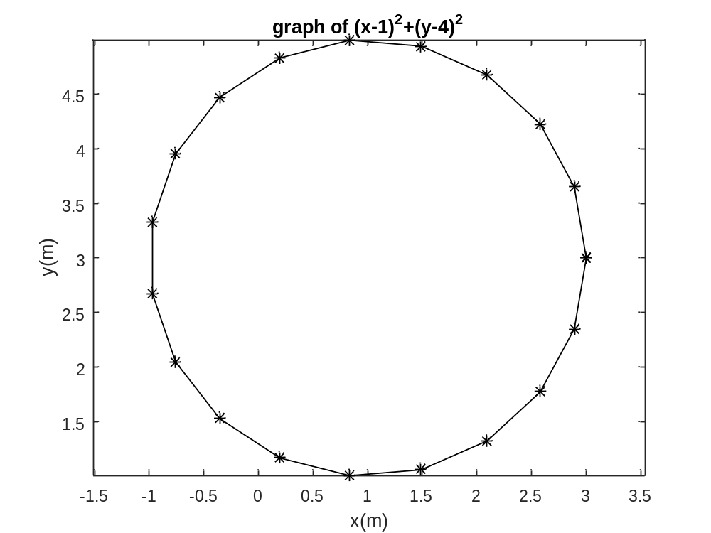
2.MULTIPLE PLOT IN A FIGURE USING COMMAND ‘hold on’

clc
clear all
x=linspace(0,1)
plot(x,x.^2,'r')
hold on
plot(x,sin(x),'g')
hold on
plot(x,exp(x),'y')
legend('x^2','sin(x)','exp(x)')

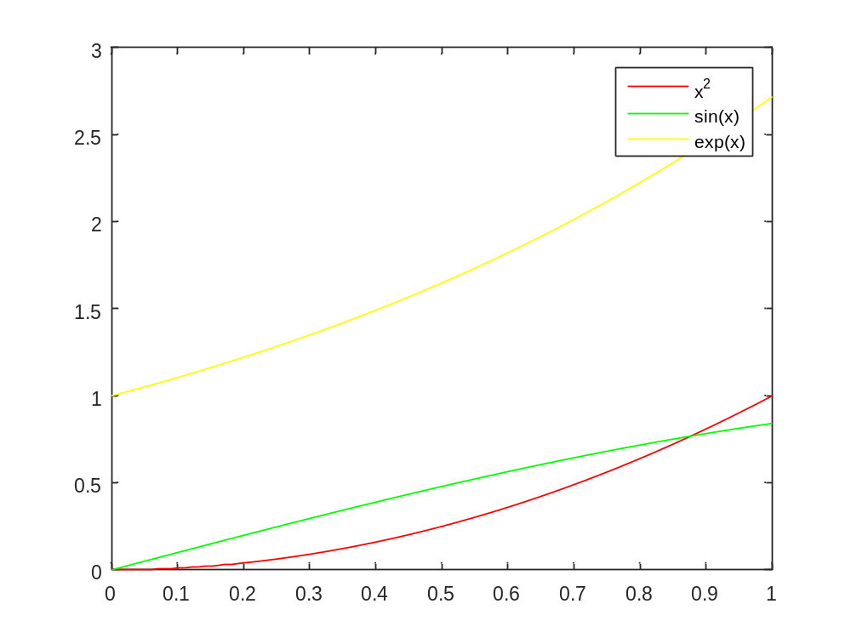
3.MULTIPLE PLOT IN A FIGURE WITHOUT USING THE COMMAND “hold on”

clc
clear all
x=linspace(0,1)
plot(x,x.^3,'r',x,sin(x),'b',x,exp(x),'k')
legend('x^3','sin(x)','exp(x)')

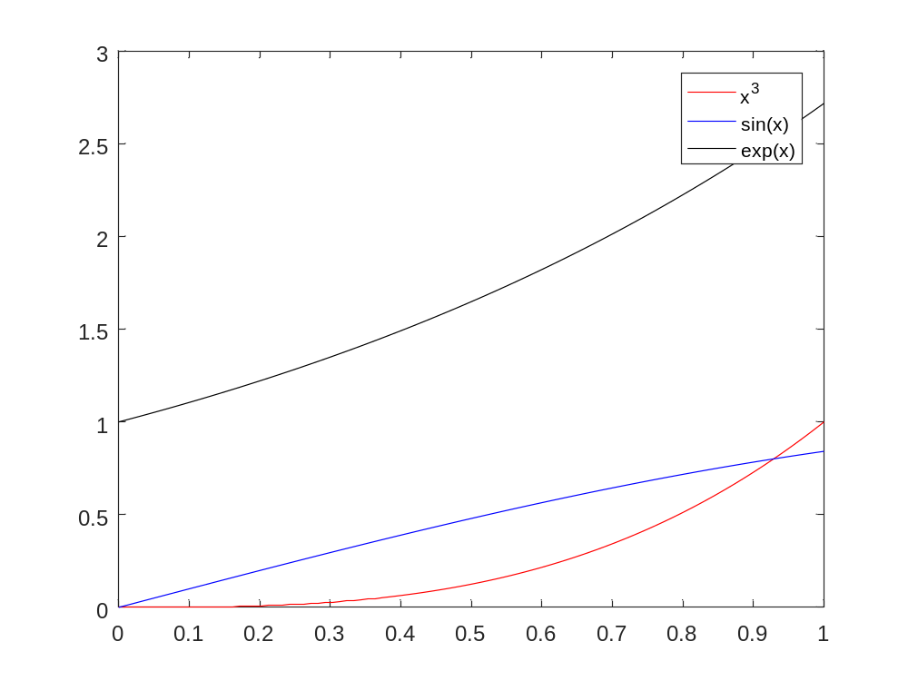

4. PLOT MULTIPLE GRAPH USING SUBPLOT COMMAND

clc
clear all
x=0:0.1:2*pi
subplot(2,2,1)
plot(x,sin(x));
subplot(2,2,2)
plot(x,cos(x),'k-*');
subplot(2,2,3)
plot(x,exp(-x),'go')
subplot(2,2,4)
plot(x,x.^5,'g.')

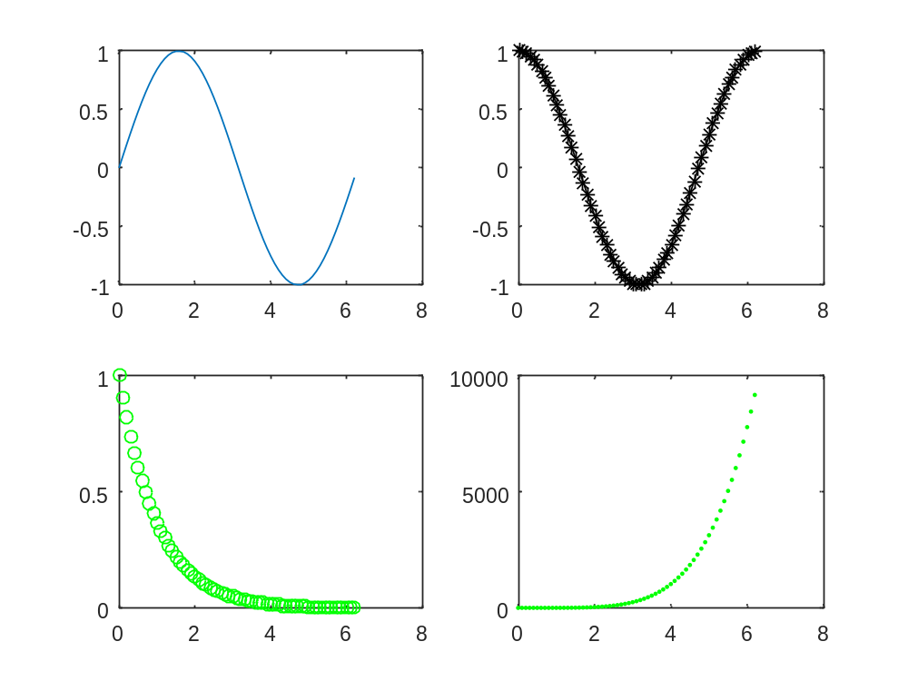
5.Graph of a curve through ezplot command

clc
clear all
syms x
f=sin(2*x)+cos(3*x);
figure(1)
ezplot(f)
figure(2)
ezplot(f,[0,3])

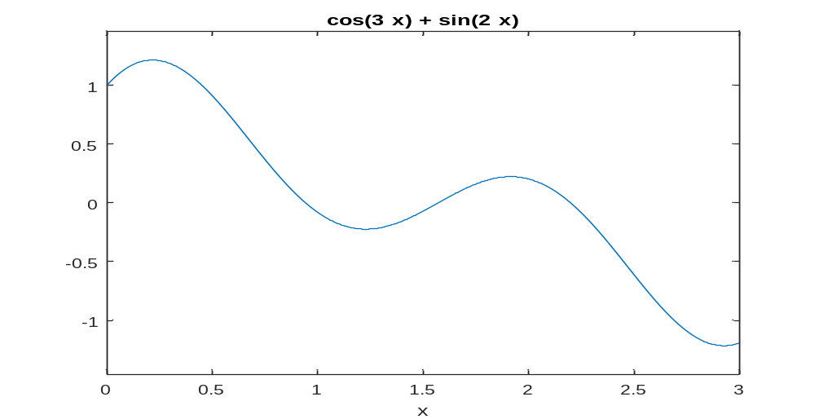
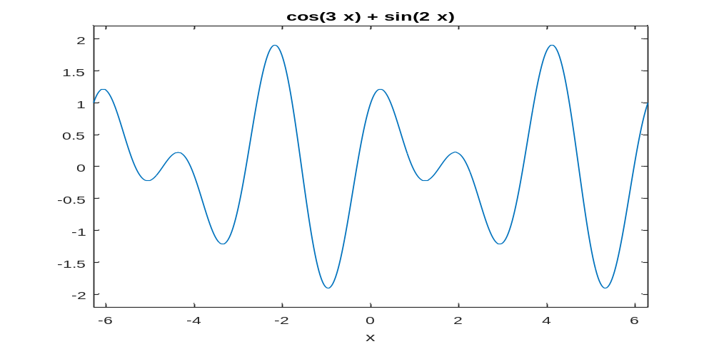
6. PLOT A GRAPH OF 3-D CURVE

clc
clear all
t=linspace(0,2*pi,500);
x=cos(t);
y=sin(t);
z=sin(5*t);
comet3(x,y,z)
xlabel('x-axis')
ylabel('y-axis')
zlabel('z-axis')
title('3D Curve')

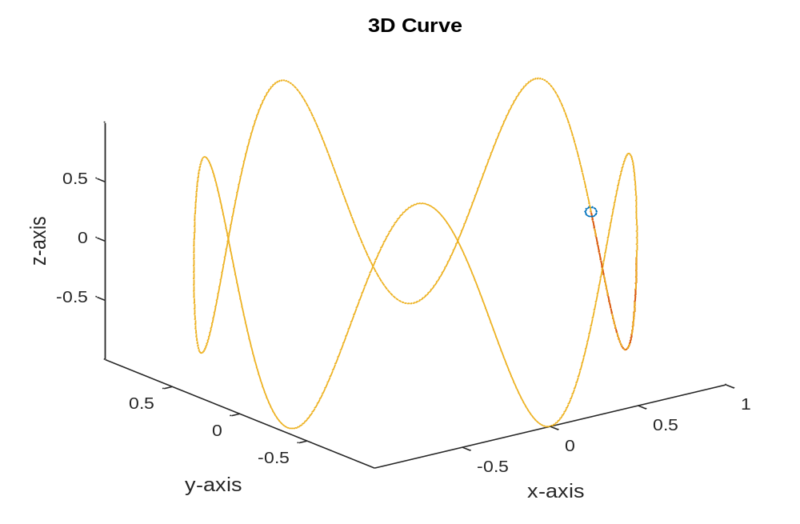

7. HOW TO DRAW A SURFACE IN MATLAB

clear all
x=-1:.05:1;
y=-1:.05:1;
[x,y]=meshgrid(x,y);
z=x.*y.^2-x.^3
surf(x,y,z);
colormap prism

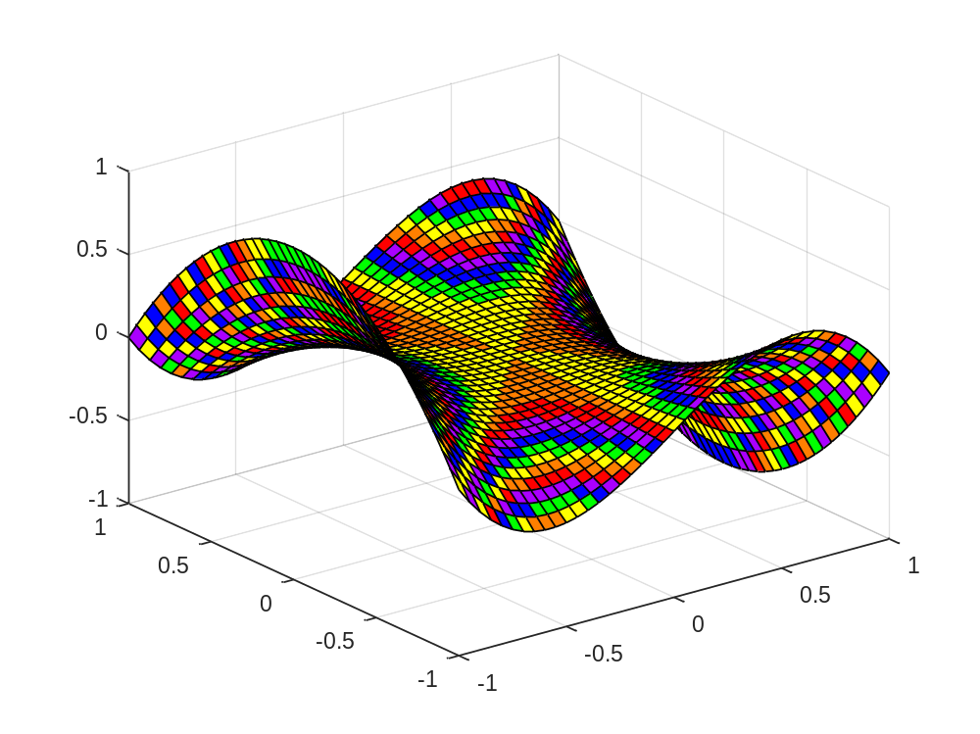

8. PLOT A GRAPH USING ’ezsurf’ COMMAND

clear all
syms x y
f=2*(x.^2+y.^2)
ezsurf(f)
colormap cool

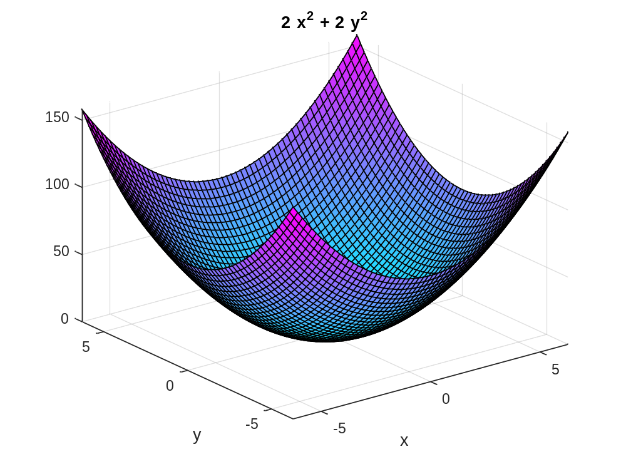

9. GRAPH OF A CURVE AND ITS TANGETS LINE IN THE NEIGHBOURHOOD D OF A POINT. AND EQUATION OF THE TANGENT LINE PASSING THROUGH A POINT.
clc
clear all
syms x y
y=x.^2-2*x
yd=diff(y,x)
x1=2
slope=subs(yd,x,x1)
D=[x1-2,x1+2]
ezplot(y,D)
hold on
y1=subs(y,x,x1)
plot(x1,y1,'ko')
tgt_line=slope*(x-x1)+y1
h=ezplot(tgt_line,D)
set(h,'color','r')

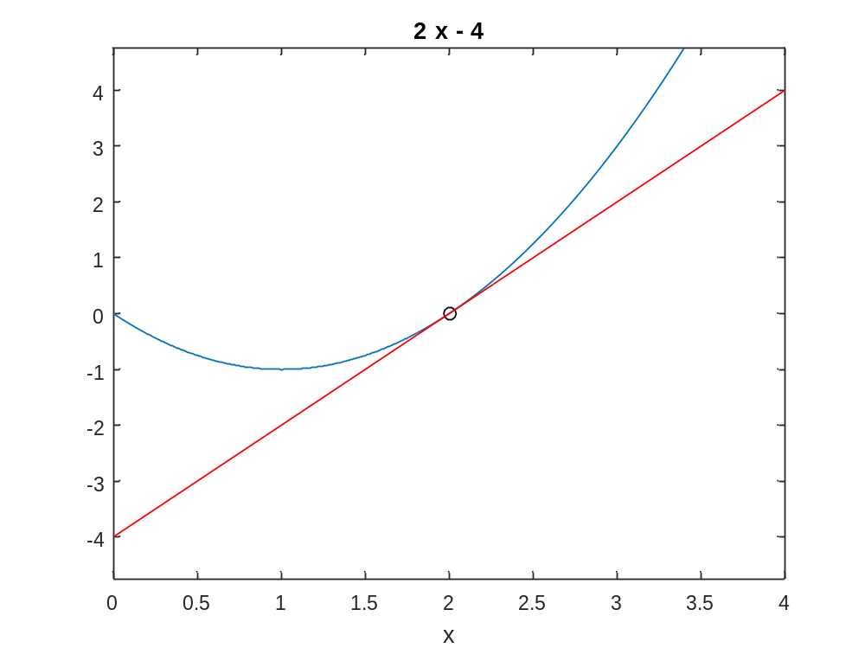
10.MAXIMA AND MINIMA FOR A FUNCTION OF A SINGLE VARIABLE
clc
clear all
syms x real
f = input('Enter the function f(x):');
fx = diff(f,x);
c = solve(fx);
cmin = min(double(c));
cmax = max(double(c));
ezplot(f,[cmin-2,cmax+2])
hold on
fxx = diff(fx,x);
for i = 1:1:size(c)
T1 = subs(fxx, x, c(i) );
T3 = subs(f, x, c(i));
if (double(T1)==0)
sprintf('The point x is %d inflexion point',double(c(i)))
else
if (double(T1) < 0)
sprintf('The maximum point x is %d', double(c(i)))
sprintf('The value of the function is %d', double(T3))
else
sprintf('The minimum point x is %d', double(c(i)))
sprintf('The value of the function is %d', double(T3))
end
end
plot(double(c(i)),double(T3),'r*', 'markersize', 15)
end
hold off

OUTPUT Command Window:-
Enter the function f(x):x^3-2*x+4

ans =

The maximum point x is -8.164966e-01

ans =

The value of the function is 5.088662e+00

ans =

The minimum point x is 8.164966e-01

ans =

The value of the function is 2.911338e+00

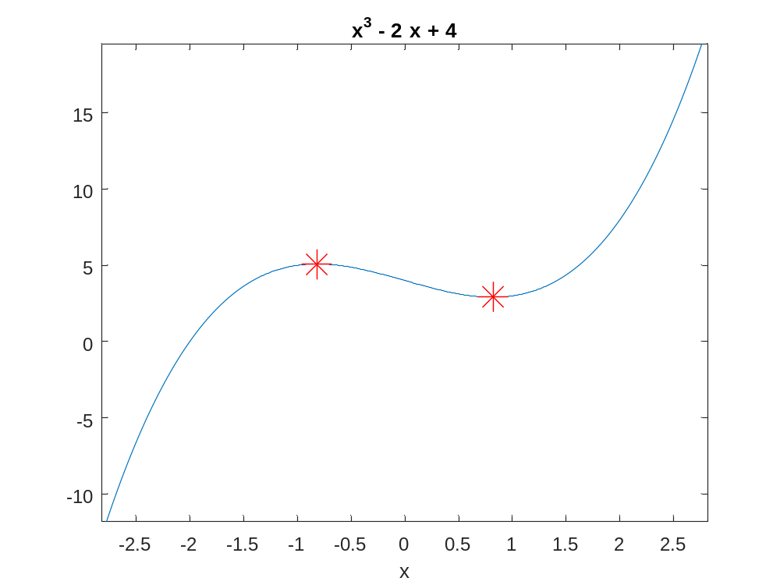

11.Finding the integral value using Rimann Sum

clc
clear all
syms x
f = input('Enter the function f(x):');
a = input('Enter lower limit of x:');
b = input('Enter the upper limit of x:');
n = input('Number of intervals:');
z = int(f,a,b);
value = 0;
dx = (b-a)/n;
for k=1:n
c = a+k*dx;
d = subs(f,x,c);
value = value + d;
end
value = dx*value;
ezplot(f,[a,b])
z = int(f,a,b);
rsums(f,a,b)

COMMAND WINDOW:-
Enter the function f(x):sin(x)
Enter lower limit of x:0
Enter the upper limit of x:2*pi
Number of intervals:10

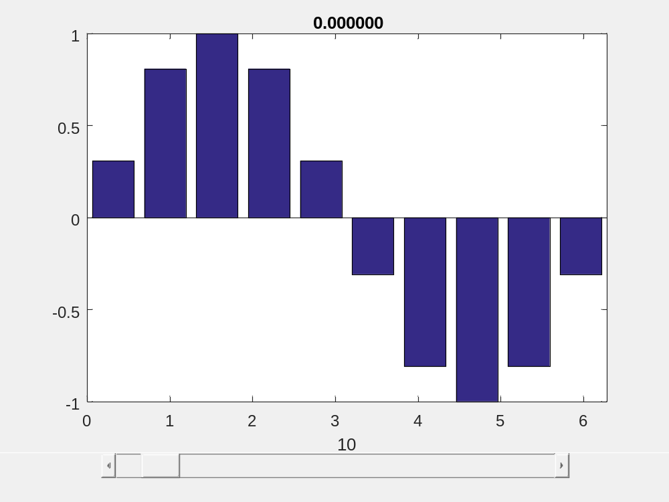

12.TO FIND THE AREA OF THE REGIONS ENCLOSED BY THE CURVES

clc
clear all
syms x
y1=input('Enter the upper curve as a function of x:');
y2=input('Enter the lower curve as a function of x:');
t=solve(y1-y2);
t=double(t);
A=int(y1-y2,t(1),t(2))
D=[t(1)-0.2 t(2)+0.2];
ez1=ezplot(y1,D);
set(ez1,'color','r')
hold on
ez2=ezplot(y2,D);
legend('y1','y2')
xv=linspace(t(1),t(2));
y1v=subs(y1,x,xv);
y2v=subs(y2,x,xv);
x=[xv,xv];
y=[y1v,y2v];
fill(x,y,'g')
grid on
ylim=([min(y)-0.2 max(y)+0.2])

Command Window:-
Enter the upper curve as a function of x:x
Enter the lower curve as a function of x:x^2-2*x

A =

9/2

ylim =

[ -6/5, 16/5]

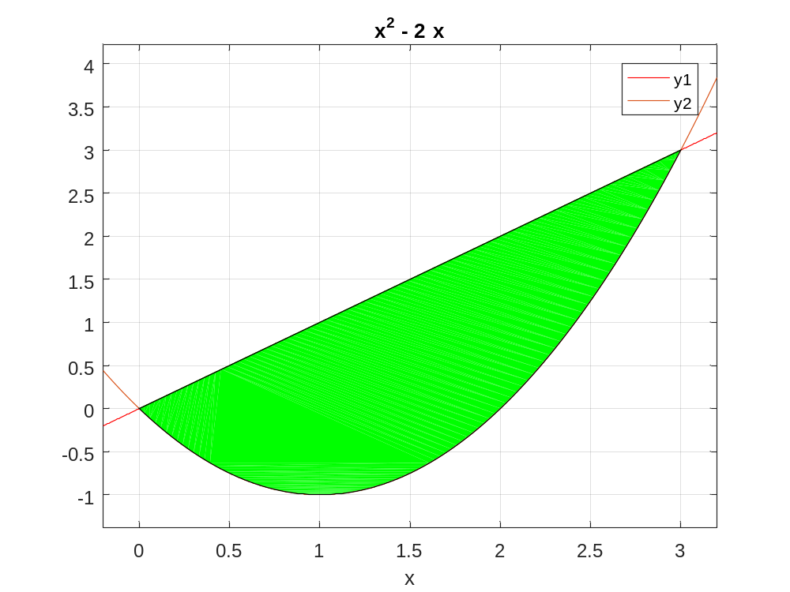

13.LAPLACE TRANSFORMATION USING UNIT-STEP FUNCTION

clc
clear all
syms x
g1=x*(heaviside(x-0)-heaviside(x-1));
g2=(2-x)*(heaviside(x-1)-heaviside(x-2));
f=g1+g2;
F=laplace(f)
xv=linspace(0,2,100);
g1v=subs(g1,x,xv);
g2v=subs(g2,x,xv);
fv=subs(f,x,xv);
subplot(3,1,1)
plot(xv,g1v,'r.')
subplot(3,1,2)
plot(xv,g2v,'r.')
subplot(3,1,3)
plot(xv,fv,'r.')

Command Window:-
F =

1/s^2 - exp(-s)/s^2 - exp(-s)/s + (exp(-2*s)*(s*exp(s) - exp(s) + 1))/s^2
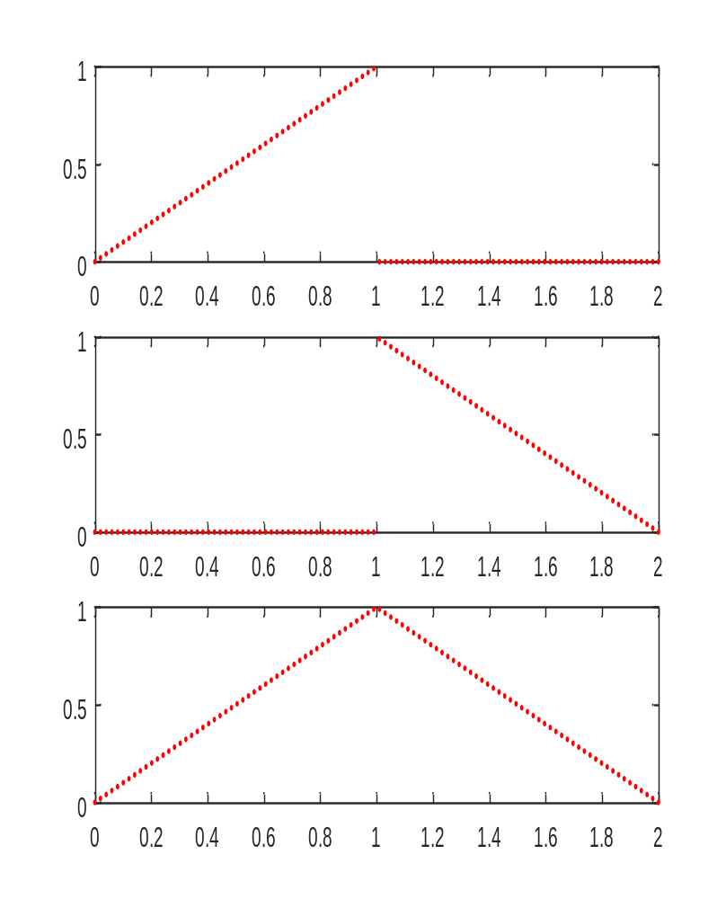

14.LAPLACE TRANSFORM OF PERIODIC FUNCTION AND VISUALIZATION OF THE PERIODIC FUNCTION

clc
clear all
syms t s
T=input('Enter the period of the periodic function: ');
n=input('Enter the number of partitions in one period: ');
fun=0*t;
for i=1:n
a(i)=input('Enter the left end point of the ith sub interval: ');
b(i)=input('Enter the right end point of the ith sub interval: ');
f(i)=input('Enter the function f(i): ');
fun=fun+f(i)*(heaviside(t-a(i))-heaviside(t-b(i)));
end
ezplot(fun,[a(1) b(n)])
sum=0;
for i=1:n
sum=sum+int(f(i)*exp(-s*t),t,a(i),b(i))
end
g=(1/(1-exp(-s*T)))*sum
g1=simplify(g)
figure
ezplot(g1,[0 b(n)])

Output-
Enter the period of the periodic function: 2*pi
Enter the number of partitions in one period: 2
Enter the left end point of the ith sub interval: 0
Enter the right end point of the ith sub interval: pi
Enter the function f(i): sin(t)
Enter the left end point of the ith sub interval: pi
Enter the right end point of the ith sub interval: 2*pi
Enter the function f(i): 0

sum =
(exp(-pi*s) + 1)/(s^2 + 1)
sum =
(exp(-pi*s) + 1)/(s^2 + 1)
g =
-(exp(-pi*s) + 1)/((s^2 + 1)*(exp(-2*pi*s) - 1))
g1 =
exp(pi*s)/((s^2 + 1)*(exp(pi*s) - 1))
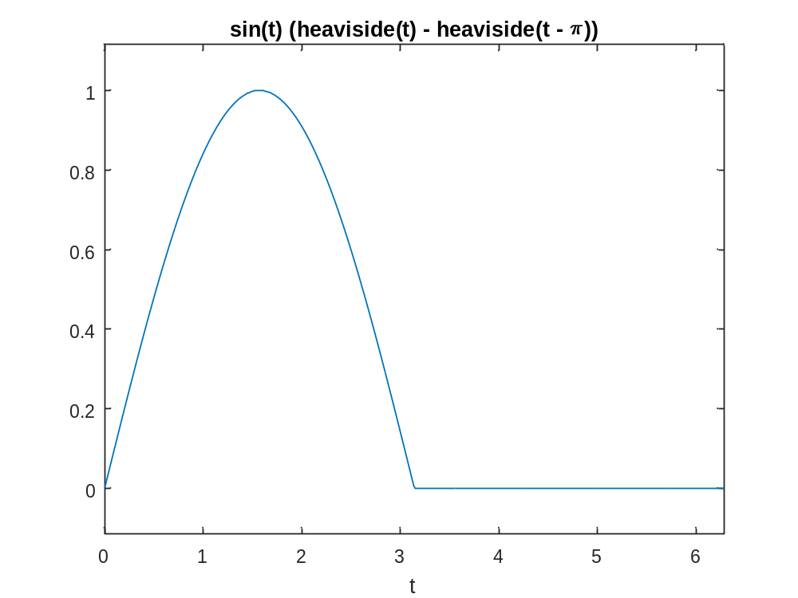
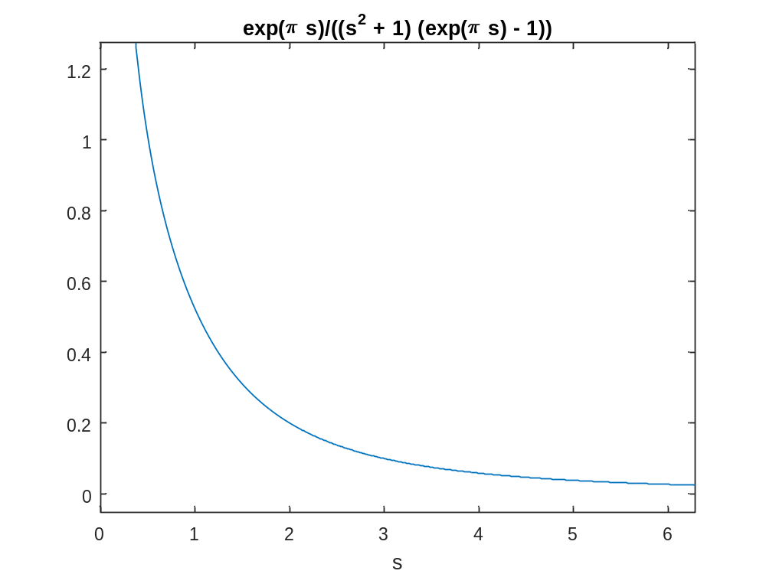
15.Fnd inverse laplace transform using convolution theorem.

clc
clear all
syms t u s
F=input('Enter first function of s: ')
G=input('Enter second function of s: ')
f=ilaplace(F)
g=ilaplace(G)
f=subs(f,t,u)
g=subs(g,t,t-u)
int(f*g,u,0,t)

Command Window;-

Enter first function of s: 1/(s+1)
F =1/(s + 1)
Enter second function of s: 1/(s+2)
G =1/(s + 2)
f =exp(-t)
g =exp(-2*t)
f =exp(-u)
g =exp(2*u - 2*t)
ans =exp(-2*t)*(exp(t) - 1)
16.Find the limit of the given function and check weather the function is continuous at a particular point.

clc
clear all
syms x y
f=input('Enter the function f(x,y) in terms of x and y: ');
x0=input('Enter the value of x0: ');
y0 = input('Enter the value of y0: ');
L1=limit(limit(f,x,x0),y,y0)
L2=limit(limit(f,y,y0),x,x0)
if((L1==NaN)||(L2==NaN)||(L1~=L2))
disp('Conclusion:Limit does not exists: ')
return
else
disp('Limit along the axes are equal')
end
y1=input('Enter the par representation of Y in terms of x along any curve: ')
z=subs(f,y,y1);
L3=limit(z,x,x0)
if(L1==L3)
disp('The limit along the axes and the given curve are equal');
else
disp('The limit along the curve does not exist ')
end
L=input('Enter the values of the function at that point: ')
z=limit(limit(f,x,x0),y,y0);
if(double(L)==double(z))
sprintf('The function is continuous and the value is %d',double(z))
else
disp('The function is not continuous at (x,y)')
end

Command Window;-
Output 1:-
Enter the function f(x,y) in terms of x and y: (sin(x^2+y^2))/(x+y)
Enter the value of x0: 0
Enter the value of y0: 0
L1 =0
L2 =0
Limit along the axes are equal
Enter the par representation of Y in terms of x along any curve: 0
y1 =0
L3 =0
The limit along the axes and the given curve are equal
Enter the values of the function at that point: 0
L =0
ans =The function is continuous and the value is 0

Output 2:-
Enter the function f(x,y) in terms of x and y: (x^2+y^2)/(x+y)
Enter the value of x0: 0
Enter the value of y0: 1
L1 =1
L2 =1
Limit along the axes are equal
Enter the par representation of Y in terms of x along any curve: 0
y1 =0
L3 =0
The limit along the curve does not exist
Enter the values of the function at that point: 0
L =0
The function is not continuous at (x,y)

17. Find the Partial Derivative of a given function and visualize it.

clc
clear all
syms x y
z=input('Enter the two dimensional function f(x,y): ');
x1=input('Enter the x value at which the derivative has to be evaluated: ')
y1=input('Enter the y value at which the derivative has to be evaluated');
z1=subs(subs(z,x,x1),y,y1)
ezsurf(z,[x1-2 x1+2])
f1=diff(z,x)
slopex=subs(subs(f1,x,x1),y,y1)
[x2,z2]=meshgrid(x1-2:.25:x1+2,0:0.5:10);
y2=y1*ones(size(x2));
hold on
surf(x2,y2,z2)
t=linspace(-1,1);
x3=x1+t;
y3=y1*ones(size(t));
z3=z1+slopex*t;
line(x3,y3,z3,'color','blue','linewidth',2)

Command Window:-
Enter the two dimensional function f(x,y): x^2+x*y+y^2
Enter the x value at which the derivative has to be evaluated: 1
x1 = 1
Enter the y value at which the derivative has to be evaluated1
z1 =3
f1 =2*x + y
slopex =3

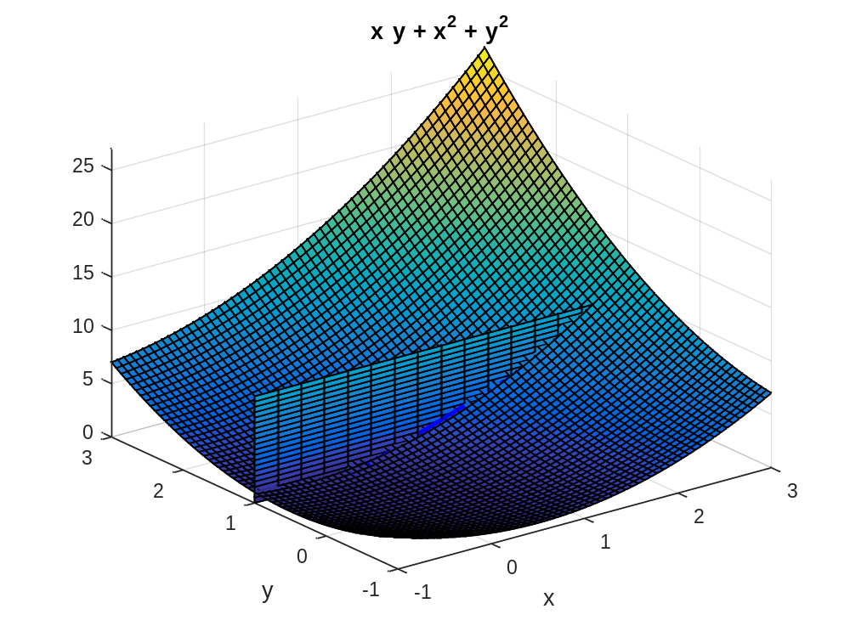

18. Find the extremum value for the function of two variables.

clc
clear all
syms x y real
f=input('Enter the funtion f(x,y):');
fx=diff(f,x);
fy=diff(f,y);
[ax ay]=solve(fx,fy);
fxx=diff(fx,x);
fxy=diff(fx,y);
fyy=diff(fy,y);
D=fxx*fyy-fxy^2;
for i=1:1:size(ax)
figure
T1=subs(subs(D,x,ax(i)),y,ay(i));
T2=subs(subs(fxx,x,ax(i)),y,ay(i));
T3=subs(subs(f,x,ax(i)),y,ay(i));
if(double(T1)==0)
sprintf('The point(x,y) is (%d,%d)andneed further investigation',double(ax(i)),double(ay(i)));
elseif(double(T1)<0)
sprintf('The point (x,y) is (%d,%d) is a saddle point',double(ax(i)),double(ay(i)));
else
if(double(T2)<0)
sprintf('The maximum point (x,y) is (%d,%d)',double(ax(i)),double(ay(i)));
sprintf('The value of the function is %d',double(T3))
else
sprintf('The minimum point (x,y) is (%d,%d) ',double(ax(i)),double(ay(i)));
sprintf('The value of the function id %d ',double(T3))
end
end
ezsurf(f,[double(ax(i))-2,double(ax(i))+2,double(ay(i))-2,double(ay(i))+2])
hold on
plot3(double(ax(i)),double(ay(i)),double(T3),'r*','markersize',15);
end

Command Window:-

Enter the funtion f(x,y):x^4+y^4-4*x*y+1
ans =The value of the function id -1
ans =The value of the function id -1
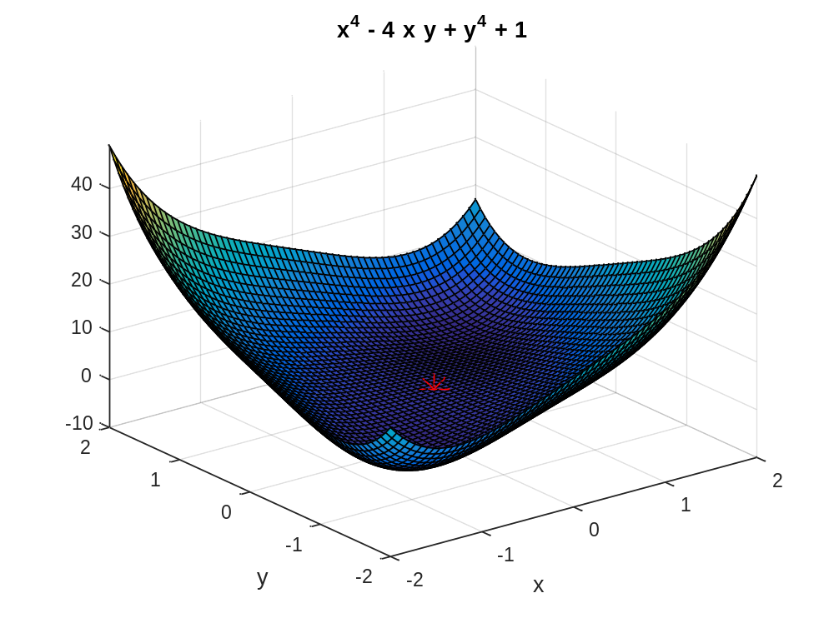
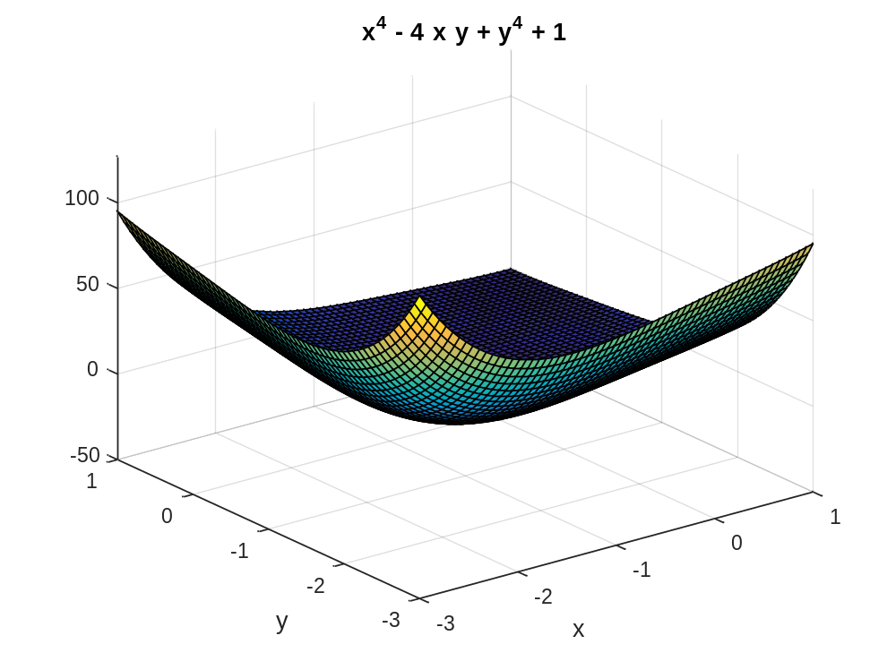
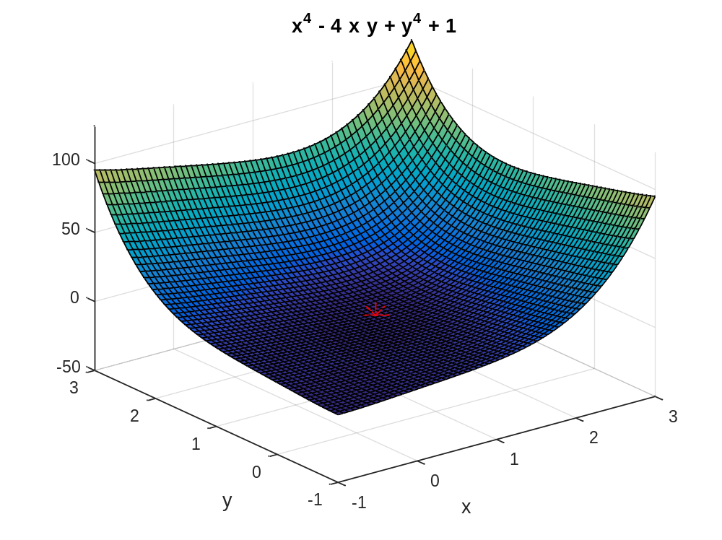
19.Maximizing the function using Lagranges multiplier method.

clc
clear all
syms x y lam real
f=input('Enter the function to be maximized in terms of x and y :');
g=input('Enter the constraint function in terms of x and y:');
[lam,ax,ay]=solve(jacobian(f-lam*g,[x y lam]));
T=subs(f,{x,y},{ax,ay});
for i=1:1:size(T)
figure
sprintf('The point (x,y) is (%d,%d)',double(ax(i)),double(ay(i)))
sprintf('The value of the function is %d',double(T(i)))
[X1,Y1]=meshgrid(double(ax(i))-3:.2:double(ax(i))+3,double(ay(i))-3:.2:double(ay(i))+3);
zfun=@(x,y)eval(vectorize(f));
Z1=zfun(X1,Y1);
contour(X1,Y1,Z1,75)
hold on
h=ezplot(g,[double(ax(i))-3,double(ax(i))+3]);
set(h,'color',[1,0.7,0.9])
plot(double(ax(i)),double(ay(i)),'r.','markersize',12)
end

Command Window:-
Enter the function to be maximized in terms of x and y :x^2-y^2
Enter the constraint function in terms of x and y:2*y-x^2
ans =The point (x,y) is (-1.414214e+00,1)
ans =The value of the function is 1
ans =The point (x,y) is (0,0)
ans =The value of the function is 0
ans =The point (x,y) is (1.414214e+00,1)
ans =The value of the function is 1
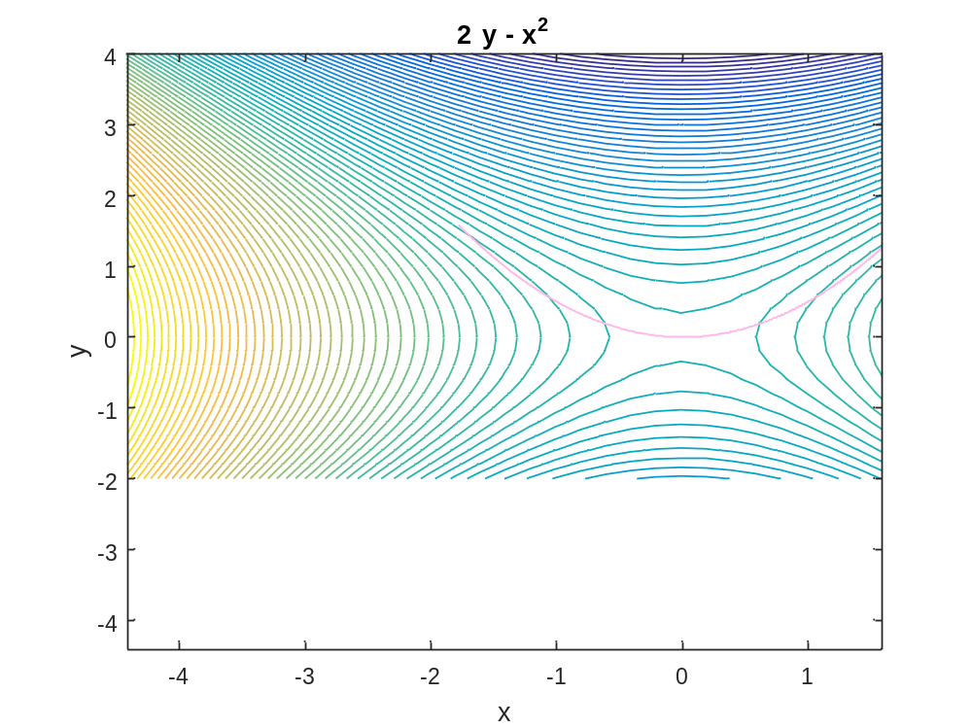
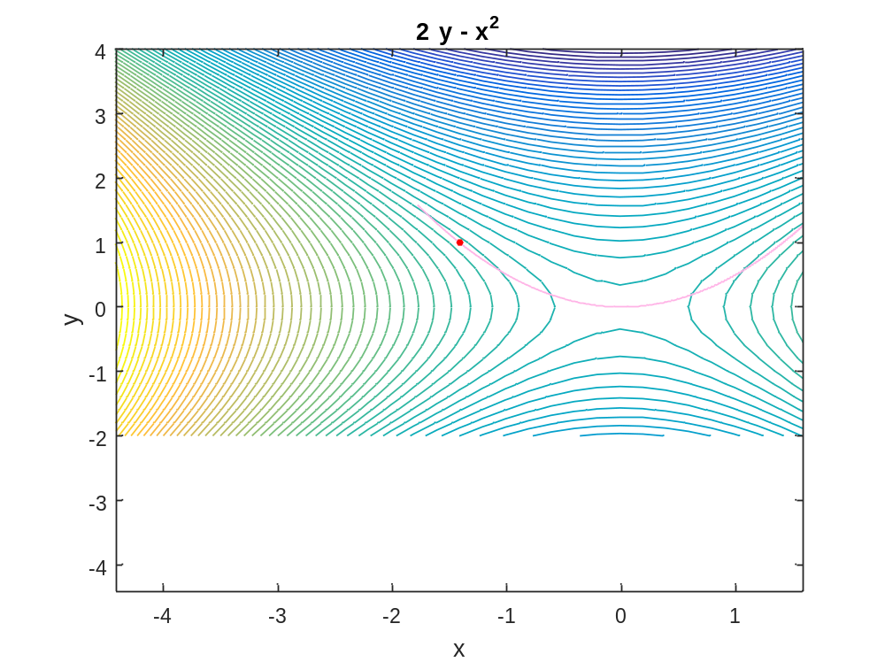
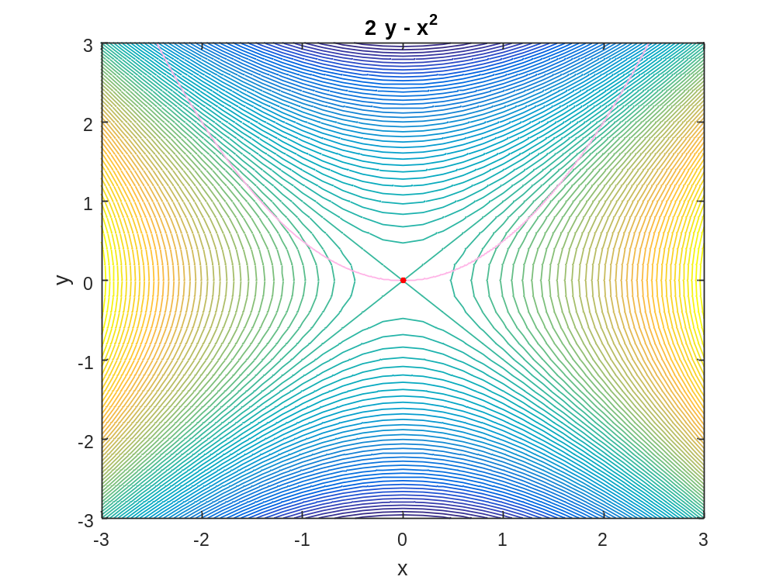
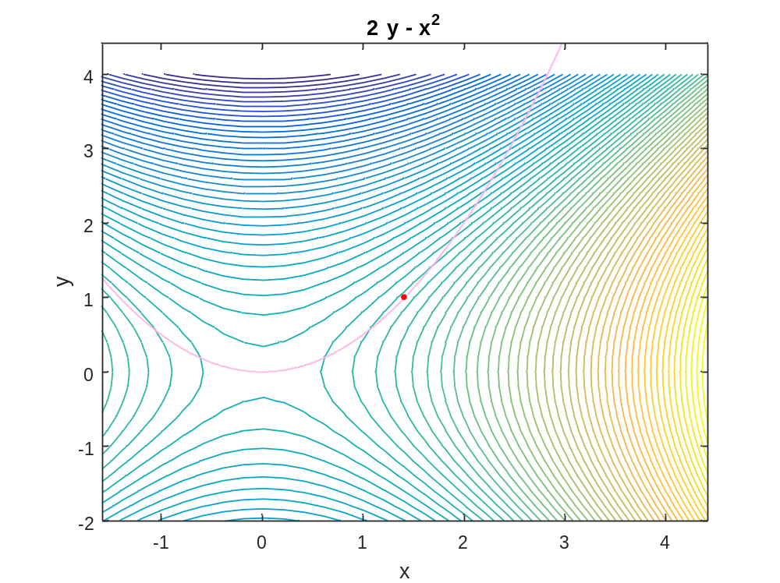
20.Draw a two dimensional vector field for the given vector.

clc
clear all
syms x y
F=input('Enter the vector as i and j order in vector form: ');
P=inline(vectorize(F(1)),'x','y');
Q=inline(vectorize(F(2)),'x','y');
x=linspace(0,1,10);
y=x;
[X,Y]=meshgrid(x,y);
U=P(X,Y);
V=Q(X,Y);
quiver(X,Y,U,V,1)
axis on
xlabel('x')
ylabel('y')

Command Window:-
Enter the vector as i and j order in vector form: [x,y]
>> P
P = Inline function:
P(x,y) = x
>> Q
Q = Inline function:
Q(x,y) = y
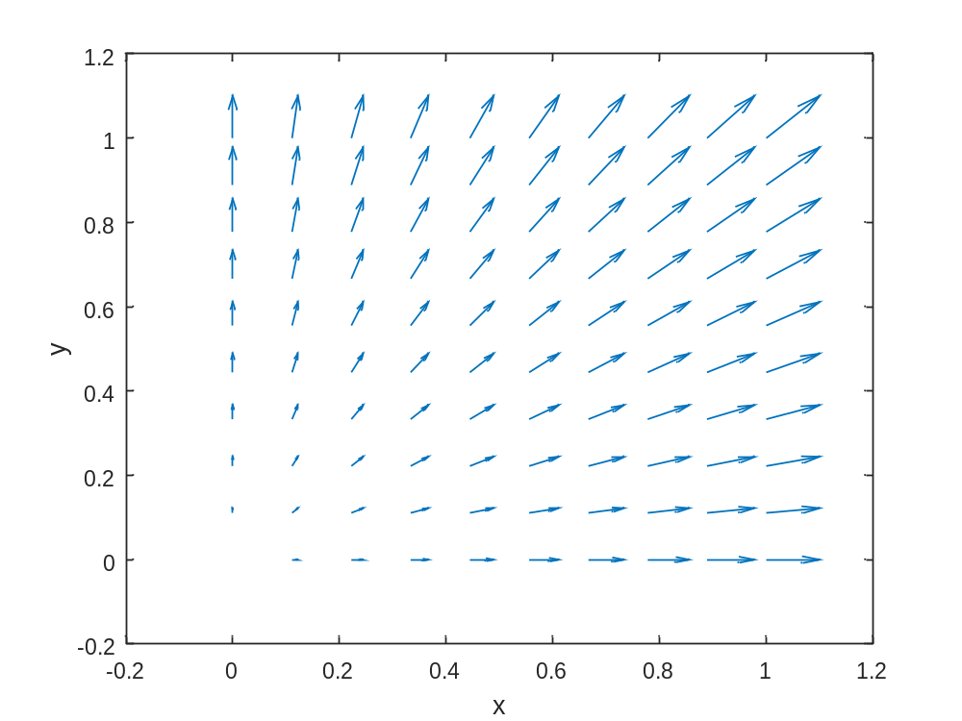
21.Draw the three dimensional vector field for the given vector.

clc
clear all
syms x y z
F=input('Enter the vector as i,j and k order in vector form: ');
P=inline(vectorize(F(1)),'x','y','z');
Q=inline(vectorize(F(2)),'x','y','z');
R=inline(vectorize(F(3)),'x','y','z');
x=linspace(-1,1,5);
y=x;
z=x;
[X,Y,Z]=meshgrid(x,y,z);
U=P(X,Y,Z);
V=Q(X,Y,Z);
W=R(X,Y,Z);
quiver3(X,Y,Z,U,V,W,1.5)
axis on
xlabel('x')
ylabel('y')
zlabel('z')

Command Window:-

Enter the vector as i,j and k order in vector form: [x -y z]
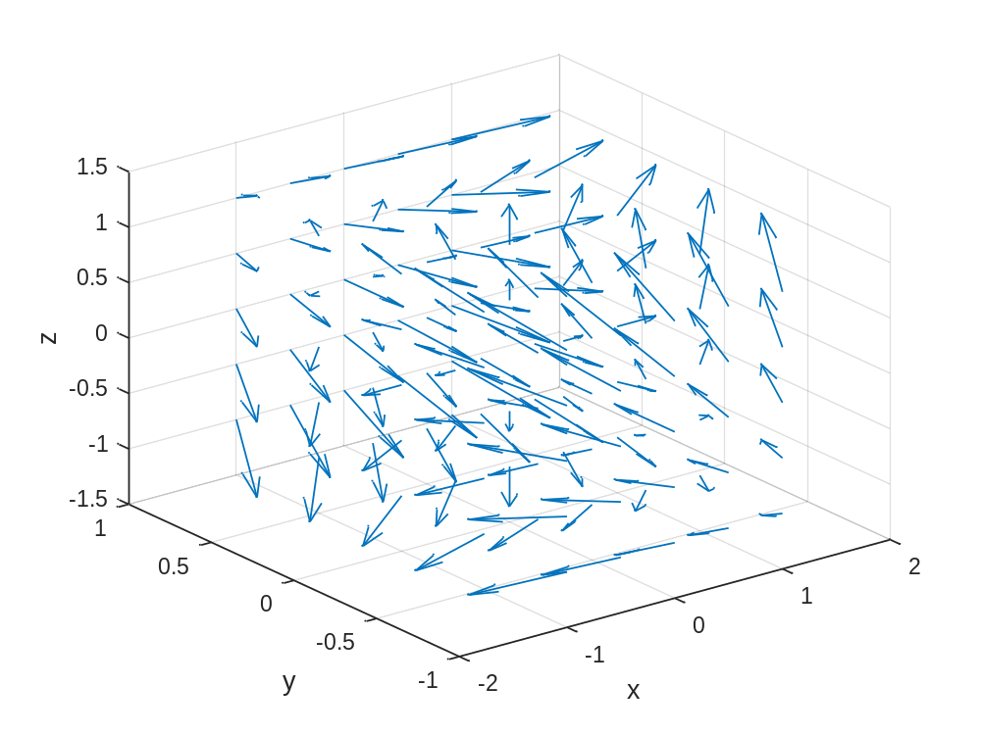
22.Find the gradient of a function.

clc
clear all
syms x y
f=input('Enter the function f(x,y): ');
f1=diff(f,x);
f2=diff(f,y);
P=inline(vectorize(f1),'x','y')
Q=inline(vectorize(f2),'x','y')
x=linspace(-2,2,10);
y=x;
[X,Y]=meshgrid(x,y);
U=P(X,Y)
V=Q(X,Y)
V=4*ones(size(U))
quiver(X,Y,U,V,1)
axis on
xlabel('x')
ylabel('y')
hold on
ezcontour(f,[-2,2])

Command Window:-

Enter the function f(x,y): x^2-4*y
P =Inline function:
P(x,y) = 2.*x
Q = Inline function:
Q(x,y) = -4
U =Columns 1 through 8
-4.0000 -3.1111 -2.2222 -1.3333 -0.4444 0.4444 1.3333 2.2222
-4.0000 -3.1111 -2.2222 -1.3333 -0.4444 0.4444 1.3333 2.2222
-4.0000 -3.1111 -2.2222 -1.3333 -0.4444 0.4444 1.3333 2.2222
-4.0000 -3.1111 -2.2222 -1.3333 -0.4444 0.4444 1.3333 2.2222
-4.0000 -3.1111 -2.2222 -1.3333 -0.4444 0.4444 1.3333 2.2222
-4.0000 -3.1111 -2.2222 -1.3333 -0.4444 0.4444 1.3333 2.2222
-4.0000 -3.1111 -2.2222 -1.3333 -0.4444 0.4444 1.3333 2.2222
-4.0000 -3.1111 -2.2222 -1.3333 -0.4444 0.4444 1.3333 2.2222
-4.0000 -3.1111 -2.2222 -1.3333 -0.4444 0.4444 1.3333 2.2222
-4.0000 -3.1111 -2.2222 -1.3333 -0.4444 0.4444 1.3333 2.2222

Columns 9 through 10

3.1111 4.0000
3.1111 4.0000
3.1111 4.0000
3.1111 4.0000
3.1111 4.0000
3.1111 4.0000
3.1111 4.0000
3.1111 4.0000
3.1111 4.0000
3.1111 4.0000
V = -4
V =4 4 4 4 4 4 4 4 4 4
4 4 4 4 4 4 4 4 4 4
4 4 4 4 4 4 4 4 4 4
4 4 4 4 4 4 4 4 4 4
4 4 4 4 4 4 4 4 4 4
4 4 4 4 4 4 4 4 4 4
4 4 4 4 4 4 4 4 4 4
4 4 4 4 4 4 4 4 4 4
4 4 4 4 4 4 4 4 4 4
4 4 4 4 4 4 4 4 4 4
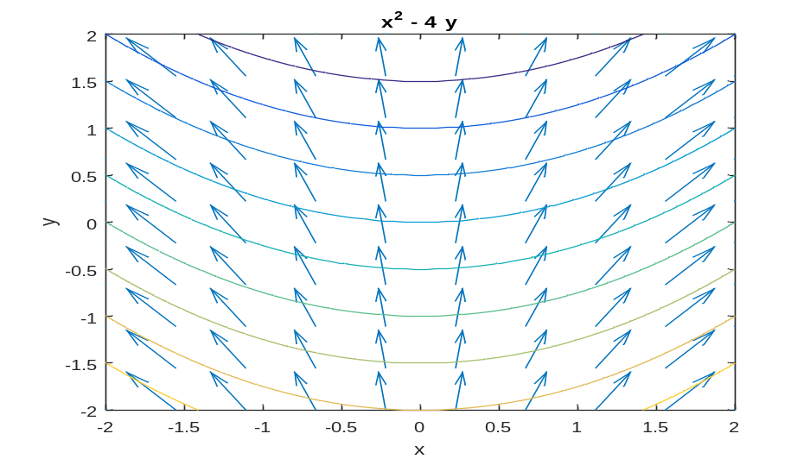

23. Evaluate double integral of (x-3y^2) where R={(x,y) 0<=x<=2, 1<=y<=2}.

clc
clear all
syms x y z
viewSolid(z,0+0*x+0*y,x-3*y^2+0*y,y,1+0*x,2+0*y,x,0,2)
int(int(x-3*y^2+0*y,y,1,2),x,0,2)

Command Window:-

ans =-12
