Implemented in simples with few functionality just to give common image of the structure and skills.

For implementing the solution I chose DB first approach.

Created DB table-Users with following structure. Here Id is the primary key.

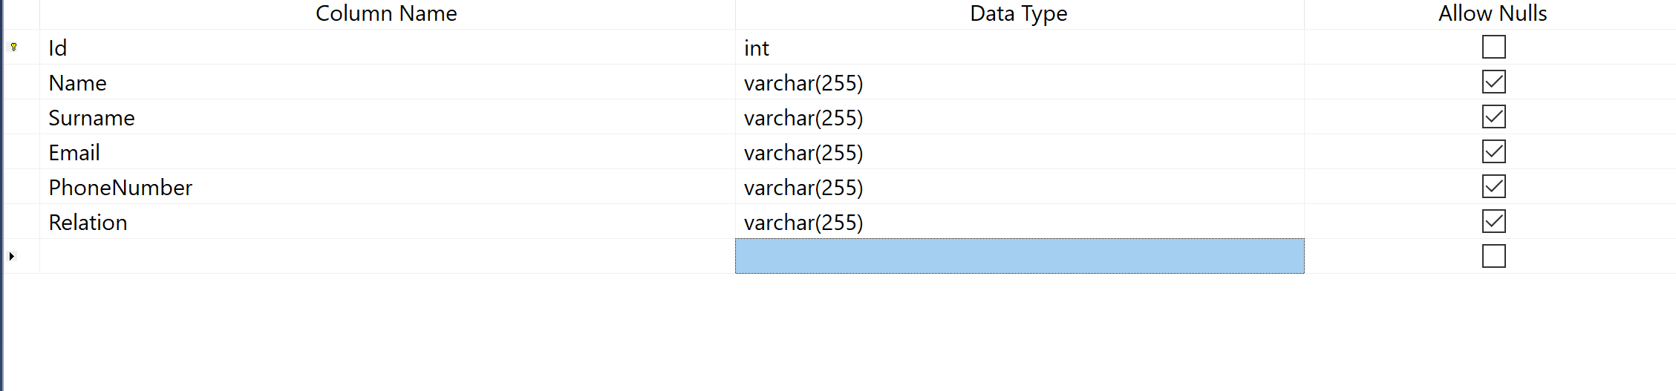

Using Entity Framework core for communication with DB. Create DAL object with corresponding fields

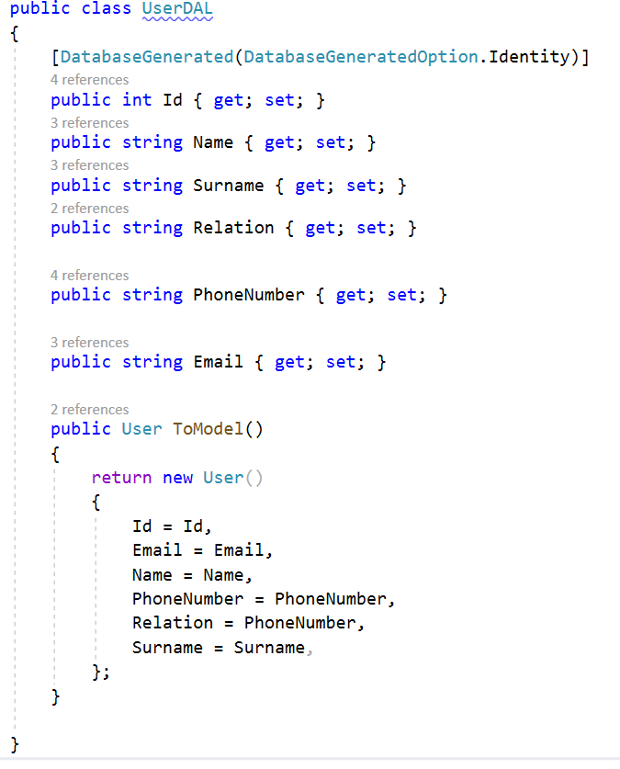

From UI you can add users, see all users and edit a user.

UI implemented using Razor technologies   to create dynamic web pages with the C#.

For better solution we can do the following.

Because User with user has many to many relationship based o relative status, we can have UserRelative table also, in which we can have 2 foreign keys to User table.

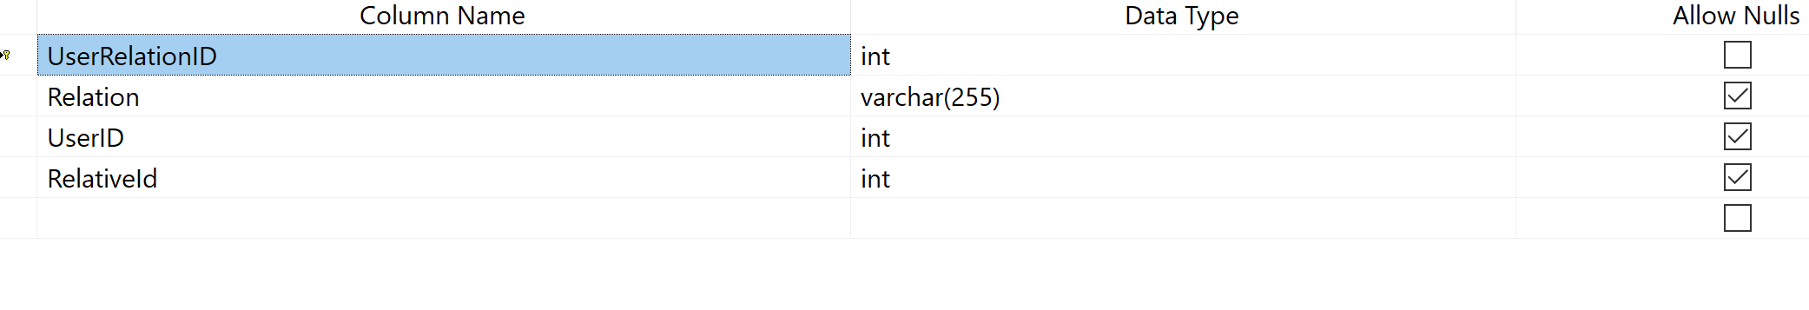

In this case the part in Entity Framework can we organized this way

We will have Relatives and Users collection of UserDAL in UserDAL, and using the Fluent API will construct the navigational properties

protected override void OnModelCreating(DbModelBuilder modelBuilder)

{

modelBuilder.Entity<UserDAL>()

.HasMany(c => c.Users)

.WithMany(c => c.Relatives)

.Map(m =>

{

m.MapLeftKey("UserID");

m.MapRightKey("RelativeId");

m.ToTable("UserRelatives");

});

}