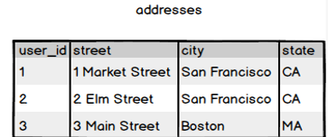

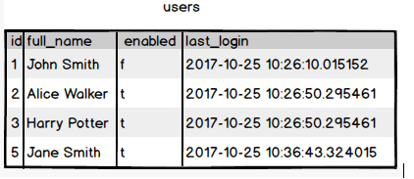

**Ques.1. Write a SQL query to fetch all users full_name from San Francisco.**

**Your Answer:**

SELECT * users.full_name from addresses inner join users on addresses.user_id=users.id where addresses.city='San Francisco'

**Ques.2. Write a SQL query to fetch all users full_name, last_login who are enabled**

**Your Answer:**

SELECT *Users.full_name, last_login from users where enabled = ‘t’;

**Ques.3. Write a SQL query to fetch all users full_name who are not from Main street**

**Your Answer:**

SELECT* Users.full_name from users WHERE users_id = (SELECT user_id from addresses where Street NOT LIKE ‘%Main Street%')

**Ques.4. Write a SQL query to fetch all users full_name who are from Main street or San Francisco**

**Your Answer:**

SELECT* users.full_name from addresses inner join users on addresses.user_id=users.id where addresses.street = 'Main Street' or 'San Francisco'

**Ques.5. Write a SQL query to fetch user full_name who is equal to user_id from Boston (find user_id value in sub_query)**

**Your Answer:**

SELECT~~*~~ users.full_name from addresses from users where users.id = (select user_id from addresses where city = 'Boston')