CSB312 | GENERATIVE AI FOUNDATIONS
NexusCare
Intelligent Care Coordination
Care, coordinated.

Mini Project Report
Assessment | Continuous Assessment 3, Mini Project 2 (30 marks)
Selected project | Option 3: NexusCare, Intelligent Care Coordination
Feature implemented | Patient or caregiver voice note to structured appointment request
Student name | [Your name]
Roll number | [Your roll number]
Deployed frontend URL | [Paste your live URL here]
GitHub repository | [Paste your repository link here]
Date | 29 October 2026

Turns a patient's voice note or text into a validated appointment request using schema-guided Gemini AI. Users review and confirm before anything is saved.

Contents
1. Project title, objective and problem statement
2. Selected automation idea and required workflow
3. Architecture and technology stack
4. Schema definition and sample structured AI output
5. Prompt design
6. Database design and the create/update operations
7. API flow, validation and safeguards
8. Testing: success case and error cases
9. Screenshots
10. Deployment and deployed frontend URL
11. Known limitations and future improvements
12. Conclusion
1. Project title, objective and problem statement
Title: NexusCare, Intelligent Care Coordination (tagline: "Care, coordinated.")
Objective: to build a full-stack Generative AI application that turns an unstructured patient or caregiver message, typed or spoken, into a structured appointment request. The AI output is validated, shown to the user for review, and saved to a database only after the user confirms.
Problem statement: hospital front desks receive appointment requests as free-form voice notes and messages, often in mixed languages. Staff must read each one, work out the patient's name, contact, reason, preferred time, department and urgency, and re-type it into a system. This is slow and error-prone, and urgent cases can be missed in a long queue. NexusCare automates the extraction and triage step while keeping a person in control of what is saved.
2. Selected automation idea and required workflow
Selected idea (Option 3, NexusCare): convert a patient or caregiver voice note into a structured appointment request. A staff board lets staff update the status of each request.
The application follows the workflow required by the assignment:
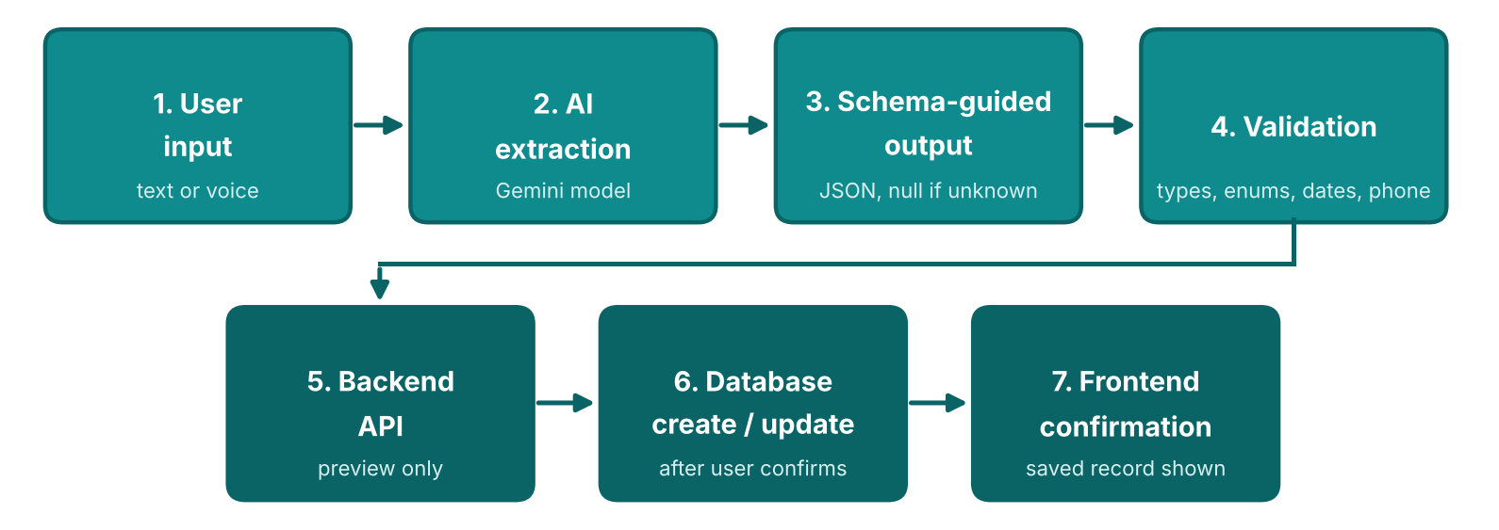
Figure A: Required workflow, from user input to frontend confirmation
- User input: the patient speaks (browser speech recognition in English, Hindi or Punjabi) or types a message.
- AI extraction: the backend sends the text to a Gemini model with a schema-guided prompt.
- Schema-guided output: the model returns one JSON object with fixed fields; unknown values are null.
- Validation: the backend checks types, enums, dates and phone format, and lists missing fields.
- Backend API: the result is returned to the frontend as a preview. Nothing is saved yet.
- Database create/update: after the user edits and confirms, the record is created. Staff later update its status.
- Frontend confirmation: the saved record is displayed with its ID and status.
3. Architecture and technology stack
The system has three layers. The browser talks only to the backend, and the backend alone talks to the AI service and the database, so the API key never reaches the browser.
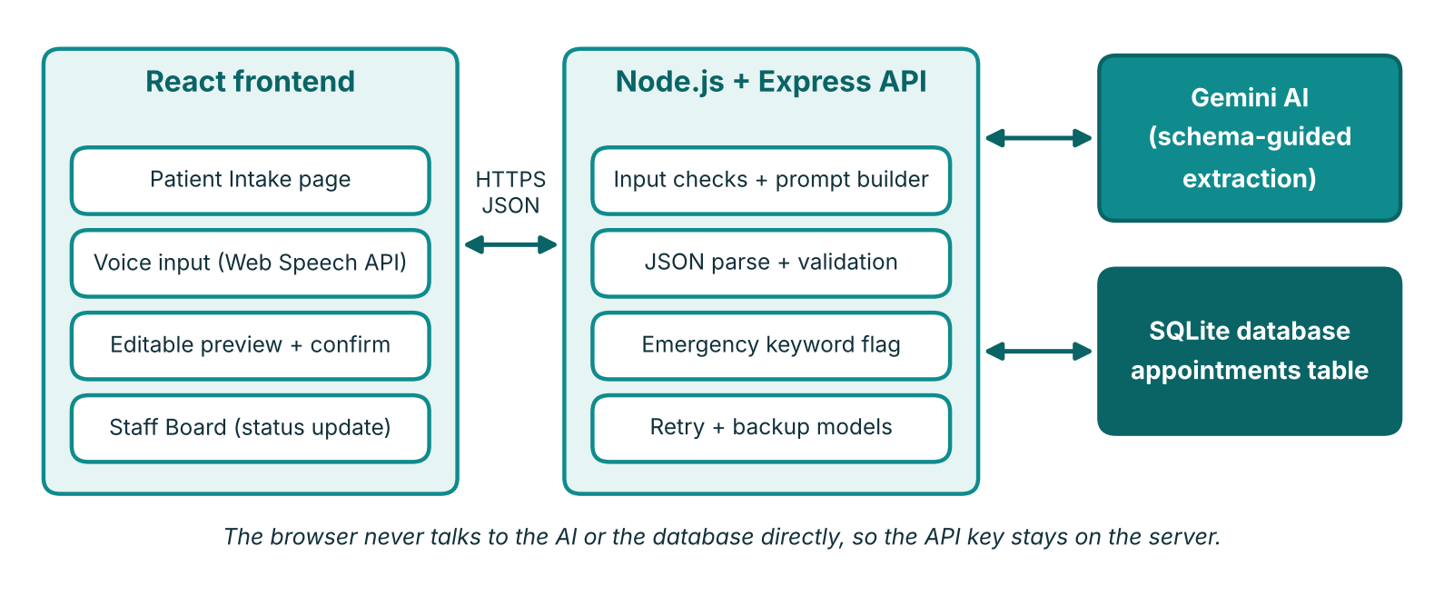
Figure B: System architecture
Layer | Technology | Purpose
Frontend | React 18, Vite, plain CSS | Intake form, editable preview, staff board
Voice input | Browser Web Speech API | Speech to text in English, Hindi, Punjabi
Backend | Node.js, Express | REST API, prompt building, validation
AI | Google Gemini via OpenAI-compatible API | Schema-guided extraction
Database | SQLite (Node built-in node:sqlite) | Stores appointment records
Hosting | Render (single web service) | Serves the API and the built frontend
4. Schema definition and sample structured AI output
The AI must return exactly these fields. Any value that is not stated in the message must be null, never guessed.
Field | Type | Rule
patient_name | string or null | Required to save
contact | string or null | Phone number, at least 7 digits
reason | string or null | Short English summary; required to save
preferred_date | YYYY-MM-DD or null | Must not be in the past
preferred_time | string or null | For example "morning" or "10:30 AM"
department | enum | General, Cardiology, Pediatrics, Orthopedics, Other
urgency | enum | routine, soon, urgent

Input message: "I'm Ravi Kumar, my number is 9876543210. I have chest pain since morning, need a doctor tomorrow morning."
Sample structured AI output:
{
"patient_name": "Ravi Kumar",
"contact": "9876543210",
"reason": "Chest pain since morning",
"preferred_date": "2026-10-30",
"preferred_time": "morning",
"department": "Cardiology",
"urgency": "urgent"
}

Tip
Replace this sample with the exact output from your own run on the deployed site if it differs.
5. Prompt design
The prompt is built on the server for every request and sent as a system message, with the patient's text as the user message. Temperature is 0 so the output is as consistent as possible.
Key design decisions
- Fixed role: "intake assistant for a hospital front desk", so the model stays on task.
- Explicit schema in the prompt: every key, its type and the allowed enum values are listed, and the model must return only one JSON object.
- No inventing values: "If a value is NOT stated, use null. Never guess or invent a name, phone number or date." This is the assignment's missing-value rule.
- Today's date is injected, so relative dates such as "tomorrow" or "next Monday" become real YYYY-MM-DD values.
- Multilingual input, English output: Hindi, Punjabi or mixed messages are accepted, and all values are returned in English.
- Urgency rules: emergencies (chest pain, breathing trouble, severe bleeding) are urgent; pain, fever or worsening symptoms are soon; everything else is routine.
- No diagnosis: the model is told not to give medical advice.
Because models sometimes wrap JSON in code fences, the backend strips them before parsing. The parsed object is never trusted directly; it always goes through validation (section 7).
6. Database design and the create/update operations
The application uses one SQLite table, appointments.
Column | Type | Notes
id | INTEGER, primary key | Auto-increment
patient_name | TEXT, not null | From the AI output, editable by the user
contact | TEXT | Phone number, may be empty
reason | TEXT, not null | Short summary of the problem
preferred_date | TEXT | YYYY-MM-DD
preferred_time | TEXT | Free text such as "morning"
department | TEXT, not null | One of the five allowed values
urgency | TEXT, not null | routine, soon or urgent
status | TEXT, not null | Pending (default), Confirmed, Completed, Cancelled
source_text | TEXT | The original message, kept for audit
created_at, updated_at | TEXT | Timestamps set by the database

Create operation: POST /api/appointments runs an INSERT after the user clicks "Confirm & Save". The saved row is read back and shown on screen as the confirmation.
Update operation: PATCH /api/appointments/:id/status runs an UPDATE that changes status and updated_at. Staff trigger it from the Staff Board dropdown.
Read: GET /api/appointments lists all requests, with urgent ones first.
7. API flow, validation and safeguards
Method | Endpoint | Purpose
POST | /api/extract | Text goes to the AI, then validation. Returns a preview only; nothing is saved.
POST | /api/appointments | Creates the record. Refused unless confirmed is true.
GET | /api/appointments | Lists all requests, urgent first.
PATCH | /api/appointments/:id/status | Updates the status of one request.
Validation rules (server side)
- The AI output must be a JSON object; anything else is rejected with an error.
- Required fields: patient_name and reason. If either is missing, saving is blocked.
- Unknown department values become Other; unknown urgency values become routine, and a warning is shown.
- A past preferred_date or a wrongly formatted date is cleared, with a warning.
- A contact with fewer than 7 digits is cleared, with a warning.
- Empty fields are listed in missing_fields and highlighted in the interface.
- The server validates again on save, because the user may have edited the preview.
Error handling
Messages that are empty, too short or longer than 2000 characters are rejected. If the AI service is busy (429 or 503), the backend retries and then tries backup models. If the AI times out or fails, the user sees the reason on screen instead of a blank page. A network failure shows a "cannot reach the server" message.
Safeguards for sensitive data
- Preview and explicit confirmation before anything is saved (a high-impact action).
- The API key is stored only in server environment variables and is never sent to the browser.
- The AI is told not to diagnose or give medical advice.
- An emergency banner appears for messages that mention symptoms such as chest pain or difficulty breathing, advising the user to call emergency services.
- Only made-up test data is used during development.
8. Testing: success case and error cases
Run each test on the deployed site, write the real outcome in the Result column, and attach the matching screenshot in section 9.
# | Input or action | Expected behaviour | Result
1 | "I'm Ravi Kumar, my number is 9876543210. I have chest pain since morning, need a doctor tomorrow morning." | All fields extracted, Cardiology, urgent, emergency banner shown, record saved after confirm | [Pass / Fail]
2 | "My son has fever for two days. Please book a child specialist. Contact 9812345678." | Pediatrics, urgency soon, patient name missing and highlighted until typed | [Pass / Fail]
3 | "I need an appointment." (missing-field case) | Missing fields highlighted, validation shows failed, Confirm button disabled | [Pass / Fail]
4 | "hi" (invalid input) | Rejected: message too short | [Pass / Fail]
5 | A Hindi message with name, problem and phone number | Fields returned in English, record can be saved | [Pass / Fail]
6 | Staff changes a request from Pending to Confirmed | Status updates on screen and in the database | [Pass / Fail]
7 | Save request sent without confirmation | Server refuses with a confirmation-required error | [Pass / Fail]
8 | AI service busy or slow | Retry and backup model, or a clear error with the reason | [Pass / Fail]

Assignment requirement
Show one successful flow and at least one invalid-input, missing-field or error case. Tests 1 and 6 show the successful flow; tests 3, 4 and 7 show the error handling.
9. Screenshots
Replace each placeholder with your screenshot from the deployed site.
[ Insert screenshot here ]
Figure 1: Patient Intake page with the message typed in
[ Insert screenshot here ]
Figure 2: AI preview with extracted fields, validation status and emergency banner (test 1)
[ Insert screenshot here ]
Figure 3: Saved confirmation showing the request number (successful database create)
[ Insert screenshot here ]
Figure 4: Missing-field case with highlighted fields and disabled Confirm button (test 3)
[ Insert screenshot here ]
Figure 5: Invalid input rejected (test 4)
[ Insert screenshot here ]
Figure 6: Hindi input converted to English fields (test 5)
[ Insert screenshot here ]
Figure 7: Staff Board showing saved requests with urgency badges
[ Insert screenshot here ]
Figure 8: Staff Board after a status change (database update, test 6)
10. Deployment and deployed frontend URL
Deployed frontend URL (mandatory)
[Paste your live Render URL here]

Source code repository: [Paste your GitHub repository link here]
The application is deployed as a single web service on Render, built from the GitHub repository. The build step installs the frontend, builds the React app, and installs the backend. The start step runs the Express server, which serves both the API and the built frontend. Because both come from one address, the deployed frontend connects directly to the working backend and database with no extra configuration.
Setting | Value
Build command | cd frontend && npm install --include=dev && npm run build && cd ../backend && npm install
Start command | cd backend && npm start
Node version | 24.14.0 (set with NODE_VERSION)
Environment variables | AI_BASE_URL, AI_API_KEY, AI_MODEL, set in the Render dashboard

The .env file and the API key are not stored in the repository; the .env file is excluded by .gitignore.
11. Known limitations and future improvements
Limitations
- Voice input depends on the browser. It uses the Web Speech API, which works in Chrome and Edge. Typing is always available.
- Free AI tier limits. The Gemini free tier has rate limits and can be busy; responses may be slow at peak times. The backend retries and uses backup models to reduce this.
- Data may reset on free hosting. The SQLite file lives on the server's disk, which can be cleared when a free service restarts.
- No login or roles. Anyone with the link can use both the intake page and the Staff Board.
- AI can be wrong. Department and urgency are suggestions. The user reviews them before saving, and staff confirm requests.
- Not a medical tool. The system does not diagnose and is not a replacement for emergency services.
- Single clinic, no real appointment slots. Requests record a preferred date and time but do not check availability.
Future improvements
- Login with separate patient and staff roles.
- Audio file upload with server-side transcription for better accuracy in Indian languages.
- SMS or email confirmation and reminders.
- Real calendar slots and doctor availability.
- A managed database such as PostgreSQL for permanent storage.
- An audit log of who changed each status, and the other NexusCare features from the brief (visit summaries, care-plan checklists).
12. Conclusion
NexusCare meets the assignment's workflow end to end: user input, AI extraction with a schema-guided prompt, validation, a backend API, a database create and update, and a frontend confirmation. Missing or invalid values are flagged instead of invented, and nothing is saved until the user confirms the preview. The project shows how Generative AI can reduce manual data entry at a hospital front desk while keeping a person in control of every saved record.

