Content Based Image Retrieval using Deep Learning
In this project we have used COREL1000 images dataset to train various deep learning algorithms such as VGG16, MobileNet and ResNet to predict content based images retrieval. After retrieving images using deep learning algorithms then we are applying COSINE similarity to fetch top 10 similar images. In below screen we are showing dataset used in this project
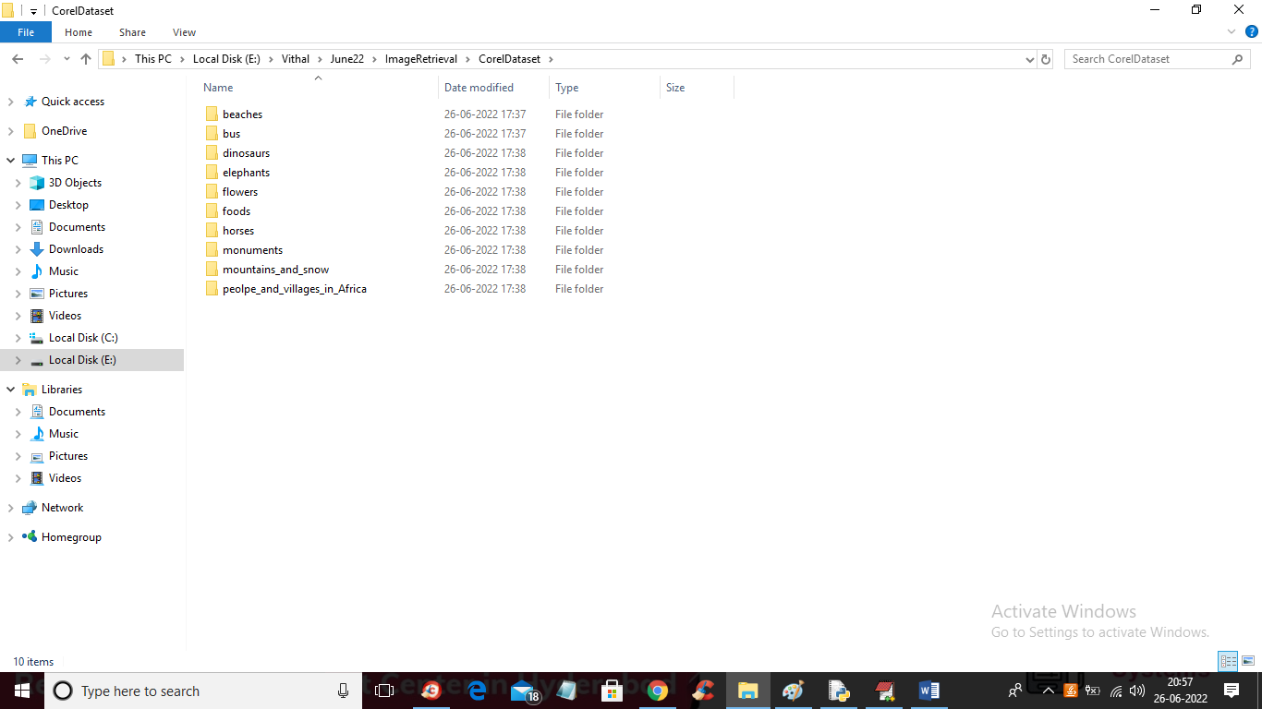
In above screen from COREL we are using 10 different images classes such as BUS, FOODS and many more and just go inside any folder to view those images
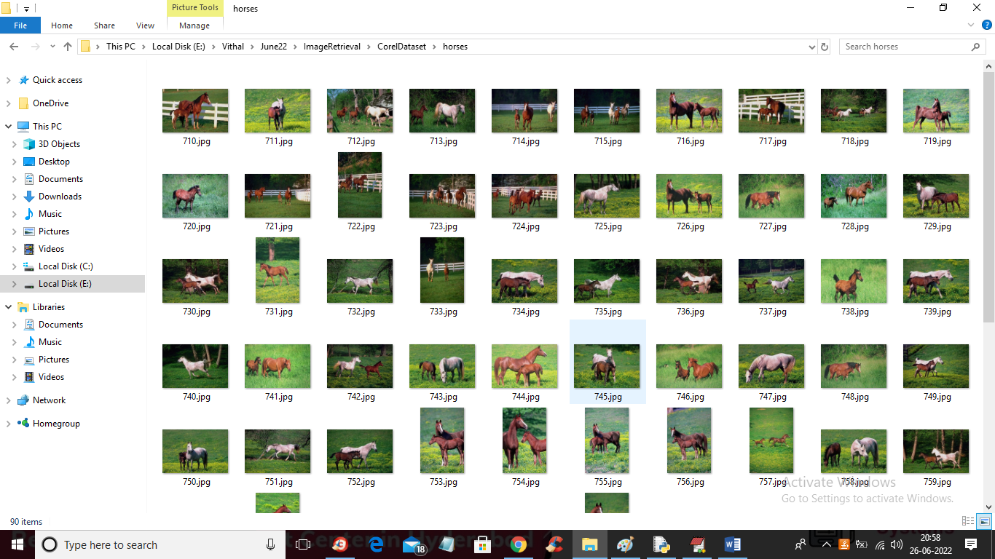
So by using above images we are training above mention algorithms and in below screen I am showing code for various algorithms
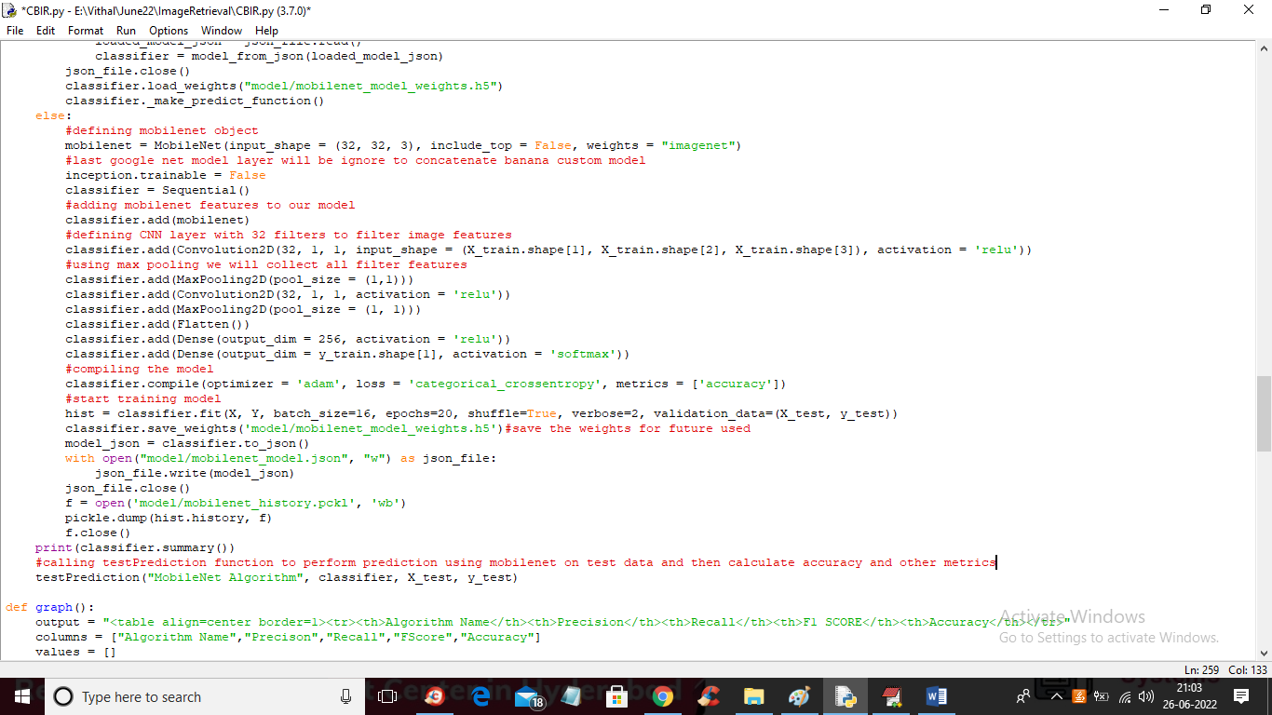
In above screen we are defining MOBILNET model and then training and then calculating accuracy by calling testPrediction function. In above screen read red colour comments to know about mobile net implementation. In below screen I am showing code for accuracy and other metrics calculation in testPrediction function
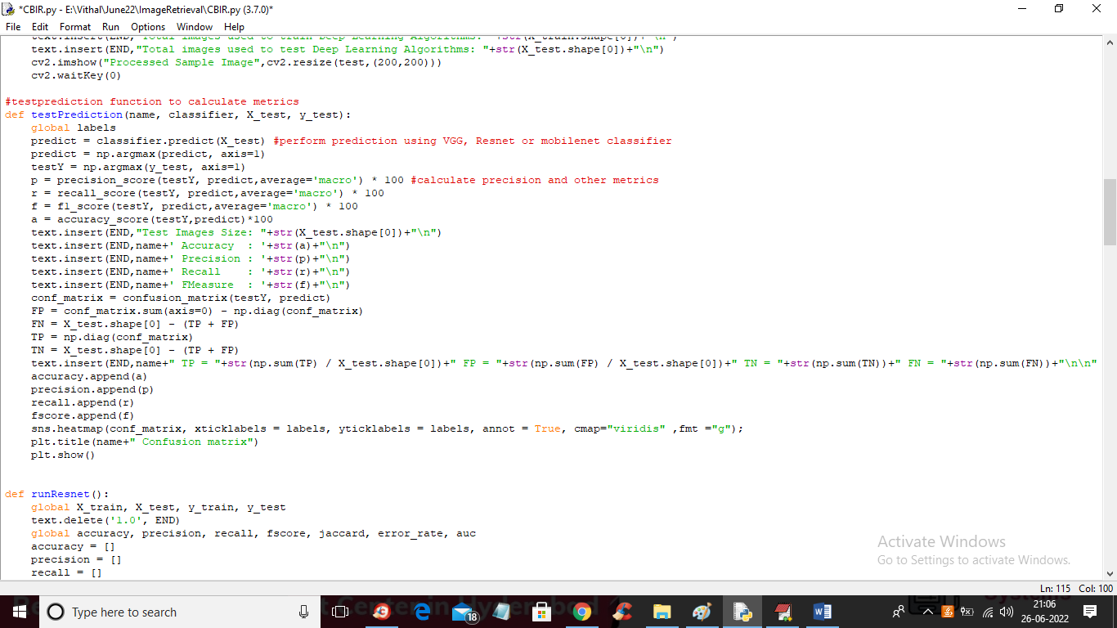
In above screen you can see code for accuracy and other metrics calculation and in below screen you can see VGG16 model code
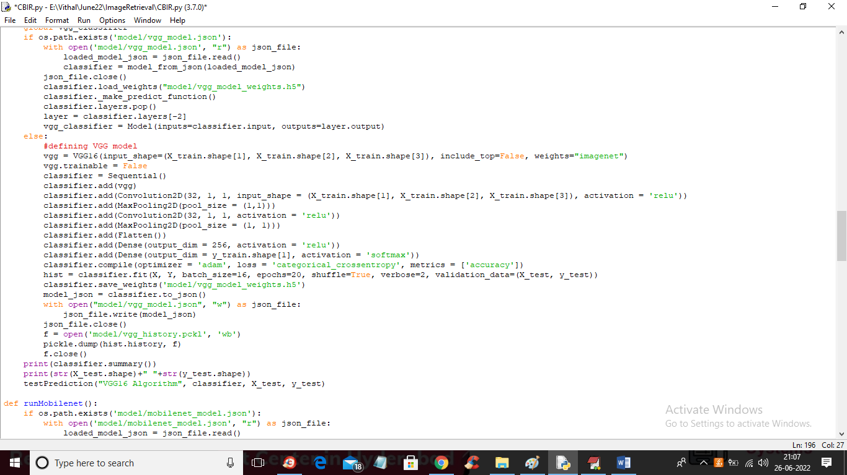
In above screen defining VGG16 model and in below screen you can see RESNET CODE
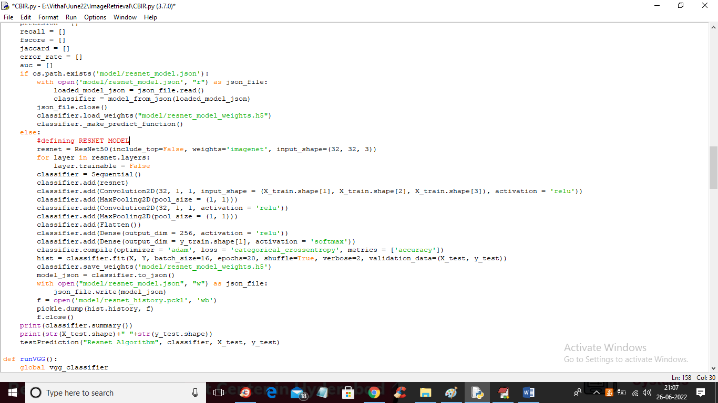
In above screen read red colour comments to know about RESNET model and in below screen using VGG16 we are extracting features and then performing Content Based image retrieval
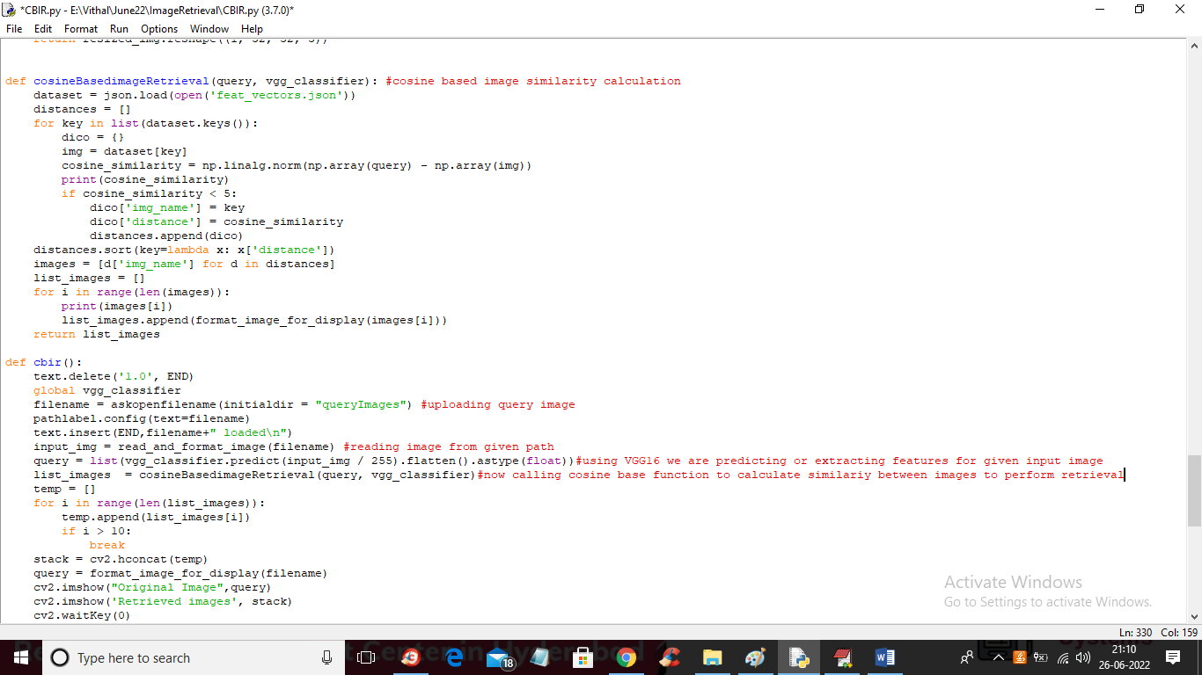
In above screen code you can see we are uploading query image and then extracting features using VGG16 and then apply COSINE function to get top similar images as CBIR.
SCREEN SHOTS
To run project double click on ‘run.bat’ file to get below screen
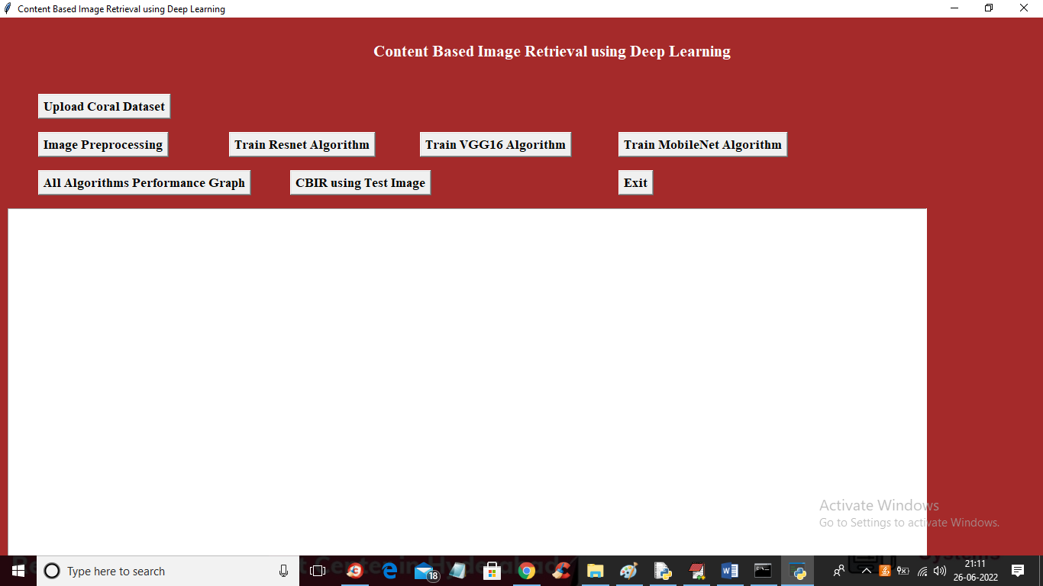
In above screen click on ‘Upload Coral Dataset’ button to upload dataset and get below screen
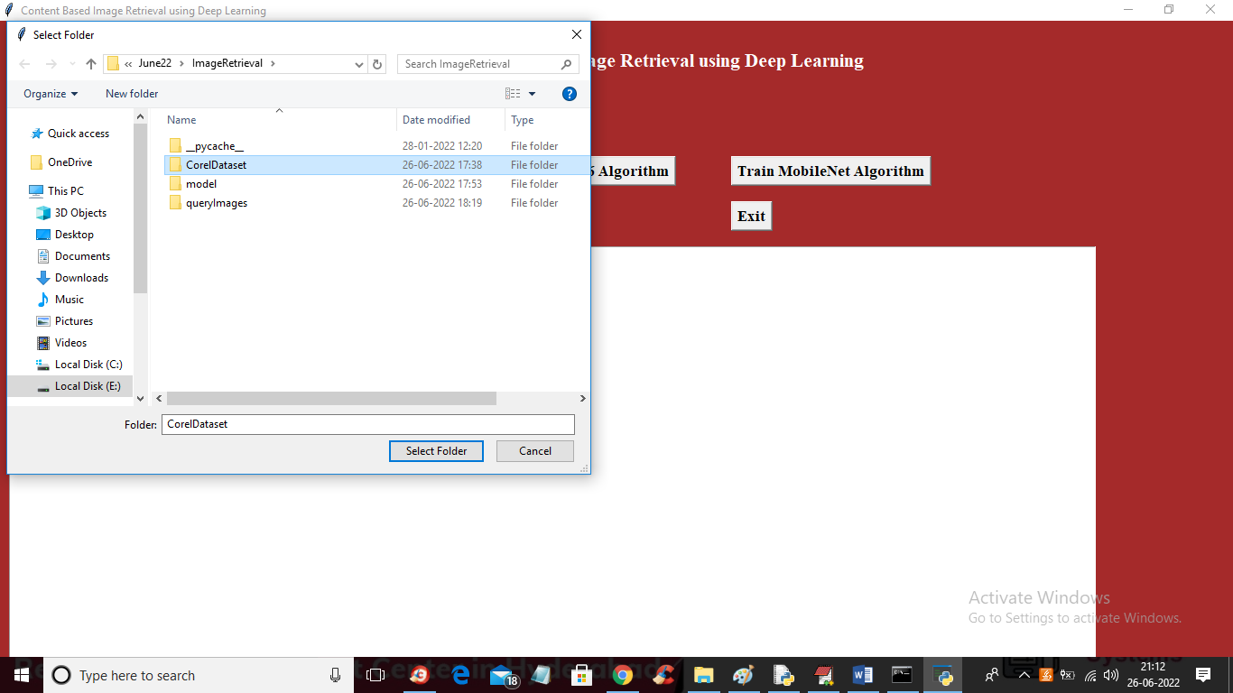
In above screen selecting and uploading CORAL dataset and then click on ‘Select Folder’ button to load dataset and get below output
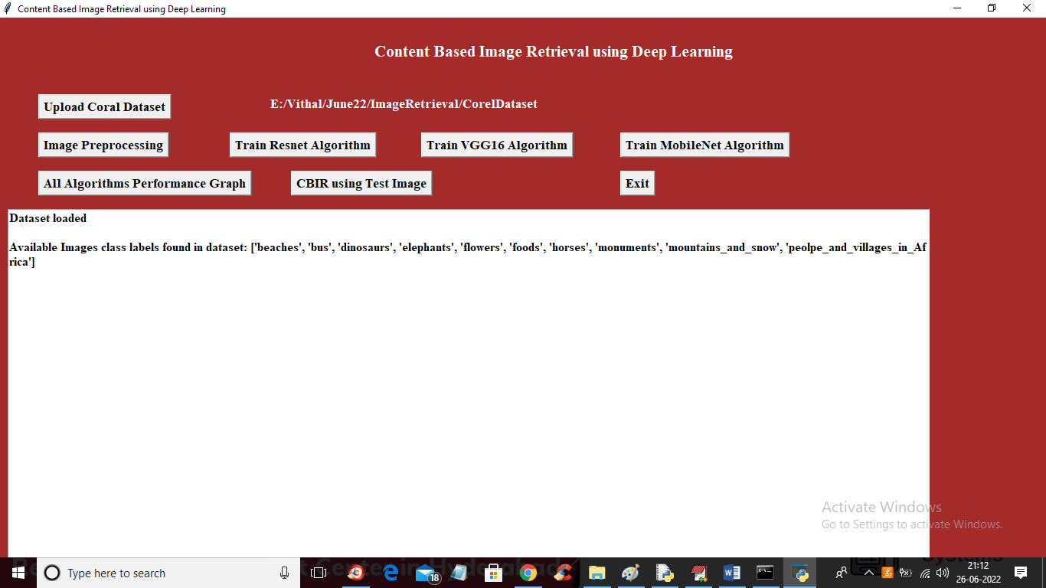
In above screen dataset loaded and we can see different classes of images found in dataset and now click on ‘Image Preprocessing’ button to read all images and then resize all images to equal size and then normalize image pixel values and then split dataset images into train and test and get below output
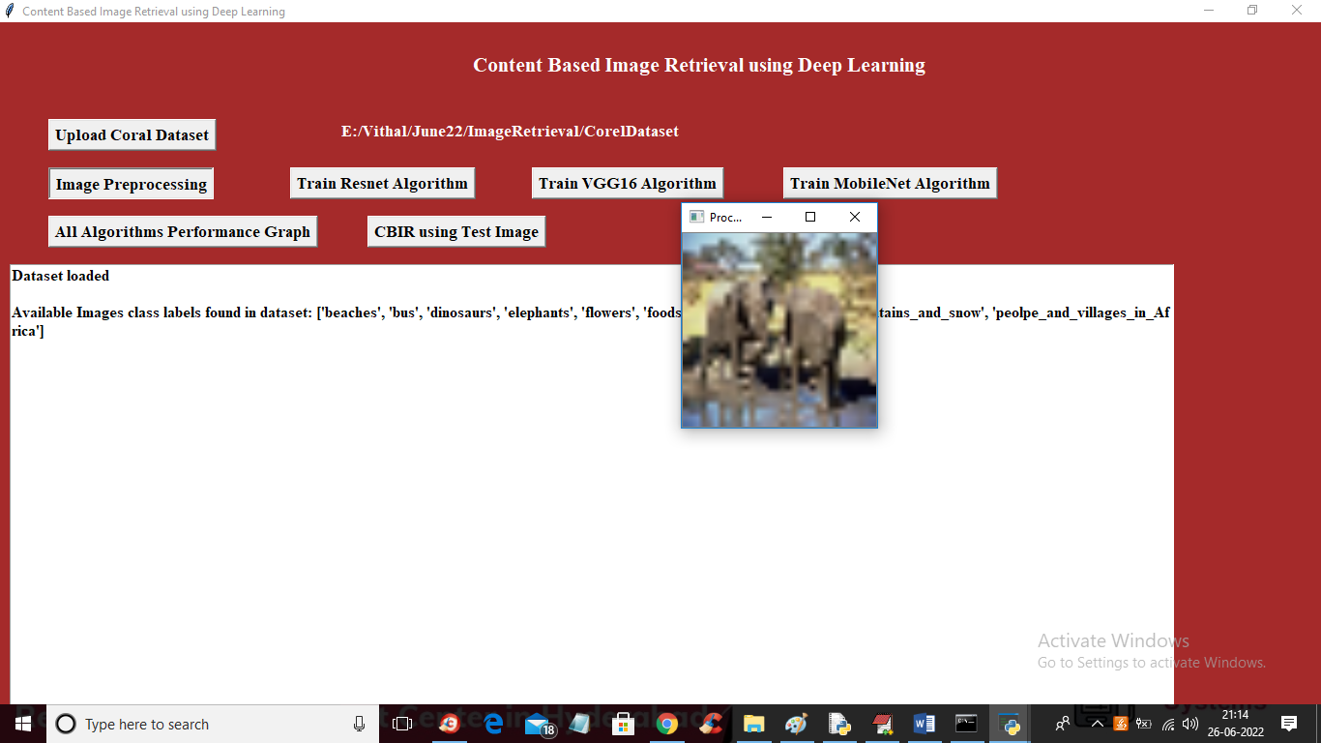
In above screen we can see all images are processed and loaded and we can see one sample processed image and now close above image to get below output
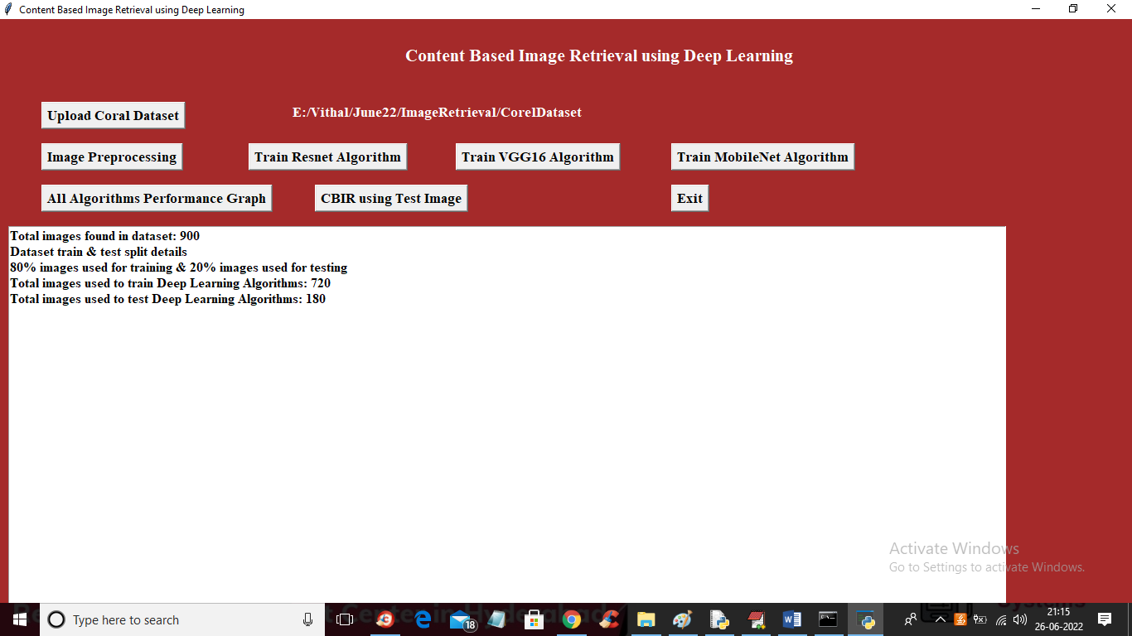
In above screen we can see dataset contains 1000 images and application using (80%) 720 images for training and 120 (20%) images for testing and now train and test data is ready and now click on ‘Train Resnet Algorithm’ button to get below output

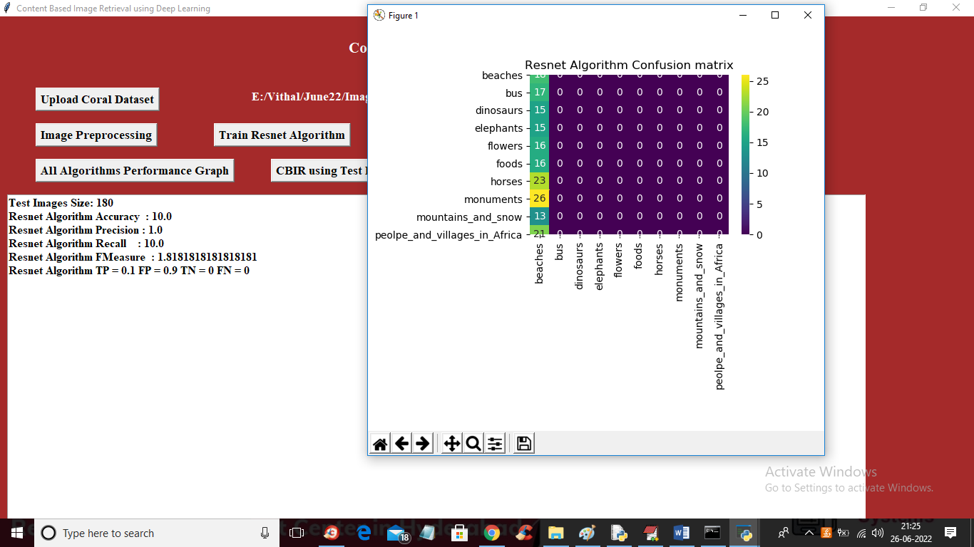
In above screen with Resnet we got 10% accuracy and this model is not giving best accuracy and in confusion matrix graph x-axis represents PREDICTED classes and y-axis represents TEST classes and in above graph we can see RESNET predicted all wrong classes and we can see all classes predicted only in 1 class so its accuracy is not good and now close above graph and then click on ‘Train VGG16 Algorithm’ button to get below output
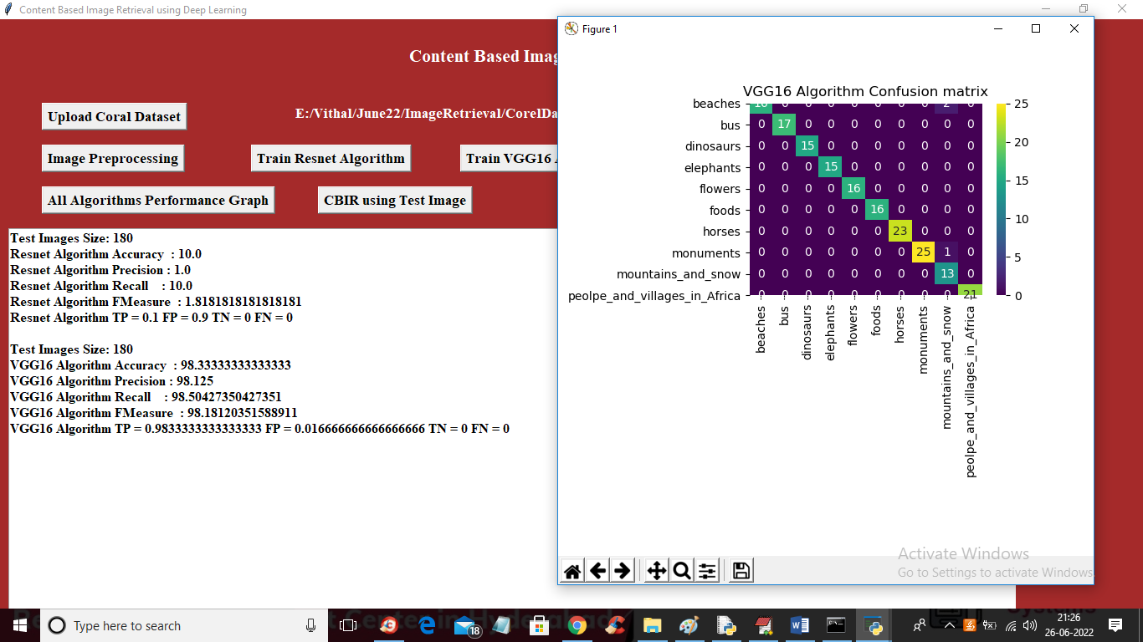
In above screen with VGG16 we got 98% accuracy and in confusion matrix in DIAGNOL we can see maximum TEST records are predicted correctly so its accuracy is high and now close above graph and then click on ‘Train MobileNet Algorithm’ button to get below output
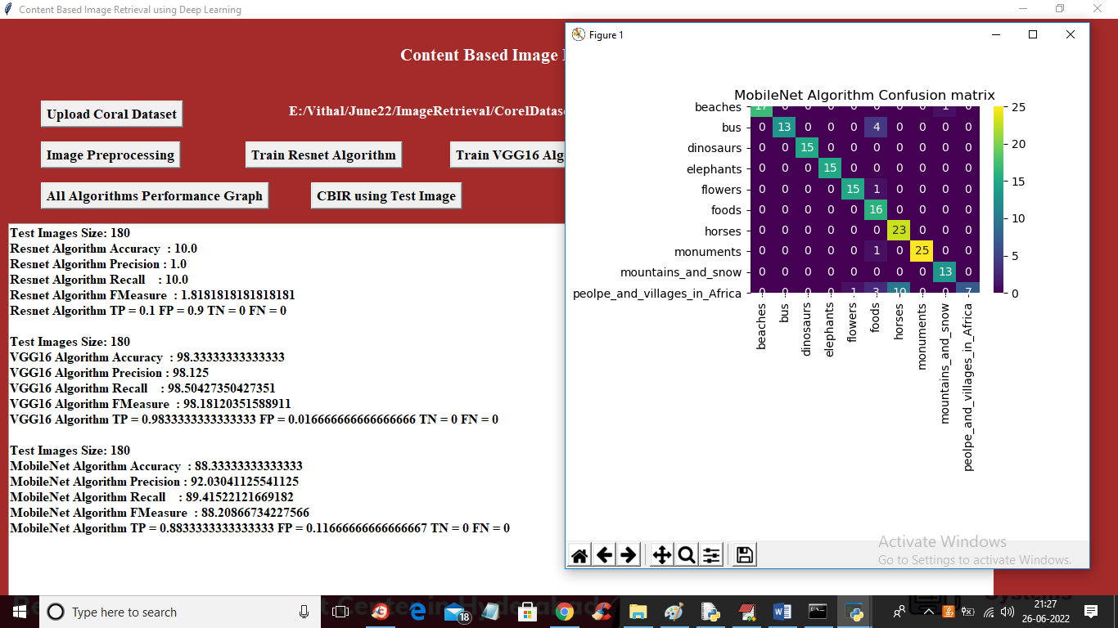
In above screen with MobileNet we got 88% accuracy and in confusion matrix graph also we can see maximum TEST records are correctly predicted and now close above graph and then click on ‘All Algorithms Performance Graph’ button to get below graph
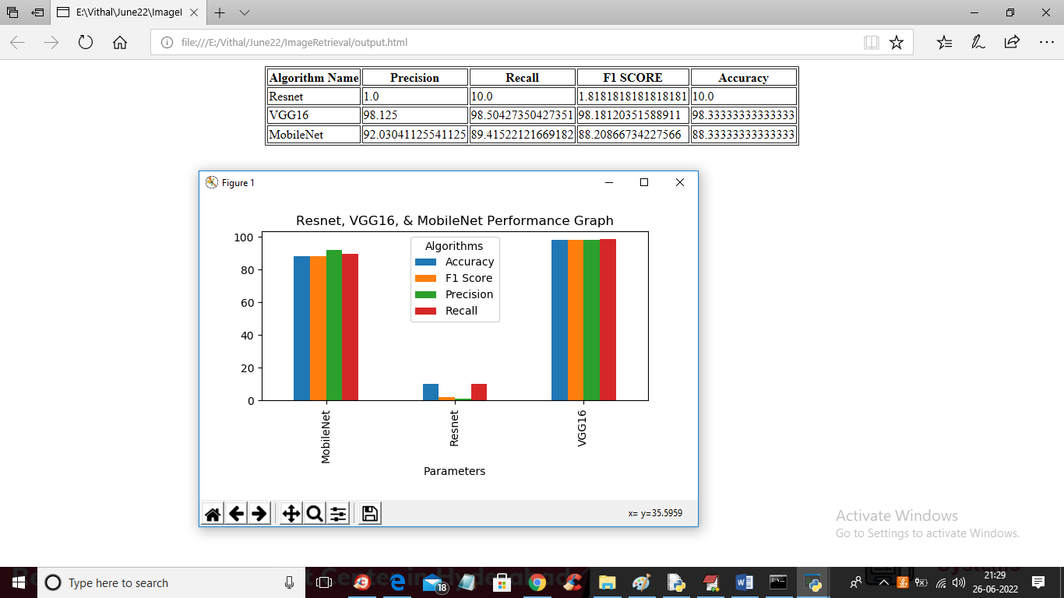
In above screen in tabular and graphical format we can see all algorithms performance and in graph x-axis represents algorithms names and y-axis represents accuracy and other metrics and each metric represent in different colour bar and we can see in all 3 algorithms VGG16 is giving high accuracy and now close above graph and then click on ‘CBIR using Test Image’ button to upload test image and then deep learning algorithm will retrieve similar images
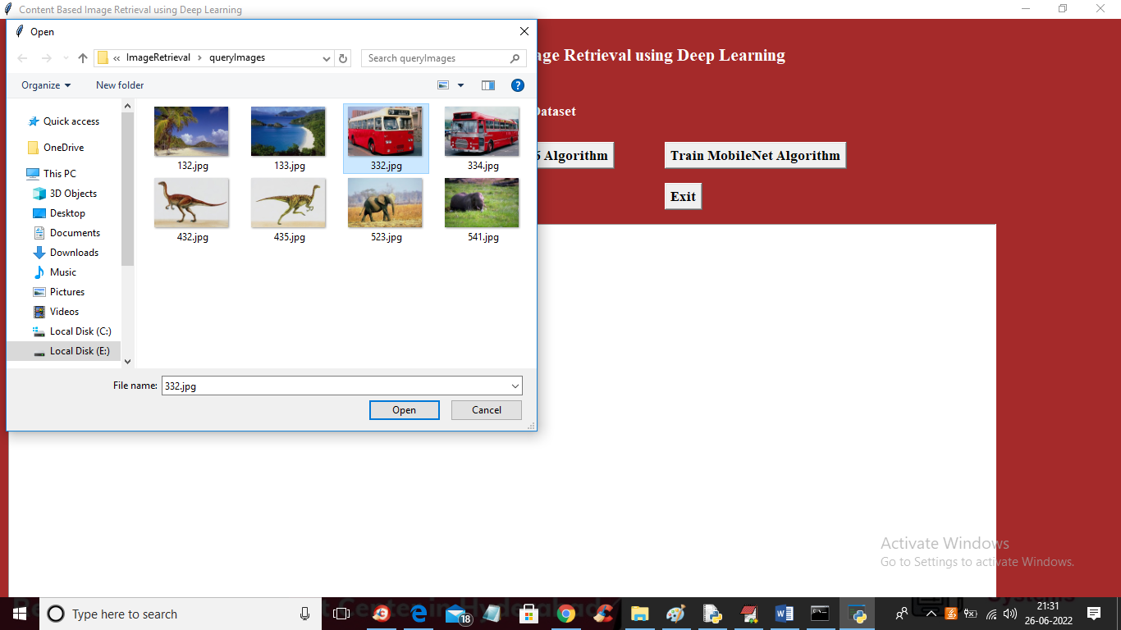
In above screen selecting and uploading BUS image and then click ‘Open’ button to get below output
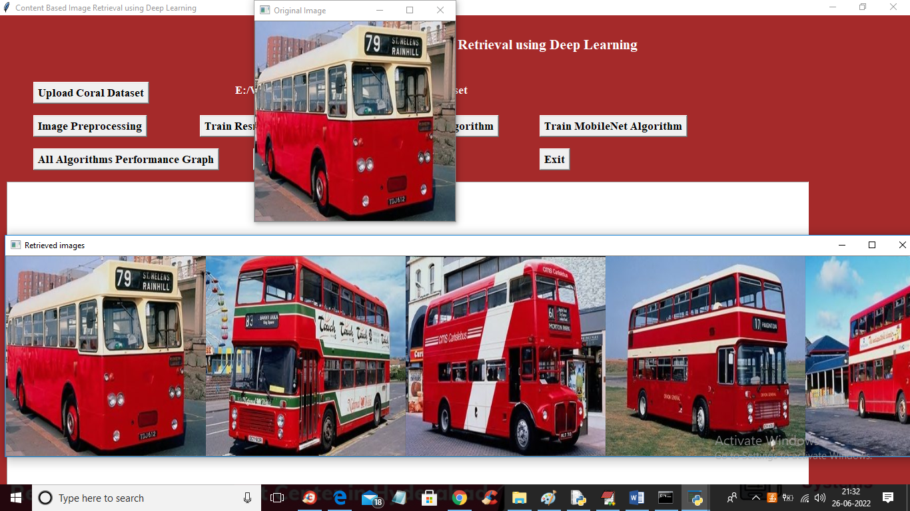
In above screen in top we can see query image and in bottom we can see similar content based image retrieval and similarly you can upload and test other images and below is the another image output
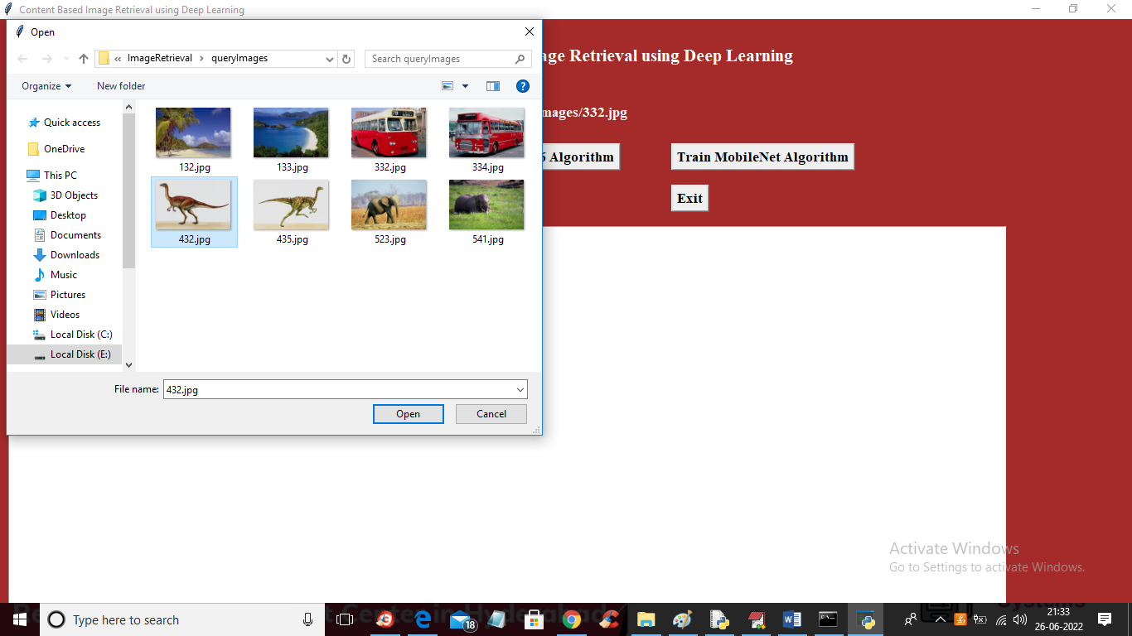
In above screen selecting and uploading ‘412.jpg’ dinosaur image and below is the output
