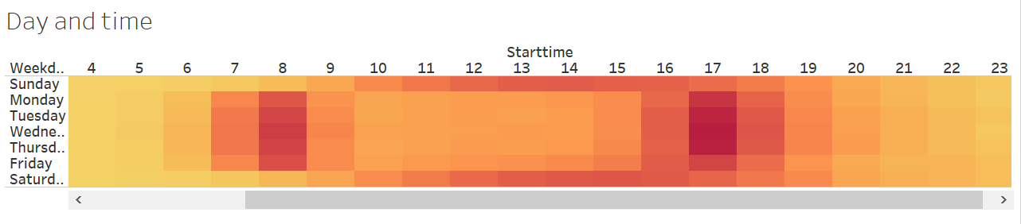

We used this heat map to visualize at what time of the data start and end stations are busy and also according to the week day.

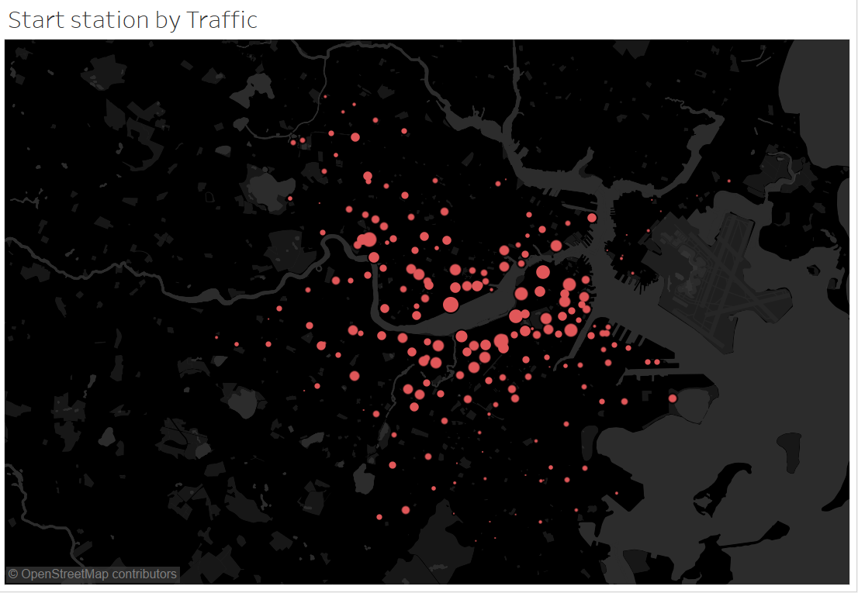

In the above map we plotted the start station locations according to their latitude and longitude data and the size of the circle represents the traffic of the station throughout the year.

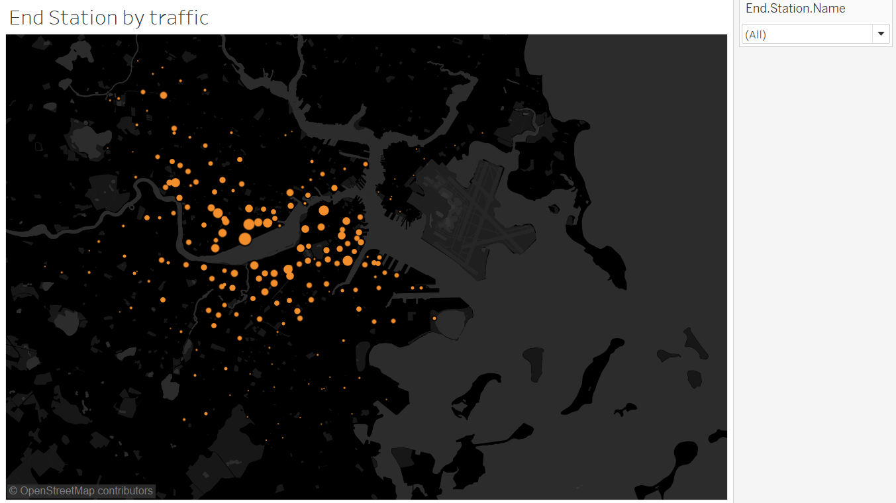

As we have seen the starting station and their traffic, we have done a similar kind of analysis and visualization on the end stations as well.

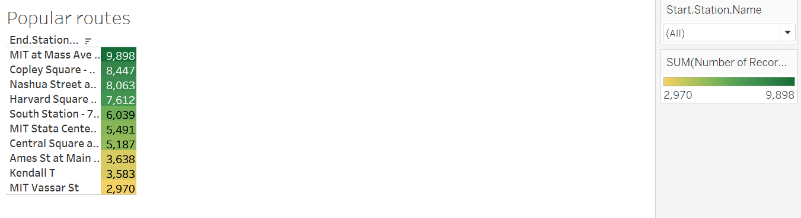

In the next sheet we listed the top 10 destination of each start station and as a play field we gave a drop down for the user to select the start station which he wants to analyze.

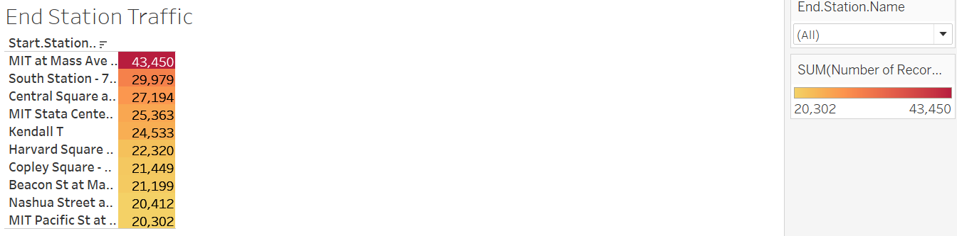

As we have seen the starting station and their top 10 end stations, we have done a similar kind of analysis and visualization on the end stations as well by showing the top 10 starting stations.

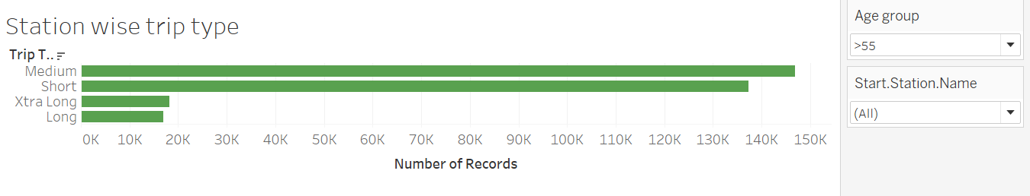

Moving further we created a interactive sheet which takes the age group and start station as input and give the Station wise trip data according to age.

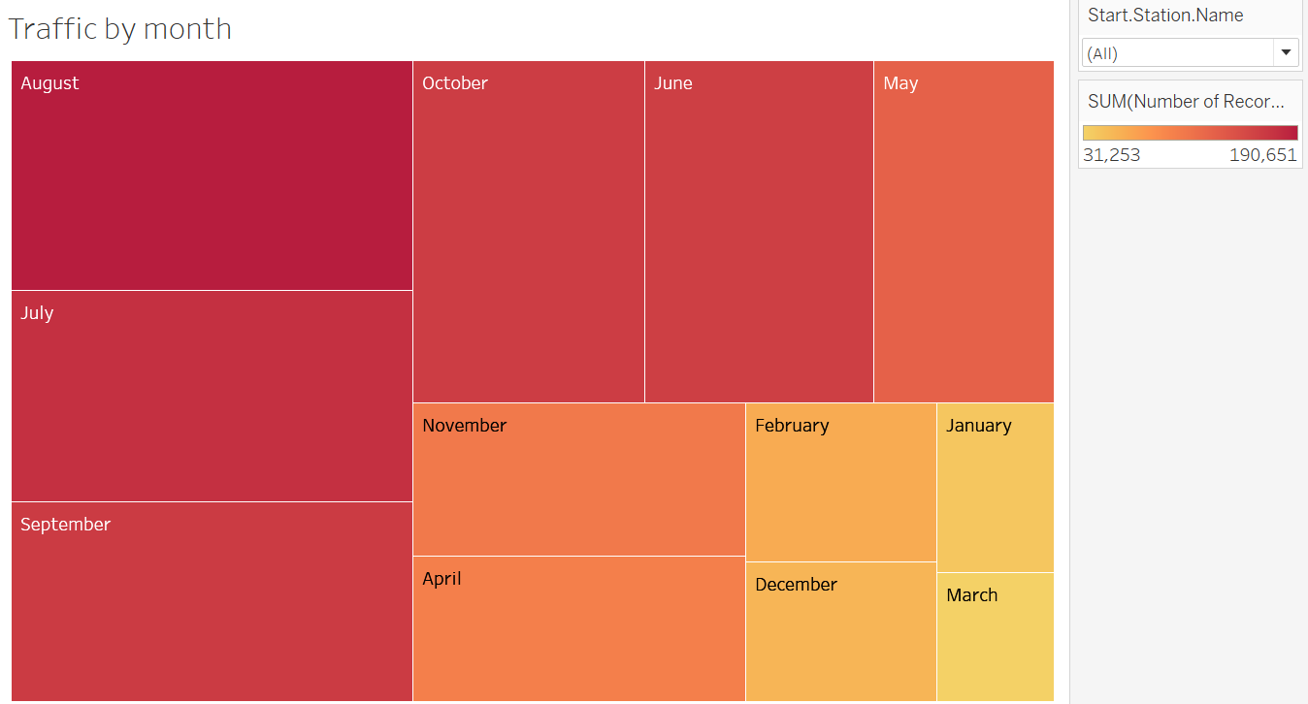

In the next sheet we created a tree map showing the traffic in the particular months for the start stations. User can select the station which he wants to analyze.

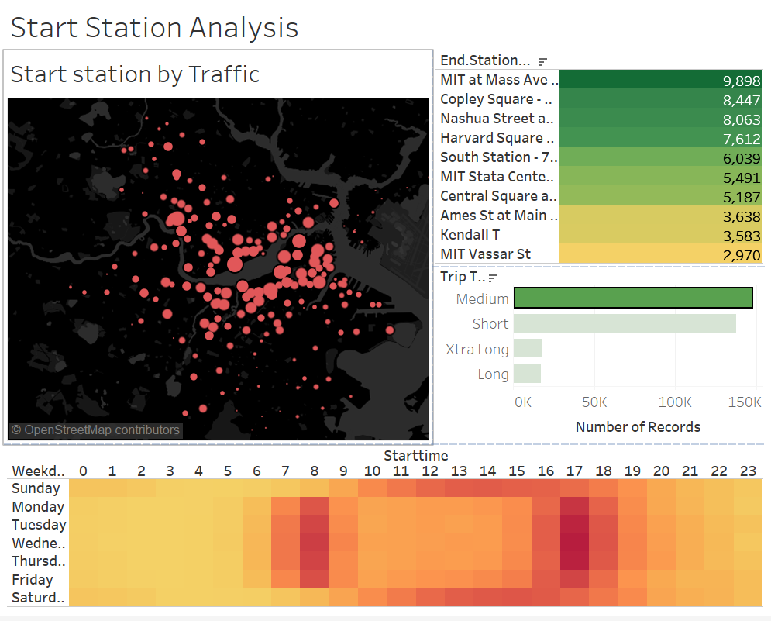

We crated an interactive dash board where user can select a start station and know the corresponding top 10 end stations and the distribution of trip types of the station and the heat map which shows the busiest hours of the station.

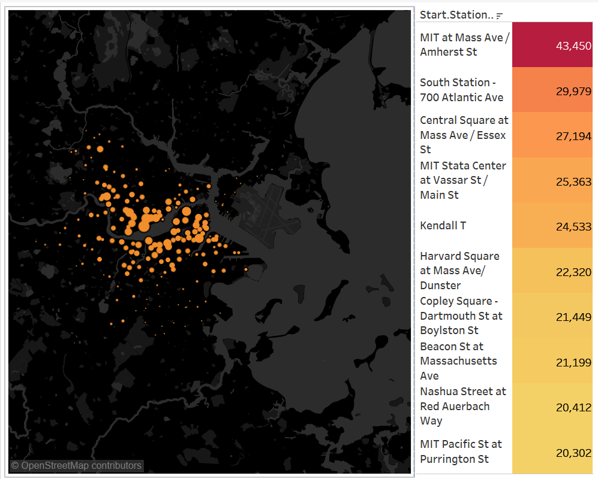

In the second dashboard we created an interactive interface where user can select a end station and the corresponding top 10 starting stations are displayed along the side.