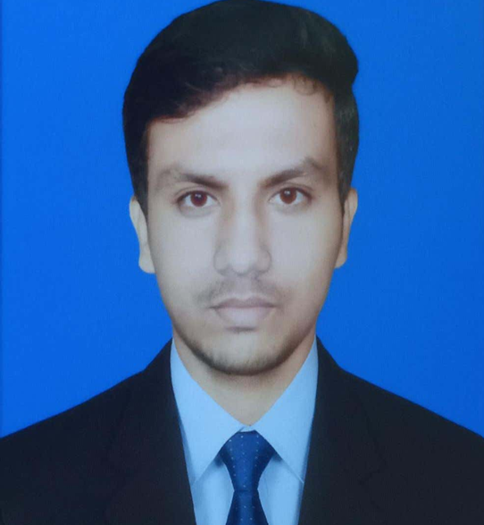
SHUSIL KUMAR NAYAK
Phone no: 9114021466
Email: shusilnayak38@gmail.com

OBJECTIVE

Looking forward to building a professional career as a Data Analyst in the IT sector ,where my skills and knowledge can be effectively utilized for the growth of organization as well as my personal development.

EDUCATION

Pursuing B.Tech in Computer Science and Engineering under BPUT, Odisha 2023-2027
12th Science | Science H S School, Hinjilicut | 58% 2023
10th | Board of Secondary Education, Odisha | Ashok Nodal High School, Jamuni | 85% 2021

TECHNICAL SKILL

- Python
- SQL
- MS Office
- Excel
- Jupyter Notebook
- Data Science Tools
- Data Analysis
- C

CERTIFICATION COURSES

- Summer Internship on From Basic to Breakthrough Python in Data Science , GCEK
- Internet of Things(IoT)-Entrepreneurship-cum-Skill Development Program(E-SDP) Ministry of MSME,Government of India.
- Intro to Analytic Thinking, Dat Science, and Data Mining, University of California,Irvine(UCI)-Coursera.

SEMINAR/WEBINAR

- Seminar On Digital Twins in Smart city.

AWARDS & RECOGNITION

- Paper Presentation on Neuralink and The Future of BCI Technology

AREA OF INTEREST

- Data Analyst
- Business Intelligence Analyst
- Data Visualization Specialist

EXTRA CURRICULAR ACTIVITIES

- Participated in Drawing Competition
- Participated in Various Cultural Activity

PERSONAL DETAILS

- Name: Shusil Kumar Nayak
- Father’s Name: mr. Purnnachandra Nayak
- DOB : 20TH JULY 2005
- Languages Known : English, Hindi, Odiya
- Address: AT: Karatali ,VTC: Polasara, PO: Kalambo, Ganjam ,PIN Code: 761105

DECLETATION

I hereby declare that the details furnished above are true and correct to the best of my knowledge and belief.

Date- 07.02.2026 ( Shusil Kumar Nayak )
PLACE- Berhampur SIGNATURE

