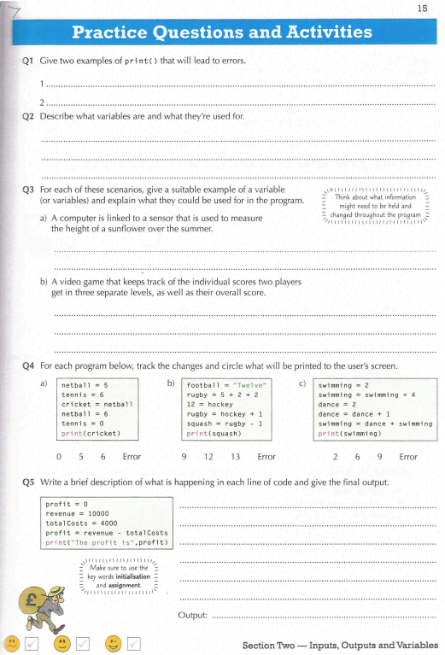Q1)
1) printf(:Hi:)
2) pritn(“Hi”
Q2)
Variables its like a box or bag which inside have something in CS its, numbers, float numbers, word or words line

Variable use for all code connect input to variables, make variables to saved data, write easy formulas and print it by using variable, operators, loops, function, algorithm and more, possible by using variable

Q3)
A) heigth_sun, heigth_nosun, difference
B) player1, player2, overall
Q4)
A) 5
B)Error
C)9
Q5)
1) variable for profit
2) variable for revenue
3) variable for total cost
4) count a profit by revenue – total cost
5) print a profit

