1. Title:
Mesh simplification: vertex-clustering studying

2. Abstract:
I want to do a vertex clustering algorithm which from Rossignac 93 [1](Multi-resolution 3D approximations for rendering complex scenes).
I want to divide the whole 3D image into slices of same size. Then partition the whole 3D image into small cubes. Then one cube can contain one vertex, then use the obj file to load the faces and using faces to find vertices. Use math to know which cube the vertices belongs to. get the mid coordinates of the cube to be the right position of the vertices. Then draw triangles to get approximate image. Then I hash the vertices into a 3 dimensional array(to make sure the vertices in the same cell in a specific position of the array). Then choose the one with the most number of the edges to be the representative vertex in the cell.

3. Introduction:
Mesh simplification is a critial technology to implement, cause as we know drawing triangles for simulating object will cost a lot of time each time we draw it if there are too many points and too many triangles to draw withing a certain area, so do the mesh simplification will reduce the vertices and the triangles to be draw, so the time that using for drawing the picture will be greatly reduced. There are several technologies for reducing the points like vertex clustering, edge collapse, vertex removal, vertex decimation. I use vertex clustering this time to do mesh simplification. The algorithm described by Rossignac and Borrel is one of the few capable of processing arbitrary polygonal input. This method is fast and can make drastic topological alterations to the model. The exact approximation produced is also depenedent on the exact position and the orientation of the original model with respect to the surrounding grid. This uniform method can easily be generalized to use an adaptive grid structure, such as an octree. This can improve the simplification results, but it still does not support the qualify and control that we desire. [2]

4. Method and Algorithm:
I use the vertex clustering algorithm which from the article [Multi-resolution 3D approximations for rendering complex scenes]-- Rossignac 93. The 3D image is partitioned into same size cells. Then one cell can only contain one vertex that with heighest number of vertices, then use the obj file to load the faces and using faces to find vertices. Then I put the vertices with the same ranges of x,y,z into the same cell of an array, then choose the one with the most number of the edges to be the representative vertex in the cell. Then use the faces to draw the vertices using the representative vertices in each cell. So the most difficult part of the algorithm is for data smoonthing, the representative vertex may be defined as the center of mass of alll the vertices of the cluster weighted with the values stored in table W, and V table stores all the vertices, C table contains, for each cluster, a list of references to the vertices falling into that cluster. So use these tables, I can get the simplified graph.

5. Experiments:
I perform the algorithm to cluster the vertices in groups to simplify the picture, there are 4 picturs, the original, the one with length of cube of 3 and another with length of cube is 6 and the last one with length of cube is 9. So the vertices are reduced with different degree.

(below is the four pictures..)
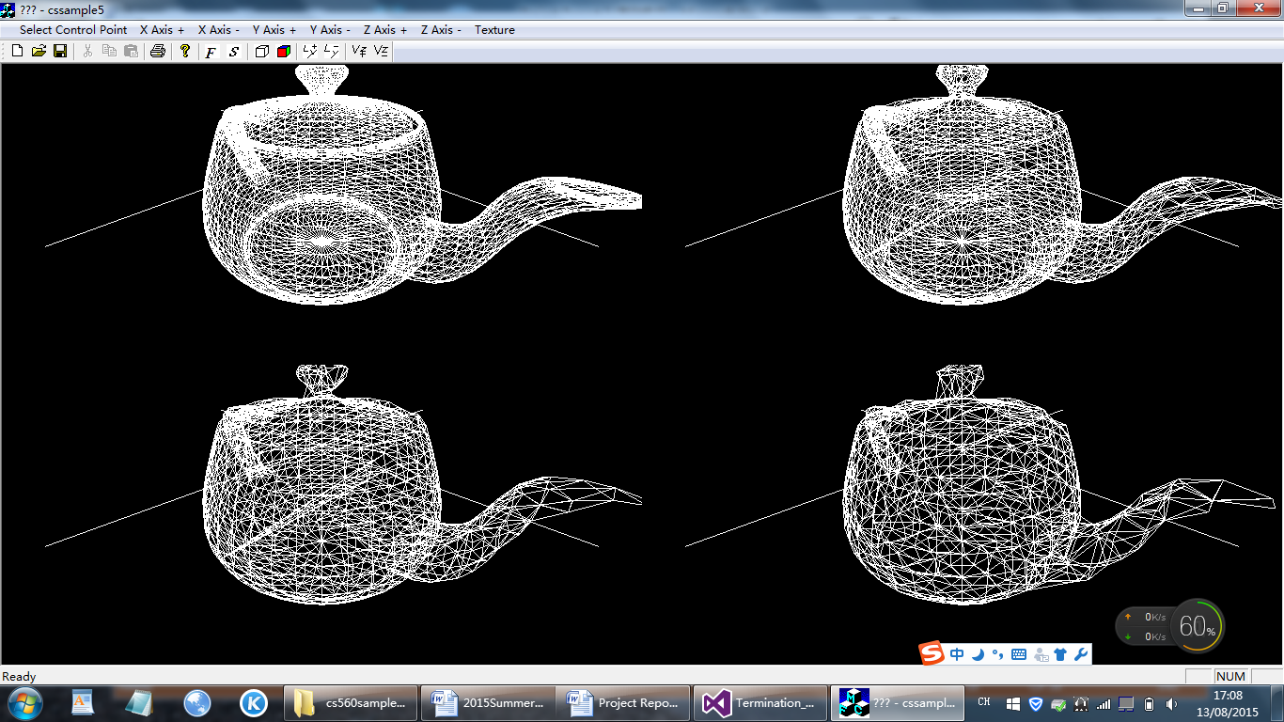
As you can see, the first one contains the most points is the original one, the up-right picture contains the a little less points is the one with cube number of 3, the lower-left picture is the one with cube number of 6 and the lower-right picture is the one with cube number of 9. And as we can see, if the length of cube is too large,the picture will not have the beautiful shape as before. And I use the technology to calculate the representative points for the graph, then draw triangles to get the approximate graph.

6. Conclusion:
The pictures represent 4 teapots with vertices clustered with different degree. The algorithm can reduce the vertices in a right way, but the results not that acurate, another algorithm, called---adaptive vertex clustering using octrees [3] deal with it using a better way. By sorting the vertices of the input mesh, our algorithm dynamically discovers portions of the mesh that are locally complete, which are then available for collapse when the octree grows too large. By studying the vertex clustering, I know there should be better ways to cluster vertices like adaptive vertex clustering using octrees. We should always think of more efficient ways to get a better algorithm to get the work done.

7. References:
[1] Multi-resolution 3D approximations for rendering complex scenes
J Rossignac, P Borrel - 1993 – Springer.
[2] Surface simplification using quadric error metrics
M Garland, PS Heckbert - Proceedings of the 24th annual conference on … 1997
[3] Adaptive vertex clustering using octrees
S Schaefer, J Warren - SIAM geometric design and computing, 2003.

