Shuttleworth Foundation Communications Expectations

The Shuttleworth Foundation maintains a network of Fellows and alumni Fellows to help everyone succeed better at changing the world. We help each other out, learn from each other, share news and stay in touch. Here we tell you what you may expect from us and what is expected of you in communicating using the means the Foundations provides. The various means of communication are for Fellows, alumni Fellows and the Foundation to communicate, and for Fellows and alumni to communicate with each other. To enable this the Chatham House Rule https://www.chathamhouse.org/about/chatham-house-rule applies:

“participants are free to use the information received, but neither the identity nor the affiliation of the speaker(s), nor that of any other participant, may be revealed.”

You can publicly relay what was discussed via the means of communication but never in a way that would allow the speaker to be identified. Obviously where someone explicitly indicates that something they say is confidential or the context indicates it is confidential then you should treat it as confidential. That means that neither the discussion nor the participants should be shared outside of the Foundation channels . Also when someone has already clearly indicated that they want to be identified as the origin of a public statement then you can do that without asking them again. When in doubt ask.

The Foundation values robust discussion, increased understanding and cooperation between people who don’t always agree and who may come from different backgrounds. Please be respectful and courteous, and also tolerant and patient with those you feel have been discourteous to you. If you feel that someone has been discourteous to you then we encourage you to speak to them privately, via a video chat if possible or over Direct Message. We expect that will resolve most issues. But if you don’t feel comfortable speaking to someone privately or you have and it hasn’t resolved the issue then speak to one of the Foundation Team members.

These explicit expectations change from time to time, we’ll alert you when they do.
We currently do not guarantee that all the communications technologies we deploy are free from AI powered analytics by service providers because we may not know. If this is a particular concern for you please speak to us.
We are pleased to provide the various means of communications that we do to help you. To be clear though, the Foundation has no legal obligation to make sure any particular technology remains in use, nor to maintain a particular technology or channel.

Messaging Channels
The technologies and channels that the Foundation uses change from time to time according to what we judge best at the time. For well documented reasons we don’t support every chat channel or even every way of connecting to chat channels.
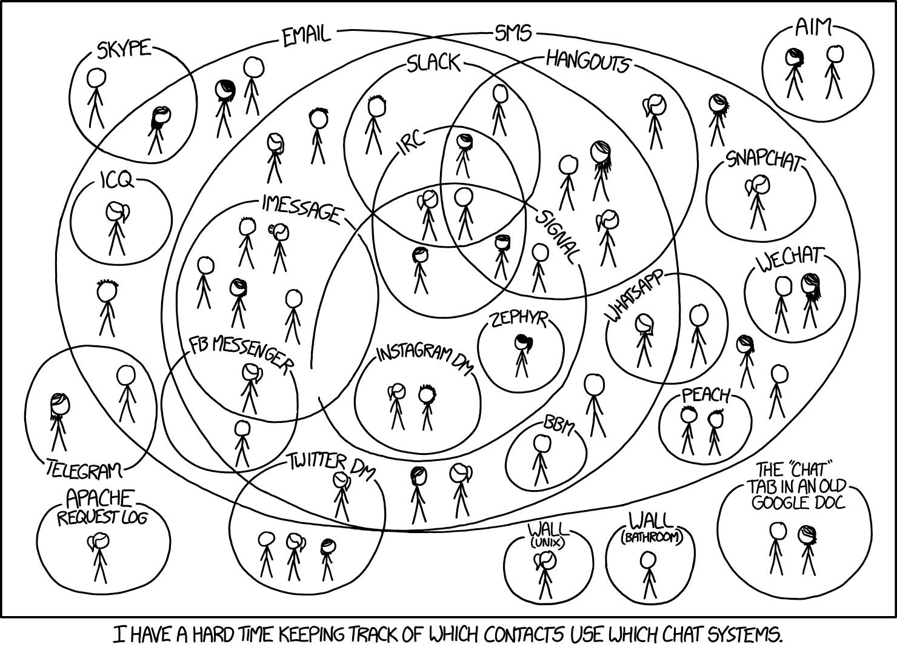

https://xkcd.com/1254/ CC By NC 2.5

We will do our best to help you to connect, but ultimately if you are a Fellow it is your responsibility find a way to connect to the channel.

At a particular point in time the technology we are using may allow us to to view Direct Messages but we don’t guarantee that any particular technology that we use will enable us to do that even if it's possible to configure the Direct Messages in that way. Where we can view Direct Messages we will do so only when we have good cause to do so. Good cause will be when there is a legal obligation or other compelling reason for example if one person in a Direct message conversation claims that another has violated our expected standards of conduct or if someone has gone missing and accessing information in the messages will help us to help that person.

We will endeavour to keep the channels a safe space for conversation but to do all this we need your co-operation and appropriate expectations.

We will warn you if we are deleting a messaging channel. We carefully back up the conversations recorded in the channels we provide but you shouldn’t rely on the messaging channels persisting. They may become inaccessible for technical reasons outside our control. If you want to be able to re-use a document or even revisit a conversation you must back it up elsewhere.
Email
We provide @shuttleworthfoundation email accounts for Fellows. Your @shuttleworthfoundation.org account will be shuttered as part of the exit process for each Fellow. If you are a Fellow you will be advised of the precise timeline and process close to your exit. . This means the archived emails will ultimately be deleted from the system that we use. You should therefore backup email yourself if you want to retain it.. We routinely retain attached documents for some time after shuttering accounts but once again don’t rely on us to store these documents for you. If you want to guarantee they will always be available you need to back them up yourself.

When you use an @shuttleworthfoundation.org address to send email you aren’t officially representing the Foundation but how you communicate does affect how the Foundation is perceived. How you communicate using the address will affect not only you but how all current and future Fellows are perceived.
We routinely have the technological ability to access emails sent from @shuttleworthfoundation.org accounts. As with direct messages we will only access emails you’ve sent from or received via these accounts only when there is good cause.

